Chapter 2: Assessment of the Pacific cod stock   
in the Gulf of Alaska

Steven Barbeaux, Bridget Ferriss, Wayne Palsson, Kalei

Shotwell, Ingrid Spies, Muyin Wang, and Stephani Zador

November 2021

# Executive Summary

## Summary of Changes in Assessment Inputs

Relative to last year’s assessment, the following changes have been made in the current assessment:

### Changes in the input data

1. Federal and state catch data for 2020 were updated and preliminary federal and state catch data for 2021 were included;
2. Commercial federal and state fishery size composition data for 2020 were updated, and preliminary commercial federal and state fishery size composition data for 2021 were included;
3. AFSC bottom trawl survey Pacific cod abundance and length composition data for 2021 were included;
4. AFSC longline survey Pacific cod abundance index and length composition data for the GOA for 2021 were included;
5. All length composition samples with less than 30 fish for a particular area, year, quarter, and gear type were excluded from the dataset. This made up 2% of the data representing < 1% of the overall catch.
6. Age-0 beach seine survey index is included in two alternative models.

*Changes in the methodology*

Model 19.1 is last year’s accepted model (Model 19.1) with the addition of the new data described above. There are two new models described this year, Model 21.1, which is Model 19.1 but with a new mortality block for 2015-2017, and Model 21.2 which has temperature dependent growth, heatwave dependent mortality, and heatwave dependent natural mortality instead of the 2014-2016 block used in Model 19.1. In addition 21.2 includes an age-0 index from beach seine surveys (Litzow *et al.* In review).

All three models presented in this document are single sex age-based models with length-based selectivity. The models have data from three fisheries (longline, pot, and combined trawl fisheries) with a single season and two survey indices (post-1990 GOA bottom trawl survey and the AFSC Longline survey indices). Length composition data are available for all three fisheries and both indices. In both models growth is parameterized using the standard three parameter von Bertalanffy growth curve. In Model 21.2 the von Bertalanffy growth curve has additional parameters on L2 and K which scale growth to the CFSR temperature at depth for 0-20cm fish and a parameter on L1 which scales this size to an index of growth for larval Pacific cod based on the relationship of larval growth to temperatures published by Laurel et al. (2016). In Model 19.1 and 21.1 recruitment is parameterized as a standard Beverton-Holt with Sigma R is fixed at 0.44 and steepness is fixed at 1.0 for all three models. For model 21.2 there is a parameter on R0 which scales it based on the spawning heatwave index. All scaling parameters are fit with non-informative priors. All selectivity estimates are fit using six parameter double-normal selectivity curves. For Model 21.2 the Beach Seine age-0 index is fit with an additional parameter which estimates variance of the index internally.

All three models performed well, however with the added parameters Model 21.2 provides the best fit to the available data. All three models produce similar results. While all three models perform well in the retrospective analyses, Model 19.1 performs marginally better in the spawning stock biomass retrospective analysis and Model 21.2 performs marginally better in the recruitment retrospective analysis. A leave-one-out analysis was performed where all the data for a single year were removed back to 11 years and changes in the variance of parameters and derived quantities evaluated. In this analysis all three models performed similarly with rather low bias. However Model 21.2 showed the least bias in the unfished spawning bimoass, 2022 spawning stock biomass, and ABC. The largest differences among models were in the projections. Model 19.1 and 21.1 assume average conditions after 2021. For Model 21.2 the authors present two different assumptions; Projection A assumes environmental conditions after 2021 will be the 1977-2021 average, Projection B assumes that the environmental conditions after 2021 will match the 2012-2021 average. Projection B was provided because conditions for 2012-2021 in the GOA have been decidedly warmer than previous decades in the time series and projections by the IPCC suggests the warming trend will continue and worsen in the coming decades.

### Summary of results

The data as interpreted through Model 21.2 indicates that the stock remains at low levels with poor recruitment since 2014. Although the 2017 and 2018 beach seine surveys indicated higher densities of age-0 cod in those years, these fish failed to materialize in the 2019 and 2021 surveys or fisheries. Given selectivity in the fisheries and surveys the high density of age-0 cod in the 2020 beach seine survey would not yet be collaborated by other data. Despite the low recruitment the stock is projected to either increase slowly (21.2A) or remain relatively stable due (21.2B) to low fishing levels in 2020 and 2021. Both projections have the stock at B24.5% in 2022, however they differ in 2023 with Projections A at B23.8% and Projection B at B21.6%. For management in 2022 and 2023 the authors recommend a conservative approach and using Projection B as the base projection.

Key results are tabulated below for Projection A and B:

|  |  |  |  |  |
| --- | --- | --- | --- | --- |
| **Quantity** | As estimated or *specified last* year for: | | As estimated or *specified this* year for: | |
| 2021 | 2022 | 2022 | 2023 |
| *M* (natural mortality rate) | 0.47 | 0.47 | 0.48* | 0.48* |
| Tier | 3b | 3b | 3b | 3b |
| Projected total (age 0+) biomass (t) | 265,661 | 312,783 | 160,755 | 169,832 |
| Female spawning biomass (t) |  |  |  |  |
| Projected | 39,977 | 50,813 | 39,873 | 35,050 |
|  |  |  |  |  |
| *B100%* | 180,111 | 180,111 | 162,426 | 162,426 |
| *B40%* | 72,045 | 72,045 | 64,970 | 64,970 |
| *B35%* | 63,039 | 63,039 | 56,849 | 56,849 |
| *FOFL* | 0.41 | 0.54 | 0.54 | 0.52 |
| *maxFABC* | 0.33 | 0.43 | 0.44 | 0.42 |
| *FABC* | 0.33 | 0.43 | 0.44 | 0.42 |
| OFL (t) | 28,977 | 46,587 | 29,131 | 27,066 |
| maxABC (t) | 23,627 | 38,141 | 24,043 | 22,882 |
| ABC (t) | 23,627 | 38,141 | 24,043 | 22,882 |
| **Status** |  | |  | |
| 2019 | 2020 | 2020 | 2021 |
| Overfishing | No | n/a | No | n/a |
| Overfished | n/a | No | n/a | No |
| Approaching overfished | n/a | No | n/a | No |

*\*Base natural mortality M varies between 0.48 and 1.07*

*\*\* Assumed 2021 catch at the ABC, 23,627t . For 2023 projections the 2022 catch was assumed to be at the projected ABC.*

## Area apportionment

In 2012 the ABC for GOA Pacific cod was apportioned among regulatory areas using a Kalman filter approach based on trawl survey biomass estimates. In the 2013 assessment, the random effects model (which is similar to the Kalman filter approach, and was recommended in the Survey Average working group report which was presented to the Plan Team in September 2013) was used; this method was used for the ABC apportionment for 2014. The SSC concurred with this method in December 2013. Using this method with the trawl survey biomass estimates through 2021, the area-apportioned ABCs would be:

|  |  |  |  |  |
| --- | --- | --- | --- | --- |
|  | Western | Central | Eastern | Total |
| Random effects area apportionment | 30.3% | 60.2% | 9.5% | 100% |
| 2022 ABC | 6,999 | 13,905 | 2,194 | 24,043 |
| 2023 ABC | 5,505 | 10,938 | 1,726 | 22,882 |

## Responses to SSC and Plan Team Comments Specific to this Assessment

**Plan Team Comments - November 2020**

**Science and Statistical Committee comments – December 2020**

# Introduction

Pacific cod (*Gadus macrocephalus*) is a transoceanic species, occurring at depths from shoreline to 500 m. The southern limit of the species’ distribution is about 34° N latitude, with a northern limit of about 63° N latitude. Pacific cod is distributed widely over Gulf of Alaska (GOA), as well as the eastern Bering Sea (EBS) and the Aleutian Islands (AI) area. The Aleut word for Pacific cod, *atxidax*, literally translates to “the fish that stops” (Betts *et al.* 2011). Recoveries from archeological middens on Sanak Island in the Western GOA show a long history (at least 6000 years) of exploitation. Over this period, the archeological record reveals fluctuations in Pacific cod size distribution which Betts et al. (2011) tie to changes in abundance due to climate variability (Fig. 2.1). Over this long period colder climate conditions appear to have consistently led to higher abundance with more small/young cod in the population and warmer conditions to lower abundance with fewer small/young cod in the population. Recent comparisons of Pacific cod length distributions extrapolated from bones retrieved from middens and those from the modern domestic fishery show a cline in size from larger fish in the west to smaller fish in the southeastern GOA that has been consistent for over 6000 years (West *et al.* 2020) (Fig 2.2).

Tagging studies (e.g., Shimada and Kimura 1994) have demonstrated significant migration both within and between the EBS, AI, and GOA outside of spawning season (Fig. 2.3). There appears to be substantial migration between the southern Bering Sea and the western GOA based on tagging data, however little movement has been observed from the Central GOA to the Western GOA. In March 2021, a cooperative tagging study between the Alaska Fisheries Science Center (AFSC) and the Aleutian East Borough was initiated to examine the seasonal movements of Pacific cod captured in the western GOA (WGOA) during the spawning season (P.I.s McDermott, Palsson, and Barbeaux, AFSC, and Levy, AEB). The goal of this study was to better understand the relationship of these fish to Pacific cod in the wider GOA and eastern Bering Sea (EBS) during the summer when the AFSC bottom trawl surveys are conducted. Twenty-five satellite-tagged and 957 conventionally-tagged Pacific cod were released in 8 subareas of the WGOA near the Shumagin and Sanak Islands (Fig. 2.4). Satellite tags were programmed to pop-up and transmit data after 90, 180, or 365 days. Early pop-ups were likely due to predation instead of tagging mortality. Locations of tags recovered in March, April, and May were largely in the vicinity of release area but fish with tags recovered in June, July, and August had moved west toward the Aleutian Islands region and north into the EBS, Northern Bering Sea, and Russia. More than half of the tag recoveries (9 of 16) between the beginning of June and the end of August were located in the Bering Sea, indicating substantial seasonal connectivity between the GOA and EBS management regions. Work is in progress to reconstruct movement paths of fish tagged with satellite tags which will provide valuable information on migration timing and pathways. Additional satellite and conventional tag releases are planned for March 2022.

Two recent genetics studies using Restriction-site Associated DNA sequencing have indicated significant genetic differentiation among spawning stocks of Pacific cod in the Gulf of Alaska and the Bering Sea (Drinan *et al.* 2018; Spies *et al.* 2019). The first study (Drinan et al. 2018) used 6,425 single-nucleotide polymorphism (SNP) loci to show high assignment success >80% of five spawning populations of Pacific cod throughout their range off Alaska. Further work using 3,599 SNP loci and spawning samples throughout the range of Pacific cod off Alaska, as well as a summer sample from the Northern Bering Sea in August 2017 showed significant differentiation among all spawning groups (Spies *et al*. 2019). The three spawning groups examined in the Gulf of Alaska, Hecate Strait, Kodiak Island, and Prince William Sound, were all genetically distinct and could be assigned to their population of origin with 80-90% accuracy (Fig. 2.4; Drinan *et al.* 2018). Cod that spawned at Unimak Pass in 2003 and 2018 were genetically distinct from the Kodiak Sample (spawning year 2003), *FST*=0.004 and *FST*=0.001. There was strong evidence for selective differentiation of some loci, including one that aligned to the zona pellucida glycoprotein 3 (ZP3) in the Atlantic cod genome. This locus had the level of differentiation of any locus examined (*FST*=0.071). ZP3 is known to undergo rapid selection (Drinan *et al.* 2018), and completely distinct haplotypes have been observed in spawning cod from Kodiak Island westward vs. Prince William Sound and samples to the east. Pooled whole genome sequence data is currently being analyzed, and individual whole genome sequencing is planned. This work is designed to enhance our understanding of mechanisms causing observed levels of differentiation among cod stocks.

Although there appears to be some genetic differentiation within the GOA management area and some cross migration between the Western GOA and Bering Sea the Pacific cod stock in the GOA region is currently managed as a single stock. Further work is needed to understand the genetic stock structure of cod in the GOA and its relationship with the Bering Sea stock of cod during spawning and feeding periods.

A detailed account of Pacific cod life history, environmental drivers, economic and social indicators can be found in the GOA Pacific cod ecosystem and social processes (ESP) Appendix 2.1.

# Fishery

## General description

During the two decades prior to passage of the Magnuson Fishery Conservation and Management Act (MFCMA) in 1976, the fishery for Pacific cod in the GOA was small, averaging around 3,000 t per year. Most of the catch during this period was taken by the foreign fleet, whose catches of Pacific cod were usually incidental to directed fisheries for other species. By 1976, catches had increased to 6,800 t. Catches of Pacific cod since 1991 are shown in Table 2.2; catches prior to that are listed in Thompson et al. (2011). Presently, the Pacific cod stock is exploited by a multiple-gear fishery, including trawl, longline, pot, and jig components. Trawl gear took the largest share of the catch in every year but one from 1991-2002, although pot gear has taken the largest single-gear share of the catch in each year since 2003. Figure 2.5 shows landings by gear since 1977. Table 2.2 shows the catch by jurisdiction and gear type.

The history of acceptable biological catch (ABC) and total allowable catch (TAC) levels is summarized and compared with the time series of aggregate commercial catches in Table 2.3. Changes in ABC over time are typically attributable to three factors: 1) changes in resource abundance, 2) changes in management strategy, and 3) changes in the stock assessment model. Assessments conducted prior to 1988 were based on survey biomass alone. From 1988-1993, the assessment was based on stock reduction analysis (Kimura *et al.* 1984). From 1994-2004, the assessment was conducted using the Stock Synthesis 1 modeling software (Methot 1986, 1990) with length-based data. The assessment was migrated to Stock Synthesis 2 (SS2) in 2005 (Methot 2005), at which time age-based data began to enter the assessment. Several changes have been made to the model within the SS2 framework (renamed “Stock Synthesis,” or SS3, in 2008) each year since then.

For the first year of management under the Magnuson-Stevens Fishery Conservation and Management Act (MSFCMA, 1977), the catch limit for GOA Pacific cod was established at slightly less than the 1976 total reported landings. During the period 1978-1981, catch limits varied between 34,800 and 70,000 t, settling at 60,000 t in 1982. Prior to 1981 these limits were assigned for “fishing years” rather than calendar years. In 1981 the catch limit was raised temporarily to 70,000 t and the fishing year was extended until December 31 to allow for a smooth transition to management based on calendar years, after which the catch limit returned to 60,000 t until 1986, when ABC began to be set on an annual basis. From 1986 (the first year in which an ABC was set) through 1996, TAC averaged about 83% of ABC and catch averaged about 81% of TAC. In 8 of those 11 years, TAC equaled ABC exactly. In 2 of those 11 years (1992 and 1996), catch exceeded TAC.

To understand the relationships between ABC, TAC, and catch for the period since 1997, it is important to understand that a substantial fishery for Pacific cod has been conducted during these years inside State of Alaska waters (Table 2.2), mostly in the Western and Central Regulatory Areas. To accommodate the State-managed fishery, the Federal TAC was set well below ABC (15-25% lower) in each of those years. Thus, although total (Federal plus State) catch has exceeded the Federal TAC in 16 of the 23 years since 1997, this is basically an artifact of the bi-jurisdictional nature of the fishery and is not evidence of overfishing as this would require exceeding OFL. At no time since the separate State waters fishery began in 1997 has total catch exceeded ABC, and total catch has never exceeded OFL.

Historically, the majority of the GOA catch has come from the Central regulatory area. To some extent the distribution of effort within the GOA is driven by regulation, as catch limits within this region have been apportioned by area throughout the history of management under the MFCMA. Changes in area-specific allocation between years have usually been traceable to changes in biomass distributions estimated by Alaska Fisheries Science Center (AFSC) trawl surveys or management responses to local concerns. Currently the area-specific ABC allocation is derived from the random effects model (which is similar to the Kalman filter approach). The complete history of allocation (in percentage terms) by regulatory area within the GOA is shown in Table 2.4. Table 2.2 and Table 2.3 include discarded Pacific cod, estimated retained and discarded amounts are shown in Table 2.5.

In addition to area allocations, GOA Pacific cod is also allocated on the basis of processor component (inshore/offshore) and season. The inshore component is allocated 90% of the TAC and the remainder is allocated to the offshore component. Within the Central and Western Regulatory Areas, 60% of each component’s portion of the TAC is allocated to the A season (January 1 through June 10) and the remainder is allocated to the B season (June 11 through December 31, although the B season directed fishery does not open until September 1).

NMFS has also published the following rule to implement Amendment 83 to the GOA Groundfish FMP:

“Amendment 83 allocates the Pacific cod TAC in the Western and Central regulatory areas of the GOA among various gear and operational sectors, and eliminates inshore and offshore allocations in these two regulatory areas. These allocations apply to both annual and seasonal limits of Pacific cod for the applicable sectors. These apportionments are discussed in detail in a subsequent section of this rule. Amendment 83 is intended to reduce competition among sectors and to support stability in the Pacific cod fishery. The final rule implementing Amendment 83 limits access to the Federal Pacific cod TAC fisheries prosecuted in State of Alaska (State) waters adjacent to the Western and Central regulatory areas in the GOA, otherwise known as parallel fisheries. Amendment 83 does not change the existing annual Pacific cod TAC allocation between the inshore and offshore processing components in the Eastern regulatory area of the GOA.

“In the Central GOA, NMFS must allocate the Pacific cod TAC between vessels using jig gear, catcher vessels (CVs) less than 50 feet (15.24 meters) length overall using hook-and-line gear, CVs equal to or greater than 50 feet (15.24 meters) length overall using hook-and-line gear, catcher/processors (C/Ps) using hook-and-line gear, CVs using trawl gear, C/Ps using trawl gear, and vessels using pot gear. In the Western GOA, NMFS must allocate the Pacific cod TAC between vessels using jig gear, CVs using hook-and-line gear, C/Ps using hook-and-line gear, CVs using trawl gear, and vessels using pot gear. Table 3 lists the proposed amounts of these seasonal allowances. For the Pacific cod sector splits and associated management measures to become effective in the GOA at the beginning of the 2012 fishing year, NMFS published a final rule (76 FR 74670, December 1, 2011) and will revise the final 2012 harvest specifications (76 FR 11111, March 1, 2011).”

“NMFS proposes to calculate of the 2012 and 2013 Pacific cod TAC allocations in the following manner. First, the jig sector would receive 1.5 percent of the annual Pacific cod TAC in the Western GOA and 1.0 percent of the annual Pacific cod TAC in the Central GOA, as required by proposed § 679.20(c)(7). The jig sector annual allocation would further be apportioned between the A (60 percent) and B (40 percent) seasons as required by § 679.20(a)(12)(i). Should the jig sector harvest 90 percent or more of its allocation in a given area during the fishing year, then this allocation would increase by one percent in the subsequent fishing year, up to six percent of the annual TAC. NMFS proposes to allocate the remainder of the annual Pacific cod TAC based on gear type, operation type, and vessel length overall in the Western and Central GOA seasonally as required by proposed § 679.20(a)(12)(A) and (B).”

The longline and trawl fisheries are also associated with a Pacific halibut mortality limit which sometimes constrains the magnitude and timing of harvests taken by these two gear types.

## Recent fishery performance

Data for managing the Gulf of Alaska groundfish fisheries are collected in multiple ways. The primary source of catch composition data in the federally managed fisheries for Pacific cod are collected by on-board observers (Faunce *et al.* 2017). The Alaska Department of Fish and Game (ADFG) sample individual deliveries for state managed fisheries (Nichols *et al.* 2015). Overall catch delivered is reported through a (historically) paper and electronic catch reporting system. Total catch is estimated through a blend of catch reporting, observer, and electronic monitoring data (Cahalan *et al.* 2014).

The distribution of directed cod fishing is distinct to gear type, Figure 2.6 shows the distribution of catch from 1990-2015 for the three major gear types. Figure 2.7 and Figure 2.8 show the distribution of observed catch for 2020 and 2021 through October 13, 2021 for the three major gear types. In the 1970’s and early to mid-1980’s the majority of Pacific cod catch in the Gulf of Alaska was taken by foreign vessels using longline. With the development of the domestic Gulf of Alaska trawl fleet in the late 1980’s trawl vessels took an increasing share of Pacific cod and Pacific cod catch increased sharply to around 70,000 t throughout the 1990’s. Although there had always been Pacific cod catch in crab pots, pots were first used to catch a measurable amount of Pacific cod in 1987. This sector initially comprised only a small portion of the catch, however by 1991 pots caught 14% of the total catch. Throughout the 1990s the share of the Pacific cod caught by pots steadily increased to more than a third of the catch by 2002 (Table 2.2 and Fig. 2.5). The portion of catch caught by the pot sector steeply increased in 2003 with incoming Steller sea lion regulations and halibut bycatch limiting trawl and by 2011 through 2019 the pot sector caught approximately half the total catch of Pacific cod in the Gulf of Alaska.

In 2015 combined state and federal catch was 79,489t (23%) below the ABC while in 2016 combined catch was 64,087 t (35% below the ABC) and in 2017 catch was 48,734 t (45% below the ABC) (Table 2.3). The ABC was substantially reduced for 2018 to 18,000 t from 88,342 t in 2017, an 81% reduction. This was a 65% reduction from the realized 2017 catch. In 2018 the total catch was 15,247 t. For 2019 the ABC was set below the maximum ABC at 17,000t and combined fishery caught 15,411 t which was 91% of the ABC.

In 2020 the spawning stock biomass was projected to have dropped below 20% of the unfished spawning biomass (B20%) and the federal Pacific cod fishery in the GOA was closed by regulation to directed Pacific cod fishing. B20% is a minimum spawning stock size threshold instituted to help ensure adequate forage for the endangered western stock of Steller sea lions. The Alaska State directed Pacific cod fishery remained open and Pacific cod bycatch in other federally managed groundfish fisheries was allowed. The Pacific cod ABC for 2020 was set to 14,621 t, but the combined TAC and Alaska State groundfish harvest level (GHL) was reduced to account for additional uncertainty. The Alaska State managed fisheries are allocated 26.7% of the GOA Pacific cod ABC. The federal Pacific cod TAC was reduced by 40% from the maximum of 10,719 t as a further level of precaution to 6,431 t. ADF&G also reduced their maximum prescribed harvest limit of 3,902 t by 35% to 2,537 t. This resulted in a total combined federal TAC and Alaska State GHL of 8,968 t or 61% of the maximum ABC. In 2020 a total combined catch of 6,233 t was harvested (Table 2.2), the state having taken 2,318 t (91% of the GHL) and federal fisheries have taken 3,916 t (61% of the federal TAC).

In 2021 the stock was projected to be above B20% and the federal fishery was once again allowed to open.

The largest component of incidental catch of other targeted groundfish species in the Pacific cod fisheries by weight are skate species in combination followed by shark species, arrowtooth flounder, octopus, and walleye pollock (Table 2.6). Rockfish, rock sole, and sculpin species also make up a major component of the bycatch in these fisheries. Incidental catch of non-target species in the GOA Pacific cod fishery are listed in Table 2.7.

### Longline

For 1990-2015 the longline fishery had been dispersed across the Central and Western GOA, however more longline catch taken to the west of Kodiak, with some longline fishing occurring in Barnabus trough and a small concentration of sets along the Seward Peninsula (Fig. 2.6). The 2017 longline fishery was predominantly conducted on the border of are 620 and 610 in deeper waters south of the Shumagin Islands and South of Unimak Island to the western edge of the 610 GOA management area shelf. In 2018 and 2019 with the drastic cut in TAC the fishery showed very little effort the majority of catch being south of the Shumagin Islands straddling the 610 and 620 management area edges (Fig. 2.7). In 2020 there was no directed Pacific cod longline fishery in federal waters (Fig. 2.8). In years with a fishery the longline fishery tends to catch larger fish on average than the other fisheries (Fig. 2.9). The mean size of Pacific cod caught in the longline fishery is 64 cm (annual mean varies from 58cm to 70cm). There was a drop in the mean length of fish in the longline fishery between 1990 and 2010, however this trend has been more variable over the last 10 years (Fig. 2.10). In the Central GOA the Longline fishery the 2017 A season had a slower start than previous years, but eventually caught the A-season TAC by mid-April; a point reached in 2016 three weeks earlier (Fig. 2.15). In 2018 and 2019 fewer boats participated in the fishery and catch was substantially slower and lower than previous years and in 2020 as stated earlier there was no directed federal fishery. The A season CPUE in the Central GOA longline fishery in 2018 was substantially lower than the previous years (Fig. 2.17) below 2008 catch rates when stock abundance had been at its previously lowest level. For both 2018 and 2019 the A- season longline fishery in the Western GOA appears to have started later than the previous 4 years, effort was lower and CPUE in January through March of 2019 declined in the Western GOA but was up in the Central GOA (Fig. 2.15, Fig. 2.16, and Fig. 2.17). It should be noted that CPUE is not available from the EM monitored vessels as number of hooks retrieved and soak time are not recorded

### Pot

The pot fishery is a relatively recent development (Table 2.2) and predominately pursued using smaller catcher vessels. In the Alaska State managed fishery an average of 84% of the state catch comes from pot fishing vessels. In 2016, 60% of the overall GOA Pacific cod catch was removed using pots. Pot fishing occurs close to the major ports of Kodiak, Sand Point and on either side of the Seward Peninsula (Fig. 2.6). In 2017, the observer coverage rate of pot fishing vessels was greatly reduced from 14% to ~4% this impacts our ability to adequately identify the spatial distribution of the pot fishery. From the data collected there appears to have been less fishing to the southwest of Kodiak in 2017, however this may be due to low observer coverage. In 2018 and 2019, there were few observed hauls throughout the GOA due to the lower TAC and low fishing levels, and in 2020 the directed federal fishery was closed (Fig. 2.7 and Fig. 2.8). The pot fishery in the Central GOA moved to deeper water in 2017 through 2019 than previous years. The 2017 pot fishery in both the Central and Western GOA showed a mark decrease in CPUE (Fig. 2.17) from 2016 and 2018 declined even further, however 2019 showed a marked increase in CPUE in both the Central and Western GOA (Fig. 2.17).

The pot fishery generally catches fish greater than 40 cm (Fig. 2.11), but like the longline fishery there was a declining trend in Pacific cod mean length in the fishery from 1998 through 2016 with the smallest fish at less than 60cm on average caught during the 2016 fishery (Fig. 2.12). The 2017 through 2019 fishery data show a sharp increase in mean length, potentially due to a combination of the fishery moving to deeper water and lower recruitment since 2014.

In 2017, the pot fishery in the Central GOA was slower than previous years and did not take the full TAC for the A season. The 2017 pot fishery in the Western GOA appears to have been similar to 2016 (Fig. 2.16). In 2018 and 2019, the Pot fisheries in both regions were slower than the previous three years. In the Western GOA, approximately half the catch was caught in a single week in March. In 2018, CPUE during the A season (January-April) in both the Central and Western GOA was lower than the previous three years (Fig. 2.17), on par with CPUE during 2013 and 2008-2010 (Fig. 2.17). In January – March 2019 there was an increase in the pot fishery CPUE in both regions.

### Trawl

The Gulf of Alaska Pacific cod trawl fishery rapidly developed starting in 1987, quickly surpassing the catch from the foreign longline fishery pursued in the 1970’s to mid-1980s in 1987. The trawl fishery dominated the catch into the mid-2000s, but was then replaced by increases in pot fishing in the mid-2000’s. This transition to pot fishing was partially due to Steller sea lion regulations, halibut bycatch caps, and development of an Alaska state managed fishery. The distribution of catch from the trawl fishery for 1990-2015 shows it has been widely distributed across the Central and Western GOA (Fig. 2.6) with the highest concentration of catch coming from southeast of Kodiak Island in the Central GOA and around the Shumigan Islands in the Western GOA. In 2016 trawl fishing in the Western GOA shows a shift away from the Shumigan Islands further to the west around Sanak Island and near the Alaska Peninsula, this continued through 2017. Trawl fishing in 2018 for the A-season shows a similar pattern as 2017 with large catches from around Sanak Island, but some increased effort on Portlock Bank to the southeast of Kodiak. There was substantially less catch and observed effort in 2018 and 2019 (Fig. 2.7) than previous years. Although the 2020 directed federal Pacific cod fishery was closed there was observations of Pacific cod catch in other fisheries (Fig. 2.8), these observations are primarily surrounding Kodiak from the pollock and shallow water flatfish fisheries.

The trawl fishery catches smaller fish than the other two gear types with fish as small as 10 cm appearing in the observed length composition samples (Fig. 2.13). The average size of Pacific cod caught by trawl in the 1980’s was on average smaller than those caught later (Fig. 2.14). The trawl fishery shows an increase in average size in the 1990s with the maturation of the domestic fishery. The decline in the mean length from the mid-1990s until 2015 mimics that observed in the longline and pot fisheries with some prominent outliers (2005-2006). The years 2005 and 2006 shows little observed fishing in the B-season when smaller fish are more often encountered with this gear type. The mean size shows a sharp increase in 2016 through 2020. The change to deeper depth and a larger proportion of the catch coming from the Western GOA might partially explain this recent increase as well as lower recruitment in recent years leading to a larger overall population on average as older fish make up higher percentage of the population age structure.

The 2018-2019, directed A-season trawl fishery in the Central GOA started much later than previous years, catch rates were lower and the fishery did not take the full TAC (Fig. 2.15). Prior to 2018, the mean CPUE for Pacific cod in both the Central and Western GOA had been stable to increasing over the previous 10 years (Fig. 2.17). In 2018, there was no observed effort in the Central GOA. In the western GOA there was very little observed effort, however where observed, CPUE remained near 2017 levels. In 2019, there was little observed effort, however the effort observed showed a decrease in CPUE in both regions from 2018.

### Other gear types, non-directed, and non-commercial catch

There is a small jig fishery for Pacific cod in the GOA, this is a primarily state managed fishery and there is no observer data documenting distribution. This fishery has taken on average 2,400 t per year. In 2017 through 2019, the jig fishery remained low with catch at less than 500 t for all regions.

Pacific cod is also caught as bycatch in other commercial fisheries. Although historically the shallow water flatfish fishery caught the most Pacific cod, since 2014, Pacific cod bycatch in the Arrowtooth flounder target fishery has surpassed it (Table 2.8). The weight of Pacific cod catch summed for all other target fisheries was 3,239 t in 2016, 2,726 in 2017, 2,786 in 2018, 3,434 t in 2019, and as of October 14th 3,535 t in 2020. This following an all-time high of 10,780 t in 2015 with 1/3 of this from the Arrowtooth flounder target fishery.

Non-commercial catch of Pacific cod in the Gulf of Alaska is considered to be relatively small at less than 400 t; data are available through 2019 (Table 2.9). The largest component of this catch comes from the recreational fishery, generally taking approximately one-third to one-half of the accounted for non-commercial catch and the IPHC Annual Longline survey also taking between one-third and one half of the accounted for non-commercial catch.

### Other fishery related indices for stock health

There is a long history of evaluating the health of a stock by its condition which examines changes in the weight to length relationship (Nash *et al.* 2006). Condition is measured in this document as the deviance from a log linear regression on weight by length for all Pacific cod fishery A season (January-April) data for 1992-2019. There is some variability in the length to weight relationships between Pacific cod captured in the Central and Western GOA fisheries and among gear types. However, there is a consistent trend in both areas for Pacific cod captured using longline and pot gear in there being lower condition during 2015-2016 (Fig. 2.18 - 2.21). In 2018 and 2019, the condition of fish in both the Central and Western GOA are mixed with differences in condition by gear and season. The Central GOA longline fishery shows improving condition in January through April (Fig. 2.20), however in 2019, the condition of Pacific cod returned to a poor condition. The Central GOA pot fishery shows improvement in 2018 in January through April as well (Fig 2.19), but lack of data availability in May through September limit our ability to evaluate condition. In the Western GOA, longline fishery cod condition in 2019 returned to average in January through April (Fig. 2.20), but again like in the Central GOA we see worse than average condition in the summer fishery. The Western GOA pot fishery shows improved cod condition in 2017 and 2018 following the heatwave (Fig. 2.21), but then again in the winter of 2019, cod condition once again drops to below average. There were not enough data in the summer of 2019 to evaluate condition in the Western GOA pot fishery.

Incidental catch of Pacific cod in other targeted groundfish fisheries is provided in Table 2.8 and noncommercial catch of Pacific cod are listed in Table 2.9.

Indices of fishery catch per unit effort (CPUE) can be informative to the health of a stock, however CPUE in directed fisheries can be hyper-stable with CPUE remaining high even at low abundance (Walters 2003). This phenomenon is believed to have contributed to the decline of the Northern Atlantic cod (*Gadus morhua*) on the eastern coast of Canada (Rose and Kulka 1999). Instead we show the occurrence of Pacific cod in other directed fisheries. We examine two disparate fisheries to evaluate trends in incidental catch of Pacific cod, the pelagic walleye pollock fishery and the bottom trawl shallow water flatfish fishery. The occurrence of Pacific cod in the pelagic pollock fishery appears to be an index of abundance that is particularly sensitive to 2 year old Pacific cod, which are thought to be more pelagic. The shallow water flatfish fishery tracks a larger portion of the adult population of Pacific cod. For the pollock fishery we track incidence of occurrence as proportion of hauls with cod (Fig. 2.22). In the shallow water flatfish fishery, catch rates in tons of Pacific cod per ton of all species catch were examined (Fig. 2.23). For the pollock fishery the 2017 value was the lowest in the series (2008-2020) with a slight increase in 2018 and continued increase through 2020 in areas 610. For the shallow water flatfish fishery, 2017 was the lowest value with an increasing trend through 2020. It should be noted that none of these indices are controlled for gear, vessel, effort, or fishing practice changes.

## Surveys

### Bottom trawl survey

The AFSC has been conducting standardized bottom trawl surveys for groundfish and crab in the Gulf of Alaska since 1984. From 1984-1997 surveys were conducted every third year, and every two years thereafter. Two or three commercial fishing vessels are contracted to conduct the surveys with fishermen working alongside AFSC scientists. Survey design is stratified random with the strata based on depth and distance along the shelf, with some concentrated strata in troughs and canyons (Raring *et al.* 2016). There are generally between 500 and 825 stations completed during each survey conducted between June and August starting in the western and ending in the southeastern Gulf of Alaska. Some changes in methods have occurred over the years with the addition of electronics to monitor how well the net is tending on-bottom, also to measure differences in net and trawl door dynamics and detect when general problems with the trawl gear occur. Surveys conducted prior to 1996 are considered to have more uncertainty given changes in gear mensuration. Also, the trawl duration was changed in 1996 to be 15 minutes instead of 30. Since 1996, methods have been consistent but in some years the extent of the survey has varied. In 2001 the Southeastern portion of the survey was omitted and in 2011, 2013, 2017, and 2019 deeper strata had fewer stations sampled than in other years due to budget and/or vessel constraints.

The 2019 survey was conducted with two chartered vessels that accomplished 541 stations following the protocols of Stauffer (2004) and von Szalay and Raring (2018). While the GOA Bottom Trawl Survey optimally employs three chartered vessels and targets 825 stations, the reduced 2019 survey likely captured the trend and magnitude of the cod abundance in the GOA. The 2019 survey covered all strata; regions; and shelf, gully, and upper slope habitats to 700 m. The percent standard error of the biomass estimate was 21.8% and was higher than the historic average of 17.7%. The 2019 survey design was comparable to the 2013 and 2017 surveys that were also conducted with two vessels and achieved 548 and 536 stations, respectively. The 2013 Pacific cod survey biomass estimate was 3.5 times higher than the 2019 estimate, and the 2019 biomass estimate was 69% greater than the 2017 estimate.

The Pacific cod biomass estimates from the bottom trawl survey are highly variable between survey years (Table 2.10 and Fig. 2.24). For example, the estimates dropped by 48% between the 1996 and 1999 estimates but subsequent estimates were similar through 2005. The 2009 survey estimate spiked at 2 times the 2006 estimate. Subsequent surveys showed a decline through 2017 with a slight uptick in 2019. The 2017 estimates for abundance and biomass estimates were the lowest in the time series (a 71% drop in abundance and 58% drop in biomass compared to the 2015 estimate). Although the 2019 survey resulted in a 126% increase in abundance over 2017, the estimate remains the second lowest in the time series at 127 million fish. The survey encounters fish as small as 5 cm and generally tracks large year-classes as they grow (e.g., the 1996, 2005-2008, and 2012 year-classes; Fig. 2.25). The mean length in the trawl survey generally increased from 1984-2005 excepting the 1997 and 2001 surveys (Fig. 2.26). The decline in mean length in 2007 and 2009 were apparently due to the large incoming 2005-2008 year-classes. The mean length in the survey increased in the 2011-2017 survey then dropped again in 2019. The average length of fish for 2007-2019 remains below the 1984-2005 overall average.

The distribution of Pacific cod in the survey has been highly variable (Fig. 2.27) with inconsistent peaks in CPUE. In 2017 the survey had the lowest average density of the time series, but also no high density peaks in CPUE were observed in any survey station. There were some higher than average densities for the 2017 survey located along the Alaska Peninsula and south of Unimak island, but for the most part CPUE was universally low throughout the Gulf of Alaska. The 2019 survey showed in increase in cod in the area of the Central GOA east of Kodiak Island on Portlock Bank and South of Marmot Island, but fewer cod in the Eastern and Western GOA.

### AFSC sablefish longline survey

Japan and the United States conducted a cooperative longline survey for sablefish in the GOA annually from 1978 to 1994, adding the AI region in 1980 and the eastern BS in 1982 (Sasaki 1985, Sigler and Fujioka 1988). Since 1987, the AFSC has conducted annual longline surveys of the upper continental slope, referred to as domestic longline surveys, designed to continue the time series of the Japan-U.S. cooperative survey (Sigler and Zenger 1989). The domestic longline survey began annual sampling of the GOA in 1987, biennial sampling of the AI in 1996, and biennial sampling of the eastern BS in 1997 (Rutecki *et al.* 1997). The domestic survey also samples major gullies of the GOA in addition to sampling the upper continental slope. The order in which areas are surveyed was changed in 1998 to reduce interactions between survey sampling and short, intense fisheries. Before 1998, the order was AI and/or BS, Western Gulf, Central Gulf, Eastern Gulf. Starting in 1998, the Eastern Gulf area was surveyed before the Central Gulf area. International Pacific halibut longline survey

A Relative Population Number (RPN) index of Pacific cod abundance and length compositions for 1990 through (Table 2.11 and Fig 2.28). Details about these data and a description of the methods for the AFSC sablefish longline survey can be found in Hanselman *et al.* (2016) and Echave *et al.* (2012). This RPN index follows the trend observed in the bottom trawl survey for 1990 through 2018 with a decline in abundance from 1990 through 2008 and a sharp increase (154%) in 2009 and continued increase through 2011 with the maturation of the large 2005-2008 year-classes. In 2012-2013 there appears a decline in the abundance index concurrent with a drop in overall shelf temperature potentially due to changes in availability of Pacific cod in these years as the population moved to shallower areas (Yang *et al.* 2019). In 2014-2016 the index increases but this may reflect increased availability with warmer conditions. The index shows a sharp drop (53%) in abundance from 2016 to 2017, again (40%) from 2017 to 2018, and yet again (37%) from 2018 to 2019. The 2019 estimate was 83% lower than the 2015 abundance estimate. The 2020 RPN shows a 30% increase from 2019, but the 2020 RPN remains the second lowest estimate of the time series.

Unlike the bottom trawl survey, the longline survey encounters few small fish (Fig. 2.29). The size composition data show consistent and steep unimodal distributions with a stepped decreasing trend in mean size between 1990 and 2015 (Fig. 2.30) and then increasing mean size from 2015-2018 and a leveling off in 2019 and 2020. This matches the trend observed in all three fisheries. Changes in mean size appear consistent with changing availability in the survey due to bottom temperatures and changes in the overall population with large year classes. A larger number of smaller fish are encountered during this survey in warm years vs. cold years. There is a sharp decline in mean size in 2009 when the large 2005 year-class would be becoming available to this survey. The even steeper decline in average length in 2015 was encountered in the second warmest year on record for the time series. In 2019 a more severe drop in average length was anticipated due to the increased temperatures on the shelf and an increase in abundance due to increased availability. That we observed neither of these anticipated outcomes portends that either very few small fish were available in the population, or a change in behavior. Given the high abundance of sablefish in recent years, there could potentially be an issue with hook competition. This has not been adequately examined and should be a priority in future examination of these data.

### Laurel and Litzow age-0 index

Beach seine sampling of age-0 cod was conducted at two Kodiak Island bays during 2006-2021 and an expanded survey was conducted during 2018-21 at 13 additional bays on Kodiak Island, the Alaska Peninsula, and the Shumagin Islands (n = 3 - 9 fixed stations per bay, 95 total stations). Sampling occured during July and August (days of year 184-240), within two hours of a minus tide at the long-term Kodiak sites, and within three hours of a low tide at the expanded survey sites. At all sites, a 36 m long, negatively buoyant beach seine was deployed from a boat and pulled to shore by two people standing a fixed distance apart on shore. Wings on the seine (13 mm mesh) were 1 m deep at the ends and 2.25 m in the middle with a 5 mm delta mesh cod end bag. The seine wings were attached to 25 m ropes for deployment and retrieval from shore. The seine was set parallel to and ~ 25 m, making the effective sampling area ~ 900 m 2 of bottom habitat.

A model-based index of annual catch per unit effort (CPUE) for age-0 cod was used to resolve inter-annual differences in sampling across different bays and different days of the year. Specifically, a Bayesian zero-inflated negative binomial (ZINB) model was used invoking year as a categorical variable, day of year as a continuous variable, and site nested within bay as a group-level (random) effect. The day of year effect was modeled with thin plate regression splines to account for non-linear changes in abundance through the season and the number of basis functions was limited to 3 to avoid over-fitting data. This model was fit using Stan 2.21.0, R 4.0.2 and the *brms* package (Carpenter et al. 2017, Buerkner 2017, R Core Team 2021). The beach seine age-0 CPUE index showed the large 2012 year class and subsequent drop in CPUE for 2013-2016, larger recruitment in 2017 and 2018, a drop again in 2019, and then large 2020 year class (Table 2). The most recent bottom trawl survey included in Model 19.1 was 2019, however Pacific cod don’t fully recruit into this survey until approximately age-3. Therefore Model 19.1 would not have much information informing year classes after 2016. The 2006 through 2016 recruitment deviations from Model 19.1 correlate positively with the log CPUE of the beach seine index with an R2 of 0.67.

### International Pacific halibut Commission (IPHC) longline survey

This survey differs from the AFSC longline survey in gear configuration and sampling design, but catches substantial numbers of Pacific cod. More information on this survey can be found in Soderlund *et al.* (2009). A major difference between the two longline surveys is that the IPHC survey samples the shelf consistently from ~ 10-500 meters, whereas the AFSC longline survey samples the slope and select gullies from 150-1000 meters. Because the majority of effort occurs on the shelf in shallower depths, the IPHC survey may catch smaller and younger Pacific cod than the AFSC longline survey. On the other hand, the IPHC uses larger hooks (16/0) than the AFSC longline survey (13/0) which may prevent very small Pacific cod from getting hooked. To compare these two surveys, IPHC relative population number’s (RPN) were calculated using the same methods used to estimate the AFSC longline survey RPNs (but using different depth strata). Stratum areas (km2) from the RACE trawl surveys were used for IPHC RPN calculations.

The IPHC survey estimates of Pacific cod tracks well with both the AFSC longline and AFSC bottom trawl surveys (Table 2.12 and Fig. 2.31). There was an apparent drop in abundance from 1997-1999 followed by a stable but low population through to 2006. The population increases sharply starting in 2007, likely with the incoming large 2005 year class and continues to increase through 2009 as the large 2005-2008 year classes matured. The population then remained relatively stable through to 2014. The RPN index shows a steep decline in 2015 and 2017 consistent with the two AFSC surveys. The 2017 RPN was the lowest on record for the 20-year time series. This index showed a slight increase of the population abundance in 2018 (28% from 2017) to values slightly higher than 2016, but remain the fourth lowest estimate on record after 2001, 2016, and 2017. The 2019 survey estimated a slight decrease (3.5%), however the uncertainty in the estimate is high. The length composition data available from 2018 and 2019 (Fig. 2.32) show the IPHC survey encounters fish greater than 40 cm. The length data in 2018 have a mode at approximately 60 cm in the western GOA. The other management areas have modes slightly higher between 65 and 75 cm. 2019 shows a slight increase in these modes for all three areas.

Due to COVID-19 restrictions the 2020 IPHC survey did not survey the western GOA and did not collect length composition data for Pacific cod. The IPHC survey Pacific cod catch data for the other GOA regions has not yet been made available for this analysis.

### Alaska Department of Fish and Game bottom trawl survey

The Alaska Department of Fish and Game (ADFG) has conducted bottom trawl surveys of nearshore areas of the Gulf of Alaska since 1987. Although these surveys are designed to monitor population trends of Tanner crab and red king crab, Pacific cod and other fish are also sampled. Standardized survey methods using a 400-mesh eastern trawl were employed from 1987 to the present. The survey is designed to sample at fixed stations from mostly nearshore areas from Kodiak Island to Unimak Pass, and does not cover the entire shelf area. The average number of tows completed during the survey is 360. On average, 89% of these tows contain Pacific cod. Details of the ADFG trawl gear and sampling procedures are in Spalinger (2006).

To develop an index from these data, a simple delta GLM model was applied covering 1988-2020. Data were filtered to exclude missing latitude and longitudes and missing depths. This model is separated into two components: one that tracks presence-absence observations and a second that models factors affecting positive observations. For both components, a fixed-effects model was selected and includes year, geographic area, and depth as factors. Strata were defined according to ADFG district (Kodiak, Chignik, South Peninsula) and depth (< 30 fathoms, 30-70 fathoms, > 70 fathoms). The error assumption of presence-absence observations was assumed to be binomial but alternative error assumptions were evaluated for the positive observations (lognormal versus gamma). The AIC statistic indicated the lognormal distribution was more appropriate than the gamma (ΔAIC= 2097.37). Comparison of delta GLM indices with the area-swept estimates indicated similar trends. Variances were based on a bootstrap procedure, and CVs for the annual index values ranged from 0.06 to 0.14. These values underestimate uncertainty relative to population trends since the area covered by the survey is a small percentage of the GOA shelf area where Pacific cod have been observed.

The ADFG survey index follows the other three indices presented above with a drop in abundance between 1998 and 1999 (-45%) and relatively low abundance throughout the 2000s (Table 2.13 and Fig. 2.33). This survey differs from other indices as the estimates only increased in 2012 (an 89% increase from 2011), and then dropped off steadily afterwards to a record low in 2016. The 2017 survey index was 5% higher than the 2016 survey index. 2018 increased by 30% from 2017. The 2019 survey showed a slight decline (15.7%) from 2018, but 2020 showed a sharp increase of 41% from 2019 and a 64% increase from the 2016 record low, but still below the time series average. Length composition data (Fig. 2.34) from this survey show wide multi-modal length distributions are common with modes of age-0 fish at times available at near 10cm, however the 2019 and 2020 surveys have no fish smaller than 22cm. The 2018 year class is apparent as a mode at between 40 cm and 55 cm and the 2017 year class at between 55 and 65cm.

## Environmental indices

### CFSR bottom temperature indices

The Climate Forecast System Reanalysis (CFSR) is the latest version of the National Centers for Environmental Prediction (NCEP) climate reanalysis. The oceanic component of CFSR includes the Geophysical Fluid Dynamics Laboratory Modular Ocean Model version 4 (MOM4) with iterative sea-ice (Saha *et al.* 2010). It uses 40 levels in the vertical with a 10-meter resolution from surface down to about 262 meters. The zonal resolution is 0.5**°** and a meridional resolution of 0.25° between 10°S and 10°N, gradually increasing through the tropics until becoming fixed at 0.5° poleward of 30°S and 30°N.

To make the index, the CFSR reanalysis grid points were co-located with the AFSC bottom trawl survey stations. The co-located CFSR oceanic temperature profiles were then linearly interpolated to obtain the temperatures at the depths centers of gravity for 10 cm and 40 cm Pacific cod as determined from the AFSC bottom trawl survey. All co-located grid points were then averaged to get the time series of CFSR temperatures over the period of 1979-2020 (Fig. 2.35 and Table 2.14).

The mean depth of Pacific cod at 0-20 cm and 20-40cm was found to be 47.9 m and 103.4 m in the Central GOA and 41.9 m and 64.07 m in the Western GOA. The temperatures of the 10 cm and 40 cm Pacific cod in the CFSR indices are highly correlated (R2 = 0.89) with the larger fish in deeper and slightly colder waters 7.49 °C vs. 6.00 °C in the Central GOA and 4.78 °C vs. 4.75 °C in the Western GOA. The shallower index is more variable (CV0-20 cm 0.12 vs. CV20-40cm=0.07). There are high peaks in water temperature in 1981, 1987, 1998, 2015, 2016 and 2019 with 2019 being the highest in both the 10 cm and 40 cm indices. There are low valleys in temperature in 1982, 1989, 1995, 2002, 2009, 2012, and 2013. The coldest temperature in the 0-20 cm index was in 2009 and in the 20-40 cm index in 2012. The trend is insignificant for both indices.

### Sum of annual marine heatwave cumulative intensity index (MHWCI)

The daily sea surface temperatures for 1981 through October 2020 were retrieved from the NOAA High-resolution Blended Analysis Data database (NOAA 2017) and filtered to only include data from the central Gulf of Alaska between 145°W and 160°W longitude for waters less than 300m in depth. The overall daily mean sea surface temperature was then calculated for the entire region. These daily mean sea surface temperatures data were processed through the R package heatwaveR (Schlegel and Smit 2018) to obtain the marine heatwave cumulative intensity (MHCI; Hobday *et al.* 2016) value where we defined a heat wave as 5 days or more with daily mean sea surface temperatures greater than the 90th percentile of the 1 January 1982 through 31 December 2012 time series. The MHCI were then summed for each year to create an annual index (MHCIAN), summed for each year for the months of January through March, November, and December to create an annual winter index (MHCIW), and the months of February and March to create an annual spawning season index (MHCISP).

The marine heatwave analysis using the daily mean Central GOA sea surface temperatures indicated a prolonged period of increased temperatures in the Central GOA from 2 May 2014 to 13 January 2017 with heatwave conditions persisting for 815 of the 917 days in 14 events of greater than 5 days (Fig. 2.36). The longest stretch of uninterrupted heatwave conditions occurred between 14 December 2015 and 13 January 2017 (397 days). By the criteria developed by Hobday et al. (2018) for marine heatwave classification the event in the Central GOA reached a Category III (Severe) on 16 May 2016 with a peak intensity (Imax) of 3.02°C. The heatwave had a summed cumulative intensity (Icum) for 2016 of 635.26°C days, more than 25% of the sum of the Icum for the entire time series (1981-2018). The 14 events of this prolonged heatwave period summed to 1291.91°C days or 52% of the summed Icum for the time series.

There have been four periods of increased winter heatwave activity in the Central GOA, the first in 1983-1986, second in 1997-2006, the third 2014-2016, and the fourth 2018-2020. Short winter marine heatwaves (Category I to II) occurred every winter between 1983 and 1986, however none of these exceeded 17 days and the total winter Icum for this period was 84.23°C days over a total of 86 days. In the winter of 1997 there were two short (7 and 12 days) winter heatwave events with a total cumulative intensity of 17.19 °C days. In 1998 there was a strong heatwave from 3 March to the 14 June (102 days) with an Imax of 2.36°C and cumulative intensity of 146.01°C days. From 2001 through 2006 there were 6 winter heatwave events, most were minor and less than two weeks in length, however between 6 November 2002 and 4 March 2003 there were two that lasted in sum 141 days with a cumulative intensity of 165.94°C days and an Imax of 2.04°C. The 2014-2016 series of marine heatwave as described above was substantially longer lasting and more intense than anything experience previously in the region reaching a maximum SST anomaly of 3.12°C on 5 May 2016 and having a cumulative intensity of 1369.24 °C days across the three years. The most recent heatwave began 9 September 2018 to 23 December 2019. There are six distinct events making up the 2018-2019 heatwave with a maximum SST anomaly of 3.03 °C and a cumulative intensity of 625.23 °C days. For 2020 the sea surface temperatures dropped below the long-term mean in March but then increased in April (Fig. 2.36). After April the SST remained above the 1982-2012 mean oscillating into and out of heatwave conditions through October 2020 with four heatwave events occurring between 8 June and mid-October for a cumulative intensity of 131.24 °C days. The highest seasonal anomaly for 2020 was on 22 August at 2.68°C. The longest heatwave event in 2020 has lasted 33 days starting 13 September and continuing to at least 16 October. This heatwave was ongoing as of the writing of this section.

# Data

This section describes data used in the current assessment (Fig. 2.37). It does not attempt to summarize all available data pertaining to Pacific cod in the GOA. All data used are provided in Appendix 2.2 in the Stock Synthesis data file ([https://archive.fisheries.noaa.gov/afsc/refm/stocks/plan_team/2020/GOA_PCOD_2020_Appendix_2.2_Model_19.1.zip](https://archive.fisheries.noaa.gov/afsc/refm/stocks/plan_team/2020/GOA_PCOD_2020_Appendix_2.2_Model19.1.zip)). Descriptions of the trends in these data were provided above in the pertinent sections.

|  |  |  |  |
| --- | --- | --- | --- |
| Data | Source | Type | Years included |
| Federal and state fishery catch, by gear type | AKFIN | metric tons | 1977 – 2021 |
| Federal fishery catch-at-length, by gear type | AKFIN / FMA | number, by cm bin | 1977 – 2021 |
| State fishery catch-at-length, by gear type | ADF&G | number, by cm bin | 1997 – 2021 |
| GOA NMFS bottom trawl survey biomass and abundance estimates | AFSC | number | 1984 – 2021 |
| AFSC Sablefish Longline survey Pacific cod RPN | AFSC | RPN | 1990 – 2021 |
| GOA NMFS bottom trawl survey length composition | AFSC | number, by cm bin | 1984 – 2021 |
| GOA NMFS bottom trawl survey age composition | AFSC | number, by age | 1990 – 2019 |
| GOA NMFS bottom trawl survey mean length-at-age and conditional age-at-length | AFSC | mean value and number | 1990 – 2019 |
| AFSC Sablefish Longline survey Pacific Cod length composition | AFSC | number, by cm bin | 1990 – 2021 |
| Federal fishery conditional age-at-length | ASC | proportion age at length | 2007 – 2020 |
| Age-0 beach seine index | AFSC | age-0 numbers per haul | 2006-2021 |
| CFSR bottom temperature indices | National Center for Atmospheric Research | temperature anomaly at mean depth for P. cod size bins 10 cm and 40 cm. | 1979-2021 |

# Fishery

## Catch Biomass

Catches for the period 1991-2021 are shown for the three main gear types in Table 2.2, with the catches for 2021 presented through October 1, 2021. For the assessment model the Oct-Dec catch was assumed to reach the full TAC and state GHL. Three gear type categories were modeled; trawl (all trawl types), longline (longline and jig) and pot. The weight of catch of other commercial species caught in the Pacific cod targeted fisheries for 2013 through 2021 are shown in Table 2.6, and incidental catch of non-commercial species for 2017 – 2021 are shown in Table 2.7. Non-commercial catch of Pacific cod in other activities is provided in Table 2.9.

## Catch Size Composition

Fishery size compositions are presently available by gear for at least one gear type in every year from 1977 through the first half of 2021. Size composition data are based on 1-cm bins ranging from 1 to 116 cm. As the maximum percent of fish larger than 110 cm over each year-gear type-season is less than 0.5%, the upper limit of the length bins was set at 116 cm, with the 116-cm bin accounting for all fish 116 cm and larger. The fishery length composition data are in Figures 2.9 – 2.14 and provided in Appendix 2.3 in an Excel spreadsheet.

([https://archive.fisheries.noaa.gov/afsc/refm/stocks/plan_team/2020/GOA_PCOD_2020_Appendix_2.3_Model 19.1.xlsx](https://archive.fisheries.noaa.gov/afsc/refm/stocks/plan_team/2020/GOA_PCOD_2020_Appendix_2.3_Model%2019.1.xlsx))

### Size composition proportioning

For the 2016 assessment models fishery length composition data were estimated based on the extrapolated number of fish in each haul for all hauls in a gear type for each year.

2016 Method: $p_{ygl}=\frac{\sum_{h}{\frac{n_{yghl}}{\sum_{l}{n_{yahl}}}N_{ygh}}}{\sum_{h}{N_{yg}}}$

Where *p* is the proportion of fishat length *l* for gear type *g* in year *y*, *n* is the number of fish measured in haul *h* at length *l* from gear type *g*, and year *y* and *N* is the total extrapolated number of fish in haul h for gear type *g*, and year *y*.

For 2017 through 2021 for post-1991 length composition we estimated the length compositions using the total Catch Accounting System (CAS) derived total catch weight for each gear type, NMFS management area, trimester, and year. Data prior to 1991 were unavailable at this resolution so those size composition estimates are unchanged.

“New” method (post-1991): $p_{ygl}=\sum_{t,a}{\left(\left(\frac{\sum_{h}{\frac{n_{ytaghl}}{\sum_{l}{n_{ytaghl}}}N_{ytagh}}}{\sum_{h}{N_{ytag}}}\right)\left(\frac{W_{ytag}}{\sum_{tag}{W_{ytag}}}\right)\right)}$

Where *p* is the proportion of fishat length *l* for gear type *g* in year *y*, *n* is the number of fish measured in haul *h* at length *l* from gear type *g*, NMFS area *a*, trimester *t*, and year *y* and *N* is the total extrapolated number of fish in haul h for gear type *g*, NMFS area *a*, trimester *t*, and year *y*. The *W* terms come from the CAS database and represent total (extrapolated) weight for gear type *g*, NMFS area *a*, trimester *t,* and year *y*. In 2020 we have added the additional condition that there be more than 30 lengths measured for a gear type, trimester, and area or else the data for that gear type/trimester/area are not included. This has resulted in a loss of approximately 2% of the length data representing less than 1% of the overall catch.

#### Addition of ADFG port sampling for pot, jig, and longline fishery length data

The ADFG has routinely collected length data from Pacific cod landings since 1997. The ADFG port sampling and NMFS at-sea observer methods follow different sampling frames so combining those poses some challenges. We used ADFG data from the fishery for gear type/trimester/areas in which observer data were missing. The resolution of the ADFG data required the assumption that all of the samples collected in a gear type/trimester/area were representative of the overall catch for that gear type/trimester/area.

Method for ADFG data: $p_{ytagl}=\frac{n_{ygl}}{\sum_{l}{n_{yal}}}\left(\frac{W_{ytag}}{\sum_{tag}{W_{ytag}}}\right)$

Where *p* is the proportion of fishat length *l* for gear type *g* in NMFS area *a* in trimester *t* for year *y*, *n* is the number of fish measured at length *l* from gear type *g* in trimester *t* of year *y.* W is the catch accounting total weight for gear type *g*, NMFS area *a*, trimester *t,* and year *y*.

### Age composition

Otoliths for fishery age composition have been collected since 1982. In 2017, the Age and Growth laboratory made a concerted effort to begin aging these data. These data have been processed in two ways, the first was to develop an age and gear specific age-length key which was then used in conjunction with the length composition data described above to create age composition distributions (Fig. 2.38). The age data was also used to develop an annual conditional length-at-age matrix for each fishery (Fig. 2.39-2.41).

## Surveys

### NMFS Gulf of Alaska Bottom Trawl Survey

#### Abundance Estimates

Bottom trawl survey estimates of total abundance used in the assessment models examined this year are shown in Table 2.10 and Fig. 2.24, together with their respective coefficients of variation.

#### Length Composition

The relative length compositions used in the assessment models examined this year from 1984-2021 are shown in Figure 2.42 and provided in Appendix 2.3 in an Excel spreadsheet ([https://archive.fisheries.noaa.gov/afsc/refm/stocks/plan_team/2020/GOA_PCOD_2020_Appendix_2.3_Model 19.1.xlsx](https://archive.fisheries.noaa.gov/afsc/refm/stocks/plan_team/2020/GOA_PCOD_2020_Appendix_2.3_Model%2019.1.xlsx)).

#### Age Composition

Age compositions (Fig. 2.42) and conditional length at age (Fig. 2.43) from 1990-2019 trawl surveys are available and included in this year’s assessment models. The age compositions and conditional length at age data are provided in Appendix 2.3 in an Excel spreadsheet. ([https://archive.fisheries.noaa.gov/afsc/refm/stocks/plan_team/2020/GOA_PCOD_2020_Appendix_2.3_Model 19.1.xlsx](https://archive.fisheries.noaa.gov/afsc/refm/stocks/plan_team/2020/GOA_PCOD_2020_Appendix_2.3_Model%2019.1.xlsx))

Kastelle *et al.* (2017) state that one of the specific reasons for their study was to investigate the apparent mismatch between the mean length at age (from growth-zone based ages) and length-frequency modal sizes in the BSAI Pacific cod stock assessments and to evaluate whether age determination bias could account for the mismatch. Mean lengths at age (either from raw age-length pairs or age-length keys) were reported to be smaller than the modal size at presumed age from length distributions. In general, for the specimens in their study, there was an increased probability of a positive bias in fish at ages 3 and 4 (Kastelle *et al.* 2017); that is, they were over-aged. In effect, this over-ageing created a bias in mean length at age, resulting in smaller estimates of size at a given age. When correcting for ageing bias by reallocating age-length samples in all specimens aged 2–5 in proportion to that seen in the true age distribution, mean size at ages 2–4 did indeed increase (Kastelle *et al.* 2017). For example, there was an increase of 35 mm and 50 mm for Pacific cod aged 3 and 4, respectively. This correction brings the mean size at corrected age closer to modal sizes in the length compositions. While beyond the scope of their study, they postulate that the use of this correction to adjust the mean size at age data currently included in Pacific cod stock assessments should prove beneficial for rectifying discrepancies between mean length-at-age estimates and length-frequency modes.

To investigate aging bias the otoliths used in the seminal paper Stark (2007) were reread using the most recent methods and reading criteria. There appeared to be a substantial change in the results to younger fish at length for all collections used in the study. The length at age data were then plotted by year for each age and a pattern appears where post-2007 fish at ages 2 through 6 were substantially larger than those aged prior to 2007 (Fig. 2.44). Plotting all of the GOA AFSC bottom trawl survey age at length data for 1996-2017 as pre- and post-2007 shows the bias is most apparent from ages 3 onward with at least one year between length categories. Upon further investigation the apparent change in growth observed post-2007 with fish becoming larger at age may have been due to a change in reading criteria and predominant age readers. As in last year’s management model aging bias for the pre-2007 ages were explored in this year’s model configuration.

### AFSC Longline Survey for the Gulf of Alaska

#### Relative Population Numbers Index and Length Composition

The AFSC longline survey for the Gulf of Alaska survey data on relative Pacific cod abundance together with their respective coefficients of variation used in the assessment models examined this year are shown in Table 2.12 and Fig. 2.28.

#### Length Composition

The length composition data for the AFSC longline survey data are shown in Figure 2.32 and provided in Appendix 2.3 in an Excel spreadsheet.

([https://archive.fisheries.noaa.gov/afsc/refm/stocks/plan_team/2020/GOA_PCOD_2020_Appendix_2.3_Model 19.1.xlsx](https://archive.fisheries.noaa.gov/afsc/refm/stocks/plan_team/2020/GOA_PCOD_2020_Appendix_2.3_Model%2019.1.xlsx))

### Laurel and Litzow age-0 index

Beach seine sampling of age-0 Pacific cod number per haul index values together with their respective coefficients of variation used in the assessment models examined this year are shown in Table 2.12 and Fig. 2.30.

## Environmental indices

### CFSR bottom temperature indices

The CFSR bottom temperature indices for 0-20 cm Pacific cod were used in this assessment (see description above; Table 2.14).

# Analytic Approach

## Model Structure

This year’s proposed management model (Model 19.1) is the same as last year’s model with updated data. We also include a description of ecosystem-linked models (Model 21.1 and Model 21.2) based on last year’s model configuration for comparison. To see the history of models used in this assessment refer to A’mar and Palsson (2015). All models for this year were run in Stock Synthesis version 3.30.18 (Methot and Wetzell 2013).

Both models presented were single sex, age-based models with length-based selectivity. The models have data from three fisheries (longline, pot, and combined trawl fisheries) with a single season and two survey indices (post-1990 GOA bottom trawl survey and the AFSC Longline survey indices). Length composition data were available for all three fisheries and both survey indices. Conditional length at age were available for the three fisheries and AFSC bottom trawl survey.

For the base Model 19.1 length at age, $L_{a}$, were modeled as three parameter von Bertalanffy growth models with length in June, $L_{1}$, maximum asymptotic length, L2, and growth rate, k, as:

$L_{a}={L_{2}-\left(L_{2}-L_{1}\right)e}^{-ak}$,

where a was age.

For the ecosystem-linked Models 21.1 and 21.2 length at age for each year, $L_{ay}$, were modeled as six parameter von Bertalanffy growth modeled with annual water temperature covariates on , , and k as:

where was the June bottom temperature anomaly in the Central GOA (described above) in year y, γ was the temperature anomaly link parameters for and an index of the ratio of the annual June temperature, , dependent juvenile growth (Laurel *et al.* 2015) for a given year over the growth in June for the mean temperature for 1982-2012, , υ was the temperature anomaly link parameter for L2, and φ the temperature anomaly link parameter for *k*.

**Time varying selectivity components for all models:**

|  |  |
| --- | --- |
| **Component** | **Temporal Blocks/Devs** |
| Longline Fishery | Annually variable 1978-1989  Blocks – 1996-2004, 2005-2006, 2007-2016, 2017-2019 |
| Trawl Fishery |
| Pot Fishery | Blocks – 1977-2012 and 2013-2019 |
| Bottom trawl survey | Blocks – 1977-1995, 1996-2006, 2007-2019 |

All Stock synthesis files for Model 19.1 are provided in a zip file in Appendix 2.2 **(**<https://archive.fisheries.noaa.gov/afsc/refm/stocks/plan_team/2021/GOA_PCOD_2021_Appendix_2.2_Model_19.1.zip>),

Model 21.1 in a zip file in Appendix 2.4 (<https://archive.fisheries.noaa.gov/afsc/refm/stocks/plan_team/2021/GOA_PCOD_2021_Appendix_2.4_Model_21.1.zip>), and

Model 21.2 in a zip file in Appendix 2.6 (<https://archive.fisheries.noaa.gov/afsc/refm/stocks/plan_team/2021/GOA_PCOD_2021_Appendix_2.6_Model_21.2.zip>).

## Parameters Estimated Outside the Assessment Model

### Natural Mortality

In the 1993 BSAI Pacific cod assessment (Thompson and Methot 1993), the natural mortality rate *M* was estimated to be 0.37. All subsequent assessments of the BSAI and GOA Pacific cod stocks (except the 1995 GOA assessment) have used this value for *M*, until the 2007 assessments, at which time the BSAI assessment adopted a value of 0.34 and the GOA assessment adopted a value of 0.38. Both of these were accepted by the respective Plan Teams and the SSC. The new values were based on Equation 7 of Jensen (1996) and ages at 50% maturity reported by (Stark 2007; see “Maturity” subsection below). In response to a request from the SSC, the 2008 BSAI assessment included further discussion and justification for these values.

For the 2016 reference model (Model 16.08.25) *M* was estimated using a normal prior with a mean of 0.38 and CV of 0.1. In 2017 Dr. Thompson presented a new natural mortality prior based on a literature search (Table 2.1) for the Bering Sea stock assessment (Thompson 2017). For the Gulf of Alaska stock, we used the same methodology and literature search to devise a new prior for M. This resulted in a lognormal prior on M of -0.81 (μ=0.44) with a standard deviation of 0.41 for the Gulf of Alaska Pacific cod. All models presented were fit with this prior on M.

In 2017 it was hypothesized that due to the drop in all available survey indices between 2013 and 2017 it was suspected that there was an increase in natural mortality during the height of the 2014-2016 natural mortality. The 2017 reference model, Model 17.09.35 used a block for 2015-2016 where M could be fit separately from all other years. In consideration of the marine heatwave analysis, models in 2018 expanded the natural mortality block to 2014-2016. For this Mstandard is fit separate from M2014-2016 with a lognormal prior of μ=-0.81 and σ of either 0.1 or 0.41. The σ of 0.41 was based on a reevaluation of the data presented by Dr. Thompson described above and in Table 2.1, but limited to not include data from the Gulf of Alaska used in the current model.

Natural mortality in the Model 19.1 were fit for two time blocks, 2014-2016 and all other years, as a single non-varying parameter for all ages for each block. Natural mortality in Model 21.1 was annually varying with a linear ecosystem-link parameter, $η$, which scaled the non-heatwave year natural mortality, $\hat{M}$, using the annual central GOA marine heatwave cumulative index (*IAy*) as:

$$M_{y}=\hat{M}+ηl_{y}$$

$$l_{y}=λ/{\left(1+e^{-ς\left(I_{Ay}-ψ\right)}\right)}$$

A logistic curve was used to convert the index forcing M to asymptote at higher index values (Table 3). Here the shape of the logistic curve including the asymptote, λ, slope, ς, and inflection point in °C days, ψ, was determined within the model iteratively and the parameters resulting in the lowest negative log-likelihood were selected for projections. The best fit model had λ at 0.65, ς = 0.005 and ψ = 400 resulting in increased natural mortality estimates for years with positive *IAy* values. Note the maximum annual marine heatwave index value in the time series was 631°C-days in 2016, well below future projected values.

For Models 21.2 natural mortality were fit for two time blocks, 2015-2021 and all other years, as a single non-varying parameter for all ages for each block with uninformative priors.

### Growth

For Model 19.1 length at age, $L_{a}$, were modeled as three parameter von Bertalanffy growth models with length in June, $L_{1}$, maximum asymptotic length, L2, and growth rate, k, as:

$L_{a}={L_{2}-\left(L_{2}-L_{1}\right)e}^{-ak}$,

where a was age.

For the ecosystem-linked models 21.1 and 21.2 length at age for each year, $L_{ay}$, were modeled as six parameter von Bertalanffy growth modeled with annual water temperature covariates on , , and k as:

where was the June bottom temperature anomaly in the Central GOA (described above) in year y, γ was the temperature anomaly link parameters for and an index of the ratio of the annual June temperature, , dependent juvenile growth (Laurel *et al.* 2015) for a given year over the growth in June for the mean temperature for 1982-2012, , υ was the temperature anomaly link parameter for L2, and φ the temperature anomaly link parameter for *k*.

The initial growth parameters L1, k, and L2 initial values and ‘priors’ based on a nonlinear least squares regression of the 2007-2015 AFSC GOA bottom trawl survey length at age data (Fig. 2.45). The *nls* function from the **nlstools** library (Baty *et al.* 2015) in R was used to fit the basic model. Variance of the parameters were determined through bootstrap of the model with 1,000 iterations. Linf was estimated at μ=99.46 CV=0.015, K was μ = 0.1966 CV=0.03, L0 was -0.11 CV=0.25. We recognized that these ‘priors’ are not true priors as they are drawn from the data used in the model, but were necessary in setting structure within the model while allowing some flexibility in the model fitting which we think is a compromise to fixing parameters. Previous modeling effort using uninformative priors on these three parameters has led to model convergence at unreasonable values or non-convergence.

### Variability in Estimated Age

Variability in estimated age in Stock Synthesis is based on the standard deviation of estimated age. Weighted least squares regression has been used in the past several assessments to estimate a linear relationship between standard deviation and age. The regression was recomputed in 2011, yielding an estimated intercept of 0.023 and an estimated slope of 0.072 (i.e, the standard deviation of estimated age was modeled as 0.023 + 0.072 × age), which gives a weighted *R*2 of 0.88. This regression was retained in the present assessment.

### Weight at Length

Parameters governing the weight-at-length were estimated outside the model using AFSC GOA bottom trawl survey data through 2015, giving the following values:

|  |  |
| --- | --- |
|  | Value |
| *α*: | 5.631×10−6 |
| *β*: | 3.1306 |
| Samples: | 7,366 |

### Maturity

The length at 50% maturity was calculated using the *morp_mature* function in the sizeMat R package (Torrejon-Magallanes 2017) using all of the length at maturity data available from the Stark (2007) study for the Gulf of Alaska. This included some maturity data that was not available to Stark (2007) at the time of publication and some maturities from March and April not used in the calculation of L50% published. This resulted in the following values: length at 50% maturity = 57.3 cm and slope of linearized logistic equation = -0.27365 (Fig. 2.46).

### Aging Error

Aging error vector was included in all models. These were developed from age reader agreement testing results for otoliths read from the 2007-2017 bottom trawl surveys. The standard deviation at age 3 was 0.57 and at age 10 was 1.16, the model assumed a linear interpolation between these values and no error at ages 1 and 2.

## Parameters Estimated Inside the Assessment Model

Parameters estimated conditionally (i.e., within individual SS runs, based on the data and the parameters estimated independently) in the model include the von Bertalanffy growth parameters, annual recruitment deviations, initial fishing mortality, gear-specific fishery selectivity parameters, aging bias adjustment parameters, and survey selectivity parameters (Table 2.15 and Appendix 2.3). (<https://archive.fisheries.noaa.gov/afsc/refm/stocks/plan_team/2020/GOA_PCOD_2020_Appendix_2.3_Model_19.1.xlsx>)

### Recruitment

In the base Model 19.1 recruitment by year, Ry, were modeled as:

$R_{y}=\left(R_{0}e^{ϑ}\right)e^{-0.5b_{y}σ_{R}^{2}+{\tilde{R}}_{y}}$, if y ≥ 1977 → $ϑ$ = 0, where ${\tilde{R}}_{y}=N\left(0; σ_{R}^{2}\right)$,

$R_{0}$ was the unfished equilibrium recruitment, ${\tilde{R}}_{y}$ was the lognormal recruitment deviation for year y, $σ_{R}^{2}$ was the standard deviation among recruitment deviations in log space and was fixed at 0.44, and by was a bias adjustment fraction applied during year, y (Methot Jr and Taylor, 2011). To account for an environmental regime change in 1977 (Anderson and Piatt, 1999) the parameter $ϑ$ was fit for recruitment allowing for a change in R0 prior to the regime change in 1977. Projections in the base model post-2017 assumed average recruitment for 1977-2017 for Ry.

The ecosystem-linked recruitment (Ry) in models 21.1 and 21.2 were modeled as Beverton-Holt relationships with parameter ($ω$) which scaled the unfished equilibrium recruitment, $R_{0}$, using the annual spawning Central GOA marine heatwave cumulative index (Iy; described below) as:

$R_{y}=\frac{4h\left(e^{ϑ+ln\left(R_{0}e^{ωI_{Sy}^{\frac{1}{3}}}\right)}\right)SB_{y}}{{SB}_{0}\left(1-h\right)+{SB}_{y}\left(5h-1\right)}e^{-0.5b_{y}σ_{R}^{2}+{\tilde{R}}_{y}}$, if y ≥ 1977 → $ϑ$ = 0, where ${\tilde{R}}_{Y}=N\left(0; σ_{R}^{2}\right)$,

h was the steepness parameter, SB0 was the unﬁshed equilibrium spawning biomass (corresponding to R0), and SBy was the spawning biomass at the start of the spawning season during year y.

Where h=1, the formula reduces to $R_{y}=e^{ϑ+ln\left(R_{0}e^{ωI_{Sy}^{\frac{1}{3}}}\right)}e^{-0.5b_{y}σ_{R}^{2}+{\tilde{R}}_{y}}$.

### Selectivity

The same functional form (pattern 24 for length-based selectivity) used in Stock Synthesis to define the fishery selectivity schedules in previous year’s assessments was used this year for both the fishery and survey in both models described. This functional form, the double normal, is constructed from two underlying and rescaled normal distributions, with a horizontal line segment joining the two peaks. This form uses the following six parameters (selectivity parameters are referenced by these numbers in several of the tables in this assessment):

1. Beginning of peak region (where the curve first reaches a value of 1.0)
2. Width of peak region (where the curve first departs from a value of 1.0)
3. Ascending “width” (equal to twice the variance of the underlying normal distribution)
4. Descending width
5. Initial selectivity (at minimum length/age)
6. Final selectivity (at maximum length/age)

All but the “beginning of peak region” parameter are transformed: The widths are log-transformed and the other parameters are logit-transformed.

In this year’s models both fishery and survey selectivities were length-based. Uniform prior distributions were used for all selectivity parameters, except for *dev* vectors in models with annually varying selectivities which were constrained by input standard deviations (“sigma”) of 0.2.

For all parameters estimated within individual SS runs, the estimator used was the mode of the logarithm of the joint posterior distribution, which was in turn calculated as the sum of the logarithms of the parameter-specific prior distributions and the logarithm of the likelihood function.

In addition to the above, the full set of year- and gear-specific fishing mortality rates were also estimated conditionally, but not in the same sense as the above parameters. The fishing mortality rates are determined exactly rather than estimated statistically because SS assumes that the input total catch data are true values rather than estimates, so the fishing mortality rates can be computed algebraically given the other parameter values and the input catch data.

For all models presented aging bias was estimated for ages 3+ with two parameters, bias at age 3 and bias at age 10, with a linear interpolation between the two, applied to all age data collected prior to 2007 (aged prior to 2008). Age data from post-2007 were assumed to be aged without bias.

### Catchability

For Model 19.1 the catchability for the AFSC bottom trawl survey was fit with a non-informative prior. For Model 21.1 and 21.2 the AFSC bottom trawl survey catchability was fixed at 1.0. In all models presented this year, the AFSC longline survey catchability included a parameter, P, which was used to additively adjust annual catchability values based on an annual temperature index, Iy, as $\log\left(Q_{y}\right)=\left(\overline{Q}+{PI}_{y}\right)$ where Qy is catchability for a given year, and Q is the expected catchability across all time. We used an index of mean annual temperature at depth for cod developed from the Climate Forecast System Reanalysis (CFSR) as our temperature index (see description above). An analysis introducing this methodology was presented in 2017 (Barbeaux *et al.* 2017) and a new method validating this methodology was presented at the 2018 September Plan team meeting and provided in Barbeaux *et al.* (2018) Appendix 2.1. Bottom trawl survey data show a centroid of distribution for cod greater than 34 cm shifts to deeper water in years with warmer shelf temperatures (Barbeaux *et al.* 2019). This relationship was verified in Yang *et al.* (2019) with a shift to deeper depths in all size classes examined during warm years and shift to shallower waters in cold years. This shift would make cod more available to the AFSC longline survey which starts at 150 m.

## Likelihood Components

The model includes likelihood components for trawl survey relative abundance, fishery and survey size composition, survey age composition, survey mean size at age, recruitment, parameter deviations, and “softbounds” (equivalent to an extremely weak prior distribution used to keep parameters from hitting bounds), initial (equilibrium) catch, and survey mean size at age.

For both models presented there were no parameters near bounds and the likelihoods appear well defined with the gradient of the objective function at less than 10e-4. Both models were examined by “jittering” starting parameters by 10% over 50 runs to evaluate if models had converged to local minima.

### Use of Size and Age Composition Data in Parameter Estimation

Size and age composition data are assumed to be drawn from a multinomial distribution specific to a particular year and gear within the year. In the parameter estimation process, SS weights a given size composition observation (i.e., the size frequency distribution observed in a given year and gear) according to the emphasis associated with the respective likelihood component and the sample size specified for the multinomial distribution from which the data are assumed to be drawn. As was done last year, we set initial sample sizes for the fishery at the number of hauls sampled or 200 whichever is least, for the surveys both size and age composition sample sizes were initially set at 100.

# Results

## Model Evaluation

Three models are presented, Model 19.1, which is the 2020 base model with updates to the data, Model 21.1, which is a climate enhanced model based on Model 19.1 with the addition of temperature dependent growth, recruitment, and mortality, and Model 21.2 which is Model 21.1 except natural mortality is modeled as a block for 2015-2020 instead of having an environmental link. Model evaluation criteria included AIC, model adherence to biological principles and assumptions, the relative sizes of the likelihood components, and how well the model estimates fit to the survey indices, the survey and fishery age composition and conditional age-at-length data, reasonable curves for fishery and survey selectivity, and retrospective pattern. All three models adequately estimated the variance-covariance matrix.

Model likelihoods and key parameter estimates are provided in Table 2.16. Likelihoods by fleet are provided in Table 2.17. Retrospective results, index RMSSR and composition mean effective sample sizes are provided in Table 2.18.

### Comparing and Contrasting Model Configurations

For this year the authors are presenting only a single model for consideration for management, Model 19.1, which has the same configuration as last year’s author’s preferred model with the addition of 2020 data. Description of this model configuration compared with other model configurations and its evolution from previous model configurations can be found in Barbeaux *et al.* (2019). The authors are also presenting an experimental ecosystem-linked model, Model 20.1, which was based on Model 19.1 with the addition of temperature dependent growth and recruitment. Model 20.1 is experimental and only presented to contrast with the author’s preferred model and not for consideration for use in management as this model requires further validation, particularly the choice of climate indices. It should be noted that the results from the GOA Pacific cod stock assessment have been particularly volatile with a wide-array of models presented over the past 18 years (A’mar and Palsson 2015). The models presented this year are well within the bounds of models presented in previous years for the spawning stock biomass time series (Fig. 2.47). The female spawning biomass and age-0 recruitment for both models presented this year are provided in Figure 2.48 along with the reference model from last year without updated data. Both models show a similar fit, and similar recruitment and biomass trends. The size based selectivity curves (Fig. 2.49 and Fig. 2.51) are nearly indistinguishable between the two models. The difference in model fit to the indices (Fig. 2.50) between Model 19.1 and Model 20.1 are difficult to discern by eye. Model 20.1 provides a slightly better fit (ΔAIC 16.6; Table 2.16 and Table 2.17) with an overall better fit to the composition data and slightly degraded fit to the survey indices. There was also a slight increase in the parameter prior penalties (+0.14) from Model 19.1 to Model 20.1. The largest improvements in Model 20.1 were to the longline survey length composition (-4.39) and the conditional length at age data (-8.91 over all data components). Model 20.1 had worse fits to the length composition for the trawl (+1.77), trawl survey length composition (+1.89), and the longline survey index (+1.00).

Effective N calculations (Table 2.18) have a pattern similar to the likelihood metric with Model 20.1 showing marginal improvements in the fits to the conditional length at age data and a mix in the length composition data where Model 19.1 provided a marginally better fit to the trawl and longline fishery and longline survey length composition data. The difference in RMSE for the survey indices were negligible.

The improvements to fit in Model 20.1 were accomplished by allowing time varying growth and recruitment. Figure 2.52 provides an illustration of the ecosystem-linked changes allowed in Model 20.1 with increased growth with increasing June temperature anomalies. The three ecosystem-linked scaling parameters on growth, α, β, and γ, were well fit with CVs of 0.22, 0.36, and 0.27 and low final gradients in the fit (Appendix 2.5; <https://archive.fisheries.noaa.gov/afsc/refm/stocks/plan_team/2020/GOA_PCOD_2020_Appendix_2.5_Model_20.1.xlsx>). Because maturity is size based Model 20.1 exhibits a decrease in age at 50% maturity (Fig. 2.53) as growth increases with temperature. Figure 2.54 illustrates the results of the ecosystem-linked recruitment model where recruitment decreases with increasing MHCISP and a steepness of 0.89. The decrease in recruitment in years with spawning heatwave values allows the model to fit a slightly lower natural mortality. Model 19.1 estimated natural mortality at 0.466 (σ = 0.02) during the standard years, while Model 20.1 natural mortality was estimated at 0.458 (σ = 0.02) during the standard years. However Model 20.1 fits a higher natural mortality during the 2014-2016 heatwave block at 0.850 (σ = 0.05) versus 0.823 (σ = 0.06) in Model 19.1. The most impactful difference between the two models is a lower recruitment estimate for 2019 (193 vs 399 million fish) being driven by the high 2019 MHCISP value (Table 2.21). There is little data informing this estimate in Model 19.1 and therefore the value tends towards the mean.

Both models exhibit low retrospective bias (Table 2.18 and Fig. 2.55) however in both spawning biomass and recruitment at age-0 across all three metrics (Mohn’s ρ, Woods hole ρ, and RMSE) Model 19.1 performed marginally better.

### Selection of Final Model

The authors do not consider Model 20.1 fully validated and therefore not ready for management at this time. The authors would prefer to have a much more rigorous review of the possible advancements in this model through a peer-reviewed journal or CIE review prior to using it for management. That said, Model 20.1 does provide a marginally better fit to the available data, however Model 19.1 provides a marginally better retrospective pattern. The authors recommend continue using Model 19.1.

All Stock Synthesis files for Model 19.1 are provided in a linked zip file Appendix 2.2:

(<https://archive.fisheries.noaa.gov/afsc/refm/stocks/plan_team/2020/GOA_PCOD_2020_Appendix_2.2_Model_19.1.zip>).

All data, results, and parameter estimates for Model 19.1 are provided in an excel sheet in Appendix 2.3:

(<https://archive.fisheries.noaa.gov/afsc/refm/stocks/plan_team/2020/GOA_PCOD_2020_Appendix_2.3_Model_19.1.xlsx>).

All Stock Synthesis files for Model 20.1 are provided in a linked zip file Appendix 2.4:

(<https://archive.fisheries.noaa.gov/afsc/refm/stocks/plan_team/2020/GOA_PCOD_2020_Appendix_2.4_Model_20.1.zip>).

All data, results, and parameter estimates for Model 20.1 are provided in an excel sheet in Appendix 2.5:

([https://archive.fisheries.noaa.gov/afsc/refm/stocks/plan_team/2020/GOA_PCOD_2020_Appendix_2.5_Model_20.1.xlsx](https://archive.fisheries.noaa.gov/afsc/refm/stocks/plan_team/2020/GOA_PCOD_2020_Appendix_2.5_Model_2020.1.xlsx)).

### Model 19.1 diagnostics and Suggestions for Future Improvement

#### Survey Indices

Model 19.1 fit to the NMFS bottom trawl survey was similar to previous base model fits (Fig. 2.50), missing the 2009 bottom trawl survey estimate. Like previous models given the available length and age composition data, the model was not able to increase abundance enough between 2007 and 2009 to match the large increase in abundance between these two surveys. Comparison of total biomass predictions and AFSC bottom trawl survey abundance estimates are relatively closely matched for the 1996-2017 values with predictions at 1.06 times the survey estimates (Fig. 2.56), an effective “catchability” of 0.94.

Model 19.1 fits the AFSC longline survey index well (Fig. 2.50). The inclusion of the 10cm CFSR bottom temperature index allowed the model to increase overall biomass in warm years and decrease it in cold year, better fitting the spikes and valleys observed in the index as well as the overall decreasing trend observed with the warming trend in the temperature index for 1990-2016. However the 2019 survey estimate is not fit well, the index value was much lower than expected, the warmer temperatures should have increased the availability of cod to the survey and the model was expecting a higher index. Given that the mean size of fish also did not decrease with the warmer temperatures this indicates that either cod did not become more available in 2019 due to warmer temperatures or there were few middle-aged fish and the population is at a lower abundance than modeled.

#### Length Composition

Selectivity curves in Model 19.1 were allowed to be dome-shaped for the pot fishery, the longline survey and the bottom trawl survey prior to 1996 (Fig. 2.51 and Fig. 2.57). Overall model predictions of the length compositions closely match the data for all components (Fig. 2.58). For the trawl fishery the model predictions (Fig. 2.59 and Fig. 2.60) although matching the mean length well, tended to underestimate the high peaks of the distributions and overestimate either side of the peaks. The addition of the 2005-2006 block on the fit selectivity parameters allowed the model to fit these two years well. Predictions of the longline fishery length composition (Fig. 2.61 and Fig. 2.62) were well fit but similarly underestimated the high peaks of some of the distributions, but matched the mean length very well. In addition, when the distributions tended to be bimodal, the model tended to predict a single mode between the two modes. The increase in mean length for 2019 and 2020 are not well fit in the model and the model underestimated the mean length. Predictions of the pot fishery length composition (Fig. 2.63) were generally well fit, again, like the trawl and longline fisheries the high peaks of the distributions tended to be underestimated. The drop in mean length for 2013-2017 were not fit well and may indicate a change in selectivity not accounted for in this model. In addition the 2020 length composition is not well fit, although the mode is modeled correctly the model predicts much smaller fish than what was observed. This is may be due to the fishery data changing substantially with the closure of the federal fishery and inclusion of only ADFG port sampling data for this year or potentially a less likely change in growth. The mean length for the pot fishery data were well matched for all years except 2018 and 2019 where the mean was expected to be smaller. For the fishery length composition, generally there is no need for improvement, residuals were small even for the minimal discrepancies noted above for the peak modes. The authors will consider creating another block in the pot fishery for 2018 and 2019 for the 2020 assessment cycle.

Model 19.1 matched the NMFS bottom trawl survey length composition data mean lengths well (Fig. 2.64), however like previous years small fish (sub-27 cm) the dominant length modes identified were not always matched in magnitude. The sub-27 cm modes in 1996, 2007, and 2009 were estimated lower than observed while a predicted mode for sub-27 cm fish in 2011 was not observed in the data. A few peak modes were underestimated, but in general the larger fish were well predicted by the model.

Although the selectivity for Model 19.1 AFSC longline survey length composition data (Fig. 2.65) was not time varying, the predictions matched the data well. The 2008 and 2015 predictions were the only ones that didn’t fit within the 95% confidence bounds of the mean length. For 2015 this was likely due to smaller fish moving to deeper waters in this very warm year. For this survey in the future, fitting the selectivity parameters on the CFSR temperature index, similar to how catchability is parameterized, could be explored.

#### Age Composition and Length-at-Age

Even though the AFSC bottom trawl survey age composition data were not fit in the model and did not contribute to the objective function we are able to examine how consistent the model expectations are to the data (Fig. 2.66). The aging bias adjustment made in the 2019 model appears to have corrected the problem identified in previous assessments with poor fits to the pre-2007 age composition data. The model expectations for age composition are consistent with the data for all years except 1987.

Model 19.1 has time-invariant growth (Fig. 2.67). Fits to the conditional length-at-age data are within the error bounds for most ages (Fig. 2.68, Fig. 2.69, Fig. 2.70, and Fig. 2.71), however there appears to be some inter-annual variability that was not captured in this model. For instance, Pacific cod in 2011 and 2015 AFSC bottom trawl survey were predicted in Model 19.1 to be larger at age than the data shown for the oldest fish, while for 2005 and 2013 the opposite was true. The fishery data appear more consistent, except for 2007 where the larger Pacific cod in both the longline and pot fisheries are predicted to be older at size than the data suggests. This was not observed in the 2017 trawl survey data. Fitting these data may be improved with annually varying growth, however reliable data for pre-2007 data are not available, and therefore modeling inter-annual variability prior to 2007 may not be possible.

Mean length and weight at age from Model 19.1 are provided in Table 2.19.

## Time Series Results

### Definitions

The biomass estimates presented here will be defined in two ways: 1) total biomass was defined as age 0+ biomass, consisting of the biomass of all fish aged 0 years or greater in a given year; and 2) spawning biomass was defined as the biomass of all spawning females in a given year. The recruitment estimates presented here was defined as numbers of age-0 fish in a given year; actual recruitment to fishery and survey depends on selectivity curves as estimated (noting that there are no indices involving age-0 Pacific cod). All results presented are from Model 19.1.

### Biomass

Estimates of total biomass were on average 106% higher than the NMFS bottom trawl survey total biomass estimates. Total biomass estimates show a long decline from their peak of 794,280 t in 1988 (Table 2.20 and Fig. 2.72) to 266,500 t in 2006 and then an increase to another peak in 2014 of 553,456 t then decrease continuously through 2018. With improved recruitment in 2018 and decrease in fishing mortality in 2018 through 2020 total biomass began to increase again in 2019. Spawning biomass (Table 2.20) shows a similar trend of decline since the late 1980s with a peak in 1990 at 243,230 t to a low in 2008 of 58,345 t. There was then a short increase in spawning biomass coincident with the maturation of the 2005-2008 year classes through 2014 to 106,775 t, after which the decline continued to lowest level of 34,631 t in 2020. The spawning biomass is projected to increase in 2021, Projections of Model 19.1 indicate that the stock was below B20% between 2018 and 2020 but is projected to be above B20% at the start of the year 2021 and continue to increase in 2022.

Numbers at age and length are shown in Figure 2.73 and given in Appendix 2.3 available online at  
(<https://archive.fisheries.noaa.gov/afsc/refm/stocks/plan_team/2020/GOA_PCOD_2020_Appendix_2.3_Model_19.1.xlsx>) .

### Recruitment and Numbers at Age

The recruitment predictions in Model 19.1 (Table 2.21, Fig. 2.74 and Fig. 2.75) show large 1977, 1980-1985, 1987-1990, 2006, 2008, and 2010-2013 year-classes with more than 0.5 billion (at age-0) fish for each, although uncertainty on the 1977 and 1984 year-class estimates were large (σ1977 = 0.34 and σ1984-1990 > 0.13). Between 1991 and 2010 the average recruitment was estimated at 0.385 billion, 40% lower than the 1977-1989 mean recruitment of 0.652 billion and 22% lower than the 1977-2017 mean recruitment of 0.493 billion.

### Fishing Mortality

Fishing mortality appears to have increased steadily with the decline in abundance from 1990 through a peak in 2008 with continued high fishing mortality through 2017 in all models examined (Table 2.22). 2017 had the highest total exploitation rate of the time series at 0.353. The period between 1990 and 2008 saw both a decline in recruitment paired with increases in catch. The period of increasing fishing mortality was mainly attributed to the rise in the pot fishery, which also shows the largest increase in continuous F (Fig. 2.76). There is a steep rise in F in 2016 and 2017 following the sharp population drop during the 2014-2016 marine heatwave. In 2018 through 2020 there was a sharp decrease in fishing mortality coincident with the drastic cuts in ABC and closure of the federal directed fishery in 2020. In retrospect the phase plane plot (Fig. 2.77) shows that F was estimated to have been above the ABC control rule advised levels for 2005 through 2011 and 2014 through 2017 and biomass was below *B35%*in 2007 through 2009 and again 2016 through 2020, and projected to continue to be below through 2022. The spawning biomass in 2018 through 2020 was below B*20%*. It should be noted that this plot shows what the current model predicts, not what the past assessments had estimated.

### Retrospective analysis

Estimates of spawning biomass for Model 19.1 with an ending year of 2011 through 2020 are not consistently biased in either direction (Fig. 2.55). The Mohn’s ρ for SSB was at 0.08, Woods Hole ρ at 0.083 and an RMSE of 0.152 (Table 2.18). Both models examined this year had retrospective patterns within reasonable bounds.

### MCMC results

MCMC were conducted with 1,000,000 iterations with 10,000 burn-in and thinned to every 1000th iteration leaving 990 iterations for constructing the posterior distributions. Geweke (1992) and Heidelberger and Welch (1983) MCMC convergence tests, as implemented in the *coda* R library (Plummer *et al.* 2006), concluded adequate convergence in the chain (Fig. 2.78). Posterior distributions of key parameters appear well defined and bracket the MLE estimates (Table 2.23). Using the projection model estimate for unfished biomass of 180,111 t there is a 74.2% probability that the stock was below B20% in 2020 and a 29.7% probability the stock was below B17.5%.  For 2021 there is a 7.1% probability of the stock being below B20% and 0.3% probability of it being below B17.5%. Using the MCMC estimates of unfished spawning biomass from the Stock Synthesis projection there is a 96.2% probability that the stock was below B20% in 2020 and a 74.2% probability the stock was below B17.5% (Fig 2.79 and Fig. 2.80). For 2021 there is a 37.1% probability of the stock being below B20% and 5.8% probability of it being below B17.5%. For 2022 there is a < 0.1% probability of the stock being below B20% using the projection model estimate of unfished spawning biomass and a 0.5% probability using the MCMC derived unfished spawning biomass from Stock Synthesis.

## Harvest Recommendations

### Amendment 56 Reference Points

Amendment 56 to the GOA Groundfish Fishery Management Plan (FMP) defines the “overfishing level” (OFL), the fishing mortality rate used to set OFL (*FOFL*), the maximum permissible ABC, and the fishing mortality rate used to set the maximum permissible ABC. The fishing mortality rate used to set ABC (*FABC*) may be less than this maximum permissible level, but not greater. Because reliable estimates of reference points related to maximum sustainable yield (MSY) are currently not available but reliable estimates of reference points related to spawning per recruit are available, Pacific cod in the GOA have generally been managed under Tier 3 of Amendment 56. Tier 3 uses the following reference points: *B40%*, equal to 40% of the equilibrium spawning biomass that would be obtained in the absence of fishing; *F35%*, equal to the fishing mortality rate that reduces the equilibrium level of spawning per recruit to 35% of the level that would be obtained in the absence of fishing; and *F40%*, equal to the fishing mortality rate that reduces the equilibrium level of spawning per recruit to 40% of the level that would be obtained in the absence of fishing. The following formulae apply under Tier 3:

*3a) Stock status:* *B/B40%* > 1

*FOFL* = *F35%*

*FABC* < *F40%*

*3b) Stock status:* 0.05 < *B/B40%* < 1

*FOFL* = *F35%* × (*B/B40%* - 0.05) × 1/0.95

*FABC* < *F40%* × (*B/B40%* - 0.05) × 1/0.95

*3c) Stock status:* *B/B40%* < 0.05

*FOFL* = 0

*FABC* = 0

Other useful biomass reference points which can be calculated using this assumption are *B100%* and *B35%*, defined analogously to *B40%*. These reference points are estimated as follows, based on this year’s model, Model 19.1:

|  |  |  |  |
| --- | --- | --- | --- |
| Reference point: | *B35%* | *B40%* | *B100%* |
| Spawning biomass: | 63,039t | 72,045 t | 180,111 t |

For a stock exploited by multiple gear types, estimation of *F35%* and *F40%* requires an assumption regarding the apportionment of fishing mortality among those gear types. For this assessment, the apportionment was based on this year’s model’s estimates of fishing mortality by gear for the five most recent complete years of data (2014-2019). The average fishing mortality rates implied that total fishing mortality was divided among the three main gear types according to the following percentages: trawl 30%, longline 20%, and pot 50%. This apportionment of catch given the projected selectivity for each gear results in estimates of *F35%* and *F40%* of 0.78 and 0.62 in aggregate.

### Specification of OFL and Maximum Permissible ABC

Spawning biomass for 2021 is estimated by this year’s model to be 39,997 t at spawning. This is below the *B40%* value of 72,045 t, thereby placing Pacific cod in sub-tier “b” of Tier 3. Given this, the model estimates OFL, maximum permissible ABC, and the associated fishing mortality rates for 2021 and 2022 as follows (2022 values are predicated on the assumption of 5,239 t catch in 2020 and that the 2021 catch will be at maximum ABC):

|  |  |  |  |
| --- | --- | --- | --- |
| Units | Year | Overfishing  Level (OFL) | Maximum  Permissible ABC |
| Harvest amount | 2021 | 28,977 | 23,627 |
| Harvest amount | 2022 | 46,587 | 38,141 |
| Fishing mortality rate | 2021 | 0.41 | 0.33 |
| Fishing mortality rate | 2022 | 0.54 | 0.43 |

The age 0+ biomass projections for 2021 and 2022 from this year’s model are 265,662 t and 312,783 t, respectively.

### ABC Recommendation

From 2008-2017 the GOA Plan Team and SSC recommended setting the ABC at the maximum permissible level under Tier 3. For 2018 through 2019 an ABC was recommended below the maximum ABC in an attempt to ensure the 2019 and 2020 SSB would remain above B20%. For 2020 although the ABC was set at the maximum the stock was below B20%  and because of the rules in place to protect forage for Steller sea lions the directed federal fishery was be required to remain closed. However for added precaution both the federal TAC and state GHL were reduced. For Biological reference points from GOA Pacific cod SAFE documents for years 2001 – 2020 are provided in Table 2.24.

For 2021 the spawning stock biomass is projected to be above B20% and is projected to continue rising through 2022. Here we recommend a maximum ABC of 23,627 t for 2021 and 38,141 t in 2022.

### Risk Table and ABC Recommendation

The following template is used to complete the risk table:

|  |  |  |  |  |
| --- | --- | --- | --- | --- |
|  | *Assessment-related considerations* | *Population dynamics considerations* | *Environmental/ecosystem considerations* | *Fishery Performance* |
| Level 1: Normal | Typical to moderately increased uncertainty/minor unresolved issues in assessment. | Stock trends are typical for the stock; recent recruitment is within normal range. | No apparent environmental/ecosystem concerns | No apparent fishery/resource-use performance and/or behavior concerns |
| Level 2: Substantially increased concerns | Substantially increased assessment uncertainty/ unresolved issues. | Stock trends are unusual; abundance increasing or decreasing faster than has been seen recently, or recruitment pattern is atypical. | Some indicators showing adverse signals relevant to the stock but the pattern is not consistent across all indicators. | Some indicators showing adverse signals but the pattern is not consistent across all indicators |
| Level 3: Major Concern | Major problems with the stock assessment; very poor fits to data; high level of uncertainty; strong retrospective bias. | Stock trends are highly unusual; very rapid changes in stock abundance, or highly atypical recruitment patterns. | Multiple indicators showing consistent adverse signals a) across the same trophic level as the stock, and/or b) up or down trophic levels (i.e., predators and prey of the stock) | Multiple indicators showing consistent adverse signals a) across different sectors, and/or b) different gear types |
| Level 4: Extreme concern | Severe problems with the stock assessment; severe retrospective bias. Assessment considered unreliable. | Stock trends are unprecedented; More rapid changes in stock abundance than have ever been seen previously, or a very long stretch of poor recruitment compared to previous patterns. | Extreme anomalies in multiple ecosystem indicators that are highly likely to impact the stock; Potential for cascading effects on other ecosystem components | Extreme anomalies in multiple performance indicators that are highly likely to impact the stock |

“The table is applied by evaluating the severity of four types of considerations that could be used to support a scientific recommendation to reduce the ABC from the maximum permissible. These considerations are stock assessment considerations, population dynamics considerations, environmental/ecosystem considerations, and fishery performance. Examples of the types of concerns that might be relevant include the following:

1. “Assessment considerations—data-inputs: biased ages, skipped surveys, lack of fishery-independent trend data; model fits: poor fits to fits to fishery or survey data, inability to simultaneously fit multiple data inputs; model performance: poor model convergence, multiple minima in the likelihood surface, parameters hitting bounds; estimation uncertainty: poorly-estimated but influential year classes; retrospective bias in biomass estimates.
2. “Population dynamics considerations—decreasing biomass trend, poor recent recruitment, inability of the stock to rebuild, abrupt increase or decrease in stock abundance.
3. “Environmental/ecosystem considerations—adverse trends in environmental/ecosystem indicators, ecosystem model results, decreases in ecosystem productivity, decreases in prey abundance or availability, increases or increases in predator abundance or productivity.
4. “Fishery performance—fishery CPUE is showing a contrasting pattern from the stock biomass trend, unusual spatial pattern of fishing, changes in the percent of TAC taken, changes in the duration of fishery openings.”

**Assessment considerations.**  The GOA Pacific cod assessment does not show a strong retrospective bias, and fits to the size composition data for the fisheries and AFSC longline survey well. The fit to the bottom trawl survey size composition does not capture some of the dynamics of the sub-27 cm fish, often underestimating the small fish from the survey. The GOA Pacific cod assessment is fit to two surveys the AFSC bottom trawl survey and AFSC longline survey. These surveys tend to agree in trend, the AFSC longline survey at times has a delay due to lower selectivity on younger fish which is captured by model selectivity well. One issue for consideration is that estimates for 1977-1989 recruitment (and hence abundance), particularly the 1977 year-class, are sensitive to assumptions on fishery selectivity. As early recruitment values have a direct result on estimates of the reference values, a review of the models presented in 2016-2020 shows substantial modeling uncertainty. We rated the assessment-related concern as level 2, a substantially increased concern, because of the modeling uncertainty in the early recruitment estimates and model sensitivity relative to other North Pacific assessments where this is not an issue. However other aspects of the assessment seem relatively robust, so we could not justify going to a higher risk level.

**Population dynamics considerations.** Female spawning biomass is currently estimated to remain at a low level but climbing. This following three years of poor recruitment in 2014-2017 and increased natural mortality during the 2014-2016 GOA marine heat wave. There are little data in the assessment to estimate recruitment post-2018 and therefore recruitment for these years is estimated at or near average in Model 19.1. With average recruitment, it is expected that the stock status will improve, however there are no data to inform Pacific cod recruitment for these years. There appears to be an increase in the 2018 recruitment over the record lows during the heatwave, however information from spring ichthyoplankton and beach seine surveys suggest a very weak 2019 year class at age-0. How these indices relate to overall recruitment into the fishery is currently unknown. However in response to heatwave conditions during the spawning months the experimental ecosystem-linked Model 20.1 shows low recruitment in 2019. Currently for the projection model the 2019 year class is assumes it to be average. Overall, we rated the population-dynamic concern as level 2, a substantially increased concern.

**Environmental/Ecosystem considerations.** During the 2019 bottom trawl survey, the average condition (defined as weight-length residuals) of sampled cod was above the time series mean, in contrast to the other groundfish examined by this method, which showed average to below-average condition. This difference potentially indicates that Pacific cod were more successful at meeting energetic demands via foraging than the other species. Condition was at or below the time series mean in the Yakutat and Southeastern survey areas, but above the time series mean from Kodiak to the west, indicating the potential for regional variation in prey abundance. However, the western GOA shelf area largely experienced heatwave conditions from 9 September 2018 to 23 December 2019. Based on knowledge gained from the 2014-2016 heatwave, we consider this to be unfavorable for Pacific cod as the prolonged increased temperatures likely increased their metabolic demands as well as the metabolic demands of the groundfish predators of juvenile cod. Sea surface temperature during spawning in 2020 was below the 1982-2012 mean suggesting good conditions for hatch success, and the beach seine surveys recorded high densities of age-0 Pacific cod in the summer of 2020. The summer of 2020 showed temperature conditions in the western GOA oscillating above and below the heatwave threshold. It is unknown whether the higher temperatures will persist, however the NMME forecast projects warm conditions in the western GOA going into the upcoming winter.

Both juvenile and adult Pacific cod eat euphausiids, polychaetes, forage fish (including walleye pollock), amphipods and crangonid shrimp. Euphausiid biomass was slightly above average during the May 2020 Seward Line sampling. Summer 2020 euphausiid densities in Icy Strait, SEAK, were below average and lower than 2019. Taken together, these euphausiid indicators suggest moderate euphausiid abundance during 2020. Forage fish indicators suggest mixed signals for abundance during 2020. Forage-fish eating seabirds at Middleton Island had strong reproductive success, although observations indicated that diets were dominated by *hexagrammidae* (primarily greenlings) and moderate amounts of sand lance relative to other years where typical forage fish such as age-0 gadids, capelin, and sand lance predominate. Winter 2020 acoustic surveys found very low biomass of age-2 (and age-3) pollock. However, a relatively small increase of age-0 pollock and a large increase in age-0 cod were observed by summer beach seine sampling in Kodiak and western GOA. Taken together these indicators suggest moderate to poor forage fish prey abundance in 2020. In general predators of Pacific cod (including Pacific cod, halibut, salmon shark, northern fur seals, Steller sea lions, harbor porpoises, various whale species, and tufted puffin) appear to be stable or declining. The most recent data available suggest that Steller sea lion trends have stabilized or continued to decline in the Gulf of Alaska. Pacific halibut, large Pacific cod (representing cannibalistic predation) are estimated at low biomass. Together these suggest no apparent concern for an increase in juvenile Pacific cod predator populations.

We consider the concern level to be 1 - some indicators showing adverse signals relevant to the stock but the pattern is not consistent across all indicators and there are indicators that environmental conditions for Pacific cod were near average or better.

**Fishery Performance.** Where data were available catch per unit effort measures in the GOA fisheries showed mixed signals with CPUE improved in the Central GOA longline and pot and Western GOA pot fisheries in 2019 over 2018, but dropping in the Western GOA bottom trawl and longline fisheries. Condition of fish in the fisheries for 2019 were above average in the winter and spring fisheries, but showed a worsening trend in the summer fisheries over previous years. It should be noted that catch levels and fishery participation have been low over the past 3 years in comparison with previous years. Bycatch in other fisheries show increasing amounts of cod, but still remaining low compared to prior to the 2014-2016 marine heatwave.

We consider the concern level to be 1 – mixed signals in the fishery showing no consistent trend for adverse conditions on this stock more than normal.

These results are summarized in the table below:

|  |  |  |  |  |
| --- | --- | --- | --- | --- |
| Assessment-related considerations | Population dynamics considerations | Environmental/ecosystem considerations | Fishery Performance | Overall score (highest of the individual scores) |
| Level 2: Substantially increased | Level 2: Substantially increased | Level 1:  Normal | Level 1:  Normal | Level 2: Substantially increased |

The overall score of level 2 suggests that setting the ABC below the maximum permissible is not warranted at this time.

### Area Allocation of Harvests

In 2012, the ABC for GOA Pacific cod was apportioned among regulatory areas using a Kalman filter approach based on trawl survey biomass estimates. In the 2013 assessment, the random effects model (which is similar to the Kalman filter approach, and was recommended in the Survey Average working group report which was presented to the Plan Team in September 2013) was used; this method was used for the ABC apportionment for 2014. The SSC concurred with this method in December 2013. Using this method with the trawl survey biomass estimates through 2019 (Fig. 2.83), the area-apportioned ABCs would be:

|  |  |  |  |  |
| --- | --- | --- | --- | --- |
|  | Western | Central | Eastern | Total |
| Random effects area apportionment | 22.7% | 70.6% | 6.7% | 100% |
| 2021 ABC | 5,363 | 16,681 | 1,583 | 23,627 |
| 2022 ABC | 8,658 | 26,928 | 2,555 | 38,141 |

Due to the large shift in distribution in the 2019 bottom trawl survey the SSC chose a ‘stair-step’ approach to the allocation of Pacific cod among regions (Table 2.4). The approach used the halfway point between the 2017 and 2019 random effects allocation which resulted in the following area allocation:

|  |  |  |  |  |
| --- | --- | --- | --- | --- |
|  | Western | Central | Eastern | Total |
| Random effects area apportionment | 33.8% | 57.8% | 8.4% | 100% |
| 2021 ABC | 7,986 | 13,656 | 1,985 | 23,627 |
| 2022 ABC | 12,892 | 22,045 | 3,204 | 38,141 |

### Standard Harvest and Recruitment Scenarios and Projection Methodology

A standard set of projections for population status under alternatives were conducted to comply with Amendment 56 of the FMP. This set of projections encompasses seven harvest scenarios designed to satisfy the requirements of Amendment 56, the National Environmental Protection Act, and the Magnuson‑Stevens Fishery Conservation and Management Act (MSFCMA).

For each scenario, the projections begin with the vector of 2020 numbers at age estimated in the assessment. This vector is then projected forward to the beginning of 2033 using the schedules of natural mortality and selectivity described in the assessment and the best available estimate of total (year‑end) catch for 2020 (here assumed to be 6,431 t). In each subsequent year, the fishing mortality rate is prescribed based on the spawning biomass in that year and the respective harvest scenario. In each year, recruitment is drawn from an inverse Gaussian distribution whose parameters consist of maximum likelihood estimates determined from recruitments estimated in the assessment. This year the recruitments were pulled from Model 19.1 with the 2014-2016 natural mortality block was set at the standard M value (Fig. 2.81 and Table 2.25). This is thought to be consistent with past practices for models with single Ms throughout. Spawning biomass is computed in each year based on the time of peak spawning and the maturity and weight schedules described in the assessment. Total catch is assumed to equal the catch associated with the respective harvest scenario in all years. This projection scheme is run 1,000 times to obtain distributions of possible future stock sizes, fishing mortality rates, and catches.

Five of the seven standard scenarios will be used in an Environmental Assessment prepared in conjunction with the final SAFE. These five scenarios, which are designed to provide a range of harvest alternatives that are likely to bracket the final TAC for 2020, are as follow (“*max* *FABC* ” refers to the maximum permissible value of *FABC* under Amendment 56):

*Scenario 1*: In all future years, *F* is set equal to *max* *FABC*. (Rationale: Historically, TAC has been constrained by ABC, so this scenario provides a likely upper limit on future TACs.)

*Scenario 2*: In all future years, *F* is set equal to the author’s recommend level, max ABC.

*Scenario 3*: In all future years, *F* is set equal to the 2015‑2019 average *F*. (Rationale: For some stocks, TAC can be well below ABC, and recent average *F* may provide a better indicator of *FTAC* than *FABC*.)

*Scenario 4*: In all future years, *F* is set equal to the *F75%*. (Rationale: This scenario was developed by the NMFS Regional Office based on public feedback on alternatives.

*Scenario 5*: In all future years, *F* is set equal to zero. (Rationale: In extreme cases, TAC may be set at a level close to zero.)

Two other scenarios are needed to satisfy the MSFCMA’s requirement to determine whether a stock is currently in an overfished condition or is approaching an overfished condition. These two scenarios are as follows (for Tier 3 stocks, the MSY level is defined as *B35%*):

*Scenario 6*: In all future years, *F* is set equal to *FOFL*. (Rationale: This scenario determines whether a stock is overfished. If the stock is expected to be above half of its *BMSY* level in 2020 and above its *BMSY* level in 2030 under this scenario, then the stock is not overfished.)

*Scenario 7:* In 2021 and 2022, F is set equal to max FABC, and in all subsequent years, F is set equal to FOFL. (Rationale: This scenario determines whether a stock is approaching an overfished condition. If the stock is 1) above its MSY level in 2022 or 2) above 1/2 of its MSY level in 2022 and expected to be above its MSY level in 2032 under this scenario, then the stock is not approaching an overfished condition.)

Scenarios 1 through 7 were projected 13 years from 2020 in Model 19.1 (Table 2.26). Scenarios 3 and 5 (no fishing) project the stock to be below *B35%* until 2023, scenarios 1, 2, 6, and 7 have the stock below *B35%* until 2024. Fishing at the maximum permissible rate indicate that the spawning stock (Fig. 2.82) will be below *B35%* in 2021 through 2023 due to poor recruitment and high mortality in 2014-2017. Under an assumption of mean recruitment, the stock recovers above *B35%* by 2024.

Our projection model run under these conditions indicates that for Scenario 6, the GOA Pacific cod stock although below *B35%* in 2021 at 39,977 t will be above its MSY value in 2030 at 68,127 t and therefore is not overfished.

Projections 7 with fishing at the OFL after 2022 results in an expected spawning biomass of 67,988 t by 2032.

Under Scenarios 6 (Fig. 2.82) and 7 of the 2020 Model 19.1 the projected spawning biomass for Gulf of Alaska Pacific cod is not currently overfished, nor is it approaching an overfished status. However the stock was below B20% in 2020 which triggered a closure of the directed Pacific cod fisheries managed under the GOA FMP. In 2021 the stock is expected to be above B20% potentially allowing for an open federal directed fishery.

|  |
| --- |
| The 2020 OFL given this year’s model would have produced a sum of apical F of 0.3180. |

### Alternative Projections for Model 20.1

Stock synthesis has the ability to conduct projections that, unlike the bootstrap method described above, propagates the full range of model uncertainty forward into the projections and use projections of environmental covariates to drive assessment model projections. For Model 20.1 we conducted exploratory projections using this feature to examine potential impacts of climate change and the increase of heatwaves on the GOA Pacific cod stock. We conducted an initial projection to 2033 assuming future conditions to be at the 1982-2012 mean conditions (Table 2.27, Fig. 2.84 and Fig. 2.85). This model reveals a similar trajectory to Model 19.1 with slightly higher ABC and OFL values until 2023 when projections of spawning biomass and catch for Model 20.1 drop below those from Model 19.1. The difference in these projections is the low estimate of recruitment for 2019 in Model 20.1. The Model 20.1 projections in this scenario after 2025 exceeds those of Model 19.1 as the assumed recruitment and growth conditions mirroring 1982-2012 were more favorable to growth and recruitment than those observed over the full time series.

For projections 2021-2099 the surface temperature anomaly for the central Gulf of Alaska for five climate models (HadGEM2-ES, MIROC-ESM, MIROC5, IMPI-ESM-LR, and IMPI-ESM-MR) under RCP 2.6 and RCP 4.5 IPCC carbon emission scenarios were used to simulate temperature and heatwave conditions. We selected these specific five models because they had both RCP 4.5 and RCP 2.6 output available to 2099 for the Gulf of Alaska. We retrieved these modeled projections from the Physical Sciences Laboratory Coupled Model Inter-comparison Project (CMIP5; Hermann et al., 2016, 2019) webserver (<https://psl.noaa.gov/ipcc/ocn/timeseries.html>). Please note that RCP 2.6 and RCP 4.5 are the two most optimistic of the four possible IPCC scenarios. RCP 2.6 is the best-case scenario in limiting anthropogenic climate change. It assumes a major turnaround in climate policies and a start to concerted action in the next few years in all countries, both developing and developed. RCP 4.5 is a moderate carbon emissions scenario where emissions peak around mid-century at around 50% higher than 2000 levels and then decline rapidly over 30 years, stabilizing at half of 2000 emission levels. In RCP 4.5 CO2 concentration in the atmosphere continues on trend upward from current condition to about 520 ppm in 2070 and then continues to increase more slowly afterwards. Future runs of the ecosystem-linked model could include the less optimistic scenarios.

The spawning marine heatwave cumulative intensity index, ${\hat{I}}_{y}$, was modeled as a function of the June temperature anomaly, *ty*, for the central GOA. We used a delta linear model where the probability of a spawning heatwave for all years 1981-2020 was fit as a binomial process and the cumulative intensity of the heatwave given the mean June temperature for the years with a heatwave modeled as a Gaussian process. $${\hat{I}}_{y}=\left(\frac{e^{β_{1}t_{y}+β_{0}}}{1+e^{β_{1}t_{y}+β_{0}}}\right)\left(β_{3}t_{y}+β_{2}\right)$$

The model was fit using *glm* function in the **stats** R library. Table 2.28 contains the covariate values and standard errors of the parameters. This allowed us to project Model 20.1 to 2099 under each of the five models and two carbon emission scenarios. We also projected each of the scenarios under no catch and under FmaxABC for each of the projections. Changes in spawning biomass under no fishing and with fishing under the current groundfish control rules and catch compared to projections using static 1982-2012 conditions are provided in Table 2.29. Figure 2.86 illustrates the projection of spawning biomass under a no fishing and provides an estimate stock productivity under RCP 2.6 and RCP 4.5. These models show a counterintuitive result, with a higher unfished spawning biomass under the higher carbon emission scenario. This is an estimate with no fishing and in this case increases in growth with increasing temperatures in the RCP 4.5 models outweigh the decreases in abundance observed in recruitment compared to RCP 2.6 when no fishing is present. Figure 2.87 illustrates the projection of spawning biomass under the standard North Pacific groundfish control rule. Under these conditions there is a larger drop in the expected spawning biomass with RCP 4.5 compared to the 1982-2012 base conditions than with RCP 2.6. As shown in Figure 2.88 and Table 2.28 these drops in average spawning biomass also result in a drop in the average maximum ABC. In all of the projections there is an apparent shift in productivity that occurs between 2050 and 2060, this is not an artifact of the ecosystem-linked assessment model but rather a feature in the CMIP5 climate models.

It should be noted that Model 20.1 does not take into account any changes in natural mortality. We assume a constant natural mortality of 0.46 for all model runs and projections. During the 2014-2016 marine heatwave we did see an increase in natural mortality that had a substantial impact on the stock, we have not been able to determine a consistent mechanism for this increase in natural mortality. Future work will concentrate on improving our understanding of this phenomenon.

# Ecosystem and Economic Considerations

An Ecosystem and Socioeconomic Profile has been provided in Appendix 2.1.

# Data Gaps and Research Priorities

Research is needed around three linked themes:

1) **Better understanding effects of warming temperatures on Pacific cod ecology and population dynamics**, with a focus on parameters to improve the stock assessment (e.g. mortality, growth,maturity),

2) **Expanded early life history work** (spawning, larval, age-0) to focus on spatial-temporal variation in stock reproductive output, survival processes, and how these vary with changes in climate, and

3) **Resolving stock spatial structure, migration patterns, and connectivity** based on new genetics/genomics approaches. Research was discussed that covered a wide range of methods, including understanding early life history, tagging, modelling, genetics, surveys, and maturity.

## Specific project to support these research themes:

### Growth and survival of young cod

Continuation of age-0 juvenile surveys across the WGOA and CGOA will generate better estimates of growth and survival for juvenile cod in the stock assessment model. Expanding the temporal scale of Kodiak surveys would help identify the timing of settlement to nearshore habitat, validate a spatial-temporal spawning model and understand overwintering ecology/survival. Larger projects (3-5 years) would include linking observations of spawning - larvae - juvenile surveys to identify climate-driven reproductive output.

### Tagging to determine cod movement

Pop-up satellite tags in GOA recording temperature and depth (modeled location) combined with bioenergetics models could be used to ascertain movement, growth, and spawn timing. Tagging is also useful for improving age estimation for cod, which is critical for successful stock assessment models.

### Improved stock assessment modeling

In connection with the pop-up tag study, there is a need to develop a multi-area assessment model for the BSAI and GOA. The development of an ecosystem-linked GOA model is also needed to test potential reactions to climate change.

### Survey

Research on seasonal migration of Pacific cod and impacts of annual variability in migration on the standard survey estimates would improve our understanding of how climate variability and survey timing impact survey estimates. One way to accomplish this would be to increase bottom trawl survey effort outside of the standard summer survey. To understand seasonal migration and interannual variability in Pacific cod migration would require several, 5 or more, years of survey effort in the spring, but could include a much smaller spatial area limited to the Central and Eastern GOA in waters < 200 m. Besides increasing funding for surveys there would need to be additional survey staff needed to conduct this work as there is currently a shortage of trained personnel for current survey efforts.

### Genetics

Genetics studies are needed to improve understanding of stock structure, which will improve our ability to realistically model stock size. Genetics studies will also allow us to identify the spawning stock origin of different components of the population, to track movement of cod from winter to summer, and to inform selectivity and stock size relative to summer surveys. All of these insights are critical to inform better understanding of stock structure, which will improve management.

### Maturity

The stock assessment critically needs better estimates of size and age at maturity and how these parameters are affected by temperature.

# Literature Cited

A’mar, T. and W. Pallson 2015. Assessment of the Pacific cod stock in the Gulf of Alaska. *In* Plan Team for Groundfish Fisheries of the Gulf of Alaska (compiler), Stock assessment and fishery evaluation report for the groundfish resources of the Gulf of Alaska, p. 173-296. North Pacific Fishery Management Council, 605 W. 4th Avenue Suite 306, Anchorage, AK 99501

Bakkala, R. G., and V. G. Wespestad. 1985. Pacific cod. In R. G. Bakkala and L. L. Low (editors), Condition of groundfish resources of the eastern Bering Sea and Aleutian Islands region in 1984, p. 37-49. U.S. Dep. Commer., NOAA Tech. Memo. NMFS F/NWC-83.

Barbeaux. S. J., K. Aydin, B. Fissel, K. Holsman, W. Palsson, K. Shotwell, Q. Yang, and S. Zador. 2017. Assessment of the Pacific cod stock in the Gulf of Alaska. *In* Plan Team for Groundfish Fisheries of the Gulf of Alaska (compiler), Stock assessment and fishery evaluation report for the groundfish resources of the Gulf of Alaska. North Pacific Fishery Management Council, 605 W. 4th Avenue Suite 306, Anchorage, AK 99501

Barbeaux. S. J., K. Aydin, B. Fissel, K. Holsman, W. Palsson, K. Shotwell, Q. Yang, and S. Zador. 2018. Assessment of the Pacific cod stock in the Gulf of Alaska. *In* Plan Team for Groundfish Fisheries of the Gulf of Alaska (compiler), Stock assessment and fishery evaluation report for the groundfish resources of the Gulf of Alaska. North Pacific Fishery Management Council, 605 W. 4th Avenue Suite 306, Anchorage, AK 99501

Barbeaux. S. J., K. Aydin, B. Fissel, K. Holsman, W. Palsson, K. Shotwell, Q. Yang, and S. Zador. 2019. Assessment of the Pacific cod stock in the Gulf of Alaska. *In* Plan Team for Groundfish Fisheries of the Gulf of Alaska (compiler), Stock assessment and fishery evaluation report for the groundfish resources of the Gulf of Alaska. North Pacific Fishery Management Council, 605 W. 4th Avenue Suite 306, Anchorage, AK 99501

Barbeaux. S. J., A’mar, T., and Palsson, W. 2016. Assessment of the Pacific cod stock in the Gulf of Alaska. *In* Plan Team for Groundfish Fisheries of the Gulf of Alaska (compiler), Stock assessment and fishery evaluation report for the groundfish resources of the Gulf of Alaska, p. 175-324. North Pacific Fishery Management Council, 605 W. 4th Avenue Suite 306, Anchorage, AK 99501

Baty, F., Ritz, C. Charles, S., Brutsche, M., Flandrois, J., Delignette-Muller, M. 2015. A Toolbox for Nonlinear Regression in R: The Package nlstools. Journal of Statistical Software, 66(5), 1-21. URL <http://www.jstatsoft.org/v66/i05/>

Betts, M., H. D. G. Maschner, and D. S. Clark 2011. Zooarchaeology of the ‘Fish That Stops’, in Madonna L. Moss and Aubrey Cannon, eds., *The Archaeology of North Pacific Fisheries*, University of Alaska Press, Fairbanks, Alaska, 188.

Cahalan, J., J. Gasper, and J. Mondragon. 2014. Catch sampling and estimation in the federal groundfish fisheries off Alaska, 2015 edition. U.S. Dep. Commer., NOAA Tech. Memo. NMFS-AFSC-286, 46 p.

Drinan, D.P., Gruenthal, K.M., Canino, M.F., Lowry, D., Fisher, M.C. and Hauser, L., 2018. Population assignment and local adaptation along an isolation‐by‐distance gradient in Pacific cod (*Gadus macrocephalus*). Evolutionary applications, 11(8), pp.1448-1464.

Echave KB, Hanselman DH, Adkison MD, Sigler MF. 2012. Inter-decadal changes in sablefish, *Anoplopoma fimbria*, growth in the northeast Pacific Ocean. Fish. Bull. 210: 361-374

Faunce, C., J. Sullivan, S. Barbeaux, J. Cahalan, J. Gasper, S. Lowe, and R. Webster. 2017. Deployment performance review of the 2016 North Pacific Groundfish and Halibut Observer Program. U.S. Dep. Commer., NOAA Tech. Memo. NMFS-AFSC-358, 75 p.

Fournier, D. 1983. An analysis of the Hecate Strait Pacific cod fishery using an age-structured model incorporating density-dependent effects. Can. J. Fish. Aquat. Sci. 40:1233-1243.

Geweke, J. 1992. Evaluating the accuracy of sampling-based approaches to calculating posterior moments. In Bayesian Statistics 4 (ed JM Bernado, JO Berger, AP Dawid and AFM Smith). Clarendon Press, Oxford, UK.

Hanselman, D.H., C.R. Lunsford, C.J. Rodgveller, and M.J. Peterson. 2016. Assessment of the sablefish stock in Alaska. In Stock assessment and fishery evaluation report for the groundfish resources of the GOA and BS/AI. North Pacific Fishery Management Council, 605 W 4th Ave, Suite 306 Anchorage, AK 99501. pp. 325-488.

Heidelberger P and Welch PD. Simulation run length control in the presence of an initial transient. Opns Res., 31, 1109-44 (1983)

Hobday, A.J., Alexander, L.V., Perkins, S.E., Smale, D.A., Straub, S.C., Oliver, E.C., Benthuysen, J.A., Burrows, M.T., Donat, M.G., Feng, M. and Holbrook, N.J., 2016. A hierarchical approach to defining marine heatwaves. Progress in Oceanography, 141, pp.227-238.Holsman, KK and K Aydin. 2015. Comparative methods for evaluating climate change impacts on the foraging ecology of Alaskan groundfish. Mar Ecol Prog Ser doi: 521:217-23510.3354/ meps11102

Hobday, A.J., Oliver, E.C., Gupta, A.S., Benthuysen, J.A., Burrows, M.T., Donat, M.G., Holbrook, N.J., Moore, P.J., Thomsen, M.S., Wernberg, T. and Smale, D.A., 2018. Categorizing and naming marine heatwaves. Oceanography, 31(2), pp.162-173.

Kastelle, C.R., Helser, T.E., McKay, J.L., Johnston, C.G., Anderl, D.M., Matta, M.E. and Nichol, D.G., 2017. Age validation of Pacific cod (Gadus macrocephalus) using high-resolution stable oxygen isotope (δ 18O) chronologies in otoliths. Fisheries research, 185, pp.43-53.

Ketchen, K.S. 1964. Preliminary results of studies on a growth and mortality of Pacific cod (*Gadus macrocephalus*) in Hecate Strait, British Columbia. J. Fish. Res. Bd. Canada 21:1051-1067.

Kimura, D.K., Balsiger, J.W. and Ito, D.H., 1984. Generalized stock reduction analysis. Canadian Journal of Fisheries and Aquatic Sciences, 41(9), pp.1325-1333.

Laurel, B., M. Spencer, P. Iseri, and L. Copeman. 2016a. Temperature-dependent growth and behavior of juvenile Arctic cod (Boreogadus saida) and co-occurring North Pacific gadids. Polar Biology 39:1127-1135.

Laurel, B. J., B. A. Knoth, and C. H. Ryer. 2016b. Growth, mortality, and recruitment signals in age-0 gadids settling in coastal Gulf of Alaska. ICES Journal of Marine Science 73:2227-2237.

Litzow M, Abookire A. 2018. Kodiak and Alaska Peninsula Cruise Report, College of Fisheries and Ocean Sciences, University of Alaska Fairbanks pgs 1-3

Low, L. L. 1974. A study of four major groundfish fisheries of the Bering Sea. Ph.D. Thesis, Univ. Washington, Seattle, WA. 240 p.

Matarese, A. C., D. M. Blood, S. J. Picquelle, and J. L. Benson. 2003. Atlas of abundance and distribution patterns of ichthyoplankton from the Northeast Pacific Ocean and Bering Sea ecosystems: based on research conducted by the Alaska Fisheries Science Center (1972–1996).

Methot, R. D. 1986. Synthetic estimates of historical abundance and mortality for northern anchovy, *Engraulis mordax*. NMFS, Southwest Fish. Cent., Admin. Rep. LJ 86-29, La Jolla, CA.

Methot, R. D. 1990. Synthesis model: An adaptable framework for analysis of diverse stock assessment data. Int. N. Pac. Fish. Comm. Bull. 50:259-277.

Methot, R. D. 2005. User manual for the assessment program Strock Synthesis 2 (SS2), Model Version 1.19. National Marine Fisheries Service, Northwest Fisheries Science Center, 2725 Montlake Blvd. East, Seattle, WA 98112-2097. 47 p.

Methot, R.D. and Taylor, I.G., 2011. Adjusting for bias due to variability of estimated recruitments in fishery assessment models. Canadian Journal of Fisheries and Aquatic Sciences, 68(10), pp.1744-1760.

Methot, R. D., and Wetzell, C. R. 2013. Stock synthesis: A biological and statistical framework for fish stock assessment and fishery management. Fish. Rsch. 142:86-99.

Nash, R.D., Valencia, A.H. and Geffen, A.J., 2006. The origin of Fulton’s condition factor—setting the record straight. Fisheries, 31(5), pp.236-238.

National Oceanographic and Atmospheric Administration (NOAA). 2017. NOAA OI SST V2 High Resolution Dataset. Available: https://www.esrl.noaa.gov/psd/data/gridded/data.noaa.oisst.v2.highres.html

Nichols, N. W., P. Converse, and K. Phillips. 2015. Annual management report for groundfish fisheries in the Kodiak, Chignik, and South Alaska Peninsula Management Areas, 2014. Alaska Department of Fish and Game, Fishery Management Report No. 15-41, Anchorage.

Plummer, M., Best, N., Cowles, K. and Vines K. 2006. CODA: Convergence Diagnosis and Output Analysis for MCMC, R News, vol 6, 7-11

Raring, N. W., E. A. Laman, P. G. von Szalay, and M. H. Martin. 2016. Data report: 2011 Gulf of Alaska bottom trawl survey. U.S. Dep. Commer., NOAA Tech. Memo. NMFS-AFSC-330, 231 p. doi:10.7289/V5/TM-AFSC-330.

Rose, G.A. and Kulka, D.W., 1999. Hyperaggregation of fish and fisheries: how catch-per-unit-effort increased as the northern cod (*Gadus morhua*) declined. Canadian Journal of Fisheries and Aquatic Sciences, 56(S1), pp.118-127.

Rutecki, T. L., and Varosi, E. R. 1997. Distribution, age, and growth of juvenile sablefish, *Anoplopoma fimbria*, in southeast Alaska. U.S. Dep. Commer., NOAA Technical Report NMFS, vol. 130, pp. 45– 54.

Schlegel, R.W. and Smit, A.J., 2018. heatwaveR: A central algorithm for the detection of heatwaves and cold-spells. J. Open Source Software, 3(27), p.821.

Shi, Y., Gunderson, D., Munro, P. and Urban, J., 2007. Estimating movement rates of Pacific cod (Gadus macrocephalus) in the Bering Sea and the Gulf of Alaska using mark-recapture methods. North Pacific Research Board Final Report, 620.

Shimada, A. M., and D. K. Kimura. 1994. Seasonal movements of Pacific cod (*Gadus macrocephalus*) in the eastern Bering Sea and adjacent waters based on tag-recapture data. U.S. Natl. Mar. Fish. Serv., Fish. Bull. 92:800-816.

Sigler, M.F., and Zenger, H.H. 1989. Assessment of Gulf of Alaska sablefish and other groundfish based on the domestic longline survey, 1987. NOAA Tech. Memo. NMFS F/NWC-169.

Soderlund, E., Dykstra, C., Geernaert, T., Anderson-Chao, E., Ranta, A. 2009. 2008 Standardized stock assessment survey. Int. Pac. Halibut Comm. Report of Assessment and Research Activities 2008: 469-496

Spalinger, K., 2006. Bottom trawl survey of crab and groundfish: Kodiak, Chignik, South Peninsula, and eastern Aleutian management districts, 2005. Alaska Department of Fish and Game, Division of Sport Fish, Research and Technical Services.

Spies, I., Gruenthal, K., Drinan, D., Hollowed, A., Stevenson, D., Tarpey, C., and Hauser, L. 2019. Genetic evidence of a northward range expansion in the eastern Bering Sea stock of Pacific cod. Evolutionary Applications. doi: 10.1111/EVA.12874.

Stark, J. W. 2007. Geographic and seasonal variations in maturation and growth of female Pacific cod (*Gadus macrocephalus*) in the Gulf of Alaska and Bering Sea. Fish. Bull. 105:396–407.

Stauffer, G. 2004. NOAA protocols for groundfish bottom trawl surveys of the Nation’s fishery resources. U.S. Dep. Commer., NOAA Tech. Memo. NMFS-F/SPO-65, 205 p.

Thompson, G. G. 2007. Assessment of the Pacific cod stock in the Gulf of Alaska. *In* Plan Team for Groundfish Fisheries of the Gulf of Alaska (compiler), Stock assessment and fishery evaluation report for the groundfish resources of the Gulf of Alaska. North Pacific Fishery Management Council, 605 W. 4th Avenue Suite 306, Anchorage, AK 99501.

Thompson, G.G. 2016. Assessment of the Pacific Cod Stock in the Eastern Bering Sea. In Stock assessment and fishery evaluation report for the groundfish resources of the Gulf of Alaska. Compiled by The Plan Team for the Groundfish Fisheries of the Gulf of Alaska. North Pacific Fishery Management Council, Anchorage, Alaska.

Thompson, G.G. 2017. Assessment of the Pacific Cod Stock in the Eastern Bering Sea. In Stock assessment and fishery evaluation report for the groundfish resources of the Gulf of Alaska. Compiled by The Plan Team for the Groundfish Fisheries of the Gulf of Alaska. North Pacific Fishery Management Council, Anchorage, Alaska.

Thompson, G. G., and M. E. Conners. 2007. Report of the Pacific cod technical workshop held at the Alaska Fisheries Science Center, April 24-25, 2007. Unpubl. manuscr., Alaska Fisheries Science Center, Resource Ecology and Fisheries Management Division, 7600 Sand Point Way NE., Seattle, WA 98115-6349. 56 p.

Thompson, G. G., and M. W. Dorn. 2005. Assessment of the Pacific cod stock in the Gulf of Alaska. *In* Plan Team for Groundfish Fisheries of the Gulf of Alaska (compiler), Stock assessment and fishery evaluation report for the groundfish resources of the Gulf of Alaska, p. 155-244. North Pacific Fishery Management Council, 605 W. 4th Avenue Suite 306, Anchorage, AK 99501.

Thompson, G. G., and R. D. Methot. 1993. Pacific cod. In Plan Team for Groundfish Fisheries of the Bering Sea/Aleutian Islands (editor), Stock assessment and fishery evaluation report for the groundfish resources of the Bering Sea/Aleutian Islands region as projected for 1994, chapter 2. North Pacific Fishery Management Council, 605 W. 4th Avenue Suite 306, Anchorage, AK 99501.

Thompson, G. G., and A. M. Shimada. 1990. Pacific cod. In L. L. Low and R. E. Narita (editors), Condition of groundfish resources of the eastern Bering Sea-Aleutian Islands region as assessed in 1988, p. 44-66. U.S. Dep. Commer., NOAA Tech. Memo. NMFS F/NWC-178.

Thompson, G. G, and H. H. Zenger. 1993. Pacific cod. In Plan Team for Groundfish Fisheries of the Gulf of Alaska (editor), Stock assessment and fishery evaluation report for the groundfish resources of the Gulf of Alaska as projected for 1994, chapter 2. North Pacific Fishery Management Council, 605 W. 4th Avenue Suite 306, Anchorage, AK 99501.

Thompson, G. G, and H. H. Zenger. 1995. Pacific cod. In Plan Team for Groundfish Fisheries of the Gulf of Alaska (editor), Stock assessment and fishery evaluation report for the groundfish resources of the Gulf of Alaska as projected for 1994, chapter 2. North Pacific Fishery Management Council, 605 W. 4th Avenue Suite 306, Anchorage, AK 99501.

Torrejon-Magallanes, J. 2020. sizeMat: Estimate Size at Sexual Maturity. R package version 1.1.2.

von Szalay, P.G., and N.W. Raring. 2018. Data report: 2017 Gulf of Alaska bottom trawl survey. NOAA Tech. Mem NMFS-AFSC-374. 260 p.

Walters, C., 2003. Folly and fantasy in the analysis of spatial catch rate data. Canadian Journal of Fisheries and Aquatic Sciences, 60(12), pp.1433-1436.

Wespestad, V., R. Bakkala, and J. June. 1982. Current abundance of Pacific cod (Gadus macrocephalus) in the eastern Bering Sea and expected abundance in 1982-1986. NOAA Tech. Memo. NMFS F/NWC-25, 26 p.

West, C.F., Etnier, M.A., Barbeaux, S., Partlow, M.A. and Orlov, A.M., 2020. Size distribution of Pacific cod (*Gadus macrocephalus*) in the North Pacific Ocean over 6 millennia. Quaternary Research, pp.1-21.

Yang, M-S. 2004. Diet changes of Pacific cod (Gadus macrocephalus) in Pavlof Bay associated with climate changes in the Gulf of Alaska between 1980 and 1995. U.S. Natl. Mar. Fish. Serv., Fish. Bull. 102:400-405.

Yang, Q., Cokelet, E.D., Stabeno, P.J., Li, L., Hollowed, A.B., Palsson, W.A., Bond, N.A. and Barbeaux, S.J., 2019. How “The Blob” affected groundfish distributions in the Gulf of Alaska. Fisheries Oceanography, 28(4), pp.434-453.

# Tables

Table 2.1. Studies of Pacific cod natural mortality and statistics on the combined values. Use? Column indicates whether the value was used in developing this year’s assessment model prior on natural mortality.

|  |  |  |  |  |  |  |  |
| --- | --- | --- | --- | --- | --- | --- | --- |
| **Area** | **Author** | **Year** | **Value** | **ln(value)** | **Use?** | **Statistics** | |
| EBS | Low | 1974 | 0.375 | -0.981 | Y | mu: | -0.815 |
| EBS | Wespestad et al. | 1982 | 0.7 | -0.357 | Y | sigma: | 0.423 |
| EBS | Bakkala and Wespestad | 1985 | 0.45 | -0.799 | Y | Arithmetic: | 0.484 |
| EBS | Thompson and Shimada | 1990 | 0.29 | -1.238 | Y | Geometric: | 0.443 |
| EBS | Thompson and Methot | 1993 | 0.37 | -0.994 | Y | Harmonic: | 0.405 |
| EBS | Shimada and Kimura | 1994 | 0.96 | -0.041 | Y | Mode: | 0.370 |
| EBS | Shi et al. | 2007 | 0.45 | -0.799 | Y | L95%: | 0.193 |
| EBS | Thompson et al. | 2007 | 0.34 | -1.079 | Y | U95%: | 1.015 |
| EBS | Thompson | 2016 | 0.36 | -1.022 | Y |  |  |
| GOA | Thompson and Zenger | 1993 | 0.27 | -1.309 | Y |  |  |
| GOA | Thompson and Zenger | 1995 | 0.5 | -0.693 | Y |  |  |
| GOA | Thompson | 2007 | 0.38 | -0.968 | Y |  |  |
| GOA | Barbeaux et al. | 2016 | 0.47 | -0.755 | N |  |  |
| BC | Ketchen | 1964 | 0.595 | -0.519 | Y |  |  |
| BC | Fournier | 1983 | 0.65 | -0.431 | Y |  |  |

Table 2.2. Catch (t) for 1991 through 2021 by jurisdiction and gear type (as of 2021-10-04)

|  |  |  |  |  |  |  |  |  |  |  |
| --- | --- | --- | --- | --- | --- | --- | --- | --- | --- | --- |
|  | **Federal** | | | | | **State** | | | | |
| **Year** | **Trawl** | **Long-line** | **Pot** | **Other** | **Subtotal** | **Long-line** | **Pot** | **Other** | **Subtotal** | **Total** |
| 1991 | 58,093 | 7,656 | 10,464 | 115 | 76,328 | 0 | 0 | 0 | 0 | 76,328 |
| 1992 | 54,593 | 15,675 | 10,154 | 325 | 80,747 | 0 | 0 | 0 | 0 | 80,747 |
| 1993 | 37,806 | 8,963 | 9,708 | 11 | 56,488 | 0 | 0 | 0 | 0 | 56,488 |
| 1994 | 31,447 | 6,778 | 9,161 | 100 | 47,485 | 0 | 0 | 0 | 0 | 47,485 |
| 1995 | 41,875 | 10,978 | 16,055 | 77 | 68,985 | 0 | 0 | 0 | 0 | 68,985 |
| 1996 | 45,991 | 10,196 | 12,040 | 53 | 68,280 | 0 | 0 | 0 | 0 | 68,280 |
| 1997 | 48,406 | 10,978 | 9,065 | 26 | 68,476 | 0 | 7,224 | 1,319 | 8,542 | 77,018 |
| 1998 | 41,570 | 10,012 | 10,510 | 29 | 62,121 | 0 | 9,088 | 1,316 | 10,404 | 72,525 |
| 1999 | 37,167 | 12,363 | 19,015 | 70 | 68,614 | 0 | 12,075 | 1,096 | 13,171 | 81,785 |
| 2000 | 25,443 | 11,660 | 17,351 | 54 | 54,508 | 0 | 10,388 | 1,643 | 12,031 | 66,560 |
| 2001 | 24,383 | 9,910 | 7,171 | 155 | 41,619 | 0 | 7,836 | 2,084 | 9,920 | 51,542 |
| 2002 | 19,810 | 14,666 | 7,694 | 176 | 42,345 | 0 | 10,423 | 1,714 | 12,137 | 54,483 |
| 2003 | 18,884 | 9,525 | 12,765 | 161 | 41,335 | 62 | 7,943 | 3,242 | 11,247 | 52,582 |
| 2004 | 17,513 | 10,326 | 14,966 | 400 | 43,205 | 51 | 10,602 | 2,765 | 13,419 | 56,624 |
| 2005 | 14,549 | 5,732 | 14,749 | 203 | 35,233 | 26 | 9,653 | 2,673 | 12,351 | 47,584 |
| 2006 | 13,132 | 10,244 | 14,540 | 118 | 38,034 | 55 | 9,146 | 662 | 9,863 | 47,897 |
| 2007 | 14,775 | 11,539 | 13,573 | 44 | 39,932 | 270 | 11,378 | 682 | 12,329 | 52,261 |
| 2008 | 20,293 | 12,106 | 11,230 | 63 | 43,691 | 317 | 13,438 | 1,568 | 15,323 | 59,014 |
| 2009 | 13,976 | 13,968 | 11,951 | 206 | 40,101 | 676 | 9,919 | 2,500 | 13,096 | 53,196 |
| 2010 | 21,765 | 16,540 | 20,116 | 429 | 58,850 | 826 | 14,604 | 4,045 | 19,475 | 78,325 |
| 2011 | 16,453 | 16,668 | 29,233 | 722 | 63,076 | 1,035 | 16,675 | 4,627 | 22,337 | 85,412 |
| 2012 | 20,072 | 14,467 | 21,238 | 722 | 56,499 | 866 | 15,940 | 4,613 | 21,419 | 77,918 |
| 2013 | 21,700 | 12,866 | 17,011 | 476 | 52,053 | 1,089 | 14,156 | 1,303 | 16,547 | 68,600 |
| 2014 | 26,798 | 14,749 | 19,957 | 1,046 | 62,550 | 1,007 | 18,445 | 2,838 | 22,290 | 84,841 |
| 2015 | 22,269 | 13,054 | 20,653 | 408 | 56,384 | 578 | 19,719 | 2,808 | 23,104 | 79,489 |
| 2016 | 15,217 | 8,153 | 19,248 | 346 | 42,964 | 806 | 18,609 | 1,708 | 21,123 | 64,087 |
| 2017 | 13,041 | 8,978 | 13,426 | 67 | 35,512 | 149 | 13,011 | 62 | 13,222 | 48,734 |
| 2018 | 3,817 | 2,964 | 4,014 | 121 | 10,916 | 36 | 3,660 | 194 | 3,889 | 14,805 |
| 2019 | 4,537 | 2,737 | 3,732 | 178 | 11,184 | 78 | 3,820 | 329 | 4,227 | 15,411 |
| 2020 | 3,427 | 459 | 30 | 0 | 3,916 | 50 | 1,780 | 488 | 2,318 | 6,233 |
| 2021 | 5,257 | 2,967 | 2,653 | 52 | 10,930 | 276 | 4,229 | 1,068 | 5,573 | 16,502 |

Table 2.3 History of Pacific cod catch (t, includes catch from State waters), Federal TAC (does not include State guideline harvest level), ABC, OFL and Alaska State GHL (1997-Present). ABC was not used in management of GOA groundfish prior to 1986. Catch for 2021 is current through 2021-10-04 and includes catch from Alaska state waters fisheries and inside waters. The values in the column labeled “TAC” correspond to “optimum yield” for the years 1980-1986, “target quota” for the year 1987, and true TAC for the years 1988-present. The ABC value listed for 1987 is the upper bound of the range. Source: NPFMC staff.

|  |  |  |  |  |  |
| --- | --- | --- | --- | --- | --- |
| **Year** | **Catch** | **TAC** | **ABC** | **OFL** | **GHL** |
| 1980 | 35,345 | 60,000 | - | - | - |
| 1981 | 36,131 | 70,000 | - | - | - |
| 1982 | 29,465 | 60,000 | - | - | - |
| 1983 | 36,540 | 60,000 | - | - | - |
| 1984 | 23,898 | 60,000 | - | - | - |
| 1985 | 14,428 | 60,000 |  | - | - |
| 1986 | 25,012 | 75,000 | 136,000 | - | - |
| 1987 | 32,939 | 50,000 | 125,000 | - | - |
| 1988 | 33,802 | 80,000 | 99,000 | - | - |
| 1989 | 43,293 | 71,200 | 71,200 | - | - |
| 1990 | 72,517 | 90,000 | 90,000 | - | - |
| 1991 | 76,328 | 77,900 | 77,900 | - | - |
| 1992 | 80,747 | 63,500 | 63,500 | 87,600 | - |
| 1993 | 56,488 | 56,700 | 56,700 | 78,100 | - |
| 1994 | 47,485 | 50,400 | 50,400 | 71,100 | - |
| 1995 | 68,985 | 69,200 | 69,200 | 126,000 | - |
| 1996 | 68,280 | 65,000 | 65,000 | 88,000 | - |
| 1997 | 68,476 | 69,115 | 81,500 | 180,000 | 12,385 |
| 1998 | 62,121 | 66,060 | 77,900 | 141,000 | 11,840 |
| 1999 | 68,614 | 67,835 | 84,400 | 134,000 | 16,565 |
| 2000 | 54,508 | 59,800 | 76,400 | 102,000 | 17,685 |
| 2001 | 41,619 | 52,110 | 67,800 | 91,200 | 15,690 |
| 2002 | 42,345 | 44,230 | 57,600 | 77,100 | 13,370 |
| 2003 | 52,582 | 40,540 | 52,800 | 70,100 | 12,260 |
| 2004 | 56,624 | 48,033 | 62,810 | 102,000 | 14,777 |
| 2005 | 47,584 | 44,433 | 58,100 | 86,200 | 13,667 |
| 2006 | 47,897 | 52,264 | 68,859 | 95,500 | 16,595 |
| 2007 | 52,261 | 52,264 | 68,859 | 97,600 | 16,595 |
| 2008 | 59,014 | 50,269 | 64,493 | 88,660 | 16,224 |
| 2009 | 53,196 | 41,807 | 55,300 | 66,000 | 13,493 |
| 2010 | 78,325 | 59,563 | 79,100 | 94,100 | 19,537 |
| 2011 | 85,412 | 65,100 | 86,800 | 102,600 | 21,700 |
| 2012 | 77,918 | 65,700 | 87,600 | 104,000 | 21,900 |
| 2013 | 68,600 | 60,600 | 80,800 | 97,200 | 20,200 |
| 2014 | 84,840 | 64,738 | 88,500 | 107,300 | 23,762 |
| 2015 | 79,489 | 75,202 | 102,850 | 140,300 | 27,648 |
| 2016 | 64,087 | 71,925 | 98,600 | 116,700 | 26,675 |
| 2017 | 48,734 | 64,442 | 88,342 | 105,378 | 23,900 |
| 2018 | 15,247 | 13,096 | 18,000 | 23,565 | 4,904 |
| 2019 | 15,411 | 12,368 | 17,000 | 23,669 | 4,632 |
| 2020 | 6,233 | 6,431 | 14,621 | 17,794 | 2,537 |
| *2021 | 16,502 | 17,321 | 23,627 | 28,977 | 5,864 |

*As of 10/04/2021

Table 2.4. History of GOA Pacific cod allocations by regulatory area (in percent) for 1991-2021 and proposed for 2022. See Barbeaux et al. (2018) for 1977-1990.

|  |  |  |  |
| --- | --- | --- | --- |
| **Year(s)** | **Western** | **Central** | **Eastern** |
| 1991 | 33 | 62 | 5 |
| 1992 | 37 | 61 | 2 |
| 1993-1994 | 33 | 62 | 5 |
| 1995-1996 | 29 | 66 | 5 |
| 1997-1999 | 35 | 63 | 2 |
| 2000-2001 | 36 | 57 | 7 |
| 2002 | 39 | 55 | 6 |
| 2002 | 38 | 56 | 6 |
| 2003 | 39 | 55 | 6 |
| 2003 | 38 | 56 | 6 |
| 2004 | 36 | 57 | 7 |
| 2004 | 35.3 | 56.5 | 8.2 |
| 2005 | 36 | 57 | 7 |
| 2005 | 35.3 | 56.5 | 8.2 |
| 2006 | 39 | 55 | 6 |
| 2006 | 38.54 | 54.35 | 7.11 |
| 2007 | 39 | 55 | 6 |
| 2007 | 38.54 | 54.35 | 7.11 |
| 2008 | 39 | 57 | 4 |
| 2008 | 38.69 | 56.55 | 4.76 |
| 2009 | 39 | 57 | 4 |
| 2009 | 38.69 | 56.55 | 4.76 |
| 2010 | 35 | 62 | 3 |
| 2010 | 34.86 | 61.75 | 3.39 |
| 2011 | 35 | 62 | 3 |
| 2011 | 35 | 62 | 3 |
| 2012 | 35 | 62 | 3 |
| 2012 | 32 | 65 | 3 |
| 2013 | 38 | 60 | 3 |
| 2014 | 37 | 60 | 3 |
| 2015 | 38 | 60 | 3 |
| 2016 | 41 | 50 | 9 |
| 2017 | 41 | 50 | 9 |
| 2018 | 44.9 | 45.1 | 10 |
| 2019 | 44.9 | 45.1 | 10 |
| 2020 | 33.8 | 57.8 | 8.4 | |
| 2021 | 33.8 | 57.8 | 8.4 | |
| *2022* |  |  |  | |

Table 2.5 Estimated retained-and discarded GOA Pacific cod ( *as of 2021-10-04)

|  |  |  |  |
| --- | --- | --- | --- |
| Year | Discarded | Retained | Grand Total |
| 1991 | 1,429 | 74,899 | 76,328 |
| 1992 | 3,873 | 76,199 | 80,073 |
| 1993 | 5,844 | 49,865 | 55,709 |
| 1994 | 3,109 | 43,540 | 46,649 |
| 1995 | 3,546 | 64,560 | 68,085 |
| 1996 | 7,555 | 60,530 | 68,064 |
| 1997 | 4,783 | 63,057 | 67,840 |
| 1998 | 1,709 | 59,811 | 61,520 |
| 1999 | 1,617 | 66,311 | 67,928 |
| 2000 | 1,362 | 52,904 | 54,266 |
| 2001 | 1,901 | 39,632 | 41,533 |
| 2002 | 3,713 | 38,594 | 42,307 |
| 2003 | 2,414 | 50,047 | 52,461 |
| 2004 | 1,265 | 55,304 | 56,569 |
| 2005 | 1,039 | 46,499 | 47,538 |
| 2006 | 1,835 | 45,986 | 47,822 |
| 2007 | 1,438 | 50,456 | 51,895 |
| 2008 | 3,299 | 55,367 | 58,666 |
| 2009 | 3,877 | 48,756 | 52,633 |
| 2010 | 2,881 | 74,821 | 77,703 |
| 2011 | 2,116 | 82,439 | 84,556 |
| 2012 | 938 | 76,273 | 77,211 |
| 2013 | 4,436 | 62,963 | 67,398 |
| 2014 | 5,248 | 78,572 | 83,820 |
| 2015 | 1,637 | 76,149 | 77,786 |
| 2016 | 831 | 62,133 | 62,963 |
| 2017 | 679 | 47,587 | 48,266 |
| 2018 | 583 | 14,222 | 14,805 |
| 2019 | 1,141 | 14,270 | 15,411 |
| 2020 | 1,492 | 4,741 | 6,233 |
| *2021 | 1,237 | 15,266 | 16,502 |

Table 2.6 – Weight of groundfish bycatch (t), discarded (D) and retained (R), for 2017 – 2021 for GOA Pacific cod as target species (AKFIN; as of 2021-10-04). For 2018 and later the discard of halibut bycatch is no longer reported in the AKFIN tables.

|  |  |  |  |  |  |  |  |  |  |  |  |
| --- | --- | --- | --- | --- | --- | --- | --- | --- | --- | --- | --- |
|  | **2017** | | **2018** | | **2019** | | **2020** | | **2021** | | **Grand Total** |
|  | **D** | **R** | **D** | **R** | **D** | **R** | **D** | **R** | **D** | **R** |  |
| Bering flounder |  |  |  |  |  |  |  |  | 0.00006 |  | 0.00 |
| flounder, Alaska plaice | 0.03 |  | 0.06 |  | 0.06 |  |  |  | 0.00009 |  | 0.15 |
| flounder, arrowtooth | 226.87 | 262.27 | 89.91 | 5.11 | 220.24 | 17.13 | 50.25 | 0.26 | 41.32 | 0.18 | 913.54 |
| flounder, general |  | 1.46 | 0.11 |  |  |  |  |  | 0.00004 | 0.003 | 1.57 |
| flounder, starry | 3.55 | 2.66 | 0.17 |  | 0.06 |  |  |  | 0.0001 |  | 6.44 |
| greenling, atka mackerel | 351.62 | 31.80 | 3.01 | 0.24 | 32.79 | 0.24 |  |  | 2.88 | 0.01 | 422.59 |
| groundfish, general | 5.85 |  | 3.63 |  | 2.96 |  | 3.31 |  | 5.07 |  | 20.82 |
| halibut, Pacific | 11.04 | 24.67 | 1.81 | 11.35 | 1.40 | 4.31 |  | 0.21 | 2.75 | 5.13 | 62.67 |
| Kamchatka flounder | 11.77 | 0.04 | 0.03 | 0.00 | 0.15 | 0.01 | 0.0008 |  | 0.02 |  | 12.02 |
| octopus, North Pacific | 26.58 | 196.91 | 10.25 | 142.35 | 39.70 | 192.28 | 0.03 | 12.01 | 9.42 | 9.78 | 639.31 |
| Pacific sleeper shark | 1.79 |  | 6.27 |  | 10.19 |  | 0.20 |  | 0.36 |  | 18.81 |
| perch, Pacific ocean | 46.27 | 30.56 | 0.07 | 0.01 | 0.16 | 19.37 | 0.01 | 7.76 | 0.16 | 1.48 | 105.85 |
| pollock, walleye | 316.62 | 485.93 | 24.59 | 71.58 | 71.50 | 31.05 | 11.37 | 4.38 | 219.19 | 18.92 | 1255.13 |
| rockfish, bocaccio |  |  |  |  |  |  |  |  |  |  | 0.00 |
| rockfish, canary |  | 0.06 |  | 0.15 | 0.11 | 0.05 | 0.002 | 0.03 |  | 0.12 | 0.52 |
| rockfish, china |  | 0.02 |  | 0.00 |  | 0.01 | 0.002 |  | 0.00022 | 0.002 | 0.03 |
| rockfish, copper |  | 0.01 |  | 0.00 |  | 0.01 |  |  |  | 0.004 | 0.02 |
| rockfish, dusky | 77.72 | 17.34 | 3.45 | 3.94 | 2.34 | 5.44 | 0.00001 | 0.81 | 0.45 | 1.92 | 113.41 |
| rockfish, harlequin | 0.64 |  | 0.02 |  |  |  |  |  | 0.00 |  | 0.66 |
| rockfish, northern | 44.34 | 9.22 | 3.57 | 1.40 | 3.33 | 0.25 |  | 0.00 | 0.03 | 0.20 | 62.34 |
| rockfish, other | 15.88 | 0.04 | 3.84 |  | 0.74 |  | 0.06 |  | 0.44 |  | 21.00 |
| rockfish, quillback | 1.54 | 7.67 | 0.07 | 2.10 | 0.90 | 2.98 | 0.01 | 0.33 | 0.28 | 6.83 | 22.71 |
| rockfish, redbanded | 1.38 | 0.53 | 0.61 | 0.02 | 0.07 | 0.02 | 0.27 | 0.07 | 0.01 | 0.03 | 3.01 |
| rockfish, redstripe | 0.25 | 0.13 |  | 0.00 |  | 0.00 |  |  | 0.003 | 0.01 | 0.39 |
| rockfish, rosethorn |  | 0.01 | 0.01 | 0.00 | 0.04 |  |  |  | 0.00001 | 0.01 | 0.07 |
| rockfish, rougheye | 8.16 | 2.46 | 5.95 | 1.72 | 0.62 | 1.22 | 0.03 | 0.22 | 2.03 | 0.80 | 23.21 |
| rockfish, sharpchin |  |  |  |  |  |  |  |  | 0.00 |  | 0.00 |
| rockfish, shortraker | 5.25 | 2.60 | 7.61 | 0.31 | 1.17 | 0.18 | 0.04 | 0.03 | 4.52 | 0.38 | 22.09 |
| rockfish, silvergray | 0.08 | 0.36 | 0.06 | 0.10 | 0.01 | 0.04 |  | 0.03 | 0.00 | 0.32 | 1.00 |
| rockfish, thornyhead (idiots) | 11.27 | 24.59 | 0.52 | 1.99 | 0.61 | 1.16 | 0.02 |  | 0.01 | 0.60 | 40.77 |
| rockfish, tiger | 0.16 | 0.22 | 0.03 | 0.03 | 0.16 | 0.05 |  |  | 0.004 | 0.20 | 0.85 |
| rockfish, widow |  |  |  |  | 0.15 |  |  |  | 0.001 |  | 0.15 |
| rockfish, yelloweye (red snapper) | 44.57 | 34.44 | 1.55 | 15.88 | 3.34 | 13.45 | 0.10 | 0.23 | 3.90 | 4.83 | 122.29 |
| rockfish, yellowtail |  |  |  | 0.01 |  |  |  |  |  | 0.01 | 0.02 |
| sablefish (blackcod) | 84.53 | 22.55 | 55.95 | 2.88 | 36.44 | 53.04 | 5.32 | 24.37 | 48.54 | 11.33 | 344.95 |
| sculpin, bigmouth | 16.51 |  | 0.36 |  | 1.18 |  |  |  |  |  | 18.05 |
| sculpin, general | 0.52 | 2.76 | 0.05 | 0.32 |  | 0.24 |  | 0.20 |  |  | 4.09 |
| sculpin, great | 324.91 |  | 18.62 |  | 4.28 |  | 0.01 |  |  |  | 347.82 |
| sculpin, other large | 226.33 |  | 42.93 |  | 79.41 |  | 0.34 |  |  |  | 349.01 |
| sculpin, plain | 0.07 |  |  |  | 0.12 |  |  |  |  |  | 0.19 |
| sculpin, warty |  |  |  |  |  |  |  |  |  |  | 0.00 |
| sculpin, yellow irish lord | 407.76 |  | 21.33 |  | 15.90 |  | 0.22 |  |  |  | 445.21 |
| shark, other |  |  |  |  | 0.61 | 0.45 |  |  | 0.005 | 0.01 | 1.08 |
| shark, salmon |  |  | 0.45 |  |  |  |  | 0.28 |  |  | 0.73 |
| shark, spiny dogfish | 242.25 |  | 104.24 | 0.00 | 104.22 | 0.00 | 12.84 |  | 49.32 |  | 512.87 |
| skate, Alaskan |  | 1.14 |  | 0.07 |  | 0.08 |  |  |  | 0.004 | 1.29 |
| skate, Aleutian |  | 18.18 |  | 2.11 |  | 1.13 |  |  |  | 0.33 | 21.75 |
| skate, big | 459.55 | 148.88 | 54.26 | 20.65 | 133.55 | 29.95 | 3.26 | 1.10 | 145.74 | 45.13 | 1042.07 |
| skate, longnose | 321.56 | 91.79 | 30.54 | 39.74 | 50.28 | 35.96 | 4.44 | 3.05 | 59.76 | 36.20 | 673.32 |
| skate, other | 943.29 | 85.13 | 170.91 | 12.66 | 202.34 | 32.58 | 3.47 | 0.09 | 119.07 | 8.49 | 1578.03 |
| skate, Whiteblotched |  | 0.74 |  | 0.01 |  |  |  |  |  |  | 0.75 |
| sole, butter | 1.87 | 9.29 | 2.79 |  | 0.17 | 0.05 |  |  | 0.04 |  | 14.21 |
| sole, dover | 0.41 | 0.50 | 0.02 | 0.01 | 0.02 |  | 0.10 | 0.001 | 0.49 |  | 1.55 |
| sole, English | 2.46 | 0.98 | 0.54 |  | 3.50 | 0.46 | 0.06 |  | 2.08 |  | 10.08 |
| sole, flathead | 51.79 | 93.20 | 22.12 | 0.68 | 92.54 | 8.53 | 0.10 | 0.002 | 12.68 | 2.77 | 284.41 |
| sole, rex | 2.75 | 14.93 | 4.51 | 0.01 | 27.68 | 2.00 | 0.15 |  | 1.50 | 0.02 | 53.55 |
| sole, rock | 263.62 | 547.33 | 19.51 | 0.37 | 36.27 | 37.47 |  | 0.04 | 14.00 | 0.005 | 918.62 |
| sole, sand |  |  |  |  |  |  |  |  | 0.00002 |  | 0.00 |
| sole, yellowfin | 1.57 | 0.02 | 4.56 | 0.00 | 0.90 |  |  |  |  |  | 7.05 |
| squid, majestic | 0.02 | 0.11 |  |  |  |  | 0.001 |  | 0.00005 | 0.38 | 0.51 |
| turbot, Greenland | 6.56 |  | 0.00 |  | 0.47 |  |  |  | 0.003 |  | 7.03 |
| Grand Total | 4571.54 | 2173.52 | 720.91 | 337.81 | 1182.67 | 491.19 | 96.02 | 55.50 | 746.08 | 156.44 | 10531.67 |

Table 2.7 - Incidental catch (t or *birds by number*) of non-target species groups by GOA Pacific cod fisheries, 2017-2021 (as of 2021-10-14). 0.0 indicates less and 0.005 tons, a blank indicates no catch.

|  |  |  |  |  |  |
| --- | --- | --- | --- | --- | --- |
| **Species Group** | **2021** | **2020** | **2019** | **2018** | **2017** |
| Benthic urochordata |  |  | 0.233 | 0.006 | 1.368 |
| *Birds* | *42* |  | *23* | *337* | *379* |
| Bivalves |  |  | 0.234 | 2.737 | 0.922 |
| Brittle star unidentified |  |  |  | 0.000 | 0.041 |
| Corals Bryozoans - Corals Bryozoans Unidentified | 0.098 | 0.172 | 1.548 | 1.461 | 1.890 |
| Eelpouts |  |  | 0.187 |  | 0.110 |
| Eulachon |  |  |  |  | 0.004 |
| Giant Grenadier | 124.671 |  | 0.116 | 0.125 | 13.784 |
| Greenlings | 0.150 |  | 0.769 | 0.769 | 5.460 |
| Grenadier - Rattail Grenadier Unidentified | 0.090 |  | 0.146 | 0.594 | 0.029 |
| Hermit crab unidentified | 0.013 |  | 0.923 | 0.088 | 0.136 |
| Invertebrate unidentified | 0.008 | 0.109 | 0.083 | 0.082 | 0.626 |
| Misc crabs | 0.157 |  | 0.143 | 0.427 | 0.802 |
| Misc crustaceans |  |  | 0.000 |  | 0.008 |
| Misc fish | 29.114 | 7.708 | 15.349 | 31.400 | 177.898 |
| Pacific Sand lance |  |  |  |  | 0.013 |
| Sculpin (ecosystem component in 2021) | 128.18 |  |  |  |  |
| Scypho jellies | 0.367 | 0.019 | 2.649 |  | 0.893 |
| Sea anemone unidentified | 0.296 | 0.002 | 1.313 | 2.633 | 12.569 |
| Sea pens whips | 0.020 |  | 0.456 | 0.335 | 0.798 |
| Sea star | 16.376 | 1.594 | 37.471 | 37.687 | 385.659 |
| Snails | 0.419 | 0.060 | 4.741 | 6.782 | 9.464 |
| Sponge unidentified | 0.038 |  | 5.357 | 2.094 | 2.338 |
| State-managed Rockfish | 1.822 |  | 3.446 | 2.798 | 68.548 |
| Stichaeidae |  |  |  |  | 0.275 |
| urchins dollars cucumbers | 0.014 |  | 0.315 | 0.393 | 4.562 |

Table 2.8 – Pacific cod catch (t) by trip target in Gulf of Alaska groundfish fisheries. *Data for 2021 is as of 10/04/2021.

|  |  |  |  |  |  |
| --- | --- | --- | --- | --- | --- |
| **Trip Target** | **2021** | **2020** | **2019** | **2018** | **2017** |
| Arrowtooth Flounder | 364 | 1,237 | 1,439 | 880 | 1,256 |
| Atka Mackerel |  |  |  | 2 | 5 |
| Flathead Sole |  |  | 18 | 2 | 2 |
| Halibut | 415 | 461 | 284 | 273 | 194 |
| Other Species |  |  |  |  | 2 |
| Pacific Cod | 12,431 | 2,330 | 11,977 | 12,009 | 45,318 |
| Pollock - bottom | 2,477 | 899 | 711 | 782 | 819 |
| Pollock - midwater | 50 | 141 | 100 | 65 | 68 |
| Rex Sole - GOA |  | 14 | 83 | 76 | 6 |
| Rockfish | 523 | 170 | 322 | 401 | 253 |
| Sablefish | 29 | 44 | 39 | 39 | 75 |
| Shallow Water Flatfish - GOA | 214 | 938 | 405 | 251 | 124 |
| Grant Total | 16,502 | 6,233 | 15,377 | 14,779 | 48,121 |
| Non-Pacific cod trip target total | 4,071 | 3,903 | 3,400 | 2,770 | 2,803 |

Table 2.9 – Noncommercial fishery catch (in kg); total source amounts less than 1 kg were omitted (AFSC for GOA bottom trawl survey values; AKFIN for other values, as of 2021-10-14)

|  |  |  |  |  |
| --- | --- | --- | --- | --- |
| **Source** | **2019** | **2018** | **2017** | **2016** |
| AFSC Annual Longline Survey | 5,530 | 10,242 | 15,597 | 24,203 |
| Bait for Crab Fishery | - | - | - | 498 |
| GOA Shelf and Slope Walleye Pollock Acoustic-Trawl Survey | - | - | 53 | - |
| Gulf of Alaska Bottom Trawl Survey | 7,796 | - | 5,197 | - |
| IPHC Annual Longline Survey | 104,968 | 89,231 | 38,927 | 46,273 |
| IPHC Research | - | 34 | - | - |
| Kachemak Bay Large Mesh Trawl Survey | - | - | 1,254 | - |
| Kenai/Prince William Sound Walleye Pollock Acoustic-Trawl Survey | - | - | 15 | - |
| Kodiak Scallop Dredge | - | - | 1 | - |
| Large-Mesh Trawl Survey | 7,317 | 6,361 | 6,597 | 6,076 |
| Prince William Sound Large Mesh Trawl Survey | - | - | 164 | - |
| Shumagin Islands Walleye Pollock Acoustic-Trawl Survey | - | 23 | 11 | - |
| Small-Mesh Trawl Survey | 341 | 151 | 161 | 160 |
| Sport Fishery | 78,575 | 42,446 | 56,994 | 122,501 |
| Spot Shrimp Survey | 4 | 1 | - | 2 |
| Summer Acoustic-Trawl Survey of Walleye Pollock in the Gulf of Alaska | 70 | - | - | - |
| Total | 204,601 | 148,489 | 124,971 | 199,713 |

Table 2.10 – Pacific cod abundance measured in biomass (t) and numbers of fish (1000s), as assessed by the GOA bottom trawl survey. Point estimates are shown along with coefficients of variation.

|  |  |  |  |  |
| --- | --- | --- | --- | --- |
|  |  | | | |
| **Year** | **Biomass(t)** | **CV** | **Abundance** | **CV** |
| 1984 | 550,971 | 0.096 | 320,525 | 0.102 |
| 1987 | 394,987 | 0.085 | 247,020 | 0.121 |
| 1990 | 416,788 | 0.100 | 212,132 | 0.135 |
| 1993 | 409,848 | 0.117 | 231,963 | 0.124 |
| 1996 | 538,154 | 0.131 | 319,068 | 0.140 |
| 1999 | 306,413 | 0.083 | 166,584 | 0.074 |
| 2001 | 257,614 | 0.133 | 158,424 | 0.118 |
| 2003 | 297,402 | 0.098 | 159,749 | 0.085 |
| 2005 | 308,175 | 0.170 | 139,895 | 0.135 |
| 2007 | 232,035 | 0.091 | 192,306 | 0.114 |
| 2009 | 752,651 | 0.195 | 573,469 | 0.185 |
| 2011 | 500,975 | 0.089 | 348,060 | 0.116 |
| 2013 | 506,362 | 0.097 | 337,992 | 0.099 |
| 2015 | 253,694 | 0.069 | 196,334 | 0.079 |
| 2017 | 107,342 | 0.128 | 56,199 | 0.117 |
| 2019 | 181,581 | 0.218 | 127,188 | 0.243 |
| 2021 | 174,414 | 0.088 | 90,914 | 0.087 |

Table 2.11 – ABL Longline Relative Population Numbers (RPNs) and CVs for Pacific cod.

|  |  |  |  |  |  |
| --- | --- | --- | --- | --- | --- |
| **Year** | **RPN** | **CV** | **Year** | **RPN** | **CV** |
| 1990 | 116,398 | 0.139 | 2007 | 34,992 | 0.140 |
| 1991 | 110,036 | 0.141 | 2008 | 26,881 | 0.228 |
| 1992 | 136,311 | 0.087 | 2009 | 68,391 | 0.138 |
| 1993 | 153,894 | 0.114 | 2010 | 86,722 | 0.138 |
| 1994 | 96,532 | 0.094 | 2011 | 93,732 | 0.141 |
| 1995 | 120,700 | 0.100 | 2012 | 63,749 | 0.148 |
| 1996 | 84,530 | 0.141 | 2013 | 48,534 | 0.162 |
| 1997 | 104,610 | 0.169 | 2014 | 69,653 | 0.143 |
| 1998 | 125,846 | 0.115 | 2015 | 88,410 | 0.160 |
| 1999 | 91,407 | 0.113 | 2016 | 83,887 | 0.172 |
| 2000 | 54,310 | 0.145 | 2017 | 39,523 | 0.101 |
| 2001 | 33,841 | 0.181 | 2018 | 23,853 | 0.121 |
| 2002 | 51,900 | 0.170 | 2019 | 14,933 | 0.185 |
| 2003 | 59,952 | 0.150 | 2020 | 19,459 | 0.218 |
| 2004 | 53,108 | 0.118 | 2021 | 30,830 | 0.162 |
| 2005 | 29,864 | 0.214 |  |  |  |
| 2006 | 34,316 | 0.197 |  |  |  |

Table 2.12 – Age-0 Pacific cod beach seine index (number/haul) and CVs.

|  |  |  |
| --- | --- | --- |
| **Year** | **Number/haul** | **CV** |
| 2006 | 113.28 | 0.32 |
| 2007 | 7.42 | 0.39 |
| 2008 | 26.23 | 0.38 |
| 2009 | 26.58 | 0.57 |
| 2010 | 9.19 | 0.52 |
| 2011 | 30.58 | 0.41 |
| 2012 | 170.75 | 0.37 |
| 2013 | 8.14 | 0.43 |
| 2014 | 7.68 | 0.55 |
| 2015 | 1.04 | 0.96 |
| 2016 | 1.66 | 0.48 |
| 2017 | 74.71 | 0.32 |
| 2018 | 103.57 | 0.24 |
| 2019 | 1.84 | 0.58 |
| 2020 | 179.03 | 0.29 |
| 2021 | 20.2 | 0.28 |

Table 2.12 – IPHC Longline Relative Population Numbers (RPNs) and CVs for Pacific cod. A full survey was not conducted in 2020 due to COVID-19.

|  |  |  |  |  |  |  |
| --- | --- | --- | --- | --- | --- | --- |
| **Year** | **RPN** | **CV** |  | **Year** | **RPN** | **CV** |
| 1997 | 29,431.30 | 0.24 |  | 2010 | 27,815.33 | 0.16 |
| 1998 | 16,367.53 | 0.21 |  | 2011 | 31,746.63 | 0.17 |
| 1999 | 12,373.39 | 0.22 |  | 2012 | 23,509.36 | 0.18 |
| 2000 | 14,641.58 | 0.22 |  | 2013 | 26,432.41 | 0.19 |
| 2001 | 12,169.30 | 0.24 |  | 2014 | 27,750.79 | 0.16 |
| 2002 | 16,494.80 | 0.22 |  | 2015 | 16,722.46 | 0.20 |
| 2003 | 15,404.35 | 0.24 |  | 2016 | 11,917.64 | 0.22 |
| 2004 | 16,046.61 | 0.20 |  | 2017 | 10,355.52 | 0.24 |
| 2005 | 16,301.24 | 0.23 |  | 2018 | 13,909.87 | 0.22 |
| 2006 | 15,804.85 | 0.21 |  | 2019 | 13,412.09 | 0.20 |
| 2007 | 18,205.76 | 0.20 |  | 2020 |  |  |
| 2008 | 22,217.52 | 0.18 |  | 2021 |  |  |
| 2009 | 30,159.79 | 0.16 |  |  |  |  |

Table 2.13 – ADFG trawl survey deltaGLM biomass index and CVs for Pacific cod.

|  |  |  |  |  |  |  |
| --- | --- | --- | --- | --- | --- | --- |
| Year | Index | CV |  | Year | Index | CV |
| 1988 | 2.782 | 0.093 |  | 2005 | 1.051 | 0.092 |
| 1989 | 3.686 | 0.086 |  | 2006 | 0.904 | 0.088 |
| 1990 | 2.755 | 0.080 |  | 2007 | 1.078 | 0.080 |
| 1991 | 1.878 | 0.138 |  | 2008 | 1.246 | 0.066 |
| 1992 | 2.855 | 0.084 |  | 2009 | 1.253 | 0.070 |
| 1993 | 2.310 | 0.086 |  | 2010 | 1.062 | 0.072 |
| 1994 | 2.074 | 0.082 |  | 2011 | 1.364 | 0.070 |
| 1995 | 2.293 | 0.109 |  | 2012 | 2.582 | 0.090 |
| 1996 | 2.325 | 0.085 |  | 2013 | 1.948 | 0.098 |
| 1997 | 2.504 | 0.079 |  | 2014 | 1.337 | 0.098 |
| 1998 | 2.257 | 0.085 |  | 2015 | 1.207 | 0.096 |
| 1999 | 1.251 | 0.071 |  | 2016 | 0.832 | 0.112 |
| 2000 | 0.973 | 0.077 |  | 2017 | 0.879 | 0.106 |
| 2001 | 0.856 | 0.075 |  | 2018 | 1.147 | 0.097 |
| 2002 | 1.082 | 0.069 |  | 2019 | 0.966 | 0.092 |
| 2003 | 0.868 | 0.079 |  | 2020 | 1.365 | 0.090 |
| 2004 | 1.330 | 0.073 |  | 2021 |  |  |

Table 2.14 – CFSR bottom temperature index for 10 cm and 40 cm Pacific cod and marine heatwave cumulative intensity index (MHCI) in °C days for full year, Winter (Jan-Mar & Oct - Dec), and spawning (Feb-Mar) for 1979-2021. Note that the MHCI for 2021 are only through October 16.

|  |  |  |  |  |  |  |  |  |  |  |  |
| --- | --- | --- | --- | --- | --- | --- | --- | --- | --- | --- | --- |
| Year | 10cm | 40cm | Annual MHCI | Winter MHC1 | Spawn MHCI | Year | 10cm | 40cm | Annual MHCI | Winter MHCI | Spawn MHCI |
| 1979 | 4.91 | 5.08 | 0 | 0 | 0 | 2001 | 4.98 | 5.02 | 46.91 | 23.35 | 11.33 |
| 1980 | 5.03 | 4.92 | 0 | 0 | 0 | 2002 | 4.20 | 4.36 | 51.27 | 51.27 | 0 |
| 1981 | 5.71 | 5.36 | 0 | 0 | 0 | 2003 | 5.30 | 5.39 | 207.85 | 151.48 | 108.12 |
| 1982 | 4.00 | 4.52 | 0 | 0 | 0 | 2004 | 4.60 | 4.98 | 117.64 | 0 | 0 |
| 1983 | 5.11 | 5.25 | 31.88 | 15.20 | 4.73 | 2005 | 4.91 | 5.27 | 284.60 | 3.78 | 0 |
| 1984 | 4.73 | 5.23 | 88.21 | 43.10 | 0.00 | 2006 | 4.63 | 4.97 | 35.14 | 5.81 | 0 |
| 1985 | 4.57 | 5.17 | 24.61 | 24.61 | 19.68 | 2007 | 4.13 | 4.29 | 0 | 0 | 0 |
| 1986 | 4.73 | 5.00 | 16.35 | 16.35 | 0 | 2008 | 4.33 | 4.56 | 0 | 0 | 0 |
| 1987 | 5.30 | 5.31 | 5.58 | 0 | 0 | 2009 | 3.66 | 4.31 | 0 | 0 | 0 |
| 1988 | 4.70 | 4.95 | 0 | 0 | 0 | 2010 | 5.21 | 5.08 | 6.52 | 0 | 0 |
| 1989 | 4.05 | 4.40 | 0 | 0 | 0 | 2011 | 4.55 | 4.66 | 0 | 0 | 0 |
| 1990 | 4.12 | 4.53 | 8.72 | 0 | 0 | 2012 | 4.00 | 4.08 | 0 | 0 | 0 |
| 1991 | 4.38 | 4.62 | 0 | 0 | 0 | 2013 | 4.18 | 4.64 | 0 | 0 | 0 |
| 1992 | 4.89 | 4.89 | 0 | 0 | 0 | 2014 | 4.73 | 4.96 | 283.02 | 105.44 | 0.00 |
| 1993 | 4.52 | 4.70 | 19.10 | 0 | 0 | 2015 | 5.88 | 5.59 | 402.32 | 202.38 | 133.28 |
| 1994 | 4.47 | 4.82 | 0 | 0 | 0 | 2016 | 5.71 | 5.10 | 630.87 | 314.57 | 155.56 |
| 1995 | 4.04 | 4.62 | 0 | 0 | 0 | 2017 | 4.75 | 4.58 | 53.03 | 38.78 | 0 |
| 1996 | 4.50 | 4.77 | 0 | 0 | 0 | 2018 | 5.10 | 5.02 | 128.50 | 99.89 | 0 |
| 1997 | 4.56 | 4.85 | 142.05 | 23.24 | 0 | 2019 | 5.94 | 5.63 | 496.74 | 199.48 | 100.45 |
| 1998 | 5.73 | 5.52 | 150.85 | 87.05 | 80.81 | 2020 | 4.30 | 4.70 |  |  |  |
| 1999 | 4.43 | 4.86 | 0 | 0 | 0 | 2021 |  |  |  |  |  |
| 2000 | 4.51 | 4.79 | 0 | 0 | 0 |  |  |  |  |  |  |

Table 2.15 – Number of parameters by category for model configurations presented.

|  |  |  |  |
| --- | --- | --- | --- |
|  | **M19.1** | **M21.1** | **M21.2** |
| **Recruitment** |  |  |  |
| Early Init Ages | 10 | 10 | 10 |
| Early Rec. Devs (1977) | 1 | 1 | 1 |
| Main Rec. Devs  (1978-2018) | 39 | 39 | 39 |
| Late Rec. Devs  (2019-2021) | 3 | 3 | 3 |
| Future Rec. Devs. (2022-2026) | 5 | 5 | 5 |
| R0 | 1 | 2 | 2 |
| 1976 R reg. | 1 | 1 | 1 |
| Steepness (H) | 0 | 0 | 0 |
| **Natural mortality** | 2 | 2 | 2 |
| **Growth** | 5 | 8 | 8 |
| **Aging Bias** | 2 | 2 | 2 |
| **Catchability** |  |  |  |
| Qtrawl | 1 | 1 | 1 |
| Qlongline | 2 | 2 | 2 |
| **Initial F** | 0 | 0 | 0 |
| **Selectivity** |  |  |  |
| Trawl Survey | 16 | 16 | 16 |
| Longline survey | 5 | 5 | 5 |
| Trawl Fishery | 58(39 dev) | 58(39 dev) | 58(39 dev) |
| Longline Fishery | 39(24 dev) | 39 (24 dev) | 39 (24 dev) |
| Pot Fishery | 8 | 8 | 8 |
| **Total** | 200 | 206 | 205 |
|  |  |  |  |

Table 2.15 – Tuning values for Model 21.1 and Model 21.2

|  |  |  |  |  |
| --- | --- | --- | --- | --- |
| Component | | Tuning | Model 21.1 | Model 21.2 |
| Index | Beach seine survey | add_to_survey_CV | 0.000 | 0.000 |
|  | Bottom trawl survey | add_to_survey_CV | 0.210 | 0.395 |
|  | Longline survey | add_to_survey_CV | 0.150 | 0.150 |
| Length | Trawl fishery | mult_by_lencomp_N | 0.144 | 0.144 |
|  | Longline fishery | mult_by_lencomp_N | 0.505 | 0.496 |
|  | Pot fishery | mult_by_lencomp_N | 0.138 | 0.140 |
|  | Bottom trawl survey | mult_by_lencomp_N | 0.431 | 0.440 |
|  | Longline survey | mult_by_lencomp_N | 0.313 | 0.317 |
| Age | Trawl fishery | mult_by_agecomp_N | 0.010 | 0.023 |
|  | Longline fishery | mult_by_agecomp_N | 0.010 | 0.021 |
|  | Pot Fishery | mult_by_agecomp_N | 0.008 | 0.020 |
|  | Bottom trawl survey | mult_by_agecomp_N | 0.002 | 0.006 |

Table 2.16 – Likelihood components and derived quantities for models reviewed in 2021.

|  |  |  |  |
| --- | --- | --- | --- |
|  | Model 19.1 | Model 21.1 | Model 21.2 |
| TOTAL_like | 3525.17 | 2061.06 | 2056.28 |
| Survey_like | -15.31 | -29.32 | -29.89 |
| Length_comp_like | 1609.84 | 481.47 | 478.81 |
| Age_comp_like | 1920.94 | 1620.74 | 1620.79 |
| Recruitment | -3.78 | -16.605 | -18.448 |
| InitEQ_Regime | 1.95 | 0.579 | 0.796 |
| Forecast_Recruitment | 3.58 | 0.302 | 0.391 |
| Parm_priors_like | 1.41 | 0.002 | 0.002 |
| Recr_Virgin_millions | 379.55 | 581.38 | 401.83 |
| SR_LN(R0) | 12.85 | 13.27 | 12.90 |
| SR_LN(R0)_ENV_mult |  | -0.0080 | -0.0085 |
| NatM (min) | 0.46 | 0.49 | 0.45 |
| NatM (max) | 0.81 | 0.86 | 0.66 |
| L_at_Amin | 11.90 | 5.60 | 5.49 |
| L at Amin ENV mult. |  | 0.73 | 0.38 |
| L_at_Amax | 99.46 | 99.46 | 99.46 |
| L at Amax ENV mult. |  | 0.05 | 0.05 |
| VonBert K | 0.17 | 0.17 | 0.17 |
| VonBert K ENV mult |  | -0.06 | -0.05 |
| Q bottom trawl index | 1.27 | 1.00 | 1.00 |
| SSB unfished 1000’s t | 377.33 | 327.53 | 313.91 |
| SSB unfished CV | 0.08 | 0.08 | 0.08 |
| FMSY (sum apical F) | 0.71 |  |  |
| 2022 FABC (sum apical F) | 0.38 |  |  |
| SSBratio 2021 |  |  |  |
| SSBratio 2022 |  |  |  |
| Index root of mean squared standardized residuals (RMSSR) | | | | |
| Bottom trawl survey | 1.491 | 1.237 | 1.006 |
| Longline survey | 1.889 | 1.105 | 1.006 |
| Beach seine survey | NA | 0.949 | 0.984 |
| Std.Dev(Ln(age-0)) 1978-2019 | 0.443 | 0.424 | 0.445 |

|  |  |  |  |  |
| --- | --- | --- | --- | --- |
|  |  | **M19.1** | **M21.1** | **M21.2** |
| **Results** | |  |  |  |
| SSB1978 (t) | | 119,849 | 119,849 | 130,820 |
| SSB100% (t) | | 180,111 | 206,773 | 181,522 |
| SSB2021 (t) | | 34,631 | 34,361 | 35,235 |
| SSB2021% | | 19.2 | 16.6 | 19.4 |
| SSB2022(t) | | 39,977 | 44,559 | 41,943 |
| SSB2022% | | 22.2 | 21.5 | 23.1 |
| SSB2023(t) | | 50,813 | 56,796 | 50,761 |
| SSB2023% | | 28.2 | 27.5 | 28.0 |
| F35% | | 0.778 | 0.778 | 0.715 |
| F40% | | 0.621 | 0.621 | 0.669 |
|  | **2022** ABC (t) | 23,627 | 24,612 | 26,533 |
|  | FABC | 0.330 | 0.344 | 0.372 |
|  | OFL (t) | 28,977 | 30,307 | 32,438 |
|  | FOFL | 0.414 | 0.433 | 0.467 |
|  | **2023** ABC (t) | 38,141 | 39,561 | 38,266 |
|  | FABC | 0.428 | 0.448 | 0.457 |
|  | OFL (t) | 46,587 | 48,505 | 46,300 |
|  | FOFL | 0.537 | 0.564 | 0.571 |

*Indicates parameters that were time varying based on environmental covariates.

Table 2.17 – Likelihood components by fleet for all proposed models.

|  |  |  |  |  |  |  |  |
| --- | --- | --- | --- | --- | --- | --- | --- |
| Model | Label | ALL | FshTrawl | FshLL | FshPot | Srv | LLSrv |
| 19.1 | Age_like |  |  |  |  |  |  |
| 21.1 | Age_like |  |  |  |  |  |  |
| 21.2 | Age_like |  |  |  |  |  |  |
| 19.1 | Catch_like |  |  |  |  |  |  |
| 21.1 | Catch_like |  |  |  |  |  |  |
| 21.2 | Catch_like |  |  |  |  |  |  |
| 19.1 | Init_equ_like |  |  |  |  |  |  |
| 21.1 | Init_equ_like |  |  |  |  |  |  |
| 21.2 | Init_equ_like |  |  |  |  |  |  |
| 19.1 | Length_like |  |  |  |  |  |  |
| 21.1 | Length_like |  |  |  |  |  |  |
| 21.2 | Length_like |  |  |  |  |  |  |
| 19.1 | Surv_like |  |  |  |  |  |  |
| 21.1 | Surv_like |  |  |  |  |  |  |
| 21.2 | Surv_like |  |  |  |  |  |  |

Table 2.18 – Retrospective analysis, index RMSE, harmonic mean effective N for length and age compositions, and recruitment variability for selected assessed models.

|  |  |  |  |  |  |
| --- | --- | --- | --- | --- | --- |
|  |  | | **M19.1** | **M21.1** | **M21.2** |
| **Retrospective** | | |  |  |  |
| *Spawning biomass* Mohn’s ρ | | | 0.080 |  |  |
| Woods Hole ρ | | | 0.083 |  |  |
|  | | RMSE | 0.152 |  |  |
| *Recruit. (age -0)* Mohn’s ρ | | | -0.061 |  |  |
| Woods Hole ρ | | | 0.039 |  |  |
|  | | RMSE | 0.217 |  |  |
| **Index RMSE**  AFSC Trawl | | | 0.295 |  |  |
| AFSC Longline | | | 0.302 |  |  |
| **Size Comp** | | |  |  |  |
| *Har. Mean EffN* Trawl | | | 297.101 |  |  |
|  | | Longline | 467.044 |  |  |
|  | | Pot | 369.869 |  |  |
|  | | AFSC Trawl | 293.466 |  |  |
| AFSC Longline | | | 264.347 |  |  |
| *Mean input N* Trawl | | | 149.140 |  |  |
|  | | Longline | 154.024 |  |  |
|  | | Pot | 170.613 |  |  |
|  | | AFSC Trawl | 94.375 |  |  |
| AFSC Longline | | | 100.000 |  |  |
| **Age Data** | | |  |  |  |
| *Har. Mean EffN* Trawl | | | 1.714 |  |  |
| Longline | | | 2.438 |  |  |
| Pot | | | 2.329 |  |  |
| AFSC Trawl | | | 3.025 |  |  |
| *Mean input N* Trawl | | | 0.401 |  |  |
| Longline | | | 1.179 |  |  |
| Pot | | | 0.824 |  |  |
| AFSC Trawl | | | 1.124 |  |  |
| **Rec. Var. (1977-2018)** | | |  |  |  |
| Std.dev(ln(No. Age 1)) | | | 0.524 |  |  |

Table 2.19 – Estimated beginning year weight and length at age from Model 19.1.

|  |  |  |
| --- | --- | --- |
| Age | Weight (kg) | Length (cm) |
| 0 |  |  |
| 1 |  |  |
| 2 |  |  |
| 3 |  |  |
| 4 |  |  |
| 5 |  |  |
| 6 |  |  |
| 7 |  |  |
| 8 |  |  |
| 9 |  |  |
| 10+ |  |  |

Table 2.19 – Estimated beginning year weight and length at age from Model 21.1 and Model 21.2.

|  |  |  |  |  |  |
| --- | --- | --- | --- | --- | --- |
| Model 21.1 | | | Model 21.2 | | |
| Age | Weight (kg) | Length (cm) | Age | Weight (kg) | Length (cm) |
| 0 |  |  | 0 |  |  |
| 1 |  |  | 1 |  |  |
| 2 |  |  | 2 |  |  |
| 3 |  |  | 3 |  |  |
| 4 |  |  | 4 |  |  |
| 5 |  |  | 5 |  |  |
| 6 |  |  | 6 |  |  |
| 7 |  |  | 7 |  |  |
| 8 |  |  | 8 |  |  |
| 9 |  |  | 9 |  |  |
| 10+ |  |  | 10+ |  |  |

Table 2.20 – Estimated female spawning biomass (t) from the last year’s assessment and this year’s assessment from Models 19.1 and the author’s recommended Model 19.1.

|  |  |  |  |  |  |  |
| --- | --- | --- | --- | --- | --- | --- |
|  | **Last Year's Model** | | | **Model 19.1** | | |
|  | Sp.Bio | **St.dev** | **Tot. Bio. 0+** | **Sp.Bio** | **St.dev** | **Tot. Bio. 0+** |
| 1977 | 110,410 | 24,581 | 364,209 |  |  |  |
| 1978 | 119,850 | 25,067 | 405,023 |  |  |  |
| 1979 | 117,990 | 23,590 | 471,526 |  |  |  |
| 1980 | 120,265 | 22,926 | 530,446 |  |  |  |
| 1981 | 143,780 | 27,033 | 556,366 |  |  |  |
| 1982 | 166,785 | 30,771 | 579,603 |  |  |  |
| 1983 | 172,375 | 30,733 | 618,424 |  |  |  |
| 1984 | 173,590 | 29,945 | 651,063 |  |  |  |
| 1985 | 188,540 | 30,012 | 690,522 |  |  |  |
| 1986 | 211,100 | 29,897 | 742,523 |  |  |  |
| 1987 | 227,490 | 28,914 | 787,267 |  |  |  |
| 1988 | 233,010 | 26,573 | 794,280 |  |  |  |
| 1989 | 243,170 | 24,688 | 787,561 |  |  |  |
| 1990 | 243,230 | 22,323 | 769,439 |  |  |  |
| 1991 | 223,300 | 19,714 | 736,250 |  |  |  |
| 1992 | 205,080 | 17,718 | 707,463 |  |  |  |
| 1993 | 191,450 | 16,417 | 665,035 |  |  |  |
| 1994 | 194,485 | 15,679 | 628,624 |  |  |  |
| 1995 | 194,410 | 14,283 | 585,143 |  |  |  |
| 1996 | 172,765 | 12,123 | 519,793 |  |  |  |
| 1997 | 146,845 | 10,039 | 465,313 |  |  |  |
| 1998 | 123,625 | 8,519 | 416,933 |  |  |  |
| 1999 | 110,480 | 7,689 | 377,406 |  |  |  |
| 2000 | 97,345 | 7,072 | 338,761 |  |  |  |
| 2001 | 87,890 | 6,394 | 324,757 |  |  |  |
| 2002 | 83,510 | 5,809 | 328,461 |  |  |  |
| 2003 | 82,880 | 5,531 | 323,780 |  |  |  |
| 2004 | 83,425 | 5,551 | 300,952 |  |  |  |
| 2005 | 79,040 | 5,302 | 274,389 |  |  |  |
| 2006 | 70,960 | 4,687 | 266,500 |  |  |  |
| 2007 | 62,375 | 4,190 | 284,405 |  |  |  |
| 2008 | 58,345 | 4,129 | 321,322 |  |  |  |
| 2009 | 63,025 | 4,683 | 365,206 |  |  |  |
| 2010 | 82,160 | 5,914 | 412,065 |  |  |  |
| 2011 | 93,315 | 7,026 | 425,550 |  |  |  |
| 2012 | 99,360 | 8,160 | 431,913 |  |  |  |
| 2013 | 102,620 | 9,141 | 475,139 |  |  |  |
| 2014 | 106,775 | 10,451 | 553,456 |  |  |  |
| 2015 | 78,265 | 6,746 | 408,888 |  |  |  |
| 2016 | 62,895 | 4,957 | 266,608 |  |  |  |
| 2017 | 44,961 | 3,601 | 157,240 |  |  |  |
| 2018 | 35,940 | 3,578 | 131,650 |  |  |  |
| 2019 | 34,794 | 3,513 | 149,969 |  |  |  |
| 2020 | 34,631 | 3,762 | 186,666 |  |  |  |
| 2021 | 44,559 | 5,019 | 247,415 |  |  |  |
| 2022 |  |  |  |  |  |  |

Table 2.21 – Age-0 recruitment and standard deviation of age-0 recruits by year for last year’s model and Model19.1, Model 21.1, and Model 21.2. Highlighted are the 1977 and 2012 year classes.

|  |  |  |  |  |  |  |  |  |
| --- | --- | --- | --- | --- | --- | --- | --- | --- |
|  | **M19.1 - 2020** | | **M19.1** | | **M21.1** | | **M21.2** | |
| **Year** | **Age-0 x 109** | **Stdev** | **Age-0 x 109** | **Stdev** | **Age-0 x 109** | **Stdev** | **Age-0 x 109** | **Stdev** |
| 1977 | 1.208 | 0.335 |  |  |  |  |  |  |
| 1978 | 0.378 | 0.132 |  |  |  |  |  |  |
| 1979 | 0.370 | 0.118 |  |  |  |  |  |  |
| 1980 | 0.624 | 0.180 |  |  |  |  |  |  |
| 1981 | 0.690 | 0.185 |  |  |  |  |  |  |
| 1982 | 0.756 | 0.205 |  |  |  |  |  |  |
| 1983 | 0.539 | 0.167 |  |  |  |  |  |  |
| 1984 | 0.709 | 0.196 |  |  |  |  |  |  |
| 1985 | 0.887 | 0.211 |  |  |  |  |  |  |
| 1986 | 0.499 | 0.135 |  |  |  |  |  |  |
| 1987 | 0.588 | 0.133 |  |  |  |  |  |  |
| 1988 | 0.598 | 0.132 |  |  |  |  |  |  |
| 1989 | 0.632 | 0.137 |  |  |  |  |  |  |
| 1990 | 0.749 | 0.152 |  |  |  |  |  |  |
| 1991 | 0.445 | 0.100 |  |  |  |  |  |  |
| 1992 | 0.385 | 0.083 |  |  |  |  |  |  |
| 1993 | 0.310 | 0.068 |  |  |  |  |  |  |
| 1994 | 0.348 | 0.072 |  |  |  |  |  |  |
| 1995 | 0.438 | 0.082 |  |  |  |  |  |  |
| 1996 | 0.309 | 0.061 |  |  |  |  |  |  |
| 1997 | 0.294 | 0.057 |  |  |  |  |  |  |
| 1998 | 0.272 | 0.052 |  |  |  |  |  |  |
| 1999 | 0.367 | 0.066 |  |  |  |  |  |  |
| 2000 | 0.439 | 0.076 |  |  |  |  |  |  |
| 2001 | 0.251 | 0.048 |  |  |  |  |  |  |
| 2002 | 0.193 | 0.037 |  |  |  |  |  |  |
| 2003 | 0.244 | 0.043 |  |  |  |  |  |  |
| 2004 | 0.308 | 0.053 |  |  |  |  |  |  |
| 2005 | 0.420 | 0.070 |  |  |  |  |  |  |
| 2006 | 0.687 | 0.112 |  |  |  |  |  |  |
| 2007 | 0.443 | 0.079 |  |  |  |  |  |  |
| 2008 | 0.652 | 0.112 |  |  |  |  |  |  |
| 2009 | 0.392 | 0.076 |  |  |  |  |  |  |
| 2010 | 0.507 | 0.097 |  |  |  |  |  |  |
| 2011 | 0.655 | 0.132 |  |  |  |  |  |  |
| 2012 | 1.215 | 0.261 |  |  |  |  |  |  |
| 2013 | 0.638 | 0.159 |  |  |  |  |  |  |
| 2014 | 0.211 | 0.060 |  |  |  |  |  |  |
| 2015 | 0.260 | 0.064 |  |  |  |  |  |  |
| 2016 | 0.168 | 0.042 |  |  |  |  |  |  |
| 2017 | 0.246 | 0.058 |  |  |  |  |  |  |
| 2018 | 0.390 | 0.108 |  |  |  |  |  |  |
| 2019 | 0.399 | 0.160 |  |  |  |  |  |  |
| 2020 | 0.464 | 0.223 |  |  |  |  |  |  |
| 2021 |  |  |  |  |  |  |  |  |
| Mean 1977-2019 | 0.493 |  |  |  |  |  |  |  |
| Stdev(Ln(x)) |  | 0.471 |  |  |  |  |  |  |

Table 2.22 – Estimated fishing mortality in Apical F and Total exploitation for Model 19.1.

|  |  |  |  |  |  |  |  |
| --- | --- | --- | --- | --- | --- | --- | --- |
|  | **Sum Apical F** | | **Total Exploitation** |  | **Sum Apical F** | | **Total Exploitation** |
| **Year** | F | σ | **Year** | F | σ |
| 1977 | 0.010 | 0.003 | 0.007 | 2001 | 0.348 | 0.031 | 0.157 |
| 1978 | 0.046 | 0.010 | 0.037 | 2002 | 0.367 | 0.030 | 0.158 |
| 1979 | 0.062 | 0.014 | 0.047 | 2003 | 0.479 | 0.037 | 0.183 |
| 1980 | 0.146 | 0.033 | 0.075 | 2004 | 0.523 | 0.039 | 0.210 |
| 1981 | 0.089 | 0.017 | 0.074 | 2005 | 0.653 | 0.104 | 0.203 |
| 1982 | 0.072 | 0.013 | 0.061 | 2006 | 0.698 | 0.103 | 0.223 |
| 1983 | 0.094 | 0.017 | 0.072 | 2007 | 0.664 | 0.060 | 0.250 |
| 1984 | 0.063 | 0.011 | 0.044 | 2008 | 0.812 | 0.082 | 0.262 |
| 1985 | 0.059 | 0.013 | 0.024 | 2009 | 0.640 | 0.063 | 0.184 |
| 1986 | 0.086 | 0.017 | 0.040 | 2010 | 0.757 | 0.074 | 0.244 |
| 1987 | 0.064 | 0.015 | 0.049 | 2011 | 0.719 | 0.069 | 0.237 |
| 1988 | 0.063 | 0.008 | 0.047 | 2012 | 0.609 | 0.063 | 0.224 |
| 1989 | 0.080 | 0.012 | 0.062 | 2013 | 0.509 | 0.056 | 0.195 |
| 1990 | 0.213 | 0.023 | 0.107 | 2014 | 0.729 | 0.080 | 0.219 |
| 1991 | 0.246 | 0.025 | 0.120 | 2015 | 0.960 | 0.097 | 0.226 |
| 1992 | 0.283 | 0.029 | 0.134 | 2016 | 0.988 | 0.094 | 0.259 |
| 1993 | 0.209 | 0.020 | 0.094 | 2017 | 0.792 | 0.102 | 0.353 |
| 1994 | 0.174 | 0.016 | 0.083 | 2018 | 0.270 | 0.034 | 0.140 |
| 1995 | 0.259 | 0.022 | 0.129 | 2019 | 0.286 | 0.034 | 0.148 |
| 1996 | 0.289 | 0.024 | 0.148 | 2020 | 0.088 | 0.010 | 0.042 |
| 1997 | 0.343 | 0.029 | 0.170 | 2021 |  |  |  |
| 1998 | 0.371 | 0.032 | 0.168 |  |  |  |  |
| 1999 | 0.478 | 0.041 | 0.206 |  |  |  |  |
| 2000 | 0.424 | 0.037 | 0.186 |  |  |  |  |

Table 2.23 – Model 19.1 parameters and reference estimates MLE and MCMC derived. SSB is calculated for January 1 in this table. FSSB100% is female unfished spawning biomass from Stock Synthesis calculated using 1977-2018 as reference.

|  |  |  |  |  |  |
| --- | --- | --- | --- | --- | --- |
|  | **MLE estimates** | | **MCMC posterior distribution** | | |
|  | **MLE** | **σ** | **50%** | **2.5%** | **97.5%** |
| MStandard | 0.4665 | 0.0217 | 0.4608 | 0.4169 | 0.4992 |
| M2014-2016 | 0.8231 | 0.0540 | 0.8134 | 0.6982 | 0.9252 |
| Von Bert K | 0.1686 | 0.0002 | 0.1675 | 0.1638 | 0.1713 |
| Lmin | 12.0887 | 0.3670 | 12.1361 | 11.3935 | 12.8171 |
| Lmax | 99.4614 | 0.0150 | 99.4617 | 99.4304 | 99.4897 |
| Ln(QTrawl survey) | 0.1471 | 0.0879 | 0.1736 | 0.0120 | 0.3362 |
| Ln(Qll survey) | 0.1631 | 0.0755 | 0.1879 | 0.0693 | 0.3393 |
| Ln(Qll survey envir.) | 0.9406 | 0.3051 | 0.8196 | 0.4433 | 1.4110 |
| FSSB1978 | 119,850 | 25,067 | 119,272 | 81,632 | 173,754 |
| FSSB2020 | 34,361 | 3,762 | 33,491 | 26,752 | 40,606 |
| Recr_1977 | 1,207,600 | 334,850 | 1,139,030 | 660,373 | 1,851,030 |
| Recr_2012 | 1,215,100 | 261,200 | 1,158,660 | 763,190 | 1,793,680 |
| FSSB100% | 173,492 | 13,381 | 172,309 | 147,198 | 206,042 |
| FSSB2020/FSSB100% | 0.1981 | 0.2811 | 0.1935 | 0.1550 | 0.2399 |

Table 2.24 – Biological reference points from GOA Pacific cod SAFE documents for years 2001 – 2021

|  |  |  |  |  |  |  |
| --- | --- | --- | --- | --- | --- | --- |
| **Year** |  | **SB100%** | **SB40%** | **F40%** | **SBy+1** | **ABCy+1** |
| 2001 |  | 212,000 | 85,000 | 0.41 | 82,000 | 57,600 |
| 2002 |  | 226,000 | 90,300 | 0.35 | 88,300 | 52,800 |
| 2003 |  | 222,000 | 88,900 | 0.34 | 103,000 | 62,810 |
| 2004 |  | 211,000 | 84,400 | 0.31 | 91,700 | 58,100 |
| 2005 |  | 329,000 | 132,000 | 0.56 | 165,000 | 68,859 |
| 2006 |  | 259,000 | 103,000 | 0.46 | 136,000 | 68,859 |
| 2007 |  | 302,000 | 121,000 | 0.49 | 108,000 | 66,493 |
| 2008 |  | 255,500 | 102,200 | 0.52 | 88,000 | 55,300 |
| 2009 |  | 291,500 | 116,600 | 0.49 | 117,600 | 79,100 |
| 2010 |  | 256,300 | 102,500 | 0.42 | 124,100 | 86,800 |
| 2011 |  | 261,000 | 104,000 | 0.44 | 121,000 | 87,600 |
| 2012 |  | 234,800 | 93,900 | 0.49 | 111,000 | 80,800 |
| 2013 |  | 227,800 | 91,100 | 0.54 | 120,100 | 88,500 |
| 2014 |  | 316,500 | 126,600 | 0.50 | 155,400 | 102,850 |
| 2015 |  | 325,200 | 130,000 | 0.41 | 116,600 | 98,600 |
| 2016 |  | 196,776 | 78,711 | 0.53 | 105,378 | 88,342 |
| 2017 |  | 168,583 | 67,433 | 0.80 | 35,973 | 18,972 |
| 2018 |  | 172,240 | 68,896 | 0.76 | 34,515 | 19,665 |
| 2019 |  | 187,780 | 75,112 | 0.67 | 32,957 | 14,621 |
| 2020 |  | 180,111 | 72,045 | 0.62 | 39,977 | 23,627 |
| 2021 |  |  |  |  |  |  |

Table 2.25 – Number of fish at age-1 from Model 19.1 with the M 2014-2016 block fixed at the standard M value used in projection model.

|  |  |  |  |  |
| --- | --- | --- | --- | --- |
| **Year** | **Age-1** |  | **Year** | **Age-1** |
| 1977 | 157,493 |  | 2000 | 237,532 |
| 1978 | 805,621 |  | 2001 | 244,546 |
| 1979 | 297,345 |  | 2002 | 159,225 |
| 1980 | 266,423 |  | 2003 | 116,050 |
| 1981 | 365,814 |  | 2004 | 135,601 |
| 1982 | 495,194 |  | 2005 | 191,349 |
| 1983 | 520,273 |  | 2006 | 232,722 |
| 1984 | 276,676 |  | 2007 | 385,937 |
| 1985 | 479,970 |  | 2008 | 230,020 |
| 1986 | 536,082 |  | 2009 | 315,332 |
| 1987 | 280,501 |  | 2010 | 143,940 |
| 1988 | 348,285 |  | 2011 | 165,940 |
| 1989 | 385,913 |  | 2012 | 192,089 |
| 1990 | 419,836 |  | 2013 | 287,778 |
| 1991 | 443,279 |  | 2014 | 136,398 |
| 1992 | 242,064 |  | 2015 | 50,699 |
| 1993 | 217,034 |  | 2016 | 58,033 |
| 1994 | 178,720 |  | 2017 | 88,964 |
| 1995 | 213,928 |  | 2018 | 145,547 |
| 1996 | 261,174 |  | 2019 |  |
| 1997 | 175,191 |  |  |  |
| 1998 | 165,797 |  |  |  |
| 1999 | 142,272 |  |  |  |

Table 2.26 – Results for the projection scenarios from Model 19.1. Female spawning stock biomass (SSB) SSB, fishing mortality (F), and catch for the 7 standard projection scenarios.

|  |  |  |  |  |  |  |  |
| --- | --- | --- | --- | --- | --- | --- | --- |
| SSB | Scenario 1 | Scenario 2 | Scenario 3 | Scenario 4 | Scenario 5 | Scenario 6 | Scenario 7 |
| 2020 | 31,974 | 31,974 | 31,974 | 31,974 | 31,974 | 31,974 | 31,974 |
| 2021 | 39,977 | 39,977 | 39,977 | 39,977 | 39,977 | 39,977 | 39,977 |
| 2022 | 50,813 | 50,813 | 53,969 | 52,127 | 58,663 | 49,088 | 50,813 |
| 2023 | 62,363 | 62,363 | 71,363 | 67,542 | 81,808 | 59,100 | 62,363 |
| 2024 | 68,786 | 68,786 | 86,858 | 80,900 | 104,075 | 64,189 | 65,046 |
| 2025 | 71,569 | 71,569 | 99,000 | 90,896 | 123,688 | 65,908 | 65,999 |
| 2026 | 73,252 | 73,252 | 107,653 | 97,718 | 139,430 | 66,858 | 66,813 |
| 2027 | 74,667 | 74,667 | 114,208 | 102,730 | 152,639 | 67,835 | 67,804 |
| 2028 | 75,544 | 75,544 | 118,881 | 106,169 | 163,151 | 68,415 | 68,403 |
| 2029 | 75,626 | 75,626 | 121,338 | 107,795 | 169,949 | 68,279 | 68,276 |
| 2030 | 75,517 | 75,517 | 122,628 | 108,548 | 174,375 | 68,127 | 68,127 |
| 2031 | 75,507 | 75,507 | 123,329 | 108,933 | 177,226 | 68,130 | 68,130 |
| 2032 | 75,332 | 75,332 | 123,511 | 108,923 | 178,882 | 67,988 | 67,988 |
| 2033 | 75,058 | 75,058 | 123,363 | 108,672 | 179,713 | 67,731 | 67,731 |
| F |  |  |  |  |  |  |  |
| 2020 | 0.11 | 0.11 | 0.11 | 0.11 | 0.11 | 0.11 | 0.11 |
| 2021 | 0.33 | 0.33 | 0.19 | 0.27 | 0.00 | 0.41 | 0.33 |
| 2022 | 0.43 | 0.43 | 0.19 | 0.27 | 0.00 | 0.52 | 0.43 |
| 2023 | 0.53 | 0.53 | 0.19 | 0.27 | 0.00 | 0.63 | 0.67 |
| 2024 | 0.57 | 0.57 | 0.19 | 0.27 | 0.00 | 0.68 | 0.68 |
| 2025 | 0.57 | 0.57 | 0.19 | 0.27 | 0.00 | 0.67 | 0.67 |
| 2026 | 0.57 | 0.57 | 0.19 | 0.27 | 0.00 | 0.67 | 0.67 |
| 2027 | 0.57 | 0.57 | 0.19 | 0.27 | 0.00 | 0.68 | 0.68 |
| 2028 | 0.57 | 0.57 | 0.19 | 0.27 | 0.00 | 0.68 | 0.68 |
| 2029 | 0.57 | 0.57 | 0.19 | 0.27 | 0.00 | 0.68 | 0.68 |
| 2030 | 0.57 | 0.57 | 0.19 | 0.27 | 0.00 | 0.68 | 0.68 |
| 2031 | 0.57 | 0.57 | 0.19 | 0.27 | 0.00 | 0.68 | 0.68 |
| 2032 | 0.57 | 0.57 | 0.19 | 0.27 | 0.00 | 0.68 | 0.68 |
| 2033 | 0.57 | 0.57 | 0.19 | 0.27 | 0.00 | 0.68 | 0.68 |
| Catch |  |  |  |  |  |  |  |
| 2020 | 6,431 | 6,431 | 6,431 | 6,431 | 6,431 | 6,431 | 6,431 |
| 2021 | 23,627 | 23,627 | 13,997 | 19,592 | 0 | 28,977 | 23,627 |
| 2022 | 38,141 | 38,141 | 18,759 | 25,491 | 0 | 43,781 | 38,141 |
| 2023 | 56,009 | 56,009 | 24,300 | 32,382 | 0 | 61,863 | 67,978 |
| 2024 | 65,404 | 65,404 | 29,135 | 38,195 | 0 | 71,218 | 72,657 |
| 2025 | 67,669 | 67,669 | 32,864 | 42,469 | 0 | 73,169 | 73,269 |
| 2026 | 69,455 | 69,455 | 35,512 | 45,384 | 0 | 74,572 | 74,489 |
| 2027 | 71,093 | 71,093 | 37,470 | 47,473 | 0 | 76,135 | 76,084 |
| 2028 | 71,717 | 71,717 | 38,812 | 48,837 | 0 | 76,734 | 76,717 |
| 2029 | 71,772 | 71,772 | 39,521 | 49,481 | 0 | 76,424 | 76,419 |
| 2030 | 71,655 | 71,655 | 39,892 | 49,781 | 0 | 76,239 | 76,238 |
| 2031 | 71,475 | 71,475 | 40,073 | 49,906 | 0 | 75,974 | 75,975 |
| 2032 | 71,209 | 71,209 | 40,105 | 49,872 | 0 | 75,739 | 75,739 |
| 2033 | 71,010 | 71,010 | 40,062 | 49,772 | 0 | 75,409 | 75,410 |

Table 2.27 – Results for the projection scenarios from Model 21.1 from Stock Sythesis projection model. Female spawning stock biomass (SSB) SSB, fishing mortality (F), and catch for the 7 standard projection scenarios.

|  |  |  |  |  |  |  |  |
| --- | --- | --- | --- | --- | --- | --- | --- |
| SSB | Scenario 1 | Scenario 2 | Scenario 3 | Scenario 4 | Scenario 5 | Scenario 6 | Scenario 7 |
| 2020 | 6,431 | 6,431 | 6,431 | 6,431 | 6,431 | 6,431 | 6,431 |
| 2021 | 26,533 | 26,533 | 26,024 | 6,180 | - | 32,438 | 27,079 |
| 2022 | 38,266 | 38,266 | 37,777 | 11,628 | - | 43,370 | 38,597 |
| 2023 | 46,064 | 46,064 | 45,673 | 17,681 | - | 49,893 | 55,361 |
| 2024 | 52,228 | 52,228 | 51,883 | 20,880 | - | 55,647 | 57,082 |
| 2025 | 64,771 | 64,771 | 64,338 | 24,297 | - | 69,196 | 69,379 |
| 2026 | 75,591 | 75,591 | 75,166 | 27,892 | - | 79,755 | 80,074 |
| 2027 | 78,792 | 78,792 | 77,927 | 31,143 | - | 83,948 | 84,715 |
| 2028 | 80,601 | 80,601 | 79,910 | 33,829 | - | 85,537 | 86,196 |
| 2029 | 82,178 | 82,178 | 81,579 | 35,948 | - | 87,164 | 87,426 |
| 2030 | 83,638 | 83,638 | 83,078 | 37,606 | - | 88,948 | 88,999 |
| 2031 | 84,820 | 84,820 | 84,279 | 38,894 | - | 90,168 | 90,201 |
| 2032 | 85,650 | 85,650 | 85,128 | 39,879 | - | 90,723 | 90,776 |
| 2033 | 86,196 | 86,196 | 85,695 | 40,618 | - | 90,941 | 90,982 |
| F |  |  |  |  |  |  |  |
| 2020 | 0.10 | 0.10 | 0.10 | 0.10 | 0.10 | 0.10 | 0.10 |
| 2021 | 0.37 | 0.37 | 0.36 | 0.08 | 0.00 | 0.47 | 0.38 |
| 2022 | 0.46 | 0.46 | 0.45 | 0.11 | 0.00 | 0.55 | 0.46 |
| 2023 | 0.51 | 0.51 | 0.50 | 0.14 | 0.00 | 0.60 | 0.63 |
| 2024 | 0.54 | 0.54 | 0.53 | 0.14 | 0.00 | 0.63 | 0.64 |
| 2025 | 0.61 | 0.61 | 0.60 | 0.14 | 0.00 | 0.71 | 0.71 |
| 2026 | 0.66 | 0.66 | 0.65 | 0.14 | 0.00 | 0.77 | 0.77 |
| 2027 | 0.67 | 0.67 | 0.65 | 0.14 | 0.00 | 0.79 | 0.80 |
| 2028 | 0.67 | 0.67 | 0.65 | 0.14 | 0.00 | 0.80 | 0.80 |
| 2029 | 0.67 | 0.67 | 0.65 | 0.14 | 0.00 | 0.81 | 0.81 |
| 2030 | 0.67 | 0.67 | 0.65 | 0.14 | 0.00 | 0.82 | 0.82 |
| 2031 | 0.67 | 0.67 | 0.65 | 0.14 | 0.00 | 0.82 | 0.82 |
| 2032 | 0.67 | 0.67 | 0.65 | 0.14 | 0.00 | 0.83 | 0.83 |
| 2033 | 0.67 | 0.67 | 0.65 | 0.14 | 0.00 | 0.83 | 0.83 |
| Catch |  |  |  |  |  |  |  |
| 2020 | 6,431 | 6,431 | 6,431 | 6,431 | 6,431 | 6,431 | 6431 |
| 2021 | 26,533 | 26,533 | 26,024 | 6,180 | - | 32,438 | 27078.5 |
| 2022 | 38,266 | 38,266 | 37,777 | 11,628 | - | 43,370 | 38597.1 |
| 2023 | 46,064 | 46,064 | 45,673 | 17,681 | - | 49,893 | 55361.3 |
| 2024 | 52,228 | 52,228 | 51,883 | 20,880 | - | 55,647 | 57082.3 |
| 2025 | 64,771 | 64,771 | 64,338 | 24,297 | - | 69,196 | 69379.2 |
| 2026 | 75,591 | 75,591 | 75,166 | 27,892 | - | 79,755 | 80074.2 |
| 2027 | 78,792 | 78,792 | 77,927 | 31,143 | - | 83,948 | 84715.2 |
| 2028 | 80,601 | 80,601 | 79,910 | 33,829 | - | 85,537 | 86195.8 |
| 2029 | 82,178 | 82,178 | 81,579 | 35,948 | - | 87,164 | 87,426 |
| 2030 | 83,638 | 83,638 | 83,078 | 37,606 | - | 88,948 | 88,999 |
| 2031 | 84,820 | 84,820 | 84,279 | 38,894 | - | 90,168 | 90,201 |
| 2032 | 85,650 | 85,650 | 85,128 | 39,879 | - | 90,723 | 90,776 |
| 2033 | 86,196 | 86,196 | 85,695 | 40,618 | - | 90,941 | 90,982 |

Table 2.28 – Results for the projection scenarios from Model 21.2 from Stock Synthesis projection model. Female spawning stock biomass (SSB) SSB, fishing mortality (F), and catch for the 7 standard projection scenarios.

|  |  |  |  |  |  |  |  |
| --- | --- | --- | --- | --- | --- | --- | --- |
| SSB | Scenario 1 | Scenario 2 | Scenario 3 | Scenario 4 | Scenario 5 | Scenario 6 | Scenario 7 |
| 2020 | 6,431 | 6,431 | 6,431 | 6,431 | 6,431 | 6,431 | 6,431 |
| 2021 | 26,533 | 26,533 | 26,024 | 6,180 | - | 32,438 | 27,079 |
| 2022 | 38,266 | 38,266 | 37,777 | 11,628 | - | 43,370 | 38,597 |
| 2023 | 46,064 | 46,064 | 45,673 | 17,681 | - | 49,893 | 55,361 |
| 2024 | 52,228 | 52,228 | 51,883 | 20,880 | - | 55,647 | 57,082 |
| 2025 | 64,771 | 64,771 | 64,338 | 24,297 | - | 69,196 | 69,379 |
| 2026 | 75,591 | 75,591 | 75,166 | 27,892 | - | 79,755 | 80,074 |
| 2027 | 78,792 | 78,792 | 77,927 | 31,143 | - | 83,948 | 84,715 |
| 2028 | 80,601 | 80,601 | 79,910 | 33,829 | - | 85,537 | 86,196 |
| 2029 | 82,178 | 82,178 | 81,579 | 35,948 | - | 87,164 | 87,426 |
| 2030 | 83,638 | 83,638 | 83,078 | 37,606 | - | 88,948 | 88,999 |
| 2031 | 84,820 | 84,820 | 84,279 | 38,894 | - | 90,168 | 90,201 |
| 2032 | 85,650 | 85,650 | 85,128 | 39,879 | - | 90,723 | 90,776 |
| 2033 | 86,196 | 86,196 | 85,695 | 40,618 | - | 90,941 | 90,982 |
| F |  |  |  |  |  |  |  |
| 2020 | 0.10 | 0.10 | 0.10 | 0.10 | 0.10 | 0.10 | 0.10 |
| 2021 | 0.37 | 0.37 | 0.36 | 0.08 | 0.00 | 0.47 | 0.38 |
| 2022 | 0.46 | 0.46 | 0.45 | 0.11 | 0.00 | 0.55 | 0.46 |
| 2023 | 0.51 | 0.51 | 0.50 | 0.14 | 0.00 | 0.60 | 0.63 |
| 2024 | 0.54 | 0.54 | 0.53 | 0.14 | 0.00 | 0.63 | 0.64 |
| 2025 | 0.61 | 0.61 | 0.60 | 0.14 | 0.00 | 0.71 | 0.71 |
| 2026 | 0.66 | 0.66 | 0.65 | 0.14 | 0.00 | 0.77 | 0.77 |
| 2027 | 0.67 | 0.67 | 0.65 | 0.14 | 0.00 | 0.79 | 0.80 |
| 2028 | 0.67 | 0.67 | 0.65 | 0.14 | 0.00 | 0.80 | 0.80 |
| 2029 | 0.67 | 0.67 | 0.65 | 0.14 | 0.00 | 0.81 | 0.81 |
| 2030 | 0.67 | 0.67 | 0.65 | 0.14 | 0.00 | 0.82 | 0.82 |
| 2031 | 0.67 | 0.67 | 0.65 | 0.14 | 0.00 | 0.82 | 0.82 |
| 2032 | 0.67 | 0.67 | 0.65 | 0.14 | 0.00 | 0.83 | 0.83 |
| 2033 | 0.67 | 0.67 | 0.65 | 0.14 | 0.00 | 0.83 | 0.83 |
| Catch |  |  |  |  |  |  |  |
| 2020 | 6,431 | 6,431 | 6,431 | 6,431 | 6,431 | 6,431 | 6431 |
| 2021 | 26,533 | 26,533 | 26,024 | 6,180 | - | 32,438 | 27078.5 |
| 2022 | 38,266 | 38,266 | 37,777 | 11,628 | - | 43,370 | 38597.1 |
| 2023 | 46,064 | 46,064 | 45,673 | 17,681 | - | 49,893 | 55361.3 |
| 2024 | 52,228 | 52,228 | 51,883 | 20,880 | - | 55,647 | 57082.3 |
| 2025 | 64,771 | 64,771 | 64,338 | 24,297 | - | 69,196 | 69379.2 |
| 2026 | 75,591 | 75,591 | 75,166 | 27,892 | - | 79,755 | 80074.2 |
| 2027 | 78,792 | 78,792 | 77,927 | 31,143 | - | 83,948 | 84715.2 |
| 2028 | 80,601 | 80,601 | 79,910 | 33,829 | - | 85,537 | 86195.8 |
| 2029 | 82,178 | 82,178 | 81,579 | 35,948 | - | 87,164 | 87,426 |
| 2030 | 83,638 | 83,638 | 83,078 | 37,606 | - | 88,948 | 88,999 |
| 2031 | 84,820 | 84,820 | 84,279 | 38,894 | - | 90,168 | 90,201 |
| 2032 | 85,650 | 85,650 | 85,128 | 39,879 | - | 90,723 | 90,776 |
| 2033 | 86,196 | 86,196 | 85,695 | 40,618 | - | 90,941 | 90,982 |

Table 2.29 – Delta-LM covariate fits and standard errors for converting the annual Gulf of Alaska June sea surface temperature anomaly to a spawning marine heatwave cumulative index value.

|  |  |  |
| --- | --- | --- |
| Covariate | Value | Std. Error |
| $$β_{0}$$ | -2.8593 | 0.8117 |
| $$β_{1}$$ | 3.6810 | 1.2133 |
| $$β_{2}$$ | -21.48 | 11.96 |
| $$β_{3}$$ | 89.60 | 17.50 |

Table 2.30– Percent change in simple model averaged spawning biomass and catch from Model 21.1 for RCP 2.6 and RCP 4.5 projection scenarios for the 5 climate models as a difference from projections generated for the same time period assuming constant 1982-2012 climate conditions.

|  |  |  |  |
| --- | --- | --- | --- |
|  | Time period | RCP 2.6 | RCP 4.5 |
| Δ unfished spawning biomass | 2022-2049 | 3.32% | 0.50% |
| 2050-2099 | 20.37% | 17.67% |
| Δ spawning biomass with fishing | 2022-2049 | 9.98% | 12.92% |
| 2050-2099 | 23.26% | 27.38% |
| Δ projected catch | 2022-2049 | 11.53% | 14.99% |
| 2050-2099 | 30.29% | 36.47% |

# Figures



Figure 2.1 Gulf of Alaska mean lengths with climate reconstruction. The shaded boxes represent periods of significant changes in air temperature, sea surface temperature, storminess, and ocean circulation that drive ocean productivity. The lightly shaded boxes represent periods of cooler and stormier environments, which are generally more productive, while the darkly shaded boxes represent warmer and generally less productive environments. Dates are presented as calibrated means; (From Betts *et al.* 2011; Figure 11.4).

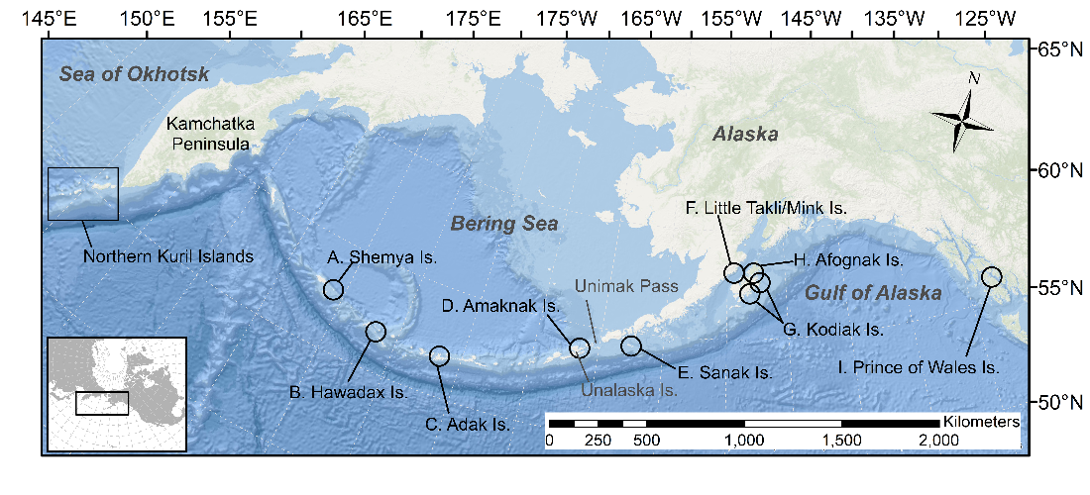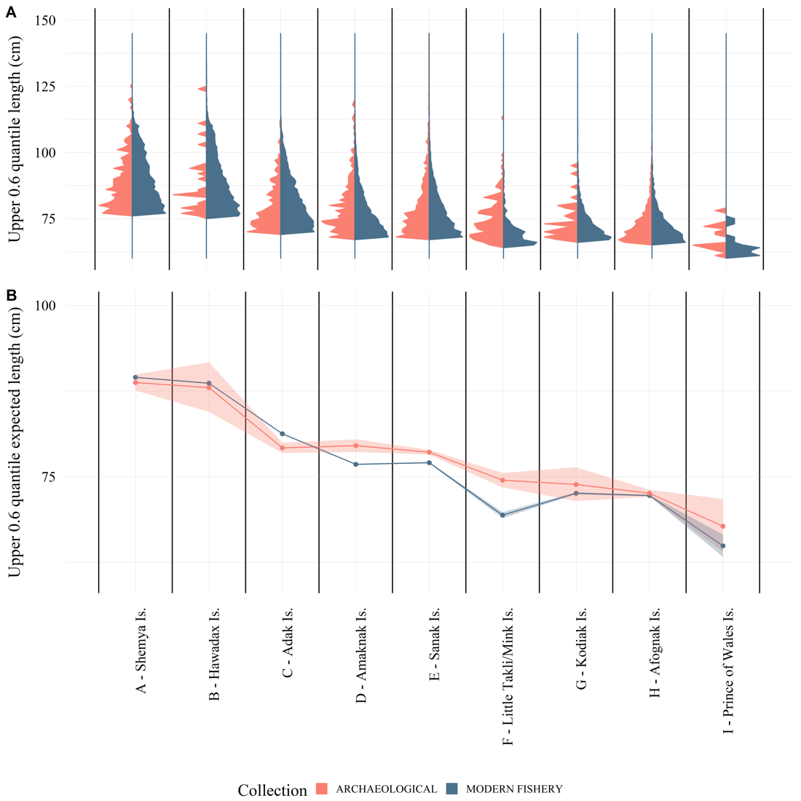

Figure 2.2 (A) The 0.6 quantile of the length distribution of Pacific cod from the Alaska archaeological collections (red) and modern longline and jig commercial fishery data (blue) within 50 km of the archaeological sites; and (B) log-linked gamma generalized linear regression results of Alaska modern fishery and archaeological collections by site showing expected lengths and 95% confidence intervals (From West *et al.* 2020; Figure 1 and Figure 5).

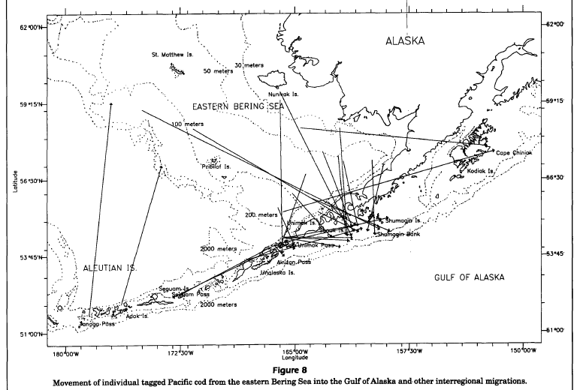

Figure 2.3 Tag recoveries from Shimada and Kimura 1994 (Figure 8), showing movement of individual tagged Pacific cod from eastern Bering Sea into the Gulf of Alaska and other interregional migrations.

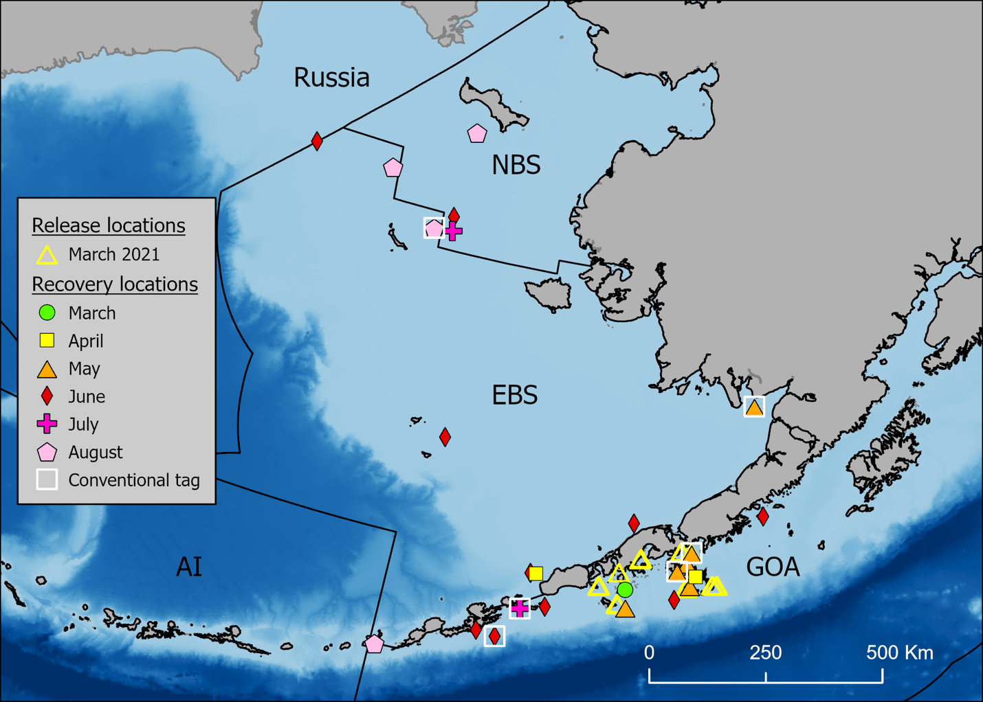

Figure 2.4 Release and monthly satellite and conventional tag recovery locations through August 2021 by region (NBS = Northern Bering Sea, EBS = Eastern Bering Sea, AI = Aleutian Islands, and GOA = Gulf of Alaska). Conventional tag recaptures are indicated by a white square around the symbol.

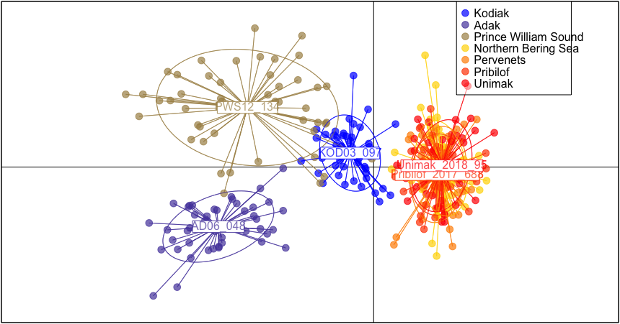

Figure 2.5 Discriminant analysis of principal components (DAPC) scatterplot with the following populations represented: Adak (2006), Prince William Sound, PWS (2012), Kodiak (2003), Unimak (2018), Pervenets (2016), Pribilof (2017), and Norton Sound, NBS (2017). All populations represent spawning groups except the Norton Sound sample, which was sampled in August, 2017. Note: The Norton Sound sample in panel b. is behind the Unimak and Pribilof labels, and barely visible.

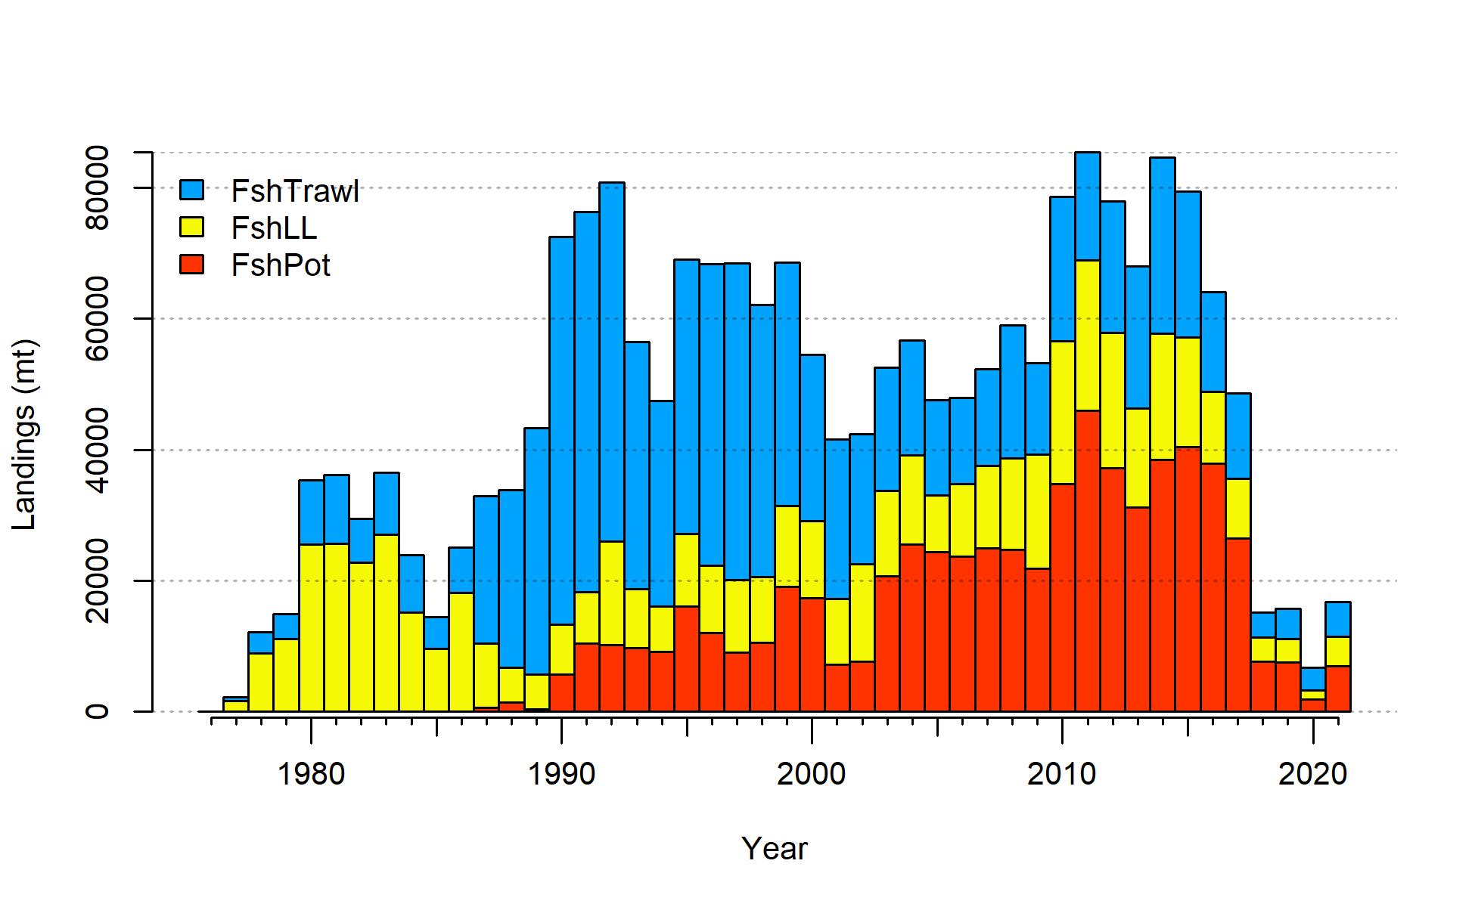

Figure 2.5 Gulf of Alaska Pacific cod catch from 1977-2021. Note that 2021 catch was through October 1.



Figure 2.6 Commercial catch of Pacific cod in the Gulf of Alaska by 20km2 grid for 1990-2015.

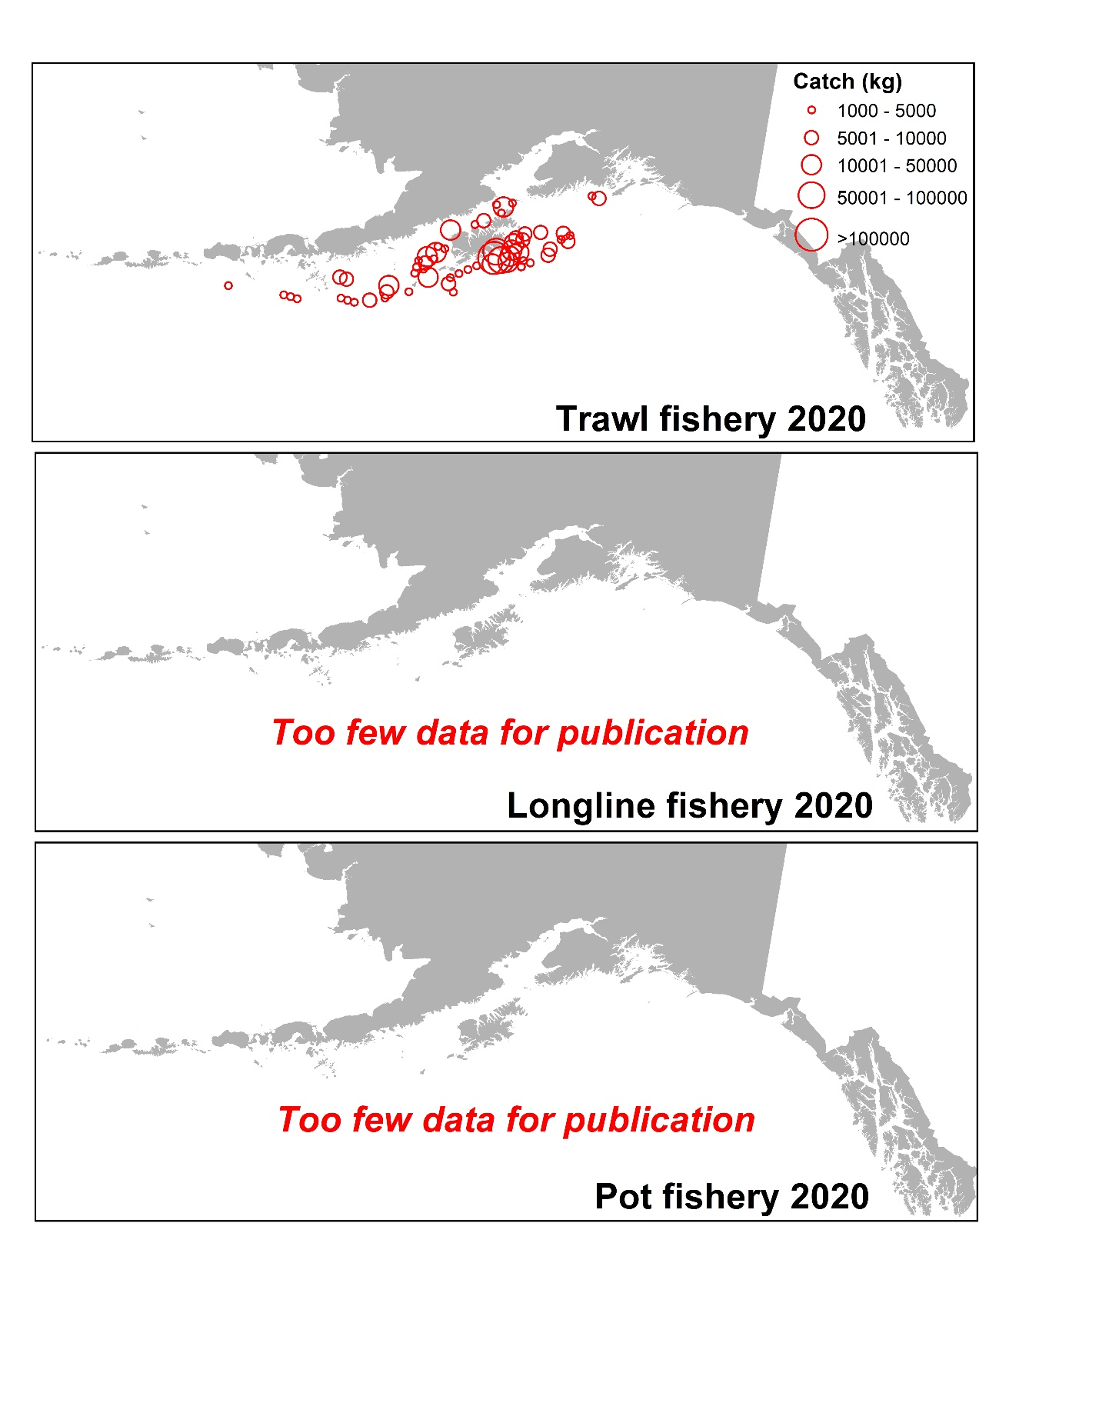

Figure 2.7 Commercial catch of Pacific cod in the Gulf of Alaska by 20km2 grid for 2020 for catch greater than 1000 kg. Observed catch in red circles and EM catch for longline and pot in blue squares. These data include bycatch Pacific cod.



Figure 2.8 Observed commercial catch of Pacific cod in the Gulf of Alaska by 20km2 grid for 2021 as of October 1, 2021 for catch greater than 1000 kg. These data include bycatch Pacific cod.

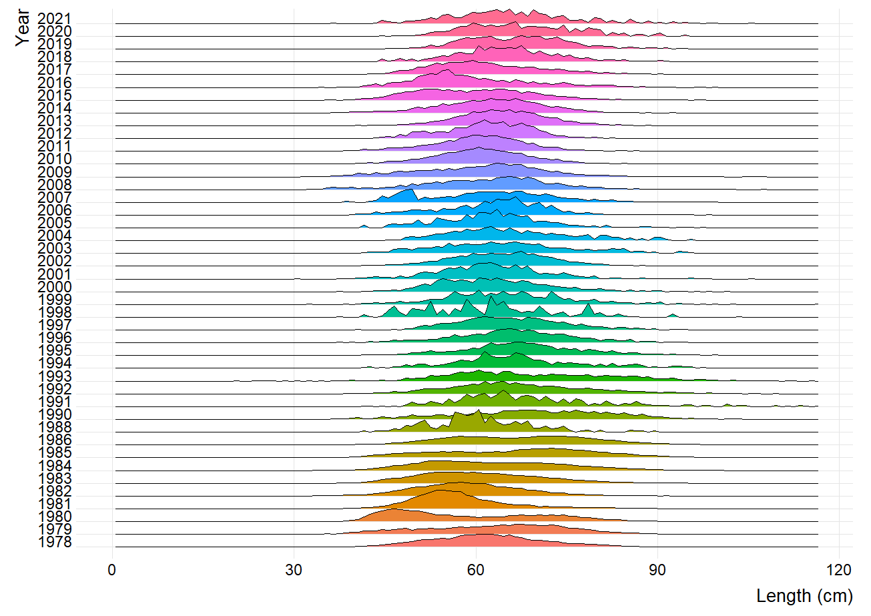

Figure 2.9 Pacific cod length composition by annual proportion from the Gulf of Alaska longline fishery.

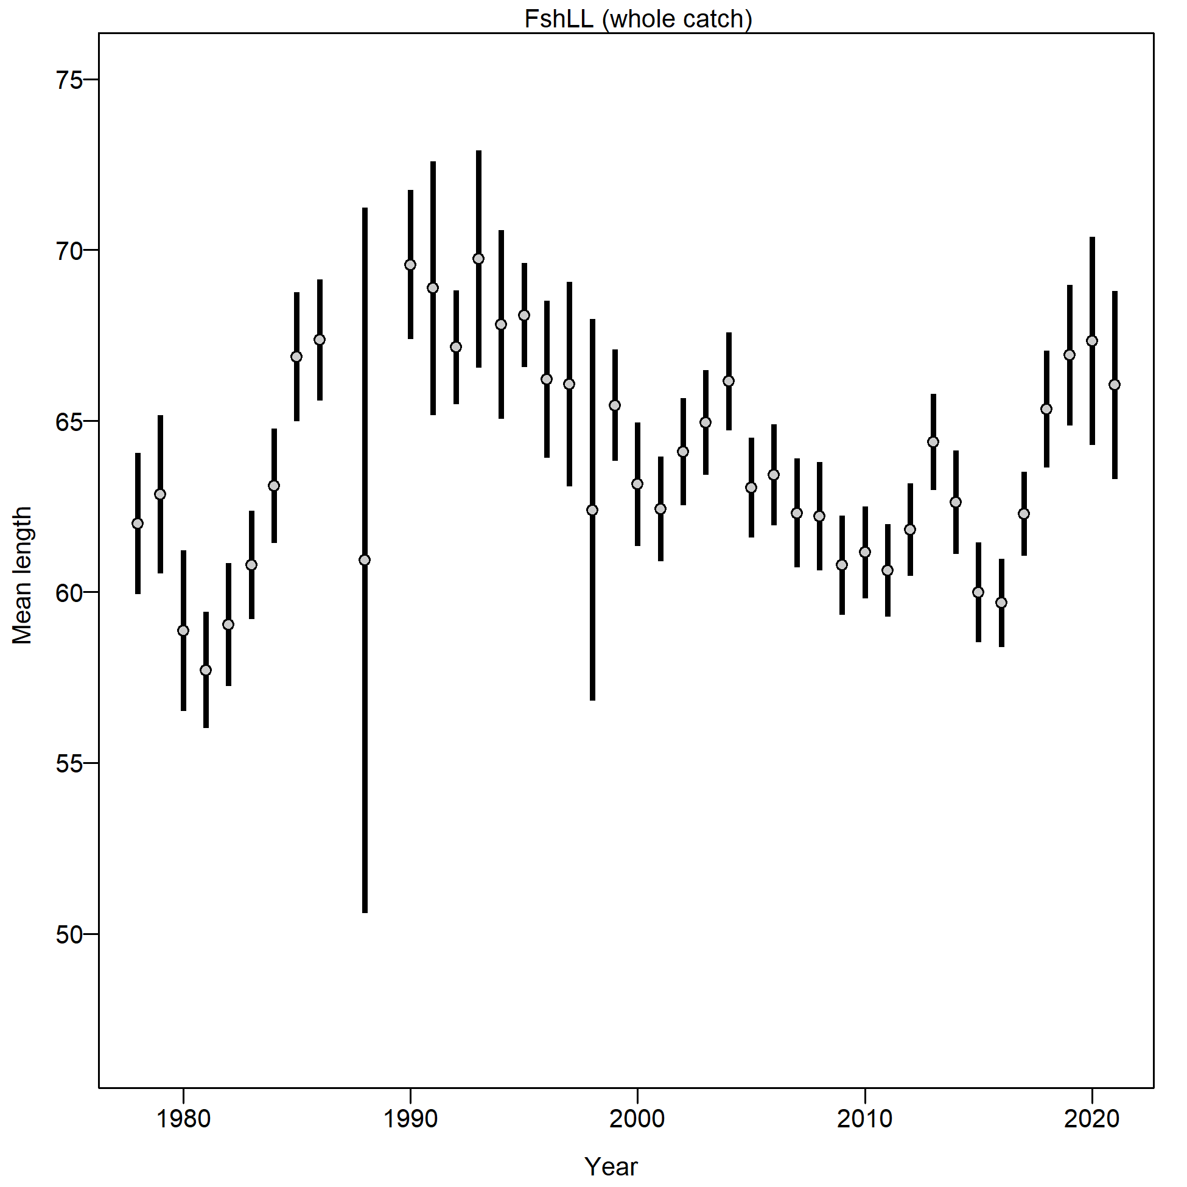

Figure 2.10 Mean length (cm) of Pacific cod from the Gulf of Alaska longline fishery.

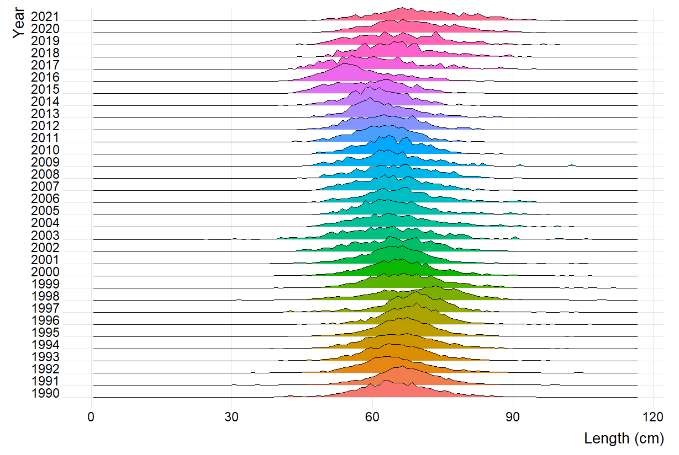

Figure 2.11 Pacific cod length composition by annual proportion from the Gulf of Alaska pot fishery.

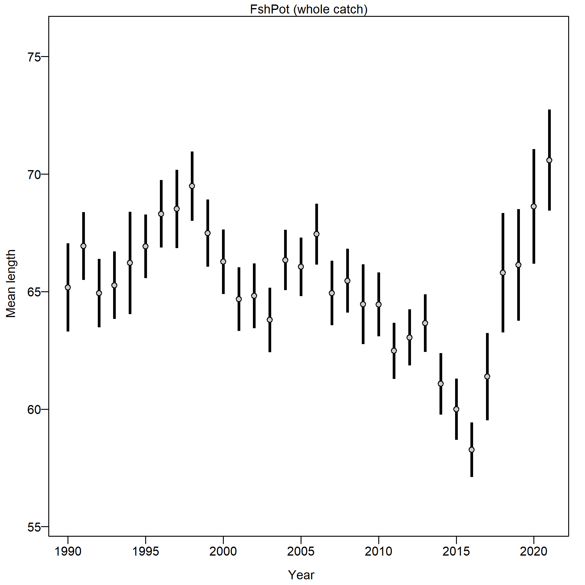

Figure 2.12 Mean length (cm) of Pacific cod from the Gulf of Alaska pot fishery.

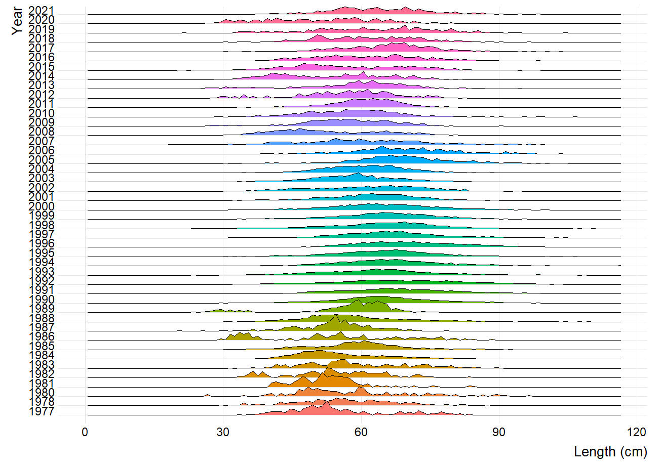

Figure 2.13 Pacific cod length composition by annual proportion from the Gulf of Alaska trawl fishery.

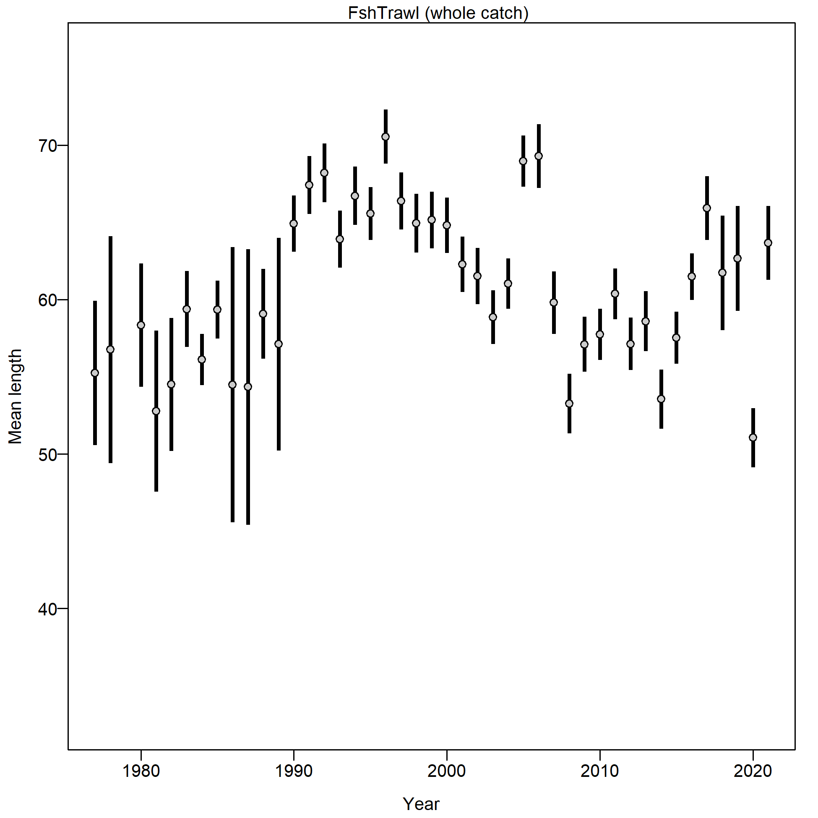

Figure 2.14 Mean length (cm) of Pacific cod from the Gulf of Alaska trawl fishery.

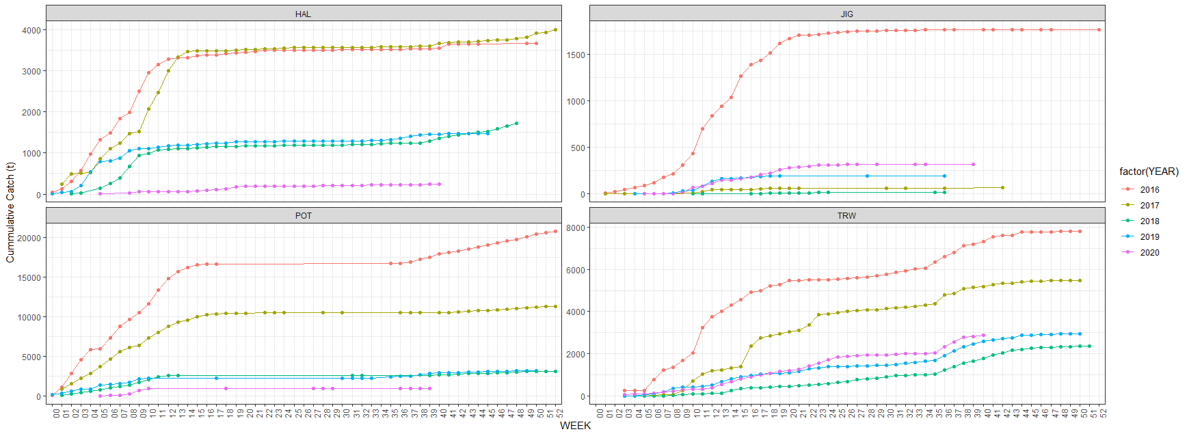

Figure 2.15 Cumulative catch by week of the year and gear for 2017-2021 in the Central regulatory area. 2021 data are through October 1, 2021.

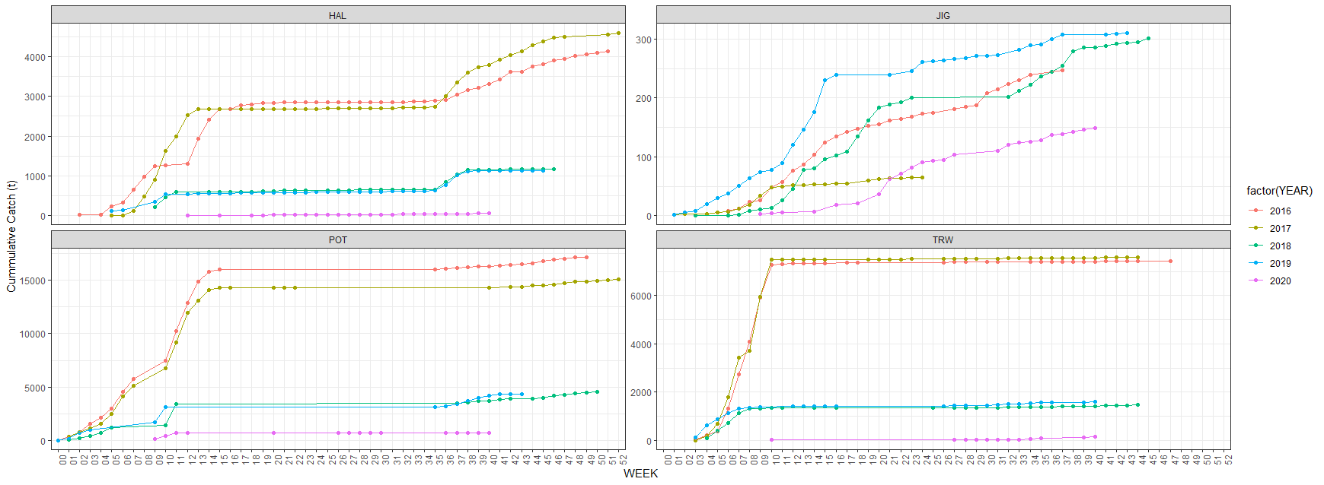

Figure 2.16 Cumulative catch by week of the year and gear for 2017-2021 in the Western regulatory area. The 2021data are through October 1, 2021.

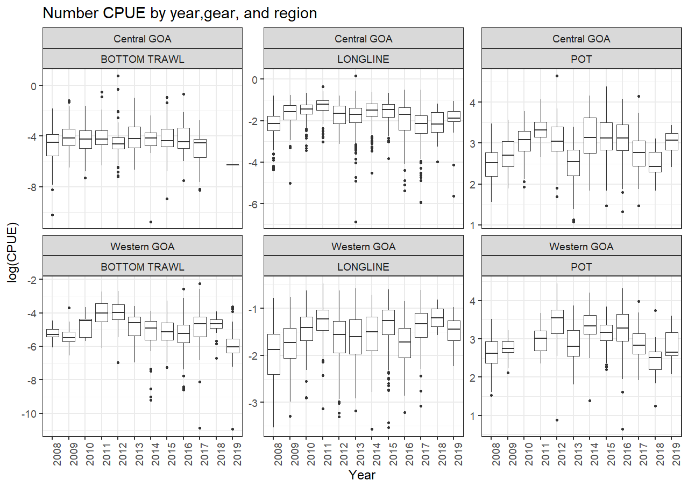

Figure 2.17 Boxplot of CPUE by number from the 2008-2021 Pacific cod CPUE for January-April for the Central (top) and Western (bottom) regulatory areas in the Pacific cod target fishery. Note that the data in these figures are not controlled for vessel or gear differences within a gear type across time, but shows the raw CPUE data distribution. These represent all observed catches and is limited to the directed cod fishery.

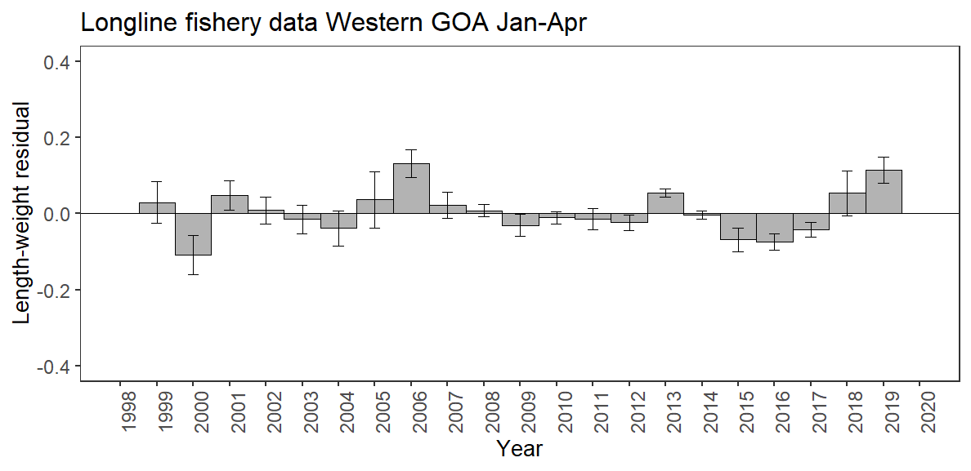

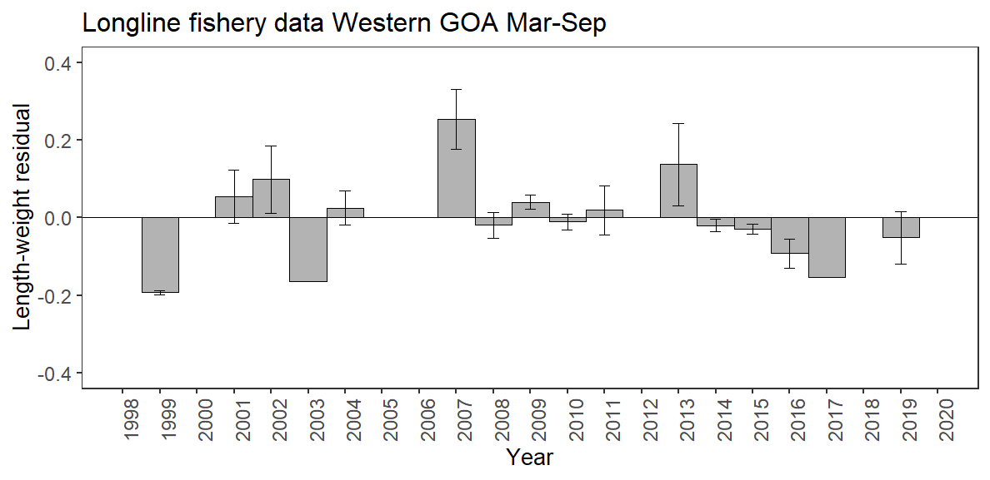

Figure 2.18 Condition of Pacific cod by year in the Central GOA for the longline January-April (top) and May-September (bottom).

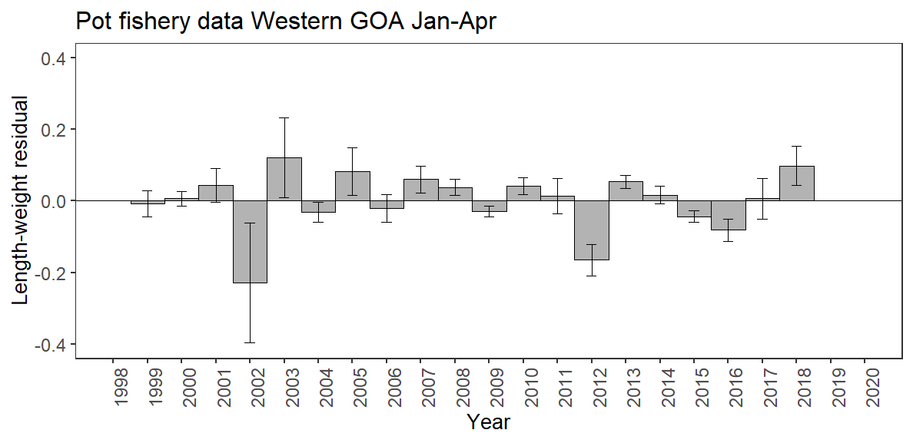

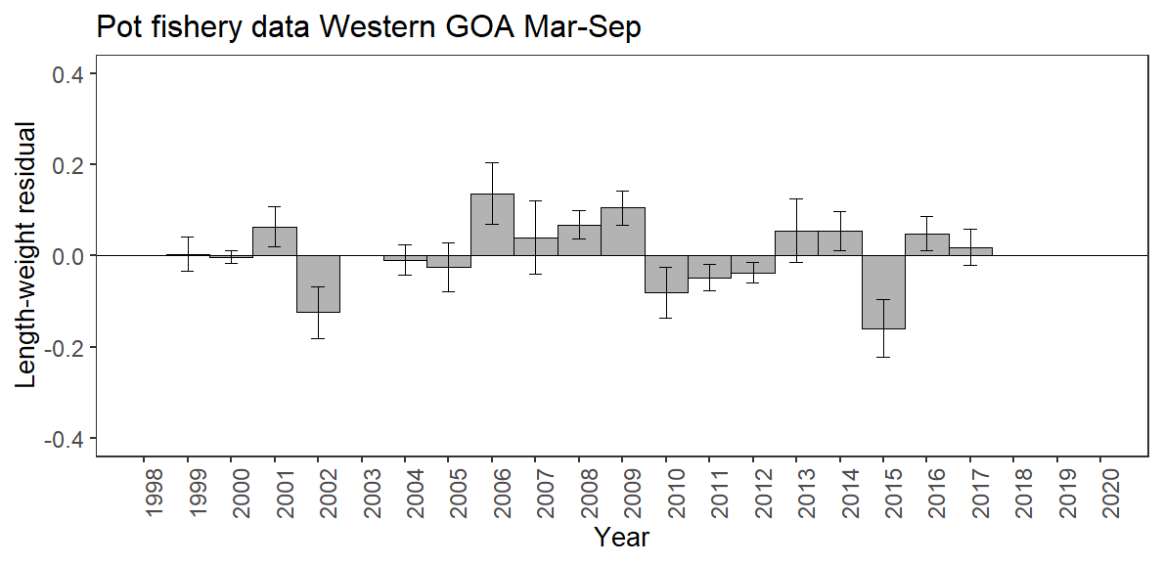

Figure 2.19 Condition of Pacific cod by length category and year in the Central GOA for the pot January-April (top) and May-September (bottom). Note that there are no pot fishery data for Central GOA in 2019 for either season and no data for 2018 May-September.

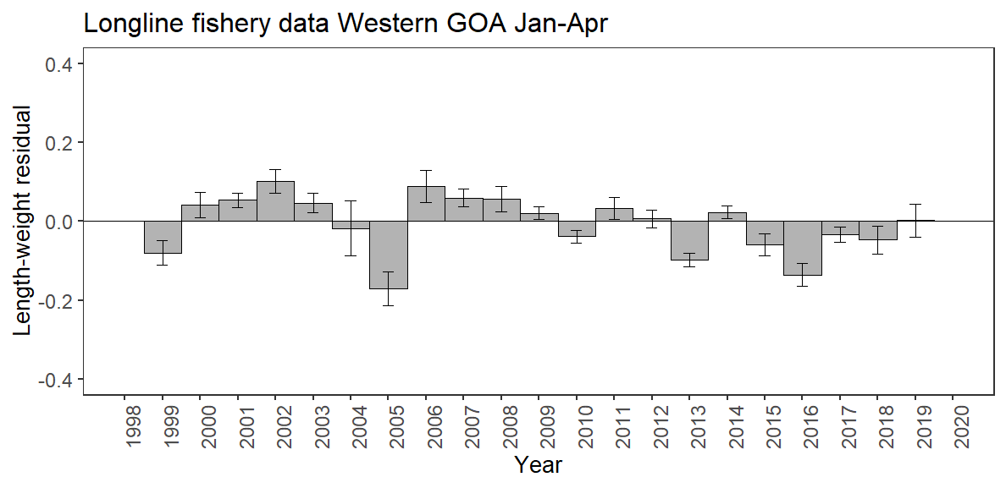

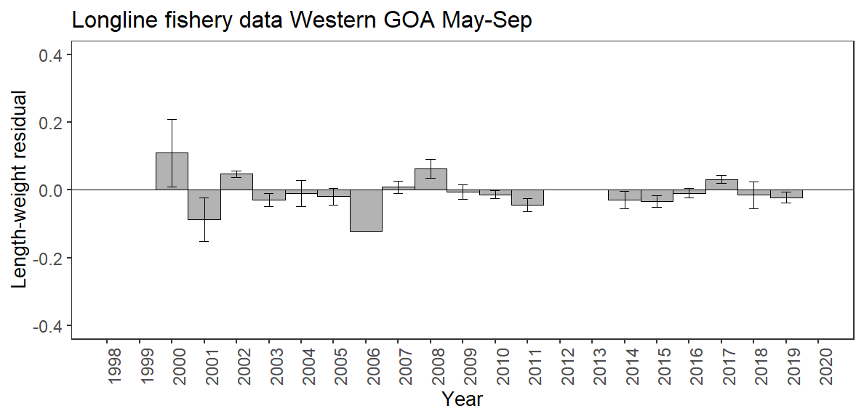

Figure 2.20 Condition of Pacific cod by year in the Western GOA for the longline January-April (top) and May-September (bottom).

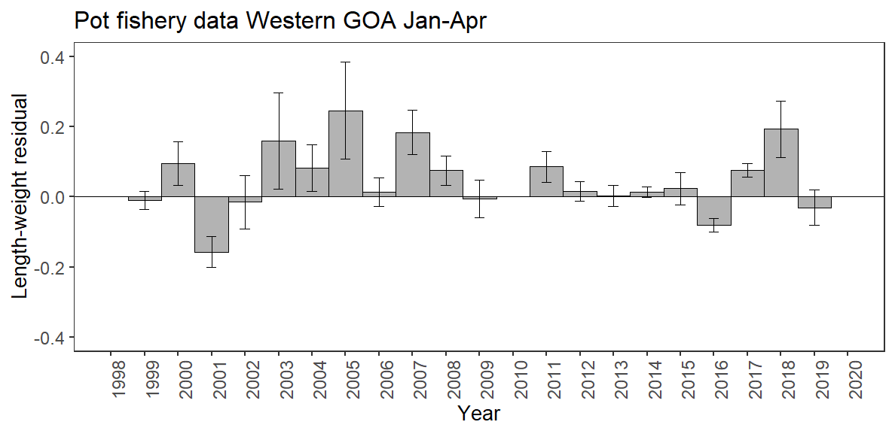

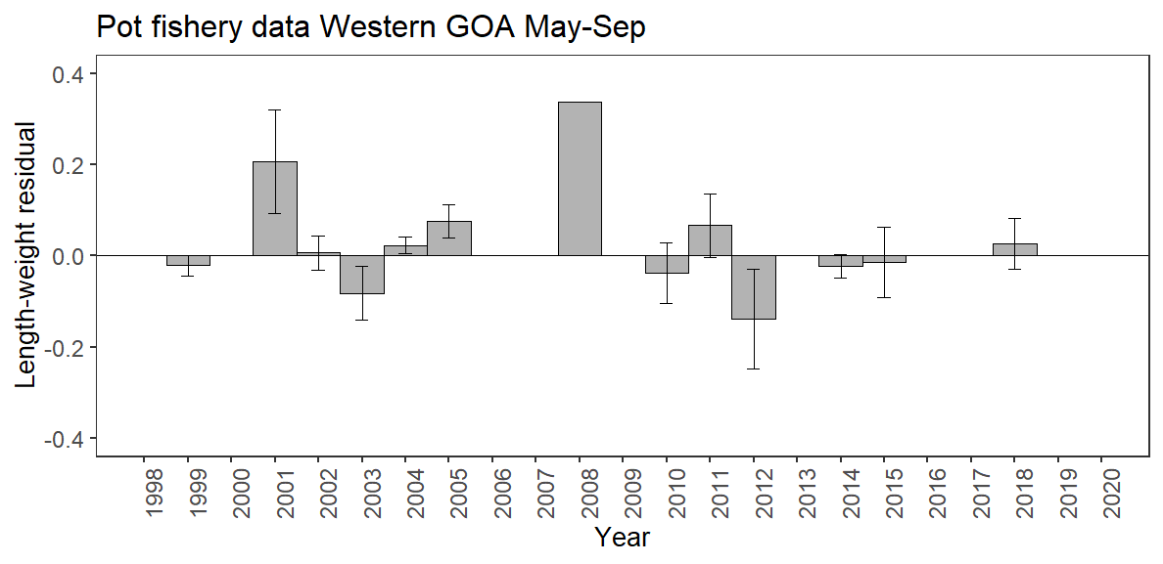

Figure 2.21 Condition of Pacific cod by year in the Western GOA for pot January-April (top) and May-September (bottom).

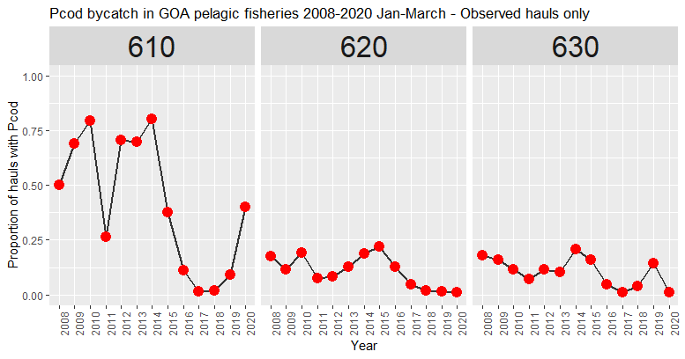

Figure 2.22 Proportion of pelagic trawls in the A Season (January-April) walleye pollock fishery with Pacific cod present by region.

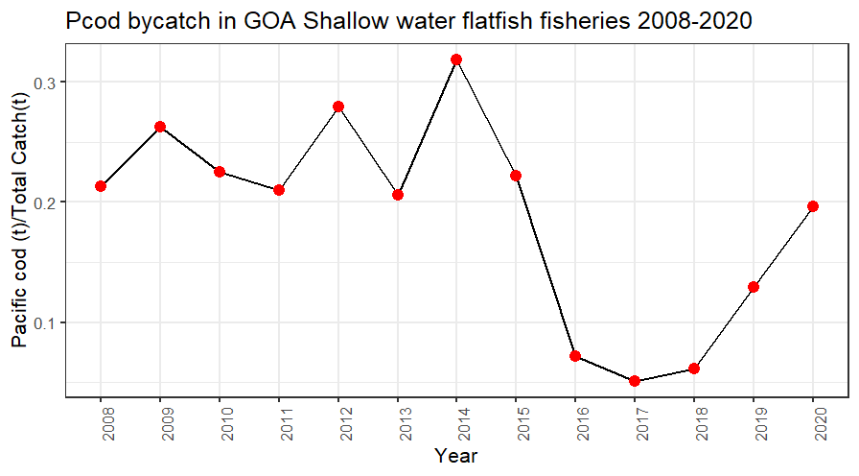

Figure 2.23 Pacific cod bycatch in the Gulf of Alaska shallow water flatfish fishery as tons of Pacific cod per tons of total catch in the fishery by year.

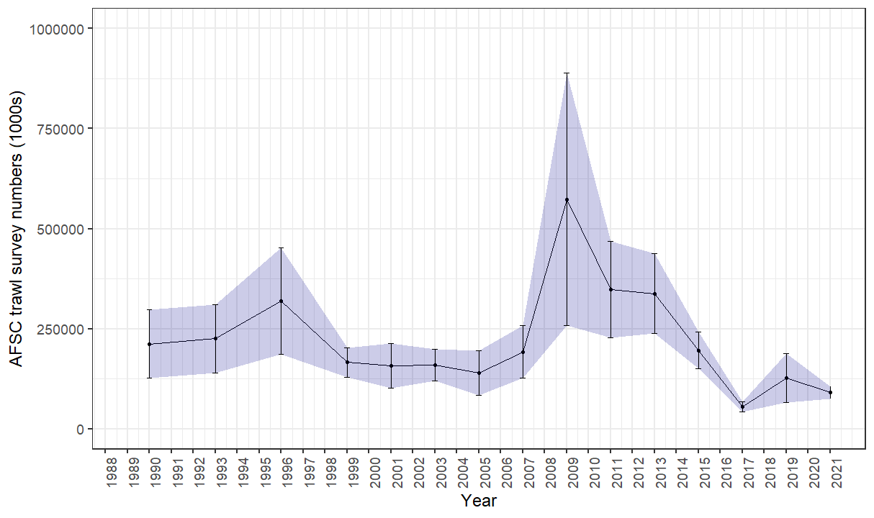

Figure 2.24 GOA bottom trawl survey abundance (numbers) estimate. Bars and shading indicate the 95th percentile confidence intervals.

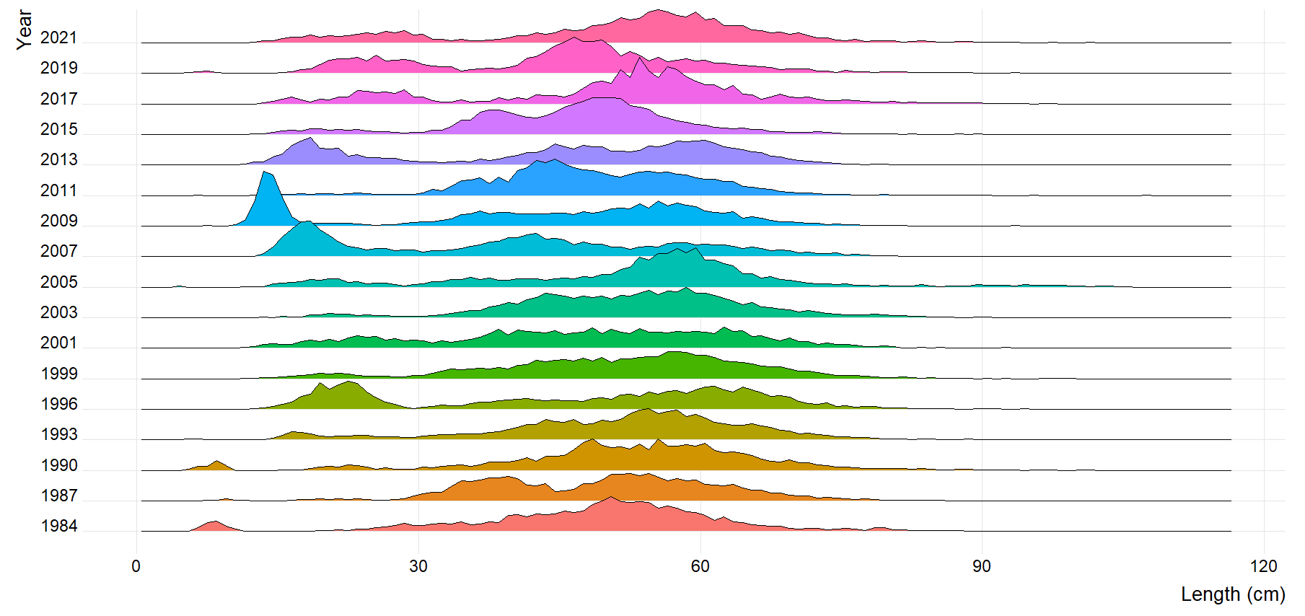

Figure 2.25 GOA bottom trawl survey Pacific cod population numbers at length estimates (max = 0.07).



Figure 2.26 Mean length (cm) of Pacific cod in the GOA bottom trawl survey.



Figure 2.27 Distribution of AFSC bottom trawl survey CPUE of Pacific cod for 2017-2019.

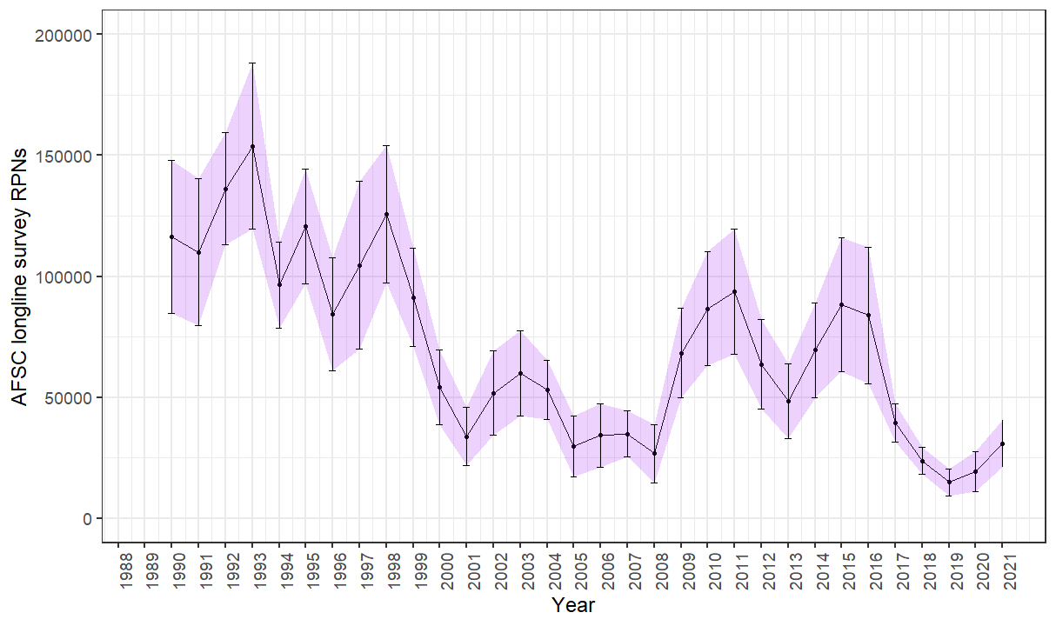

Figure 2.28 AFSC longline survey Pacific cod relative population numbers (RPN) time series. Bars and shading indicate the 95th percentile confidence intervals.

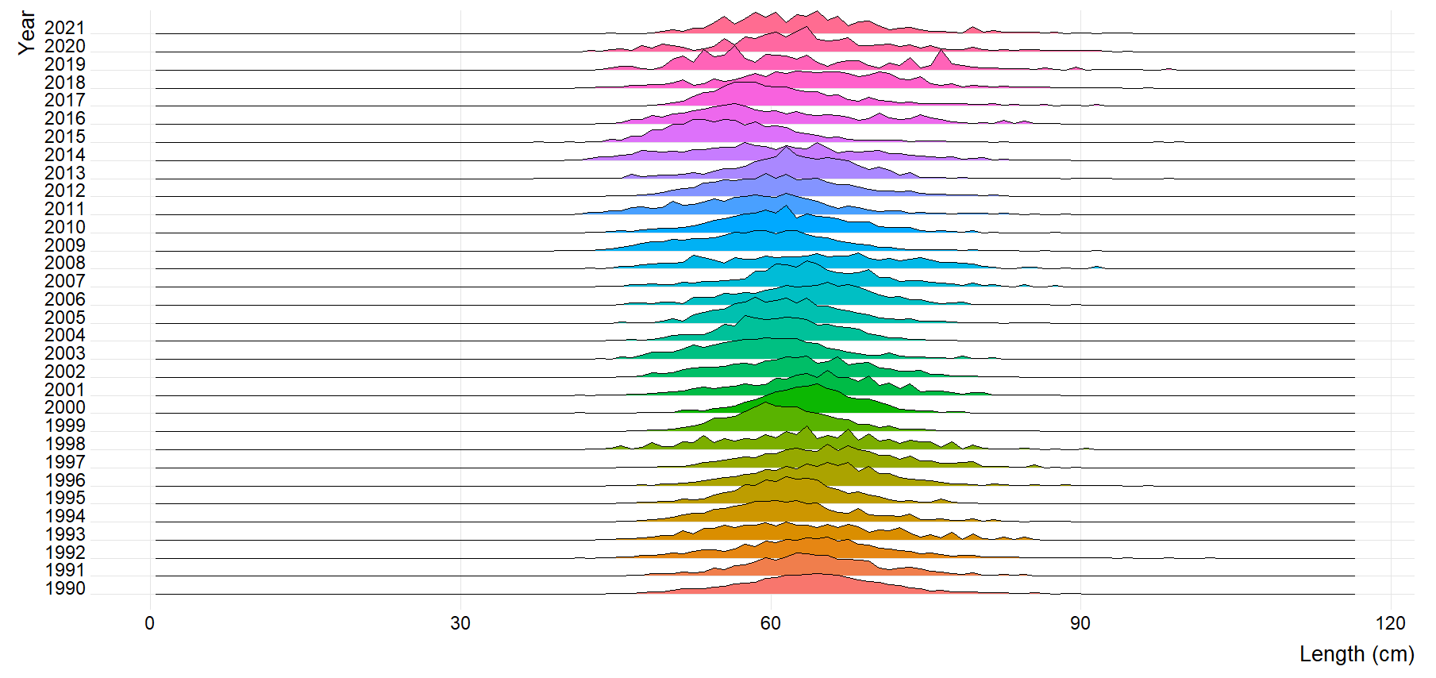

Figure 2.29 AFSC longline survey Pacific cod size composition (max=0.09).

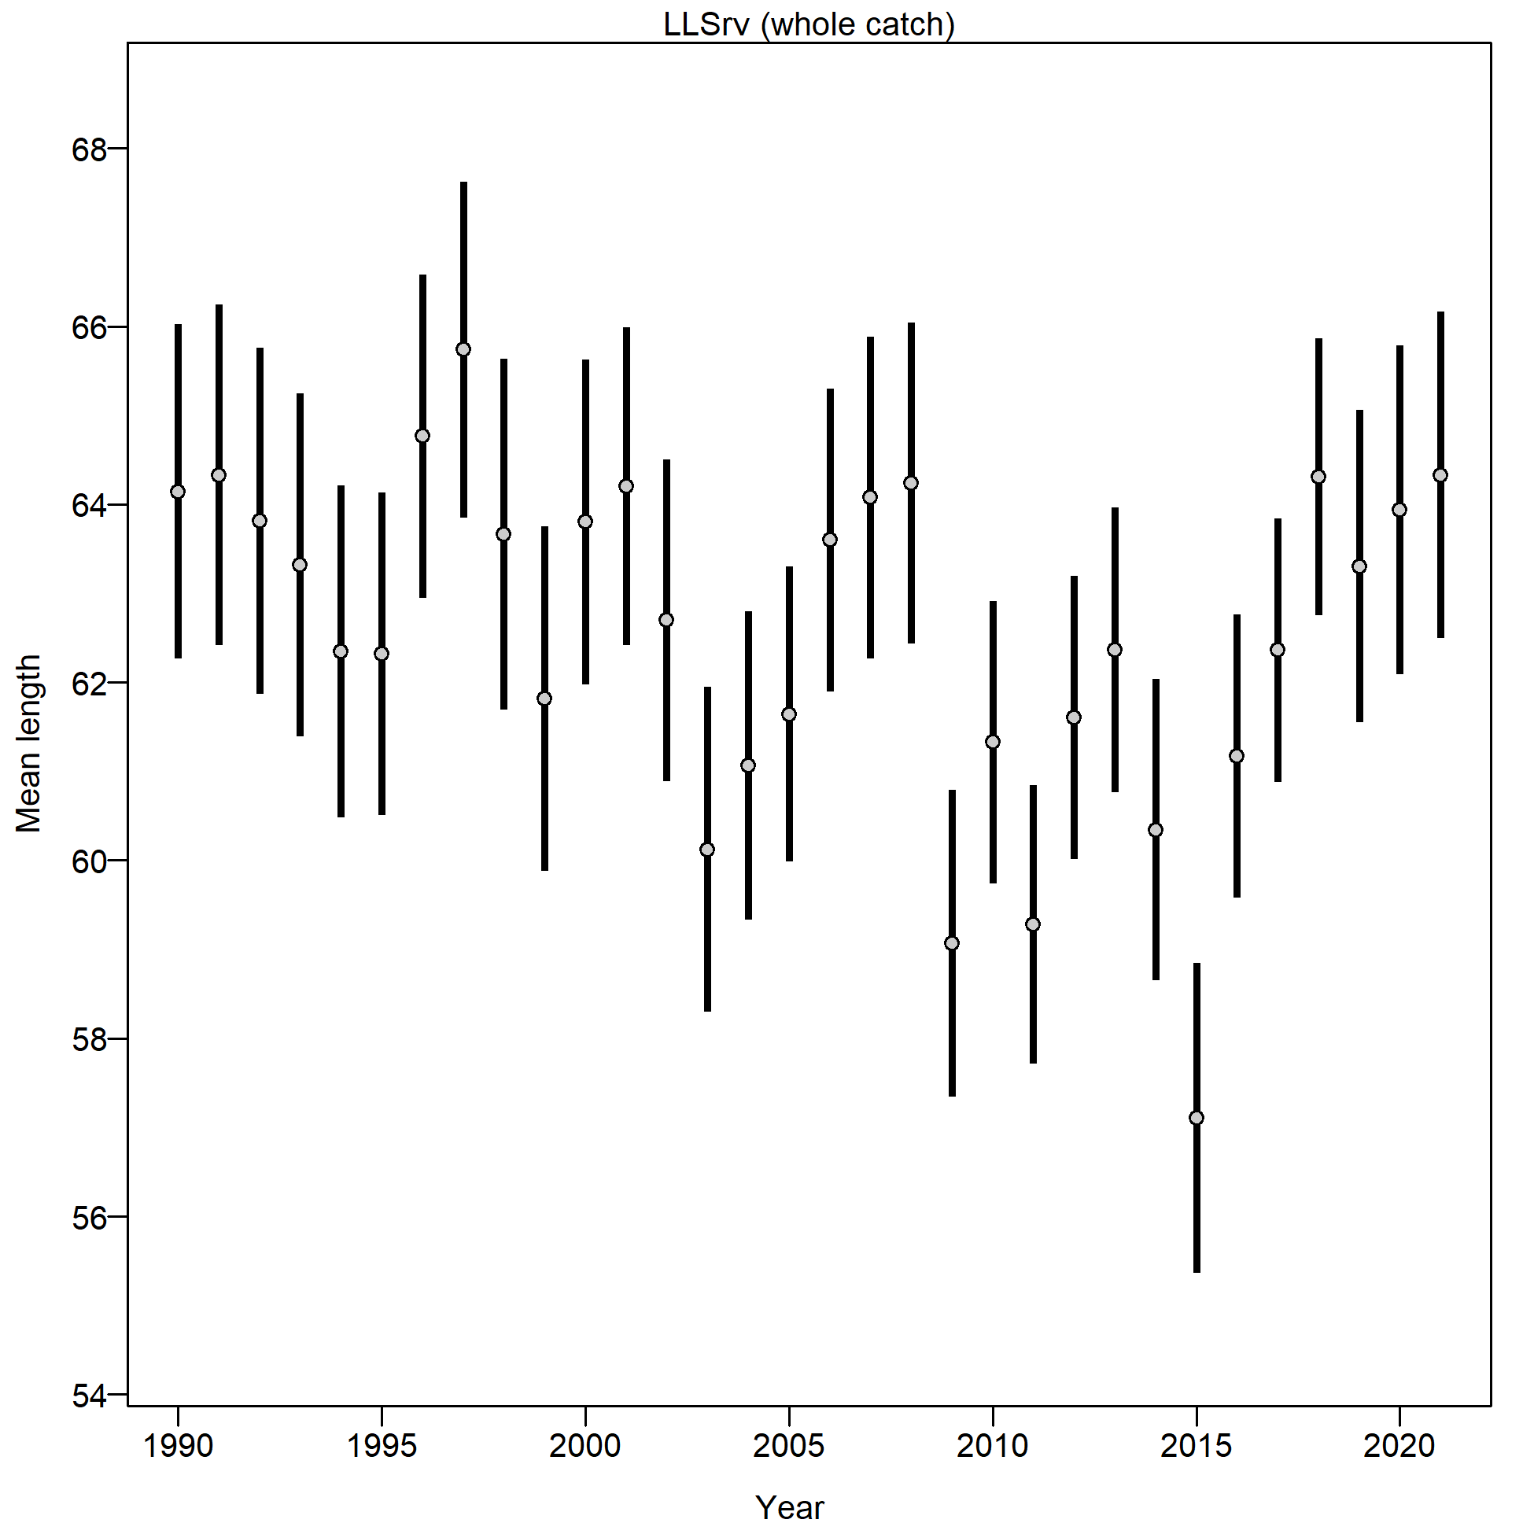

Figure 2.30 Mean length (cm) of Pacific cod from the AFSC longline survey.

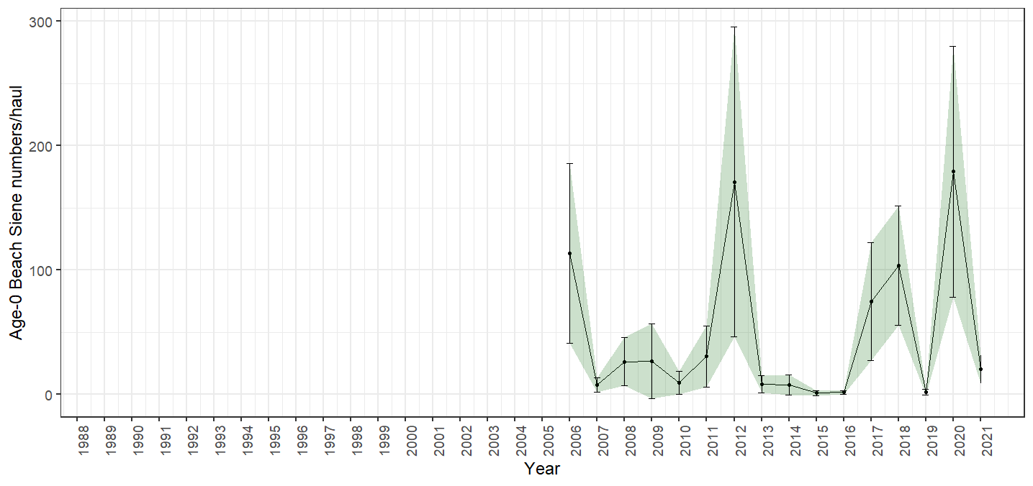

Figure 2.31 Age-0 beach seine survey numbers per haul, bars and shading indicate the 95th percentile confidence intervals.

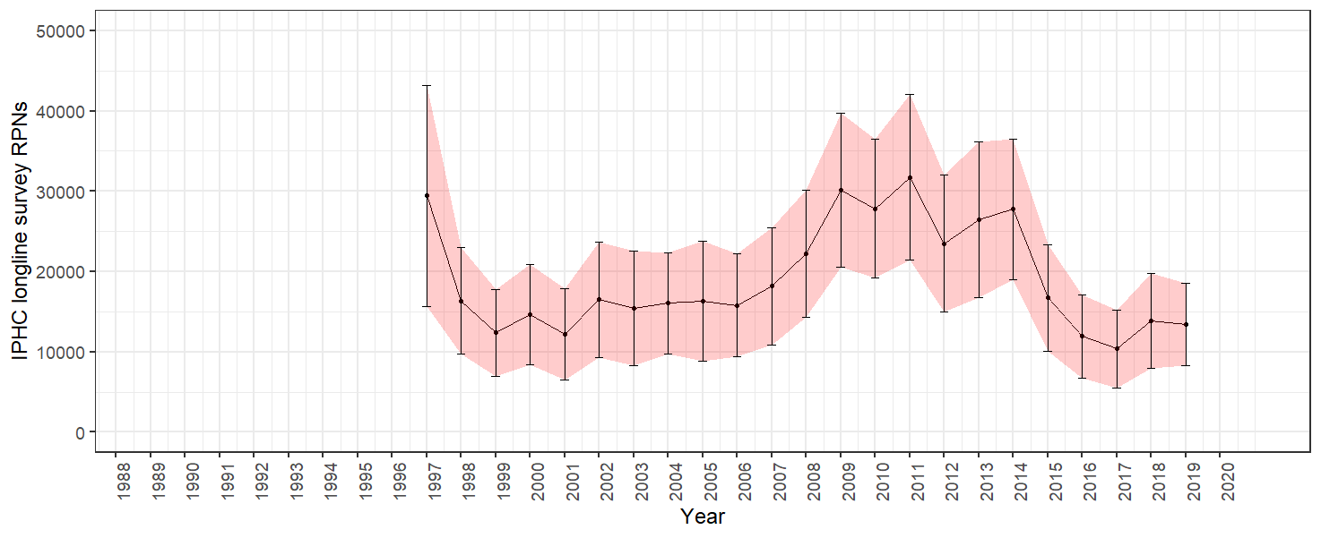

Figure 2.32 IPHC halibut longline survey Pacific cod RPN time series. Bars and shading indicate the 95th percentile confidence intervals.

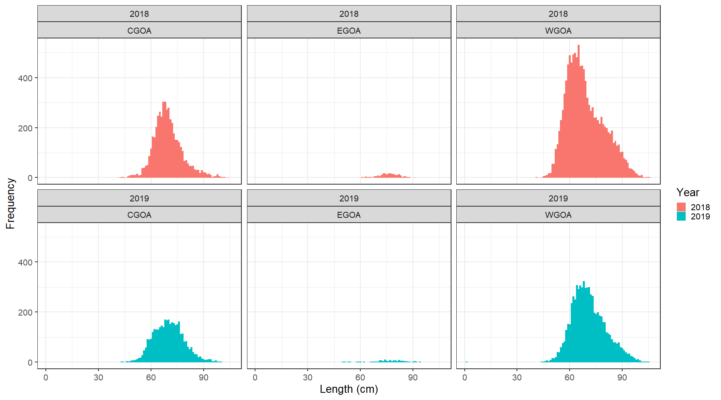

Figure 2.33 IPHC halibut longline survey Pacific cod RPN length composition collection for 2018 by GOA Regions for 2018 and 2019.

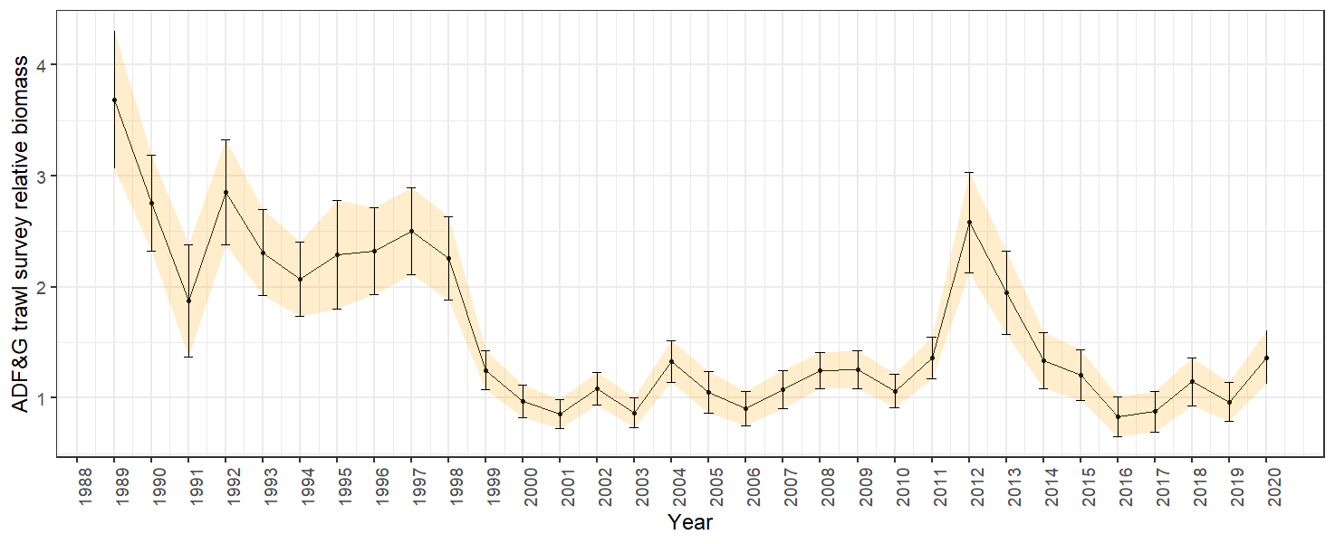

Figure 2.34 ADFG bottom trawl survey delta-glm Pacific cod density index time series. Bars and shading indicate the 95th percentile confidence intervals.

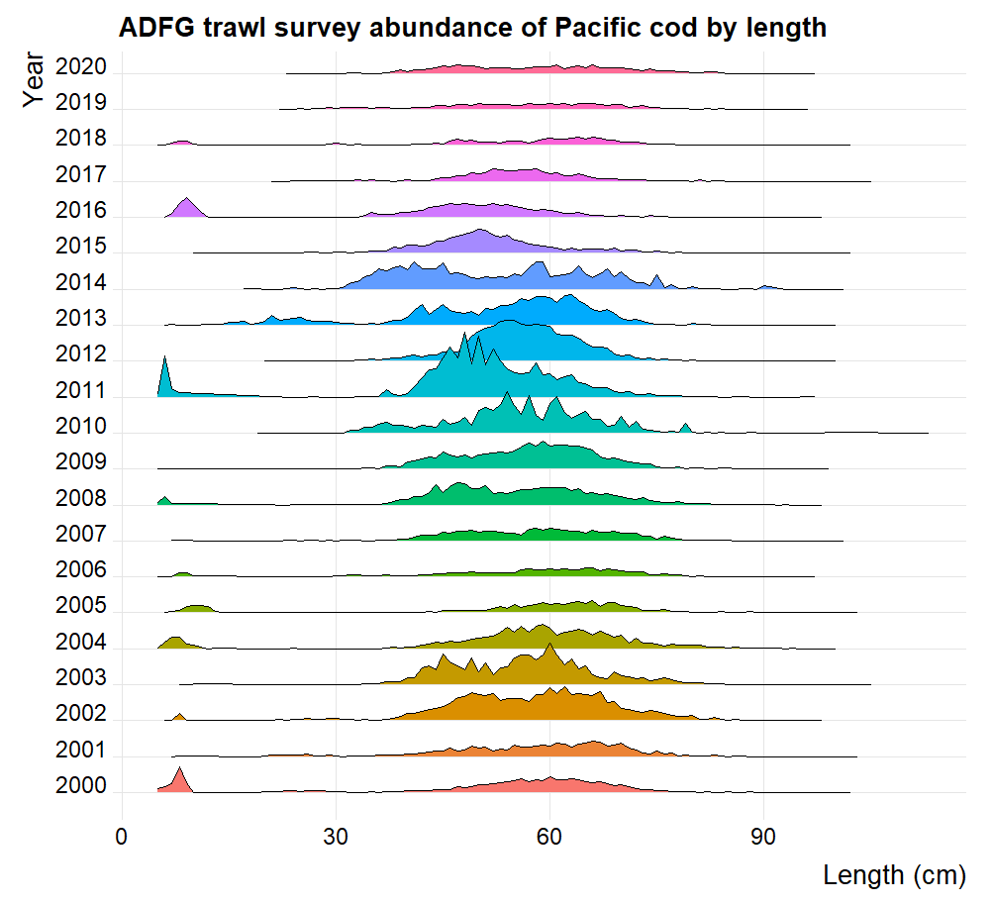

Figure 2.35 ADFG large-mesh trawl survey Pacific cod population numbers at length estimates.

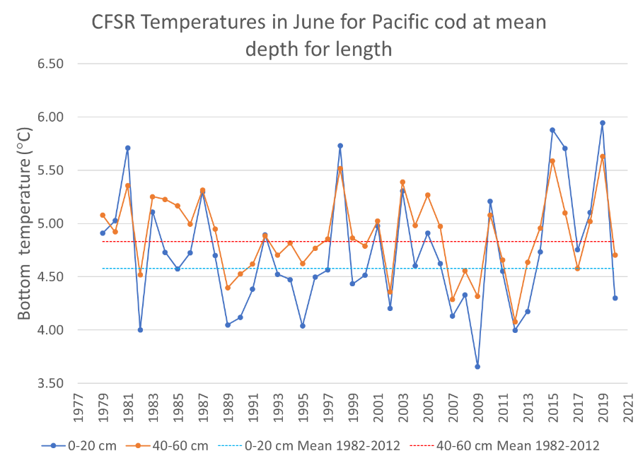

Figure 2.36 Climate Forcast System Reanalysis (CFSR) Central Gulf of Alaska bottom temperatures at the AFSC bottom trawl survey mean depths for 0-20 cm and 40-60 cm Pacific cod in June.

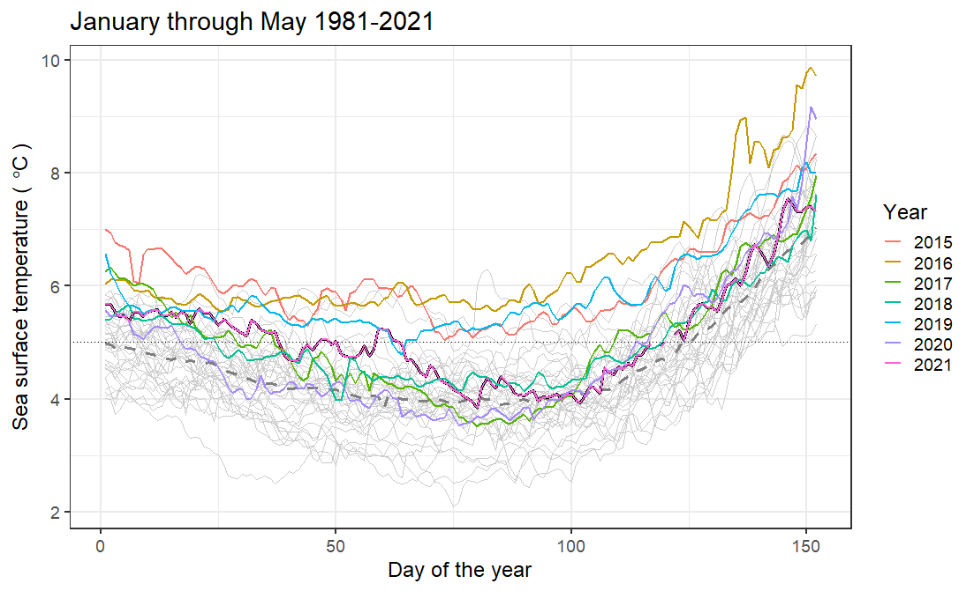 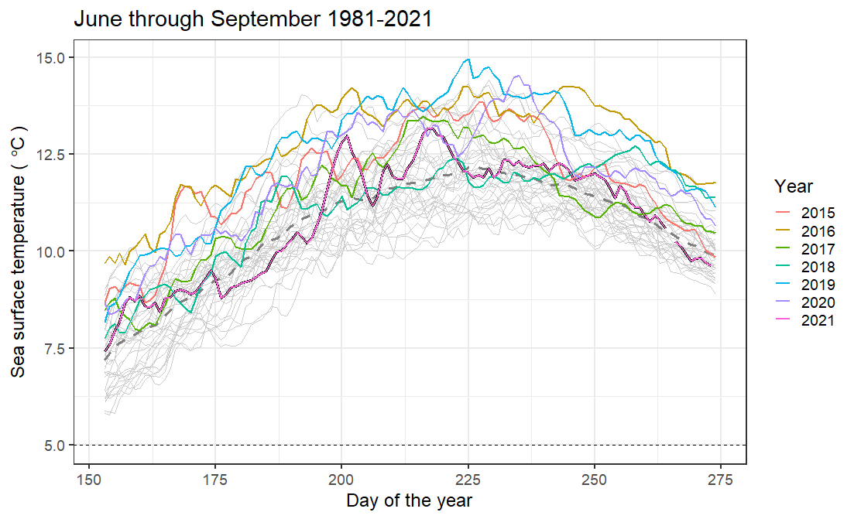

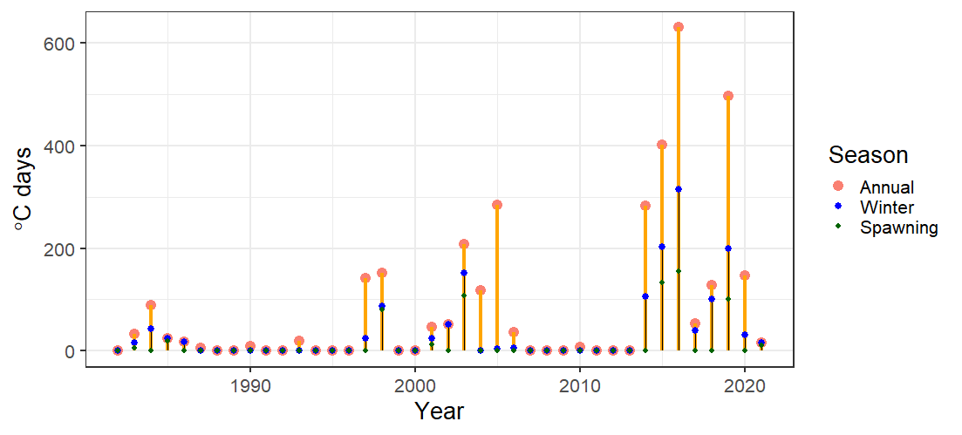

Figure 2.37 Sea surface temperatures (top left) February to March, (top right) June through September, and (bottom) index of the sum of the annual marine heatwave cumulative intensity (℃ days) for 1981-2021 (larger yellow points) and index of the sum of the annual winter marine heatwave cumulative intensity for 1981-2021 (smaller blue points) from the daily mean sea surface temperatures NOAA high resolution blended analysis data for the Central Gulf of Alaska. The 2021 index value is the sum through 30 September 2021.

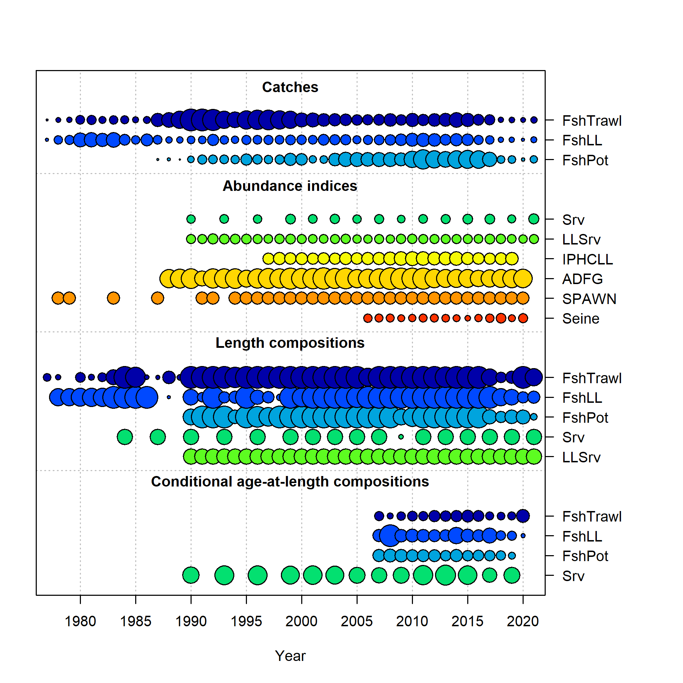

Figure 2.38 Data used in the 2021 models, circle area is relative to initial precision within data type. Note that the ADFG and IPHC are included in the data, but are not fit in any of the models presented this year. In addition the Seine (Age-0 index) data were not included in Model 19.1. Data presence by year for each fleet, where circle area is relative within a data type. Circles are proportional to total catch for catches; to precision for indices and to total sample size for compositions and length-at-age observations. Note that since the circles are scaled relative to maximum within each type, the scaling within separate plots should not be compared.

**Trawl Longline Pot**

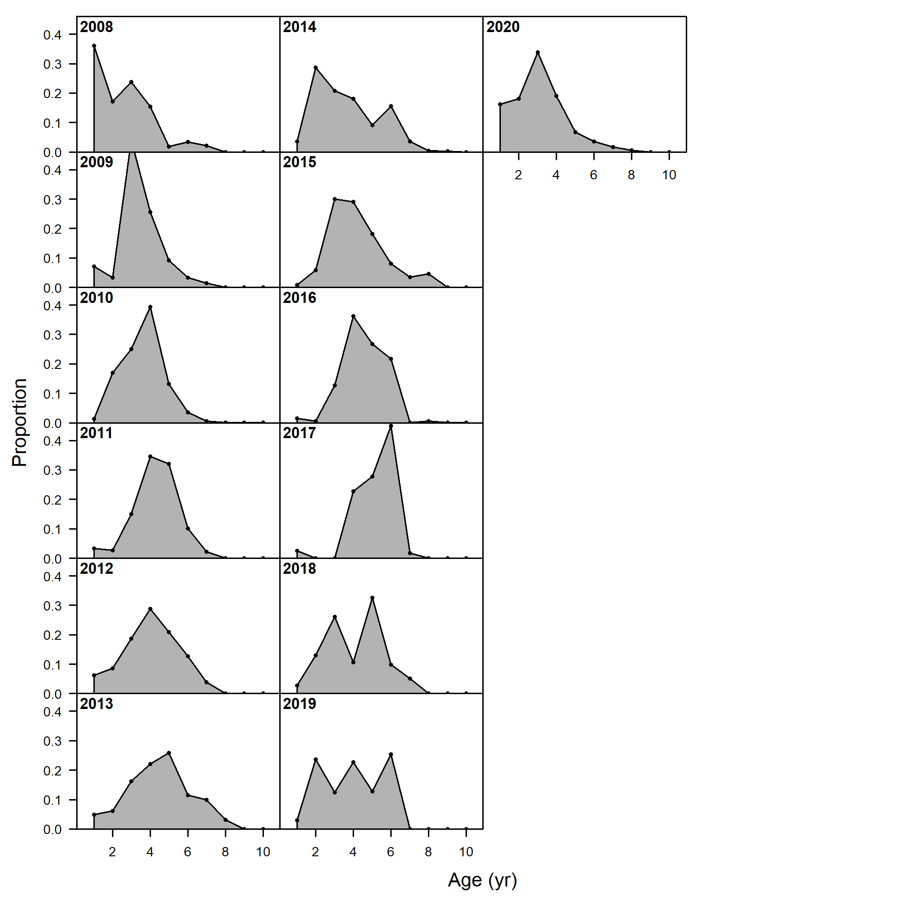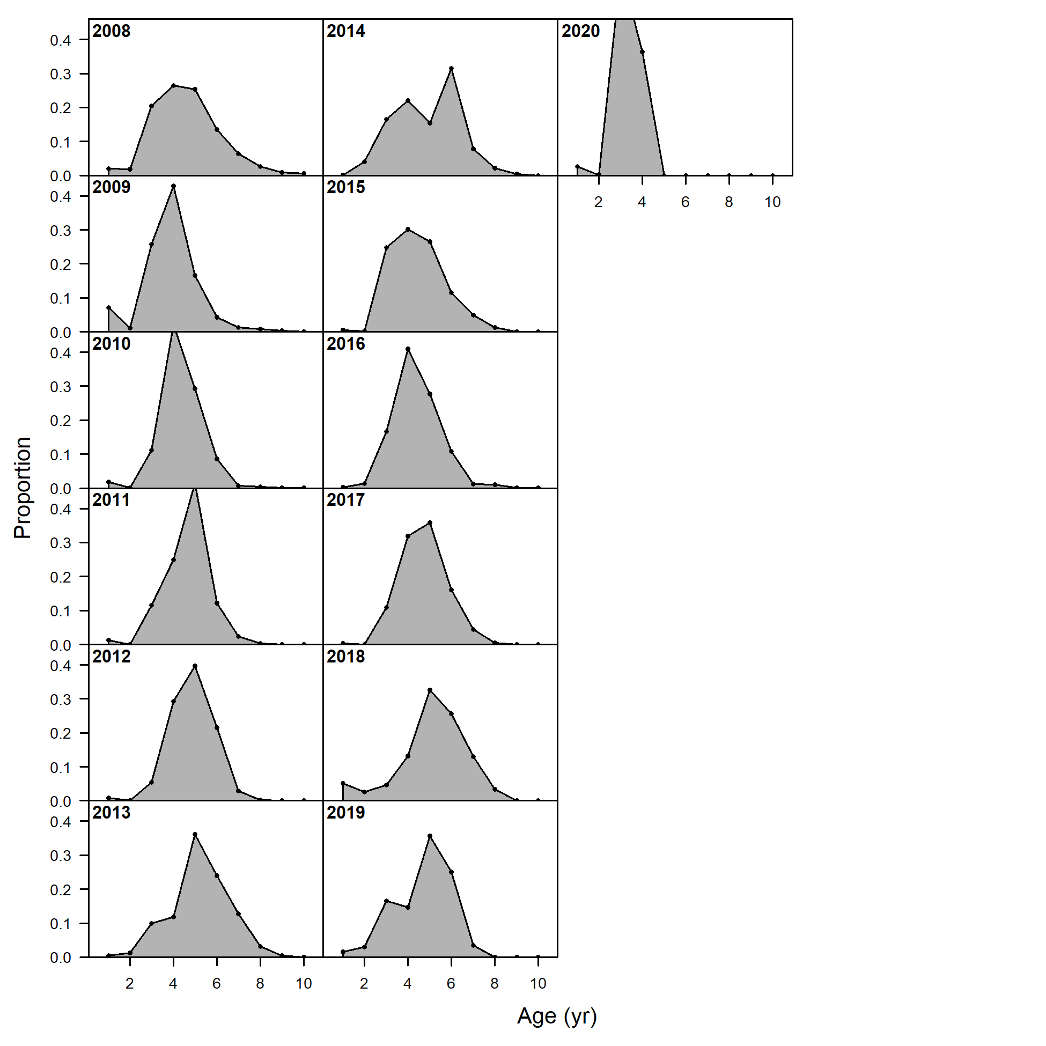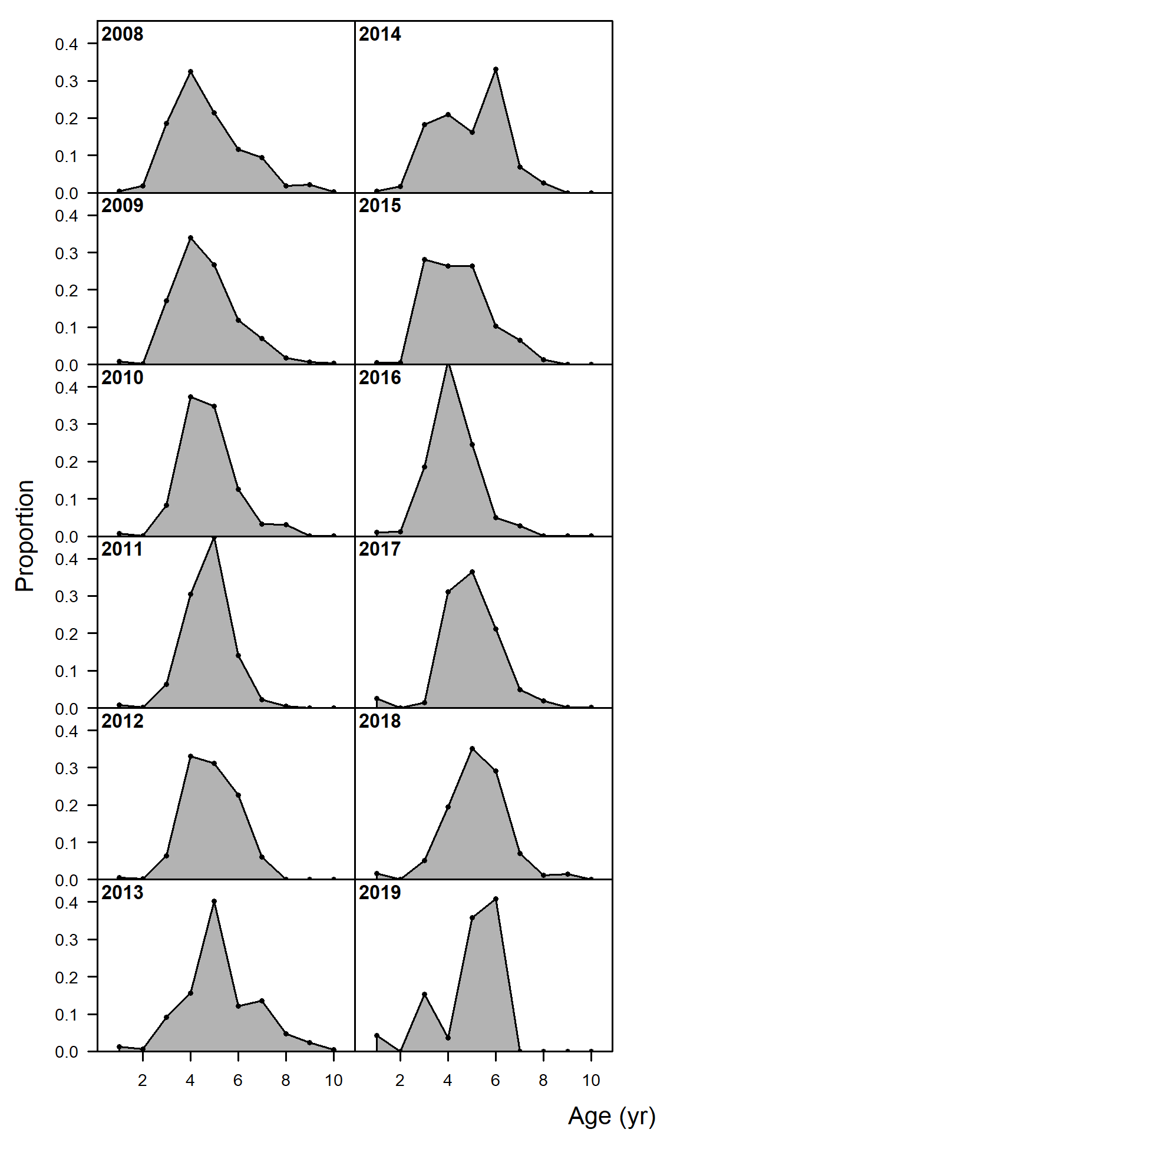

**Age**

Figure 2.39 Pacific cod age composition data from the Gulf of Alaska fisheries by gear type.

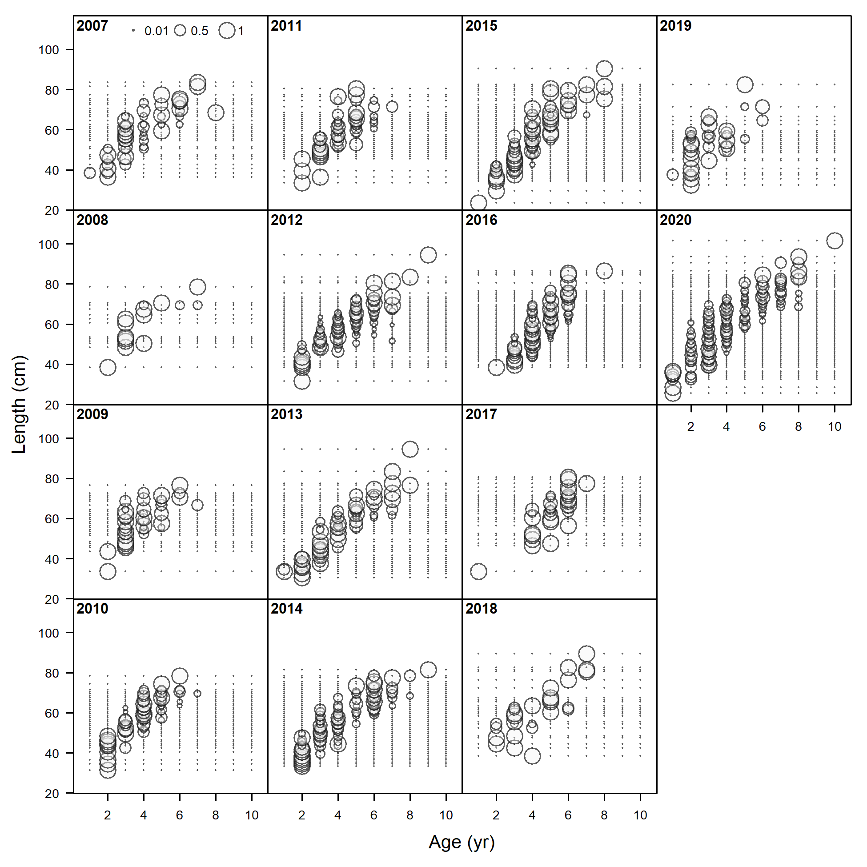

Figure 2.40 Pacific cod conditional length at age from the Gulf of Alaska trawl fishery.

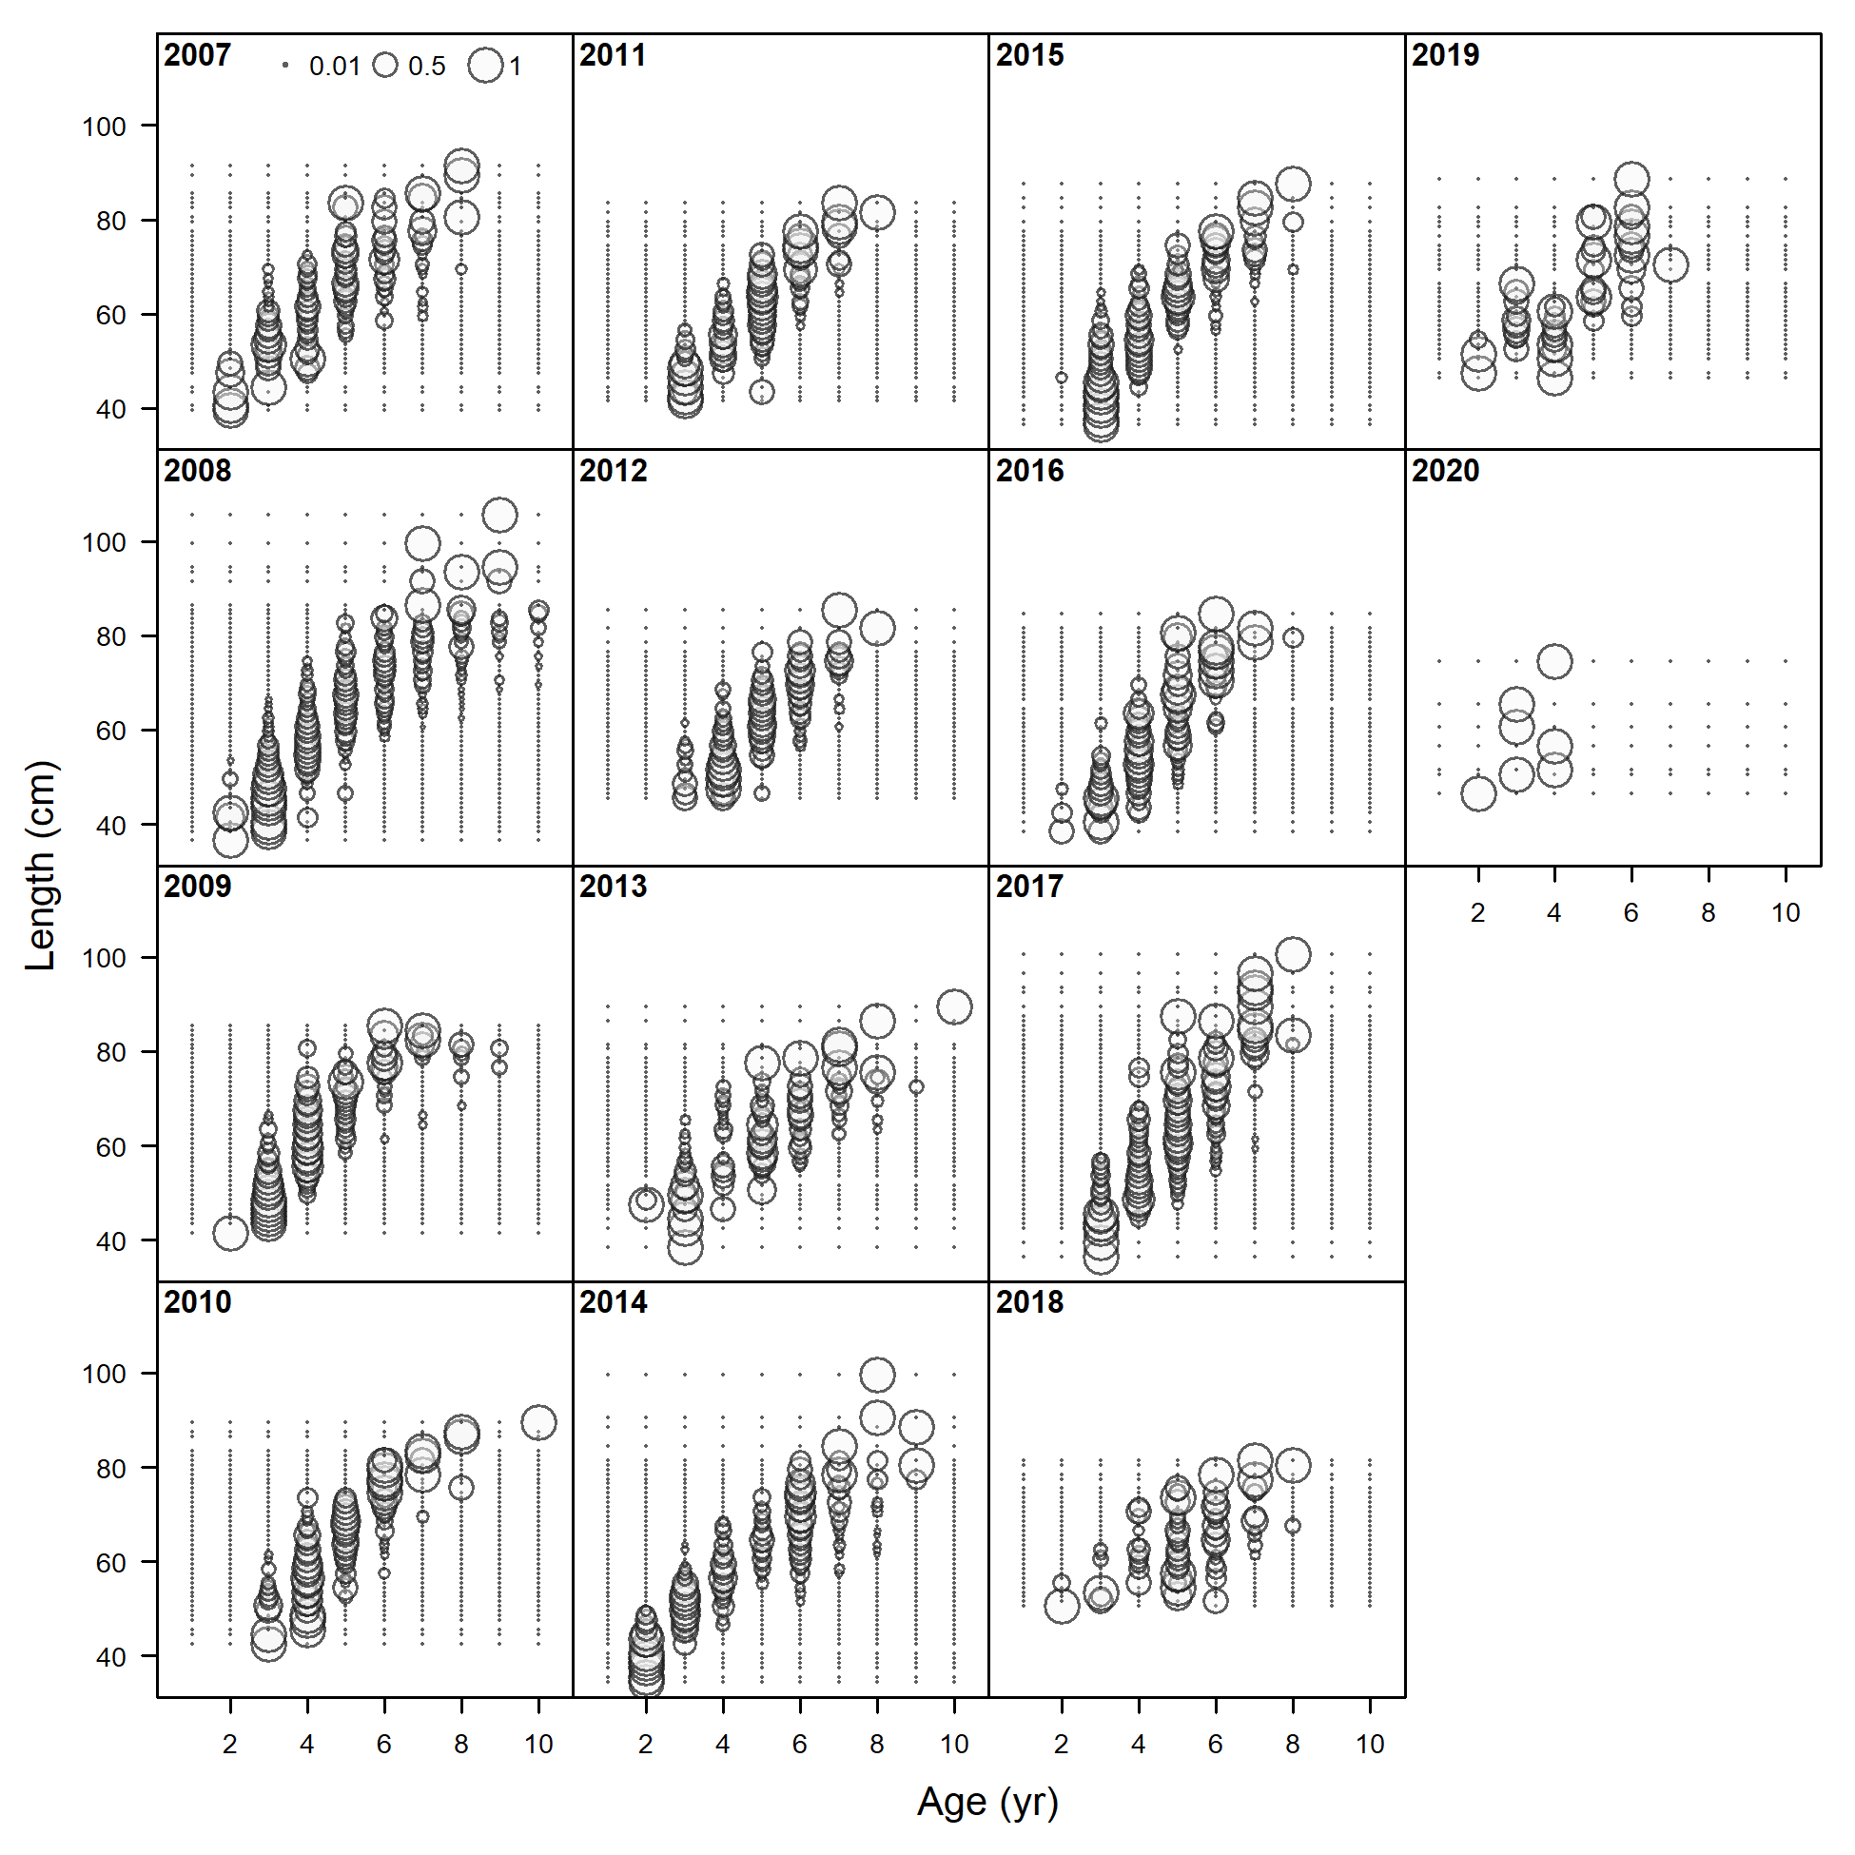

Figure 2.41 Pacific cod conditional length at age from the Gulf of Alaska bottom longline fishery.

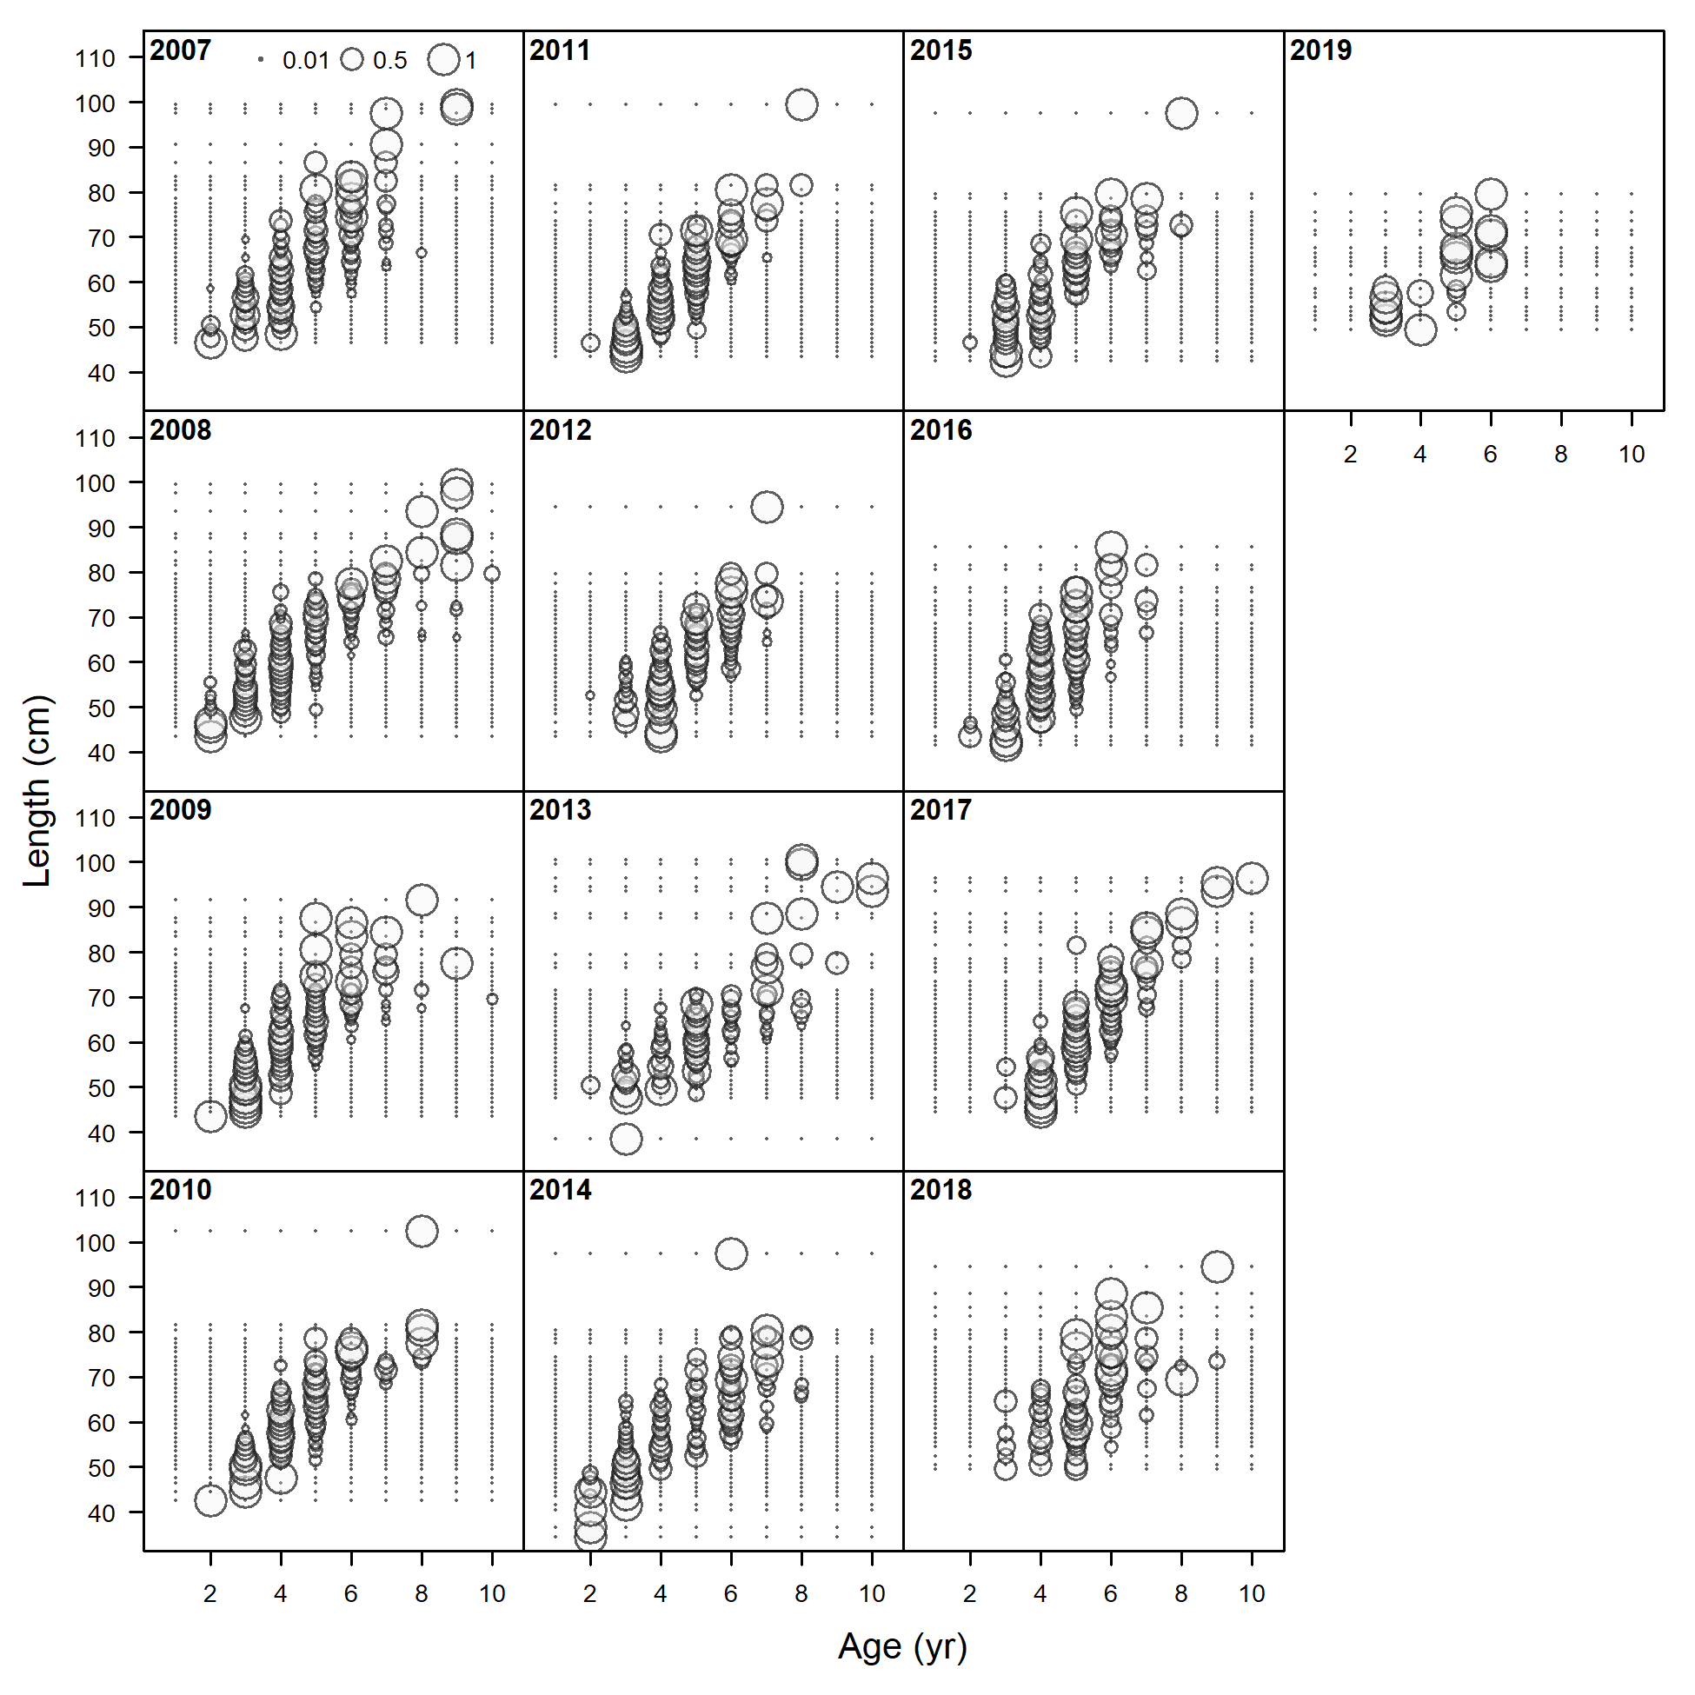

Figure 2.42 Pacific cod conditional length at age from the Gulf of Alaska pot fishery.

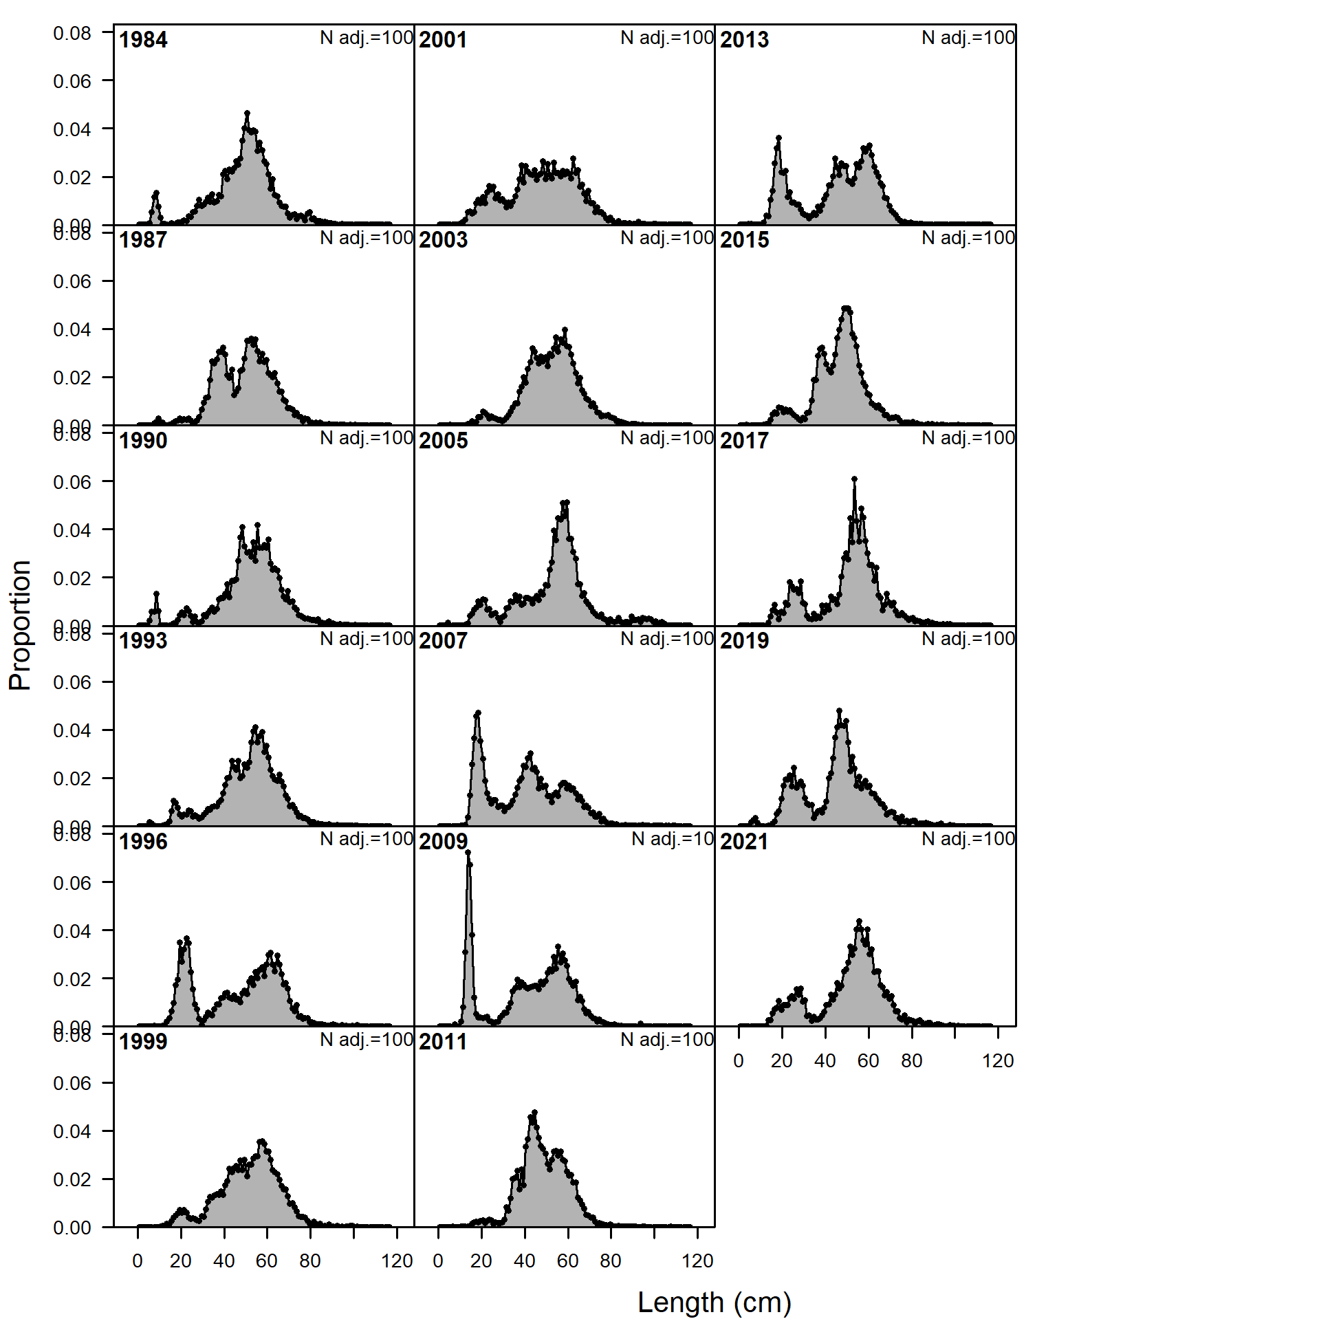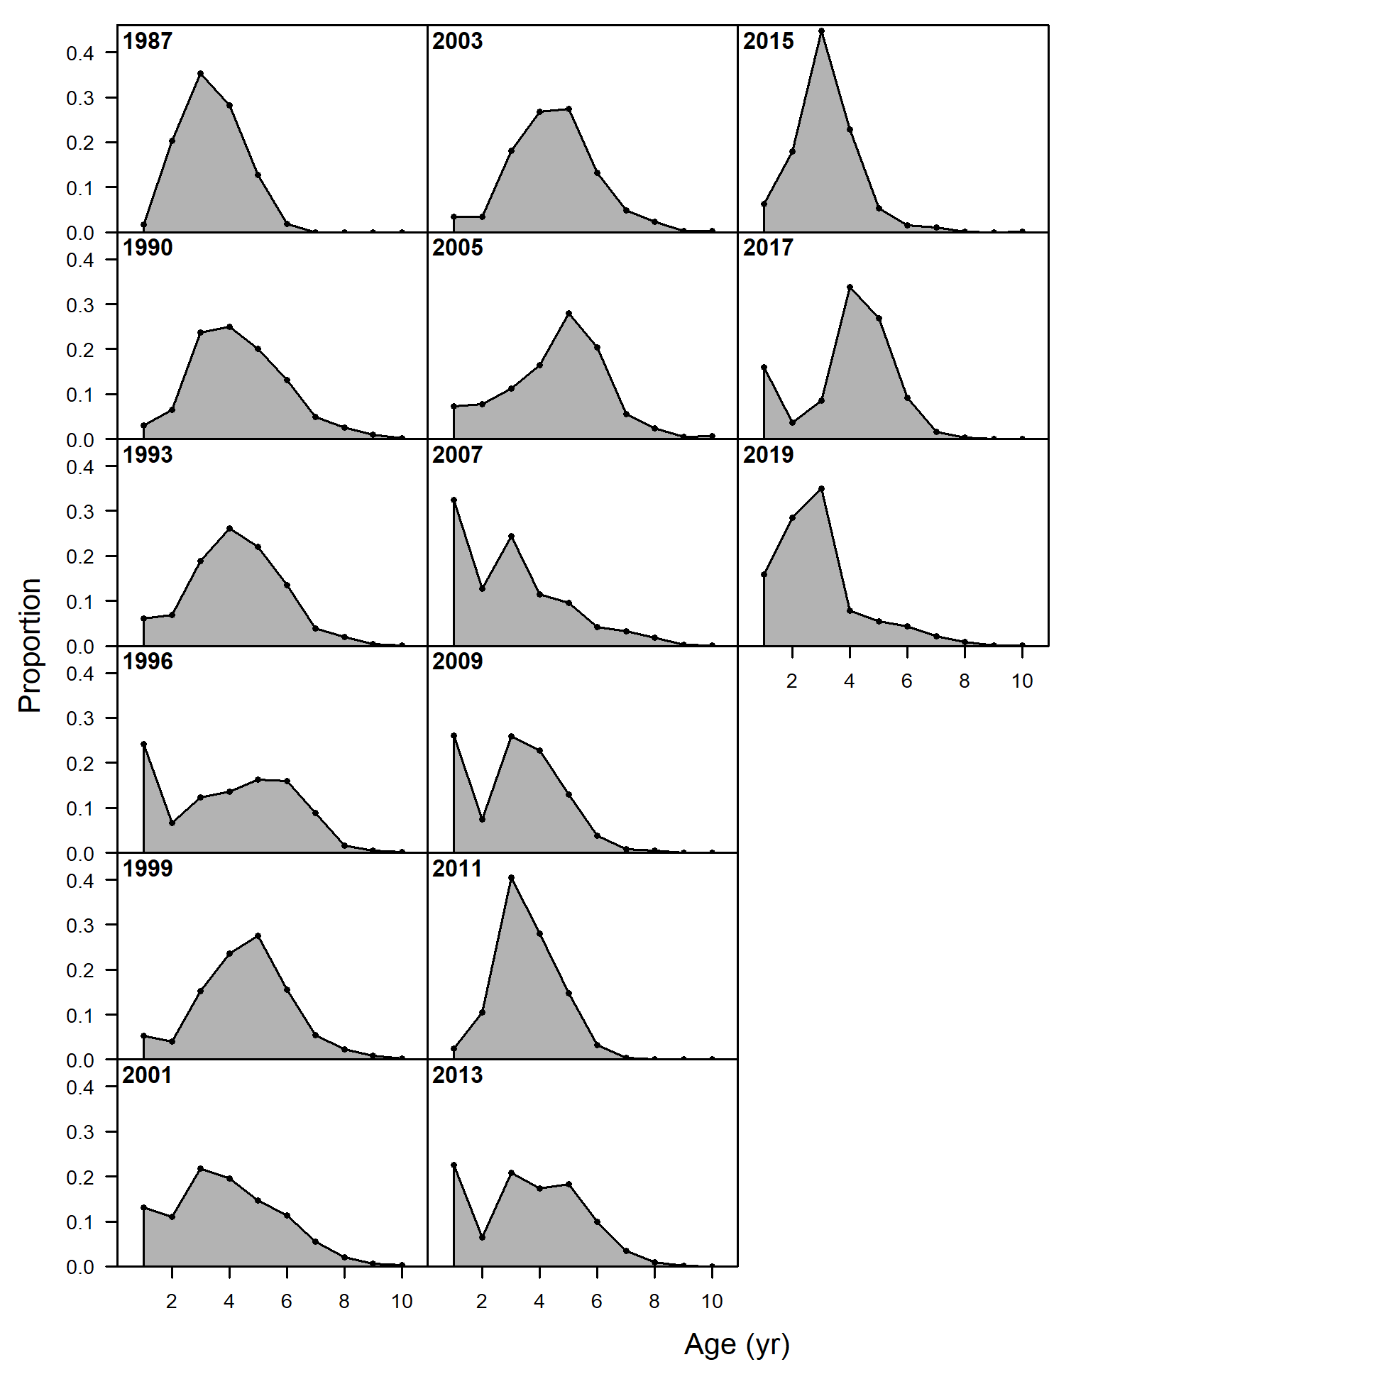

Figure 2.43 Pacific cod length (left) and age (right) composition data from the Gulf of Alaska bottom trawl survey 1984-2019.

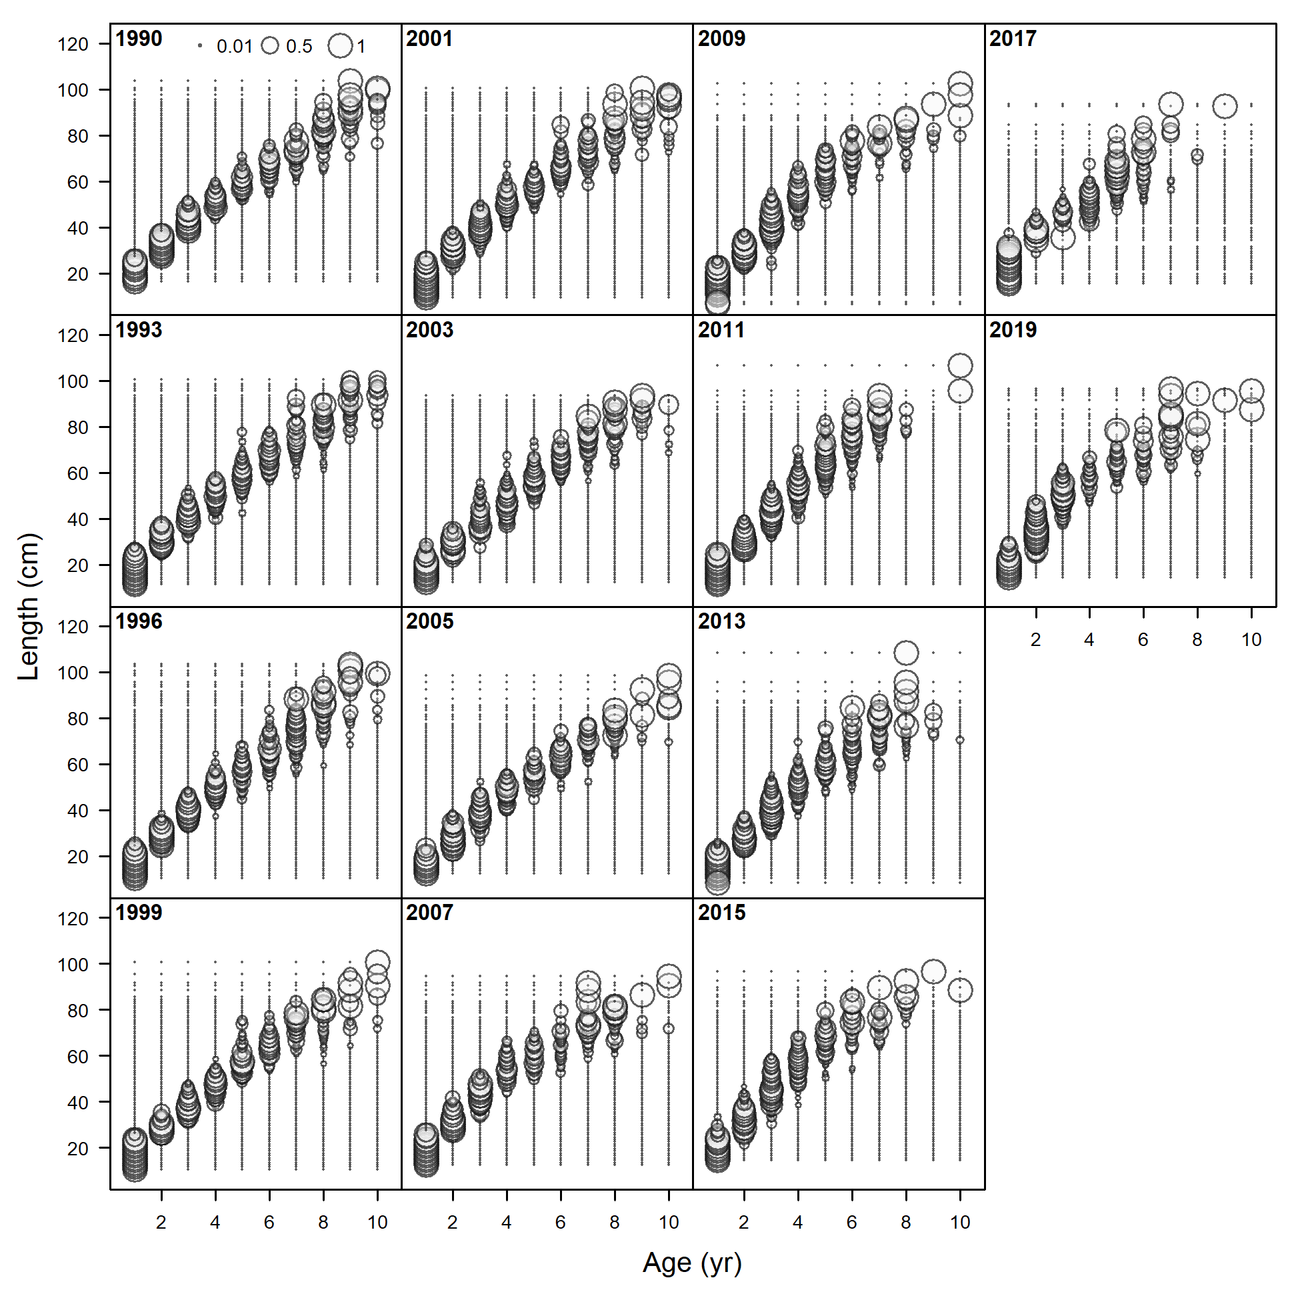

Figure 2.44 Pacific cod conditional length at age from the Gulf of Alaska bottom trawl survey 1990-2019.

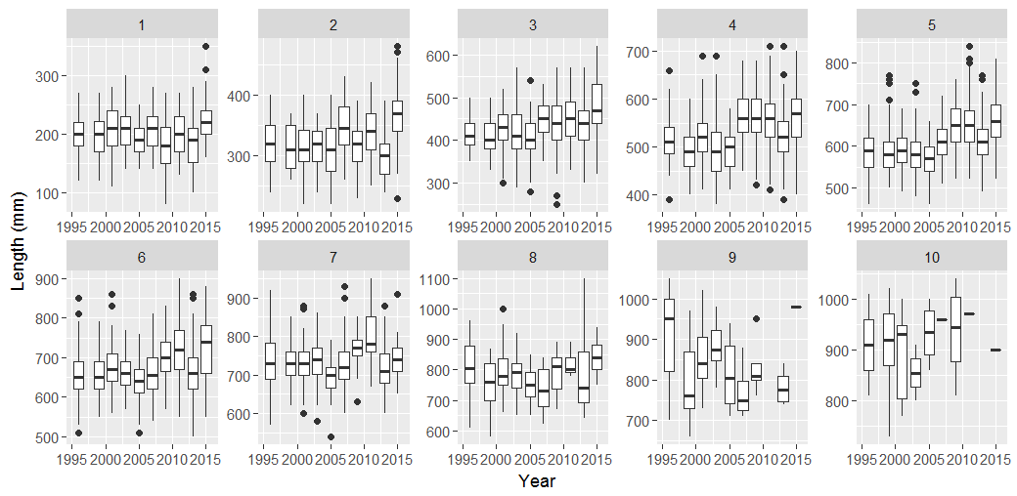

Figure 2.45 Length-at-age by year for each age 1 through 10 for Pacific cod otoliths collected during the summer bottom trawl surveys showing an increase in median length in 2007 for ages 2 through 6.

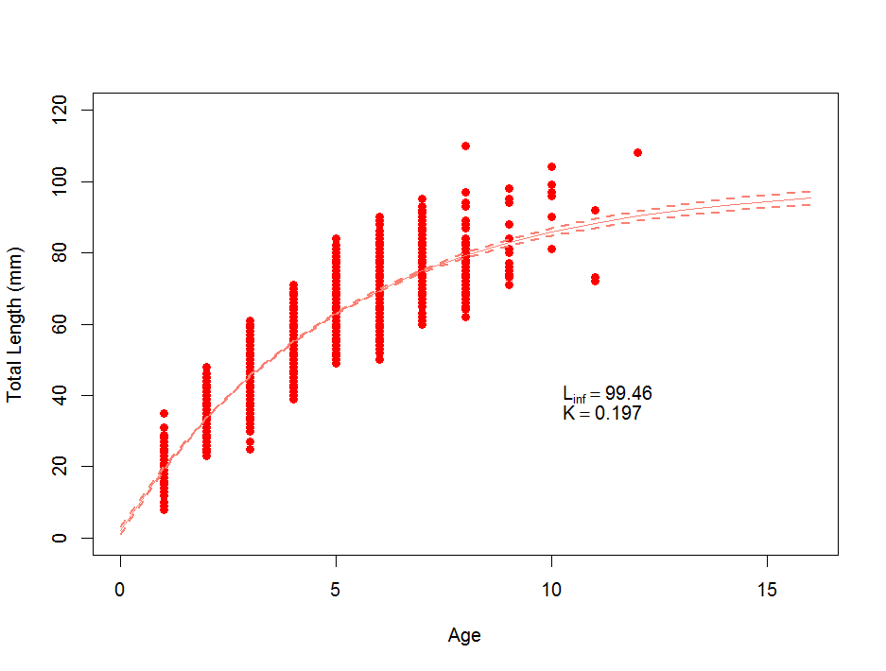

Fork length (cm)

Figure 2.46 Fit to von Bertalanffy growth model for 2007-2015 length at age data from the AFSC bottom trawl surveys.

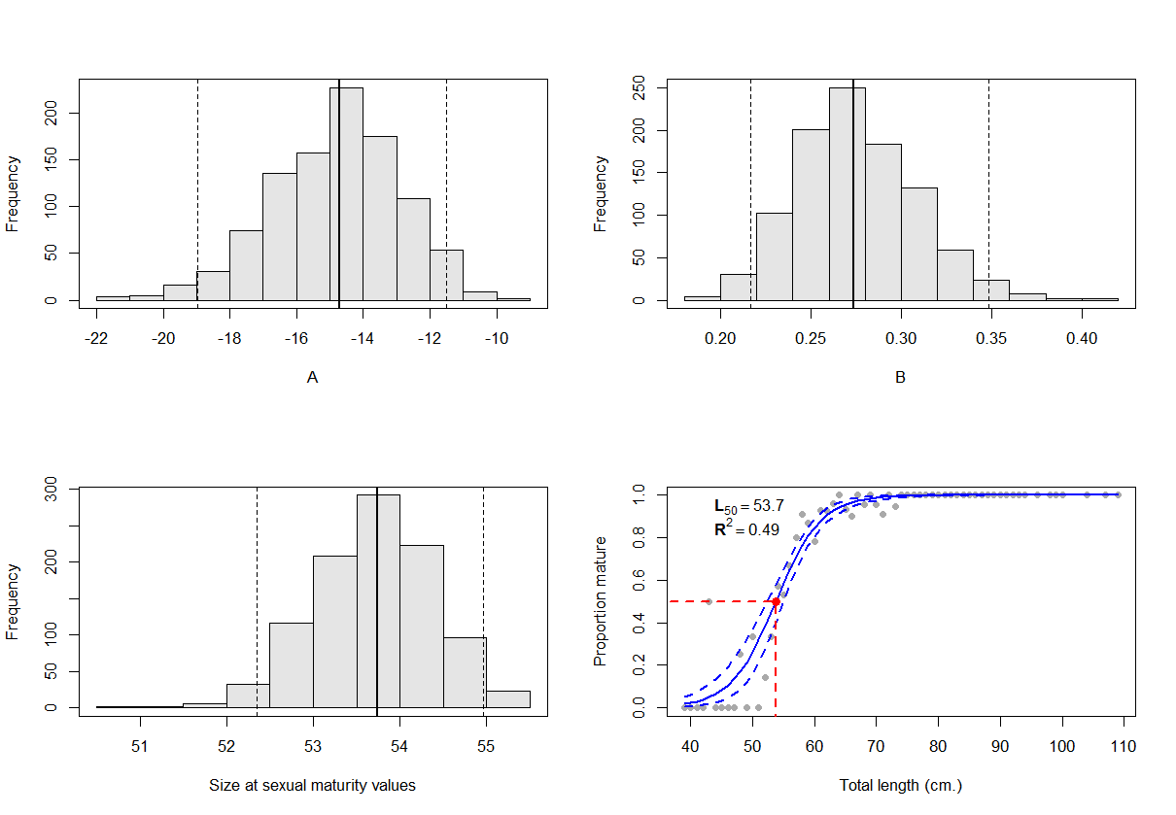

Figure 2.47 Bootstrapped (n=1000) parameters and results for the logistic length-based maturity using Stark (2007) reread otolith and maturity data. Proportion mature and L50 = A/-B

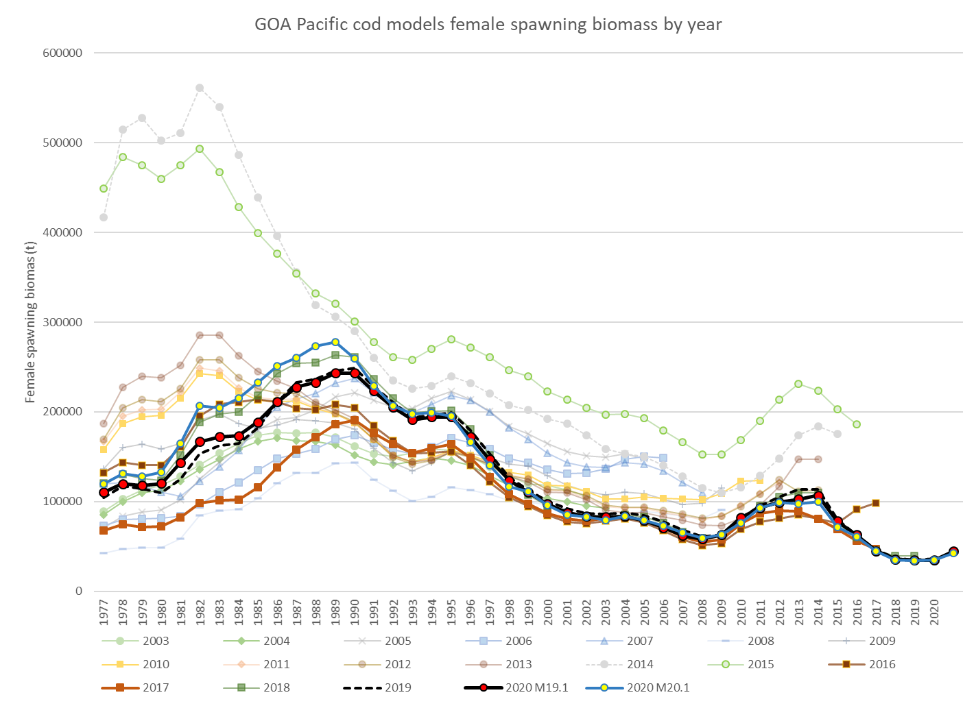

Figure 2.48 1977-2021 Gulf of Alaska Pacific cod female spawning biomass from the 2003 through 2020 stock assessments with estimates from both the author’s preferred (Model 19.1) and research (Model 20.1) model results and (inset) images from the NMFS small net surveys off Kodiak Alaska showing change in species composition over time from: http://www.thexxnakedscientists.com/HTML/articles/article/brucewrightcolumn1.htm/

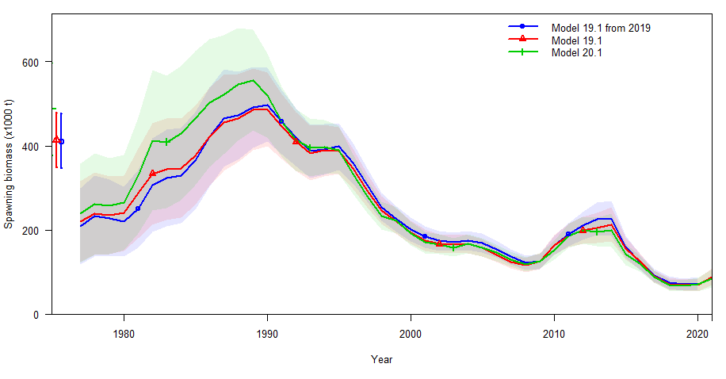 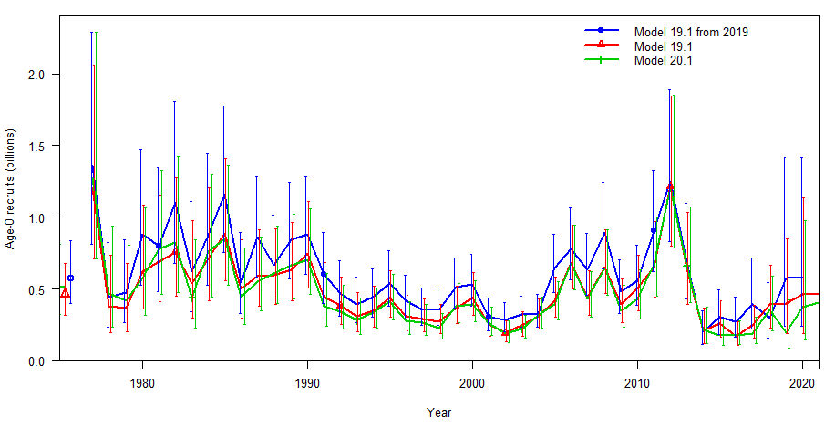

Figure 2.49 Estimates of female spawning biomass (t; top) and age-0 recruits (billions; bottom) for 2020 reference model (Model 19.14.48c), the proposed alternate Model 19.1, and the experimental environmentally enhanced Model 20.1.

Model20.1

Model19.1

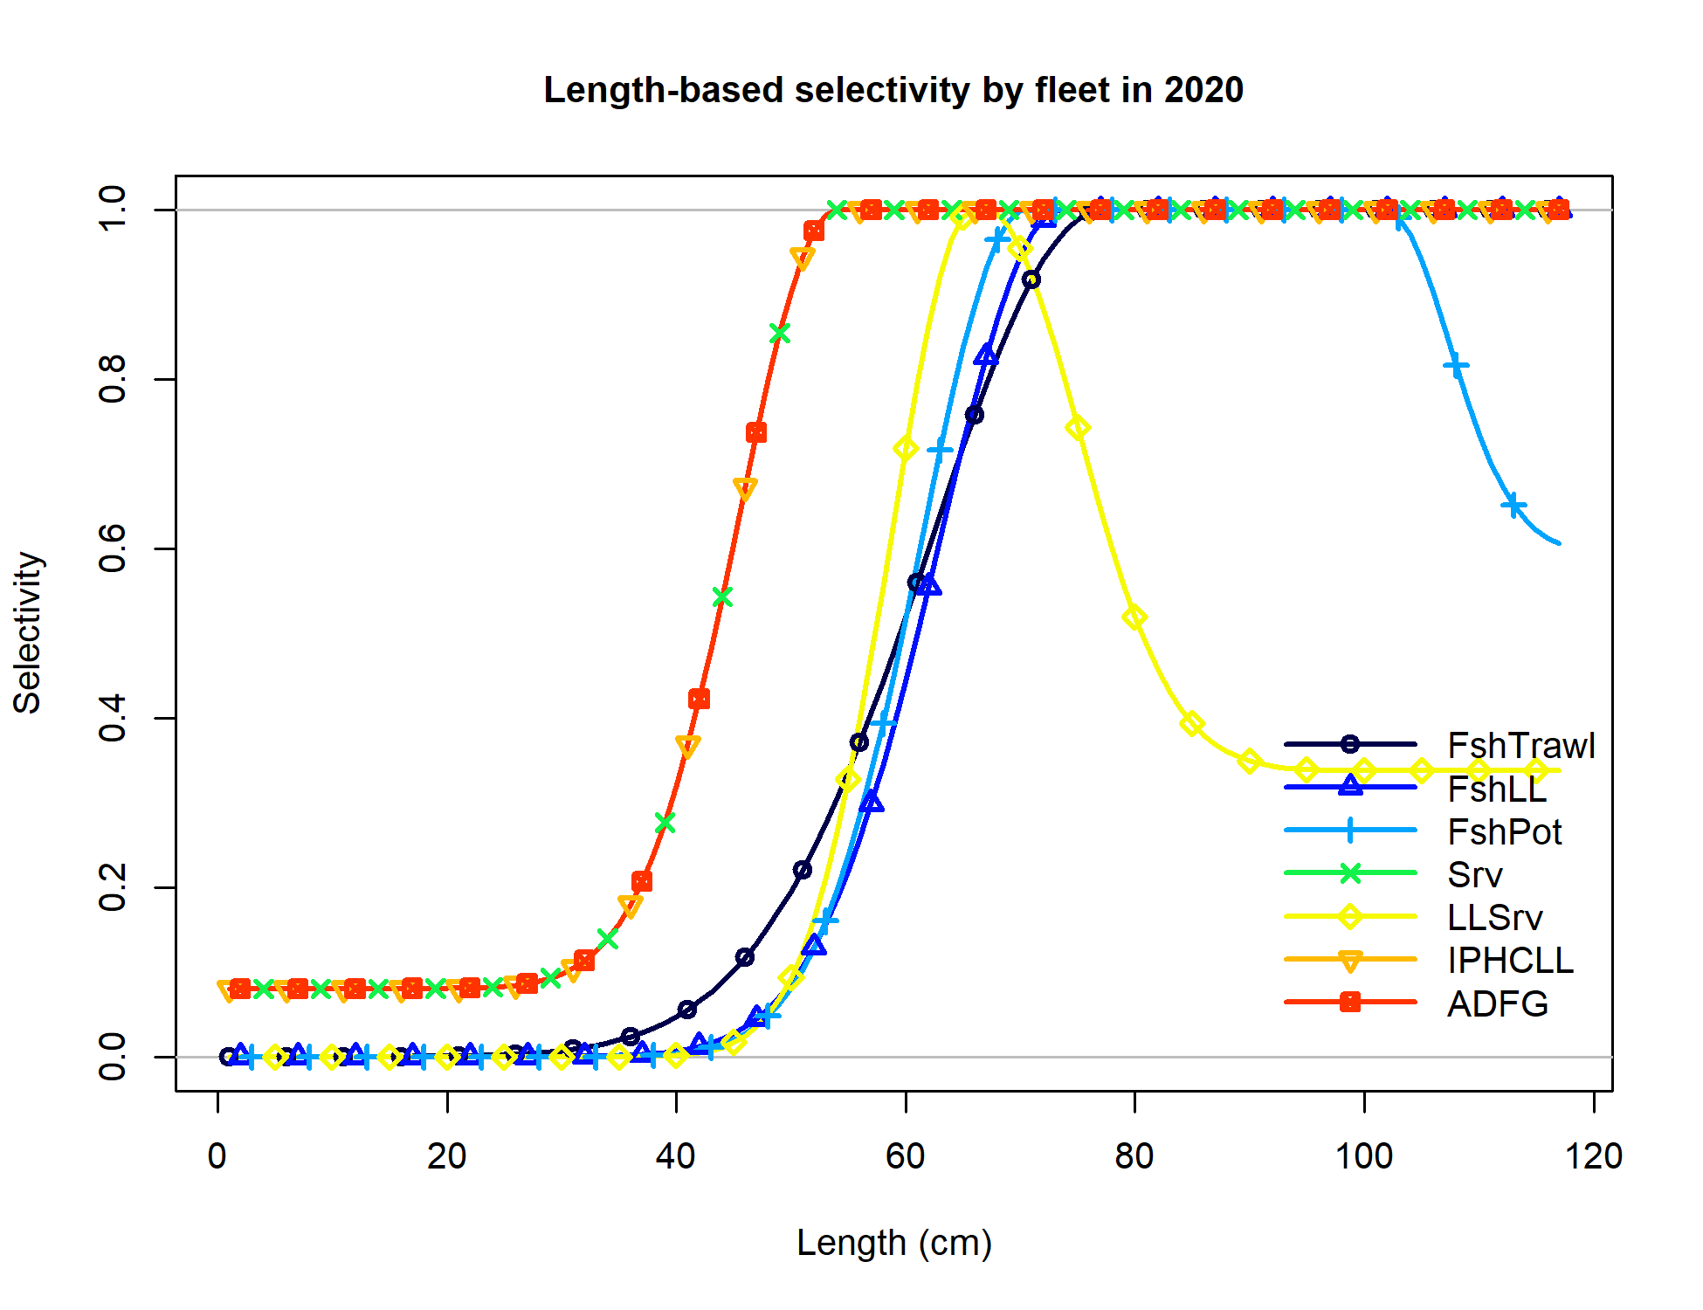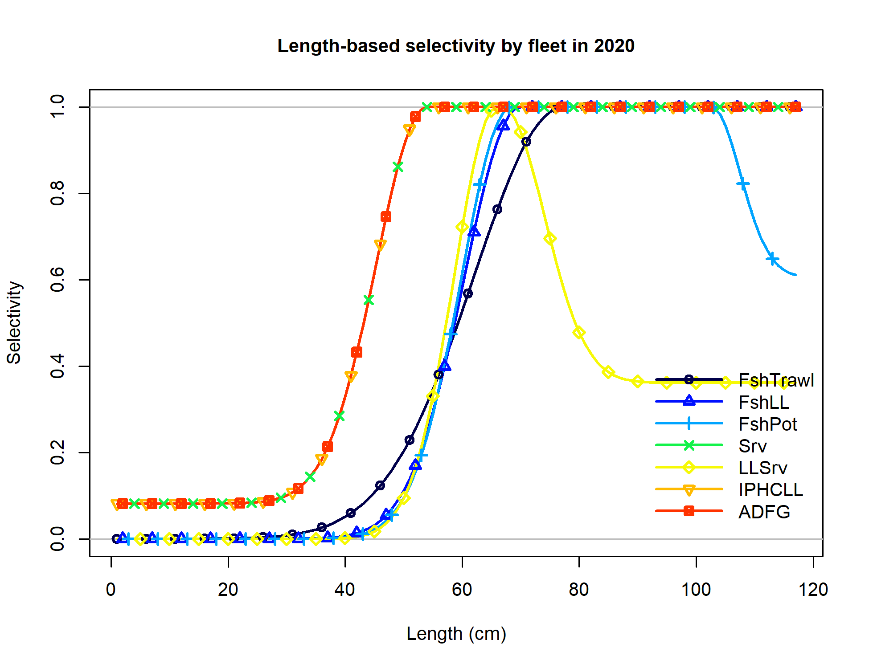

Figure 2.50 Model19.1 and Model 20.1 selectivity for all size composition components for 2020.

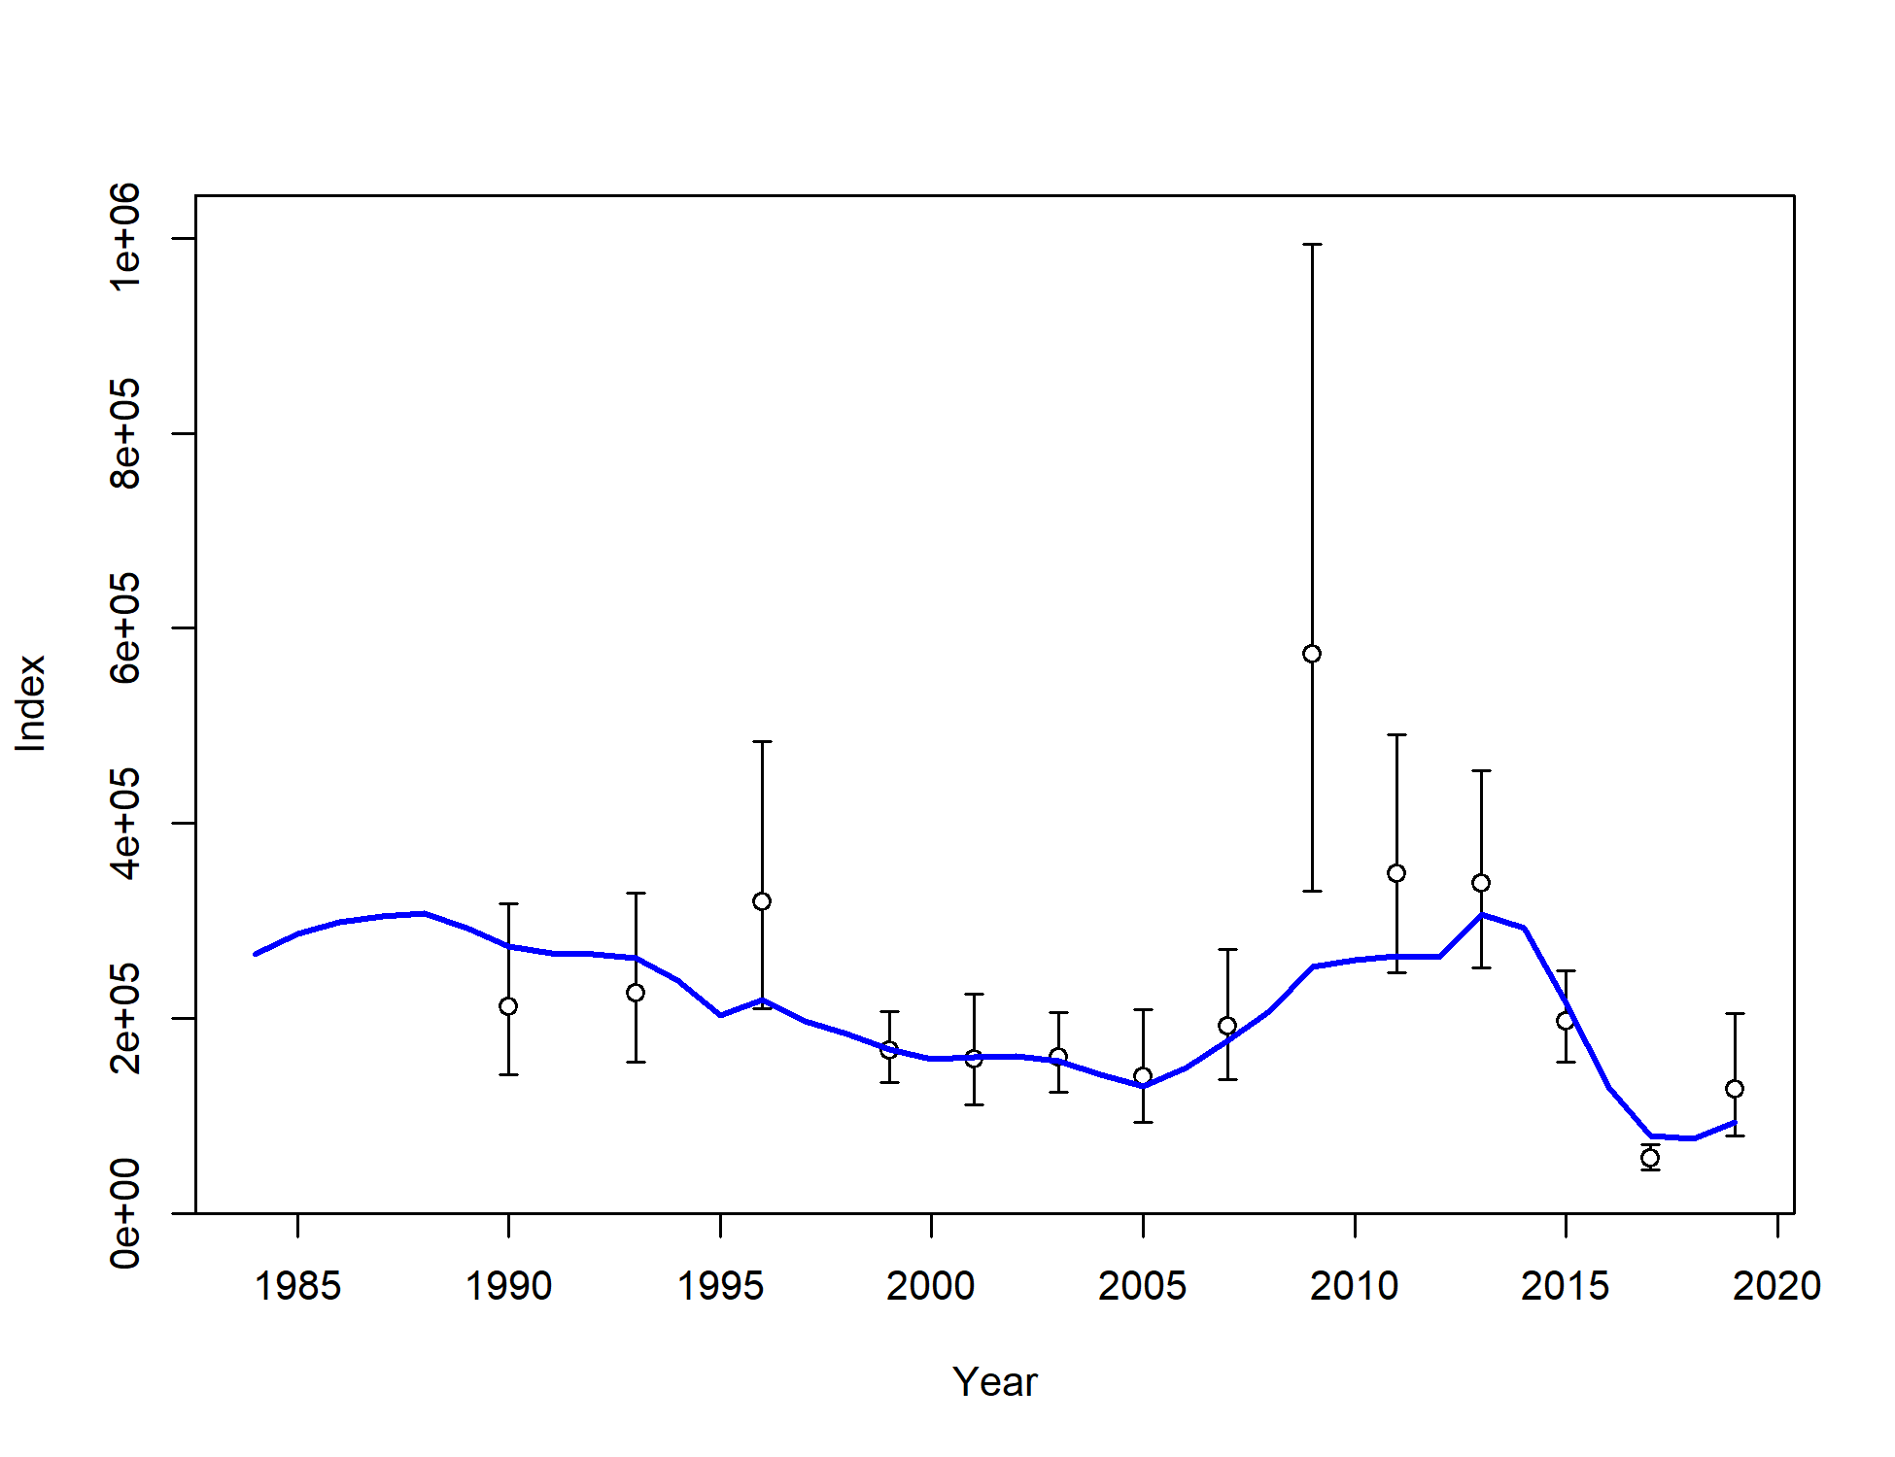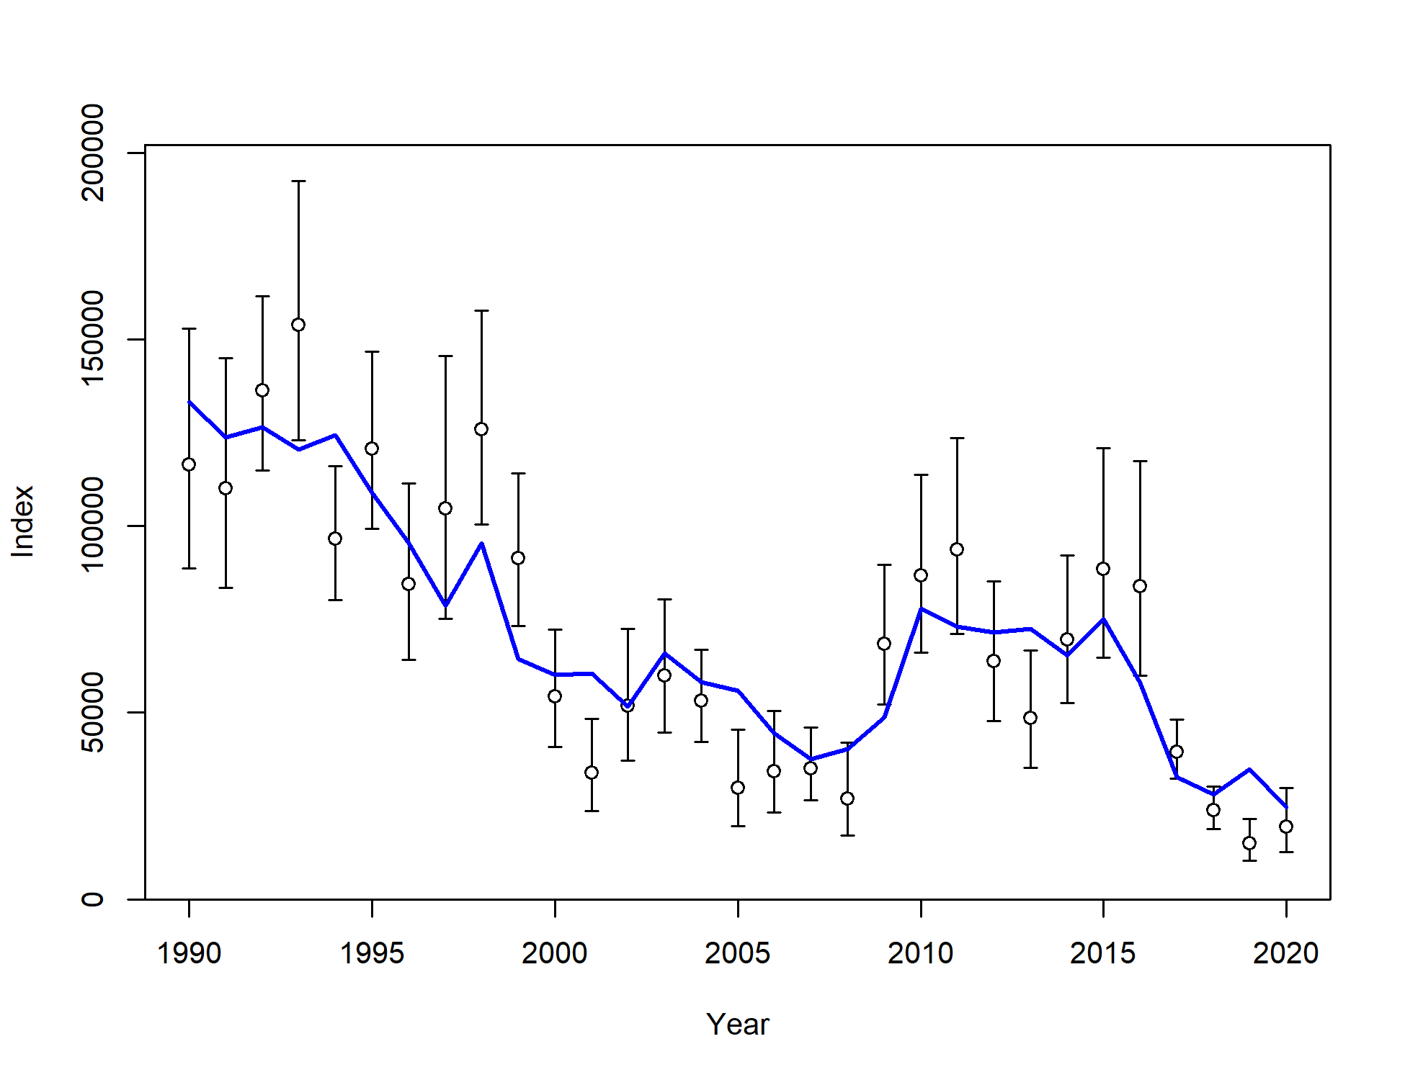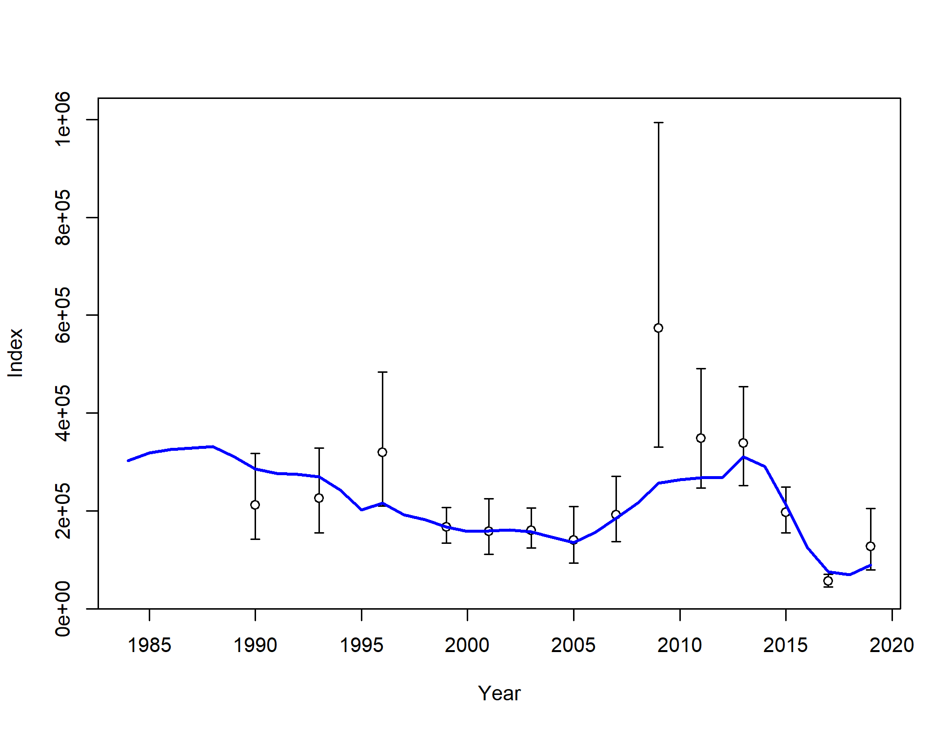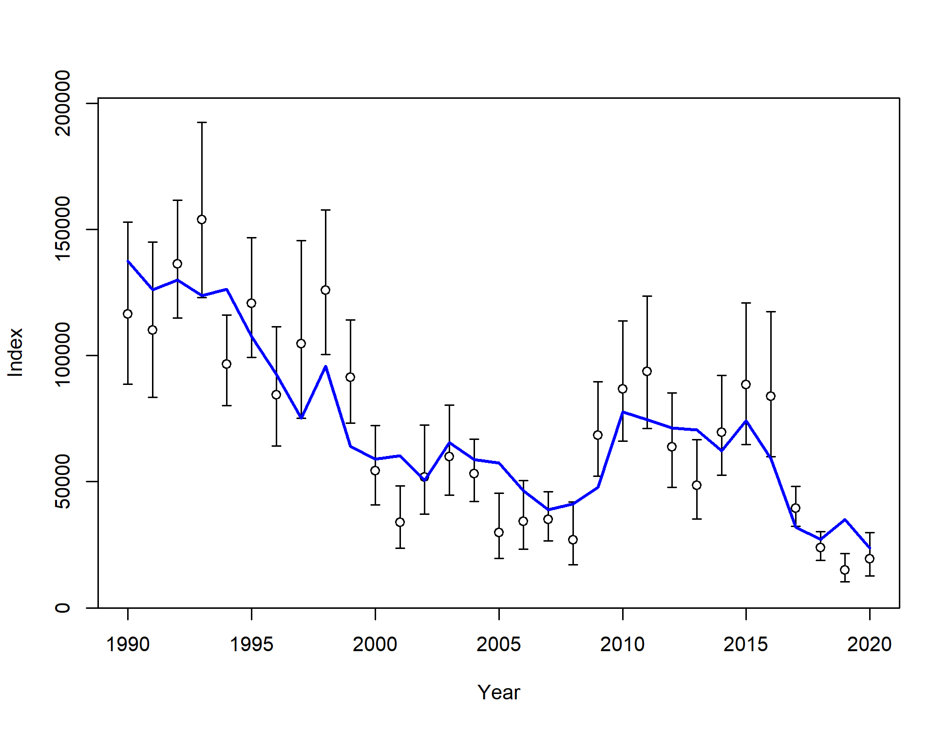

Model 20.1

Model 19.1

Figure 2.51 Model fits to AFSC bottom trawl (left) and AFSC longline (right) survey indices.

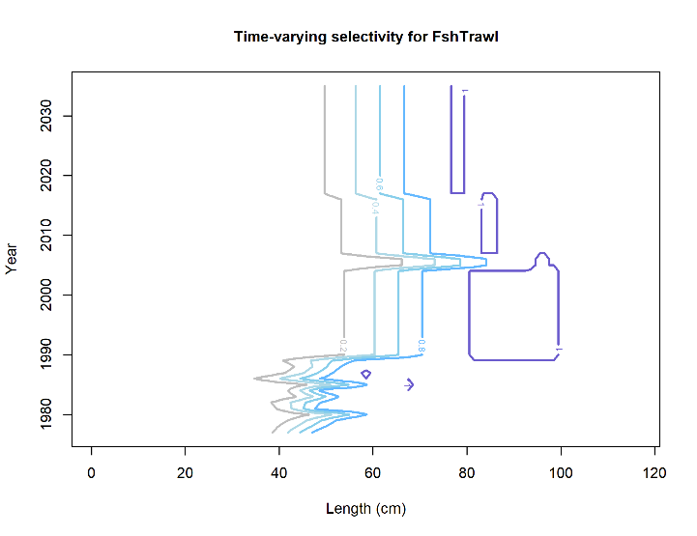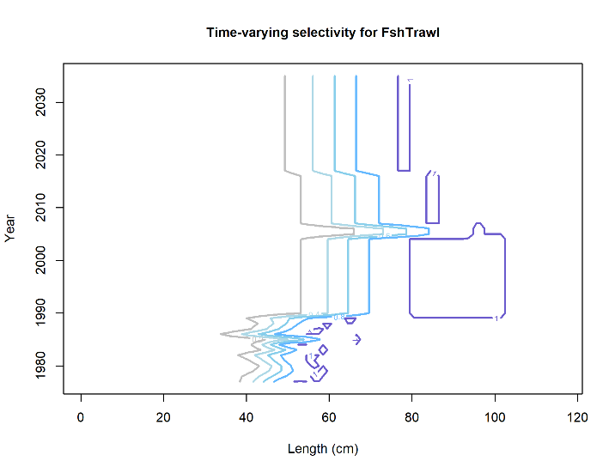

M 19.1

Trawl

M 20.1

Trawl

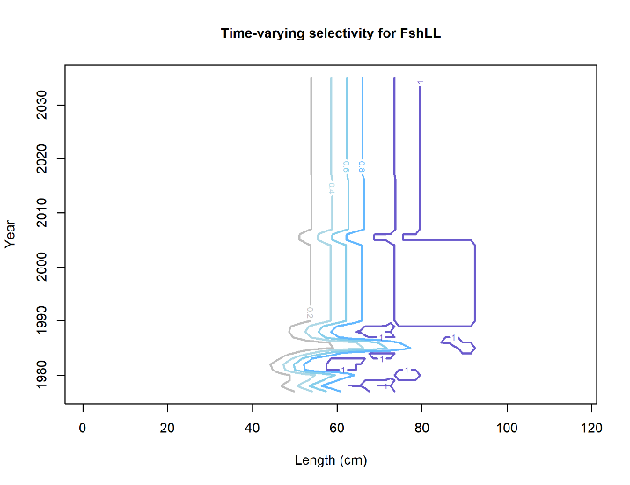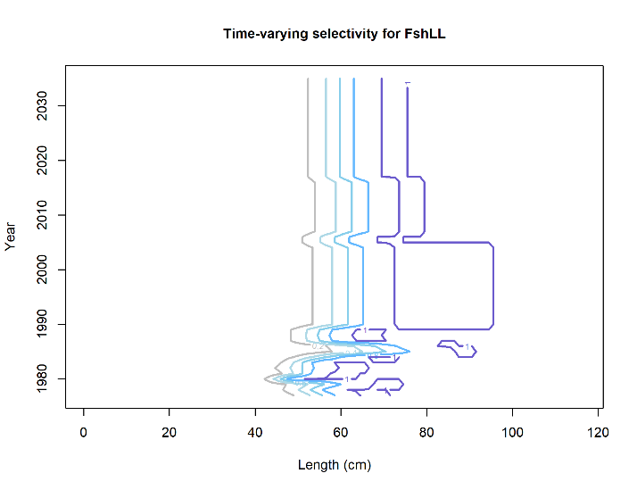

M 20.1

Longline

M 19.1

Longline

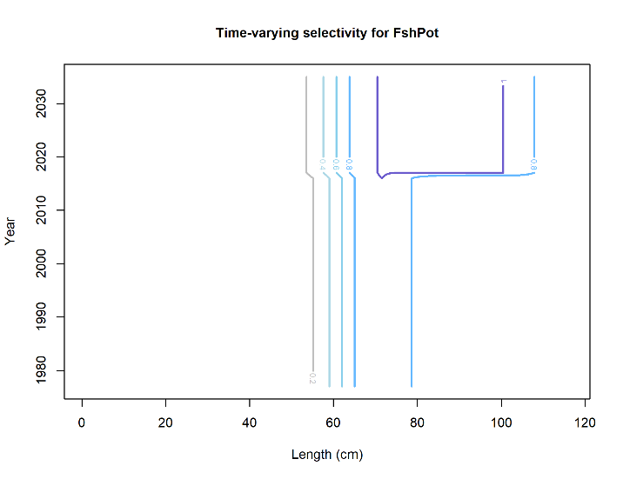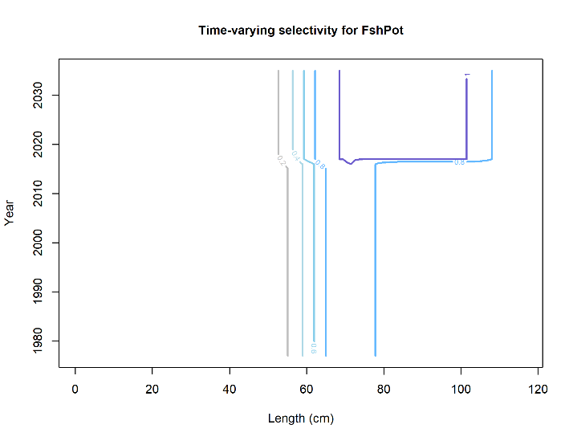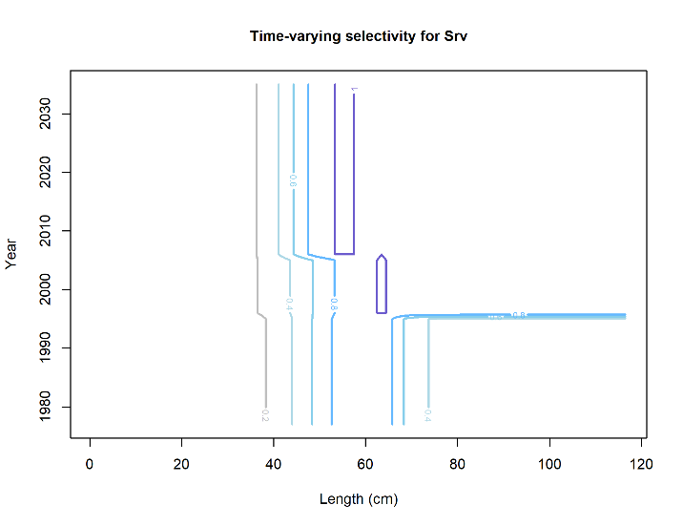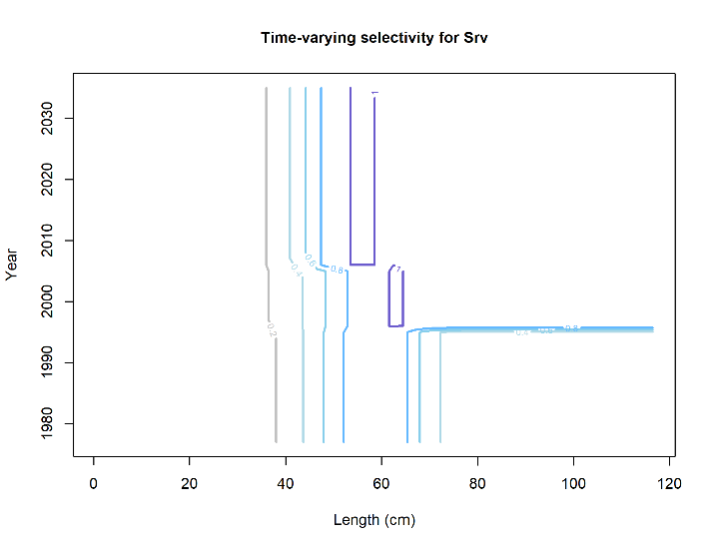

M 19.1

BT Survey

M 20.1

BT Survey

M 20.1

Pot

M 19.1

Pot

Figure 2.52 Estimates of fishery and AFSC bottom trawl survey selectivities for Model 19.1 (left) and Model 20.1 (right). Red dashed line is the size at 50% mature.

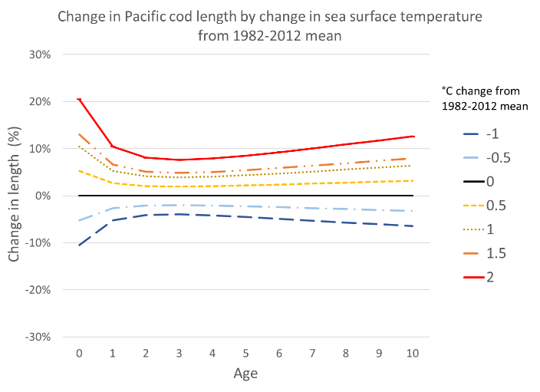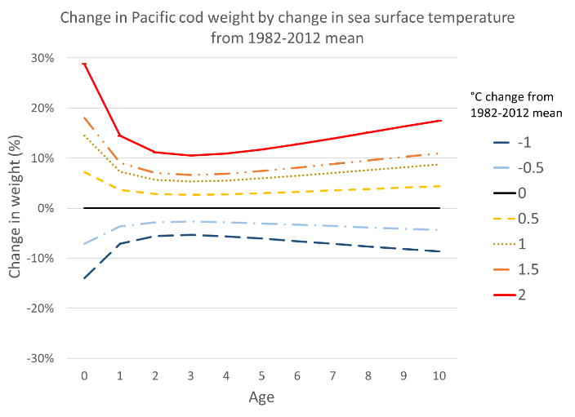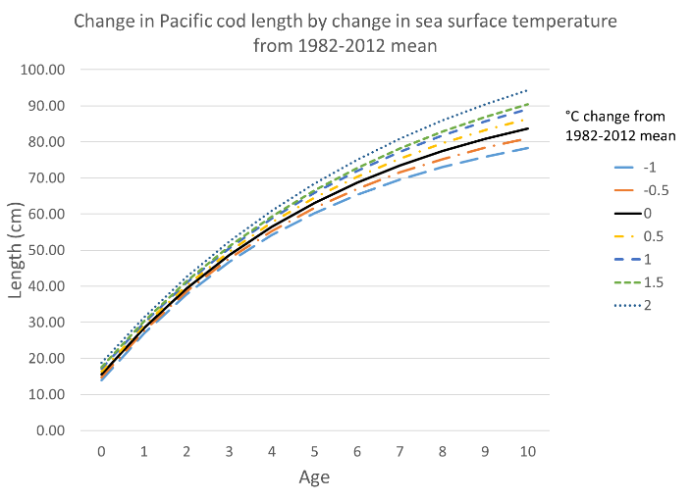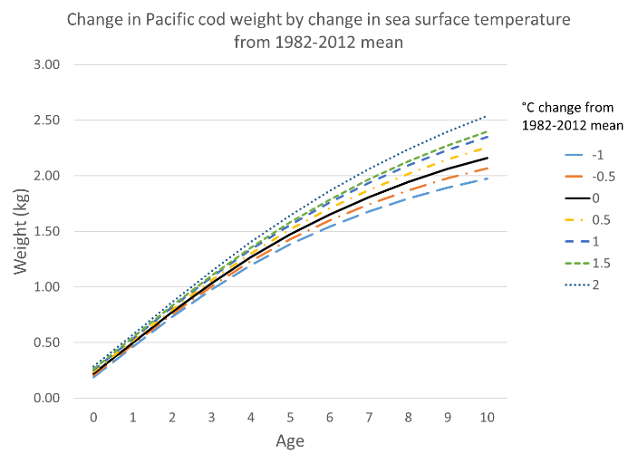

Figure 2.53 Model 20.1 change in length by age (left) and change in weight by age (right) by temperature anomaly from the 1982-2012 mean.

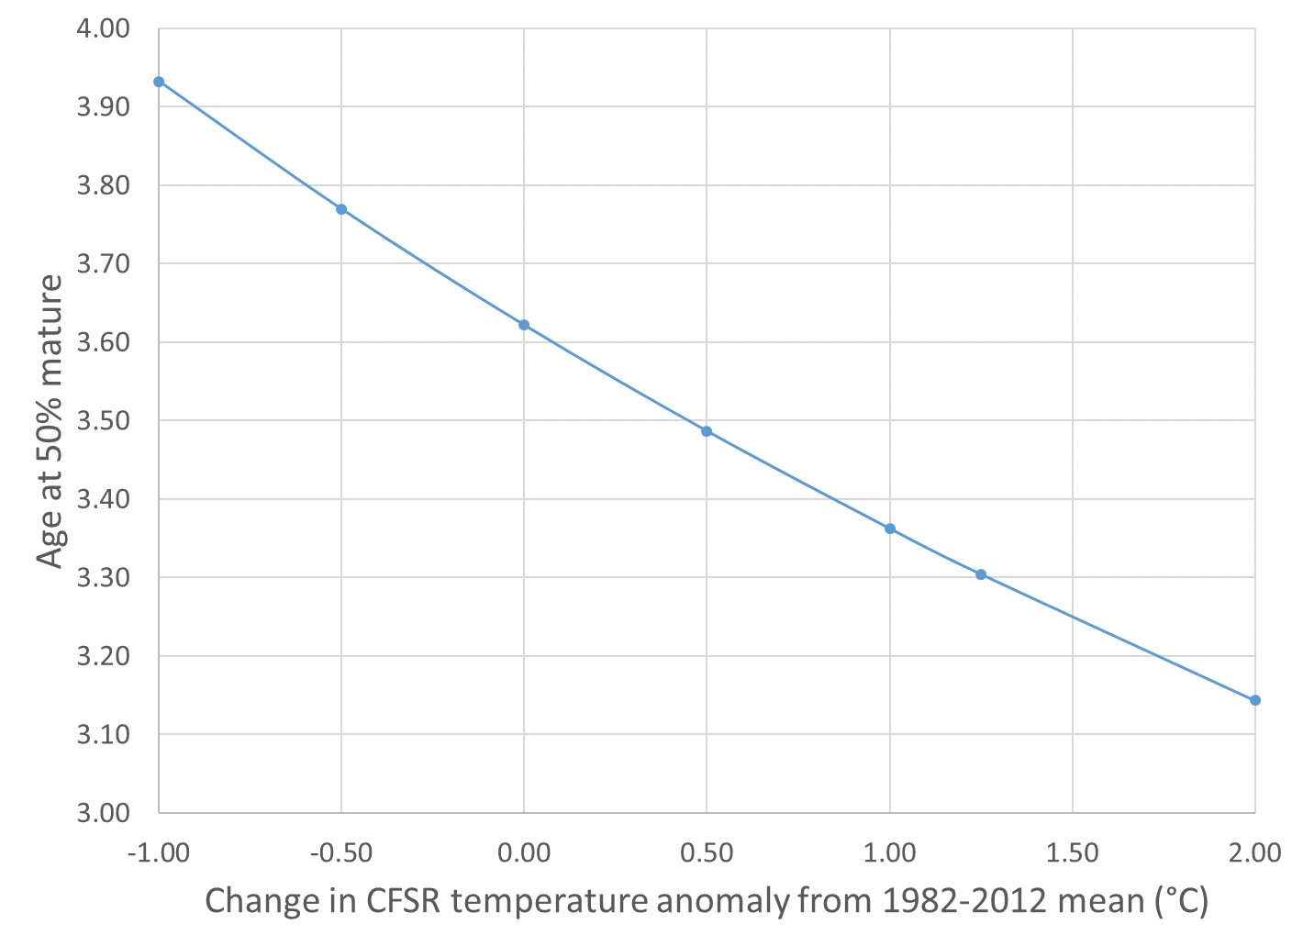

Figure 2.54 Relationship of maturity to temperature anomaly from the 1982-2012 mean for Model 20.1.

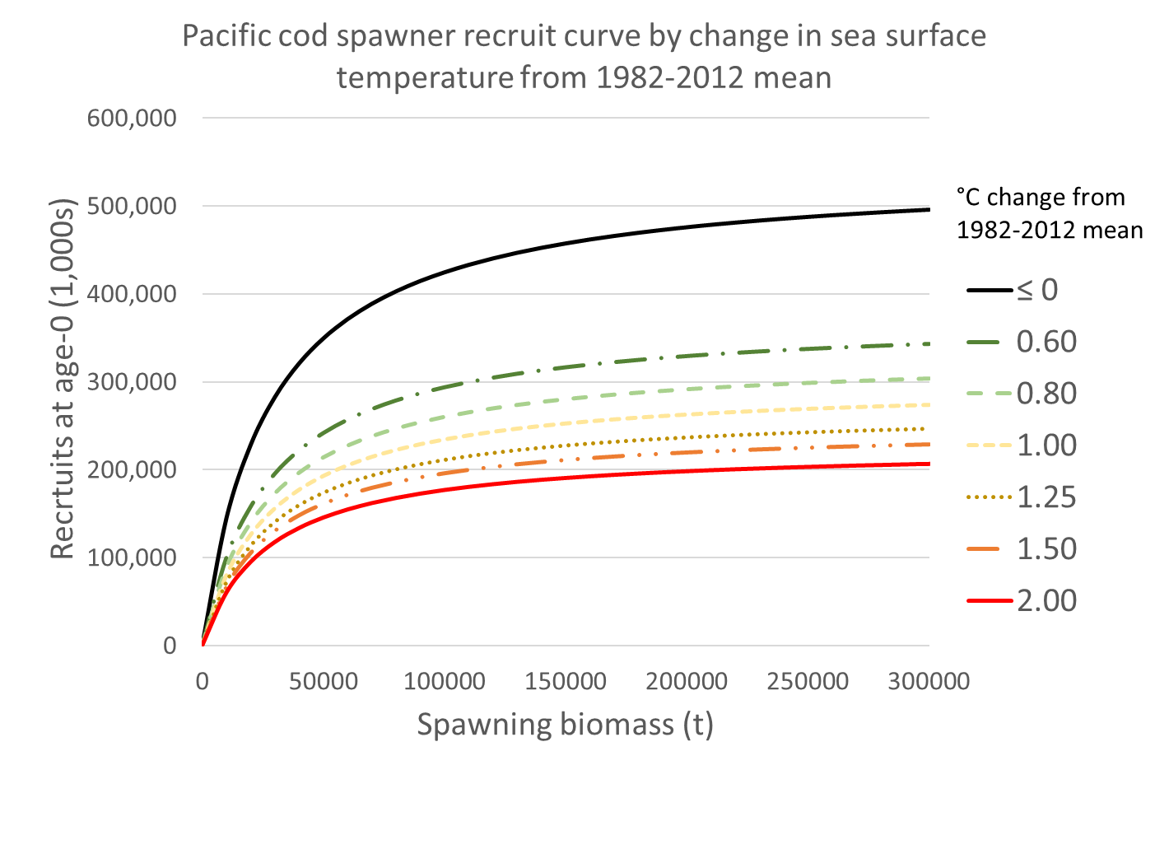

Figure 2.55 Recruits by spawning biomass in Model 20.1 related to temperature anomaly as interpreted through the modeled relationship with the spawning marine heatwave index (MHWISP).

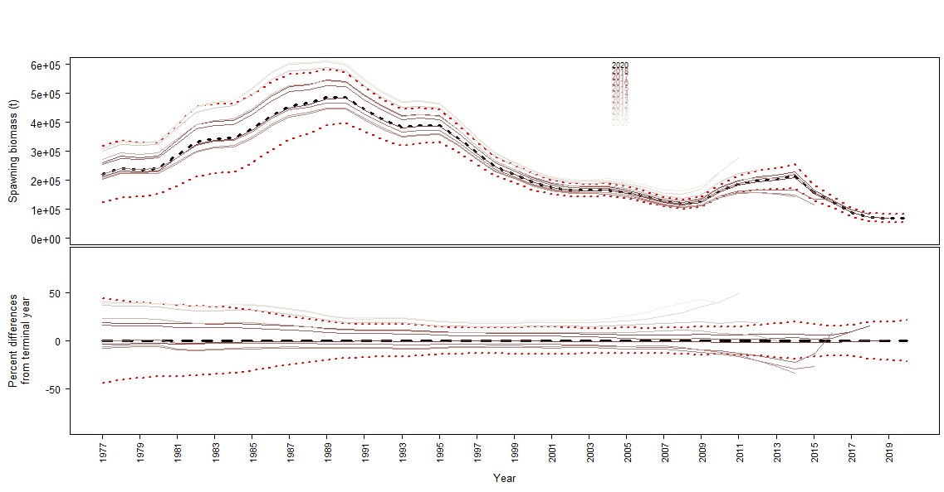

Model 19.1

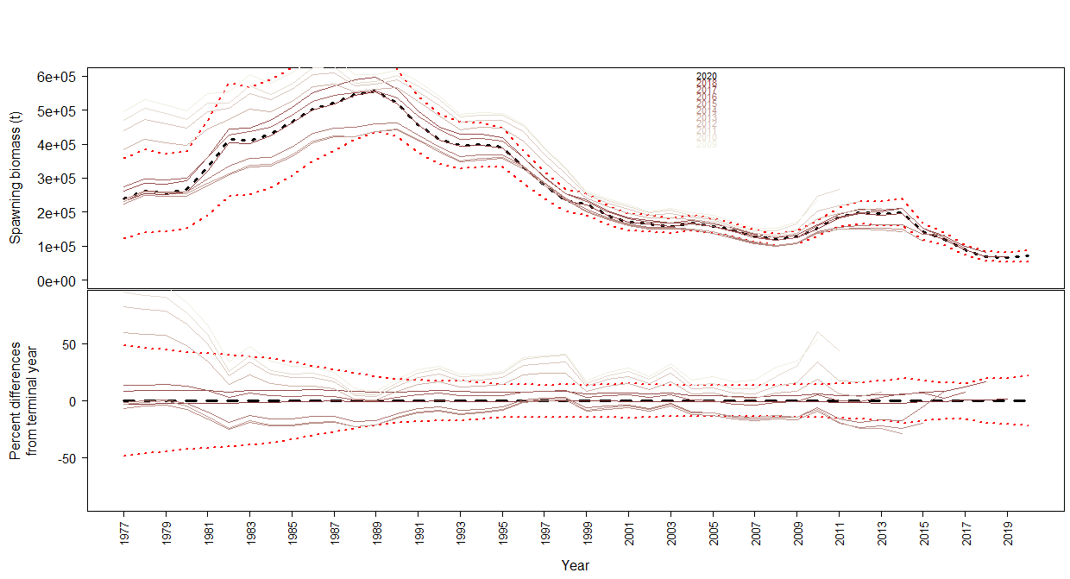

Model 20.1

Figure 2.56 Retrospective analysis for (top) Model 19.1 and (bottom) Model 20.1 for Female spawning biomass.

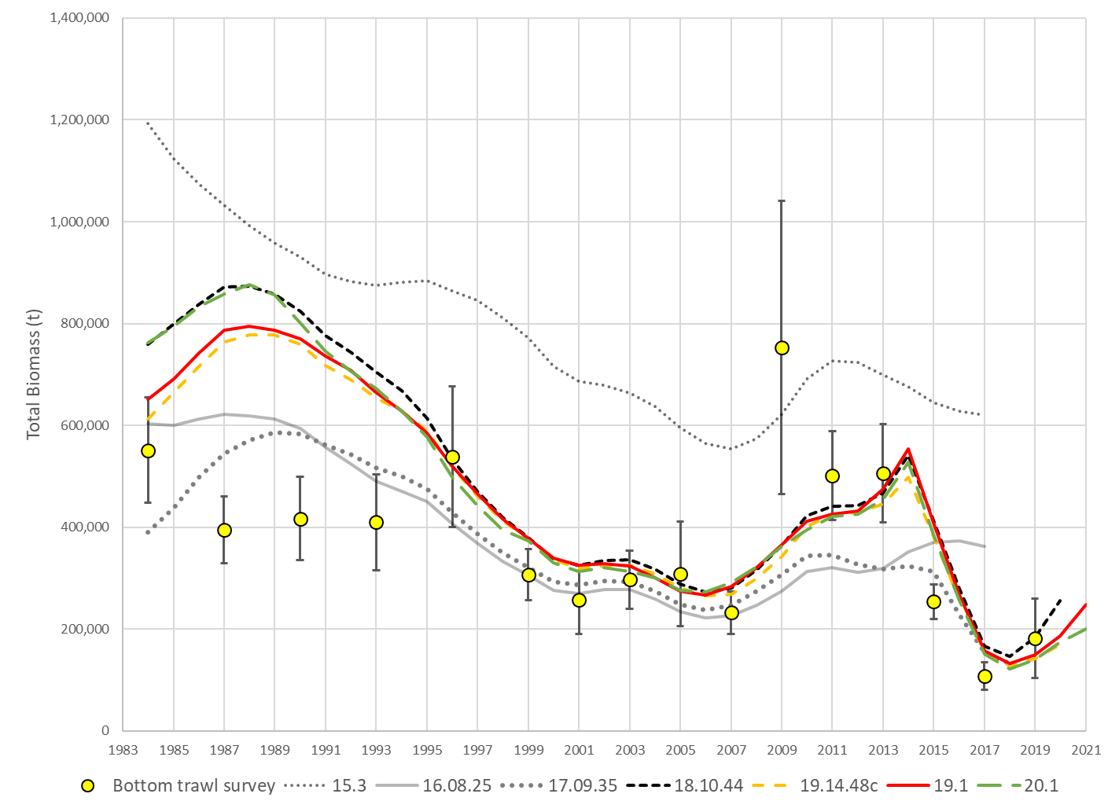

Figure 2.57 Total biomass estimates from reviewed models and NMFS bottom trawl survey biomass estimates with 95% confidence bounds.

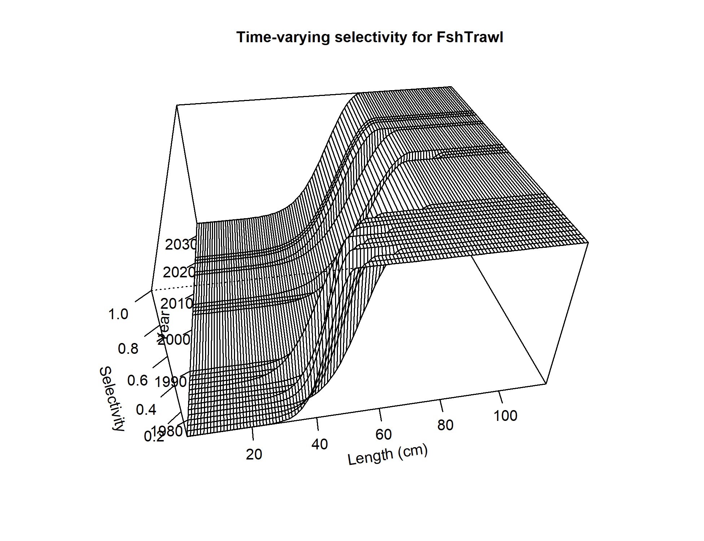 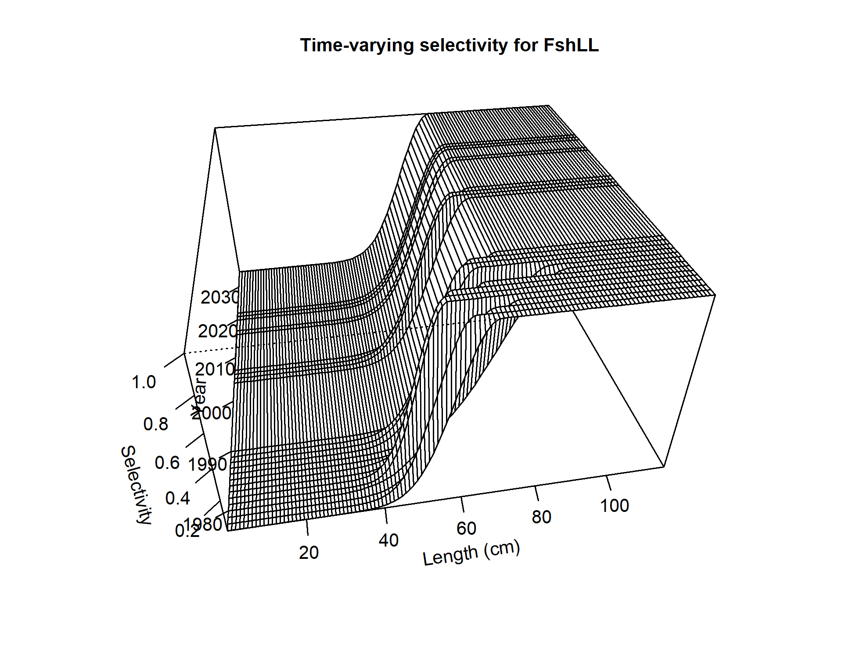 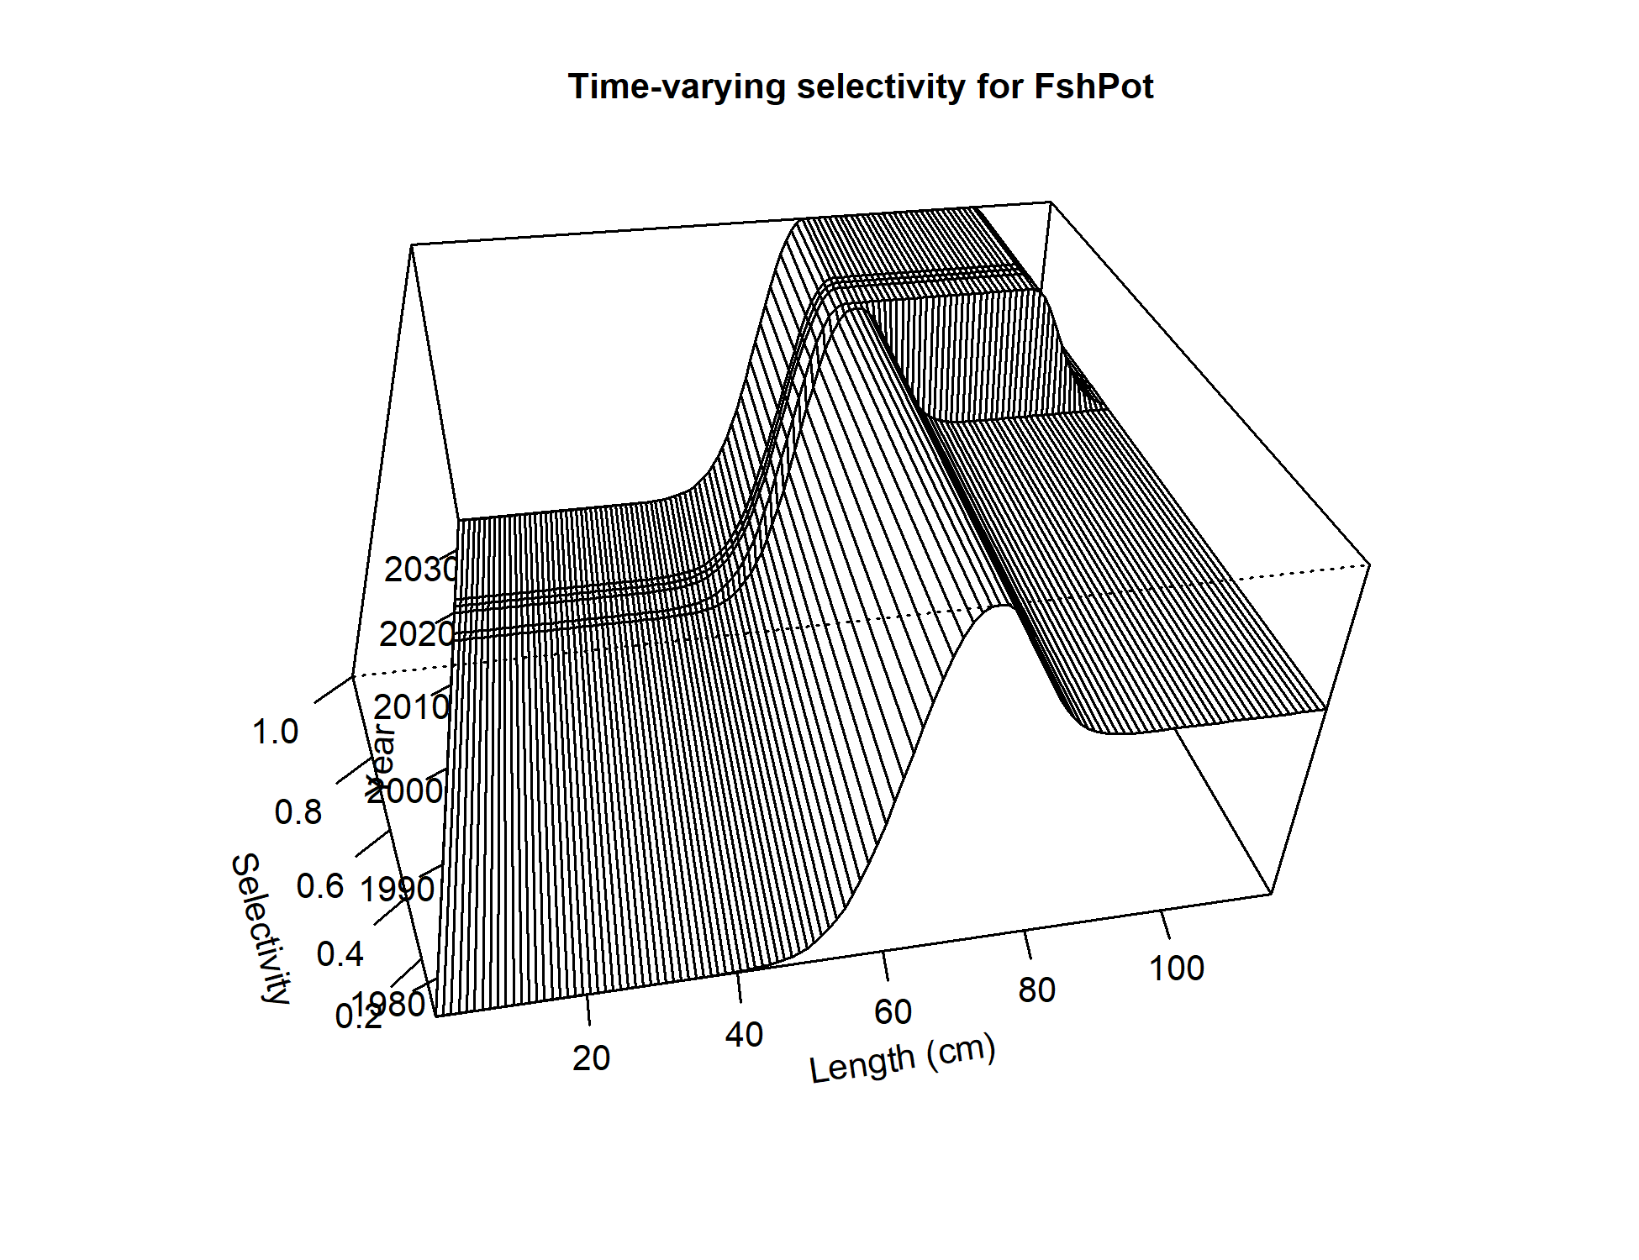 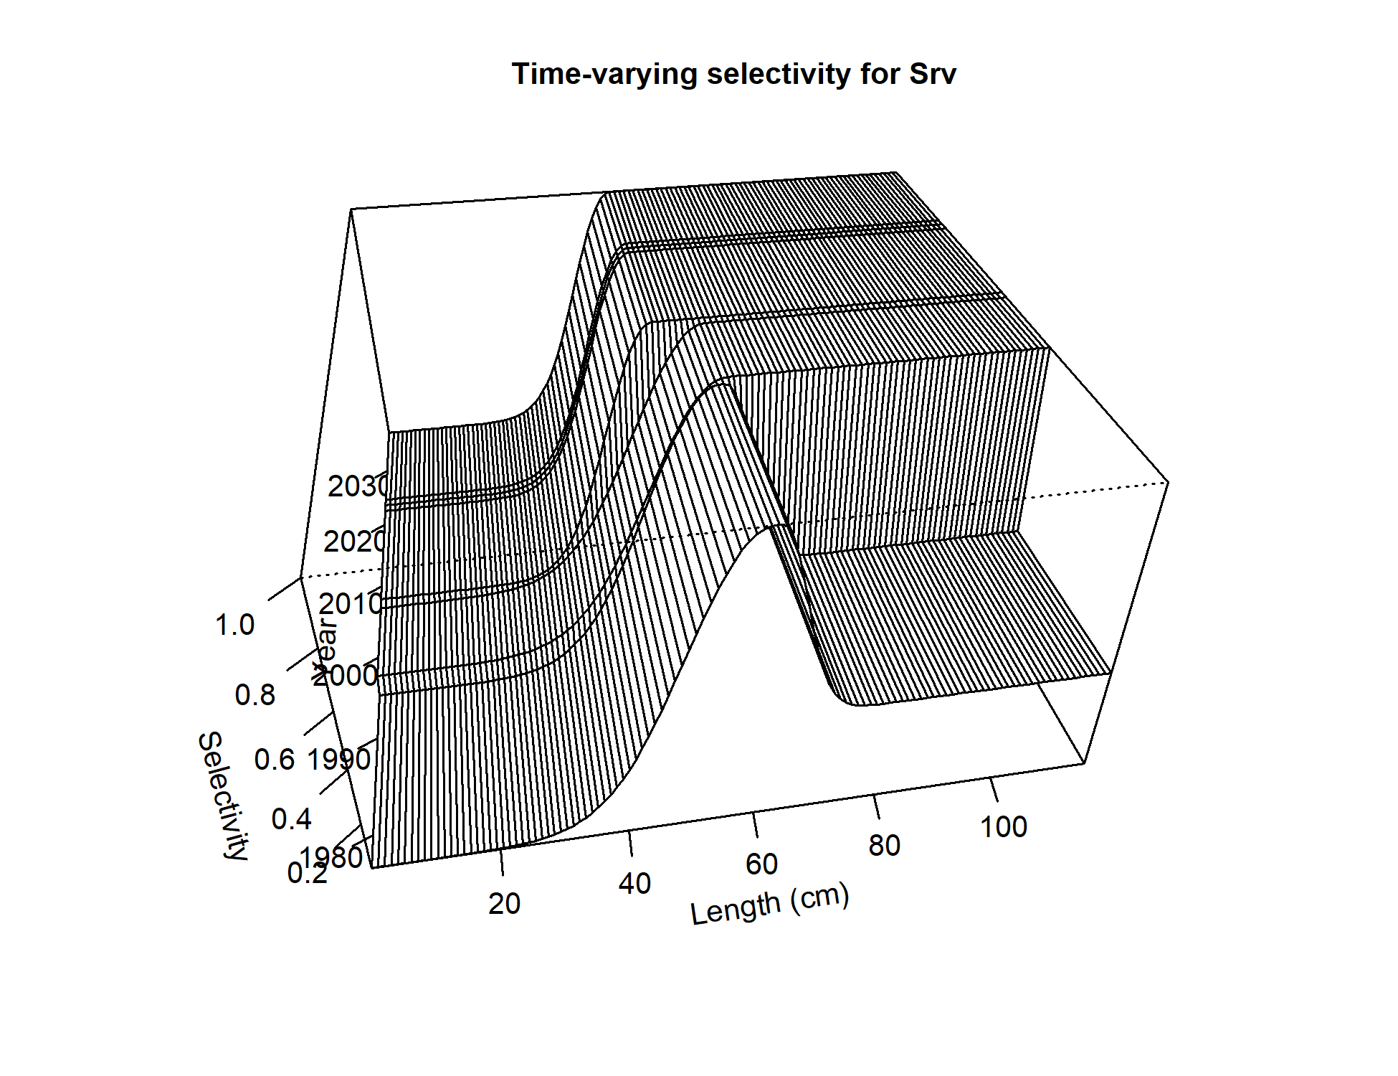 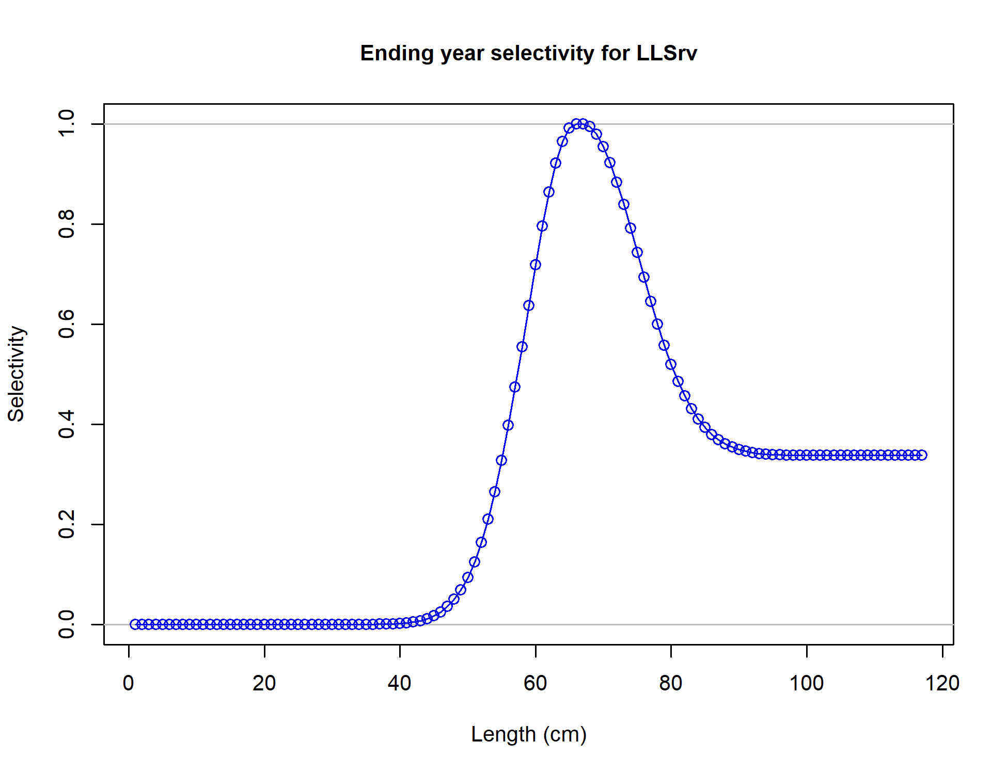

Figure 2.58 Selectivity curves for Model 19.1 Trawl fishery (FshTrawl), longline fishery (FshLL), pot fishery (FshPot), NMFS bottom trawl survey (Srv), and AFSC Longline survey (LLSrv) length composition data.

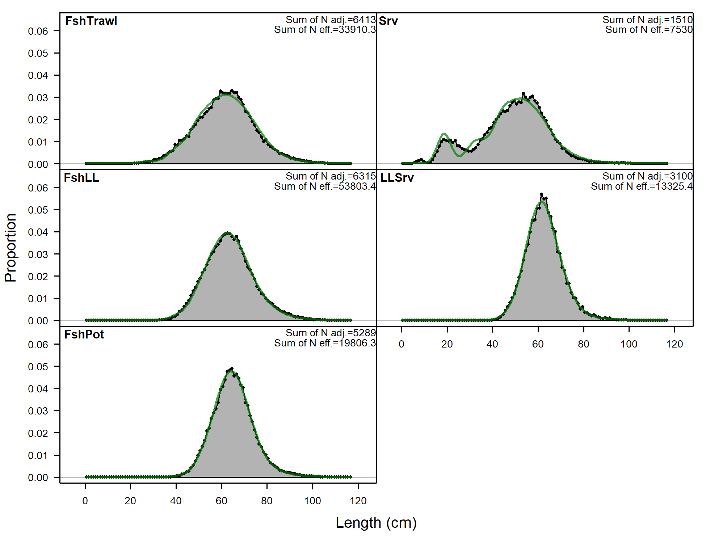

Figure 2.59 Overall Model 19.1 fits to Trawl fishery (FshTrawl), longline fishery (FshLL), pot fishery (FshPot), NMFS bottom trawl survey (Srv), and AFSC Longline survey (LLSrv) length composition data.

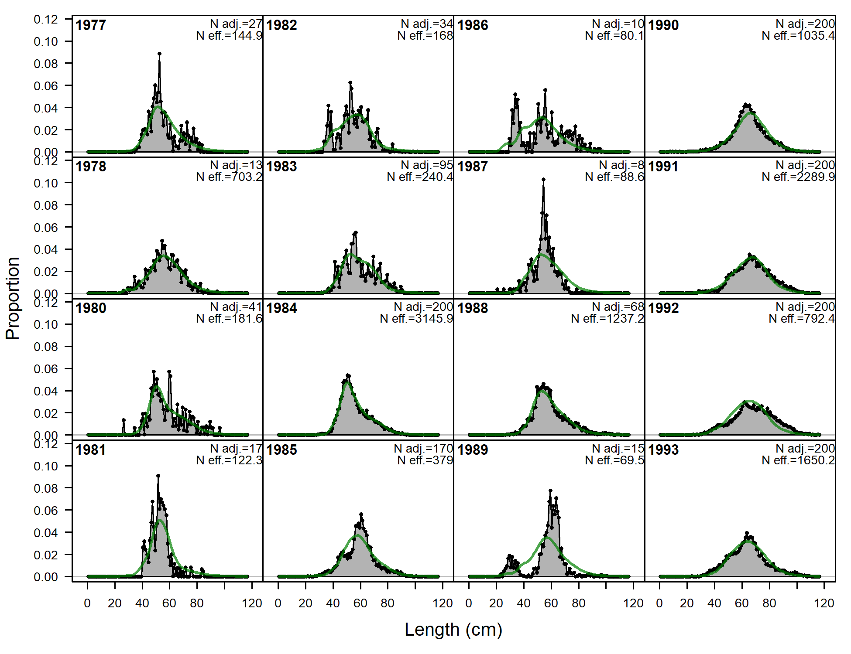 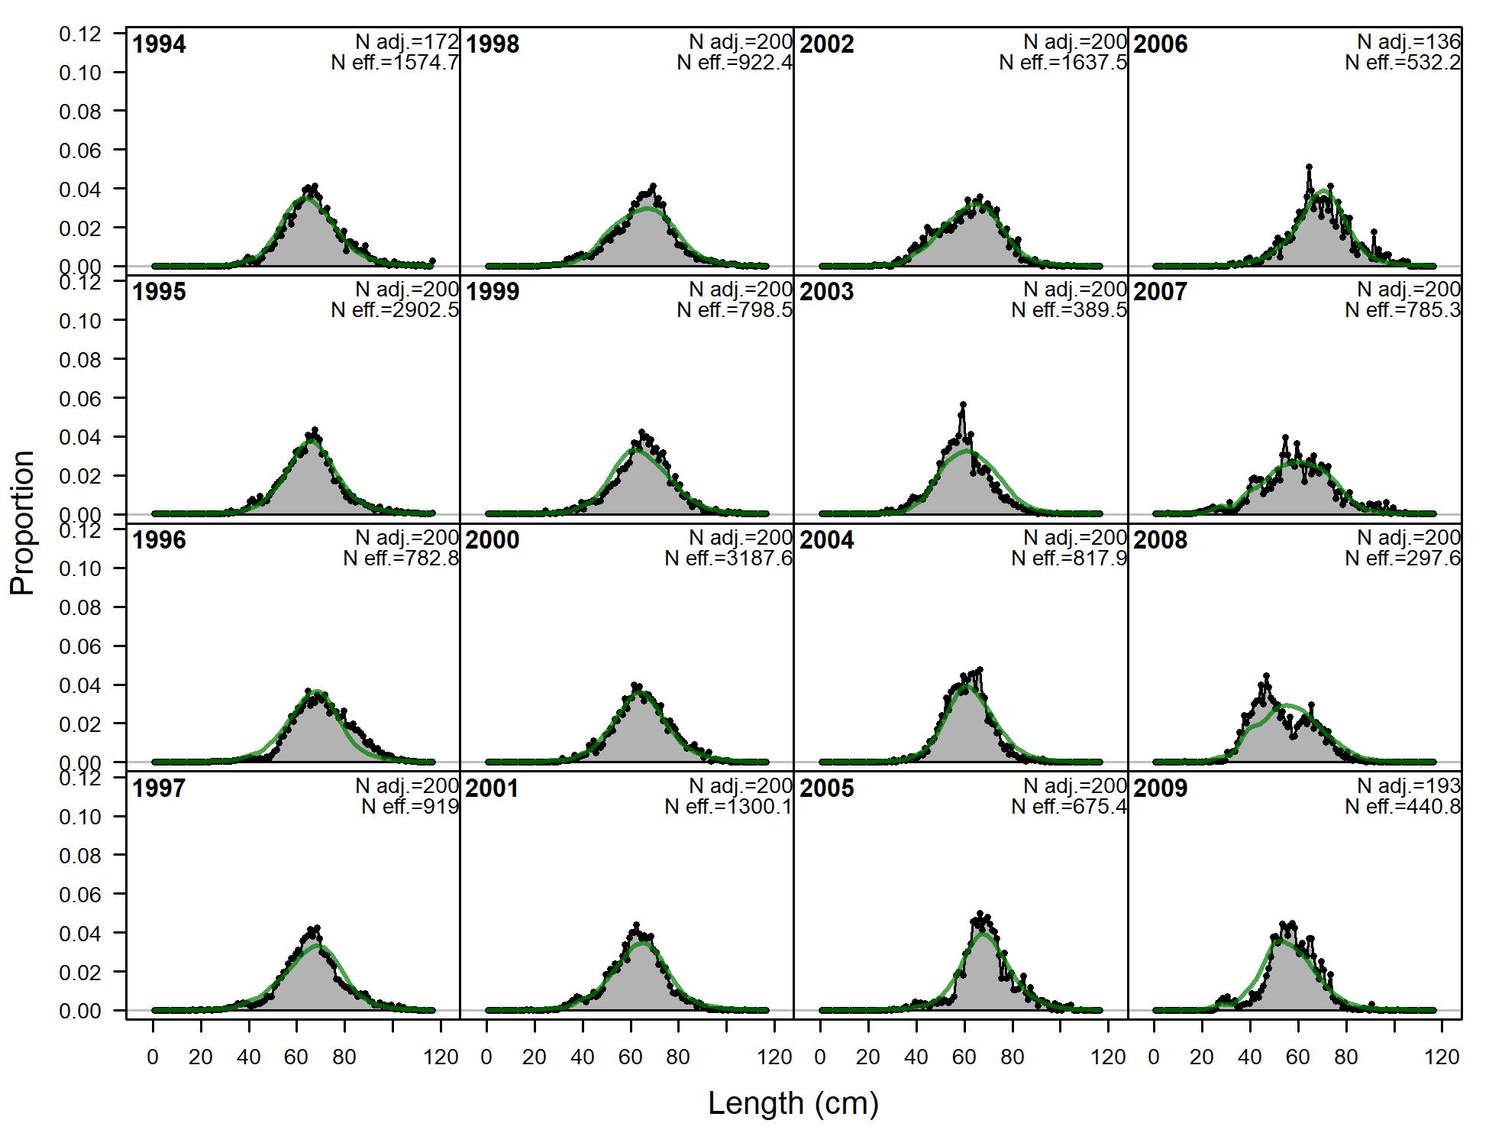 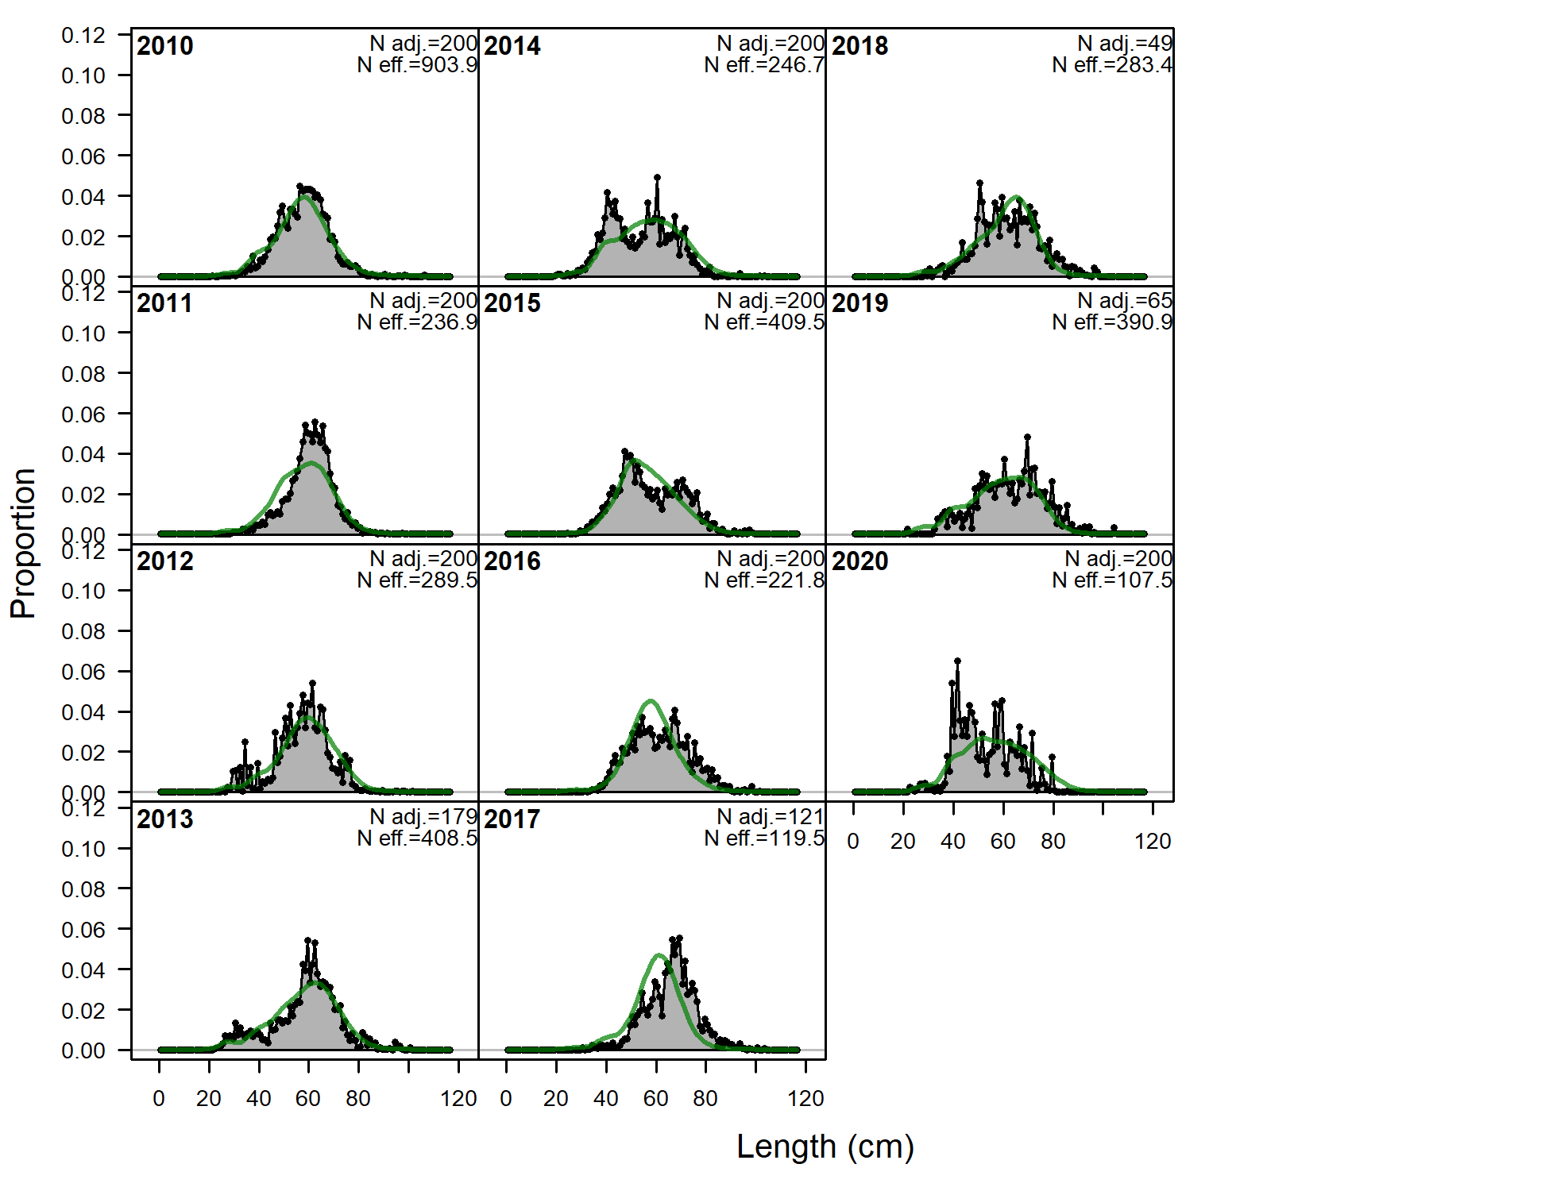 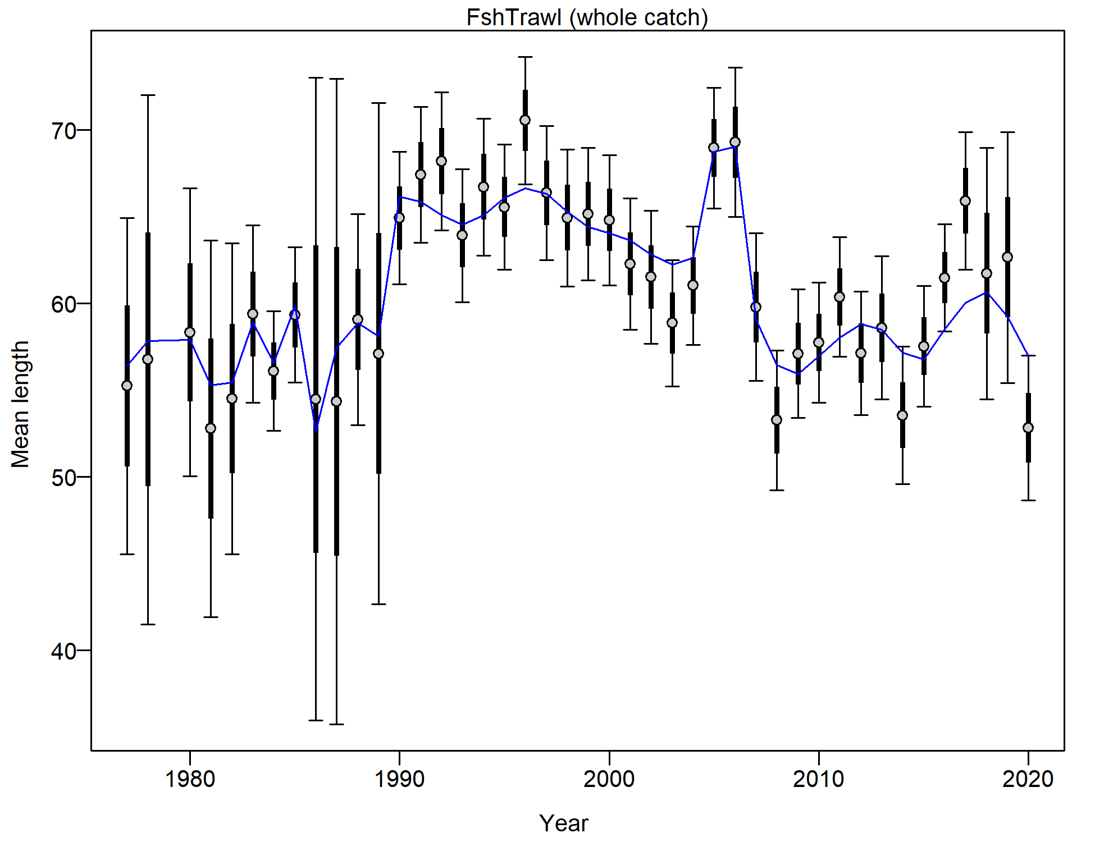

Figure 2.60 Trawl fishery length composition and Model 19.1 fit (top and left) and mean length (cm; right bottom).

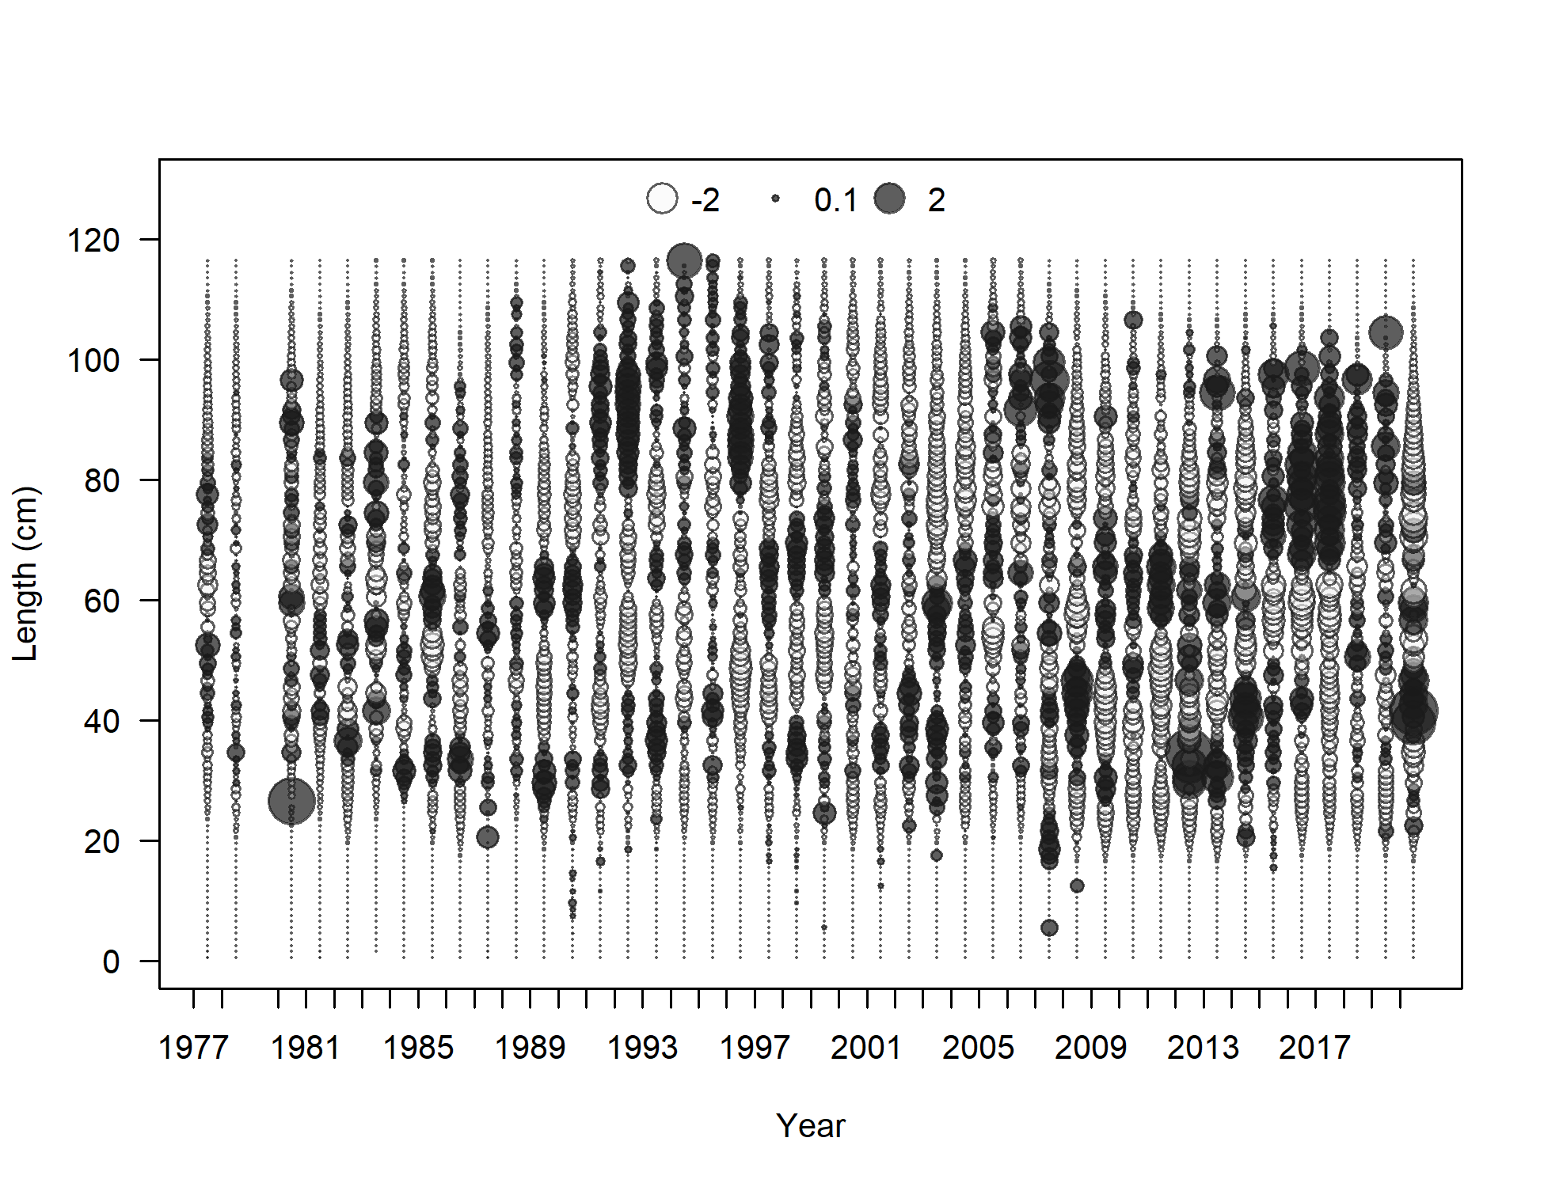

Figure 2.61 Trawl fishery length composition Pearson residuals (max = 8.01) for Model 19.1.

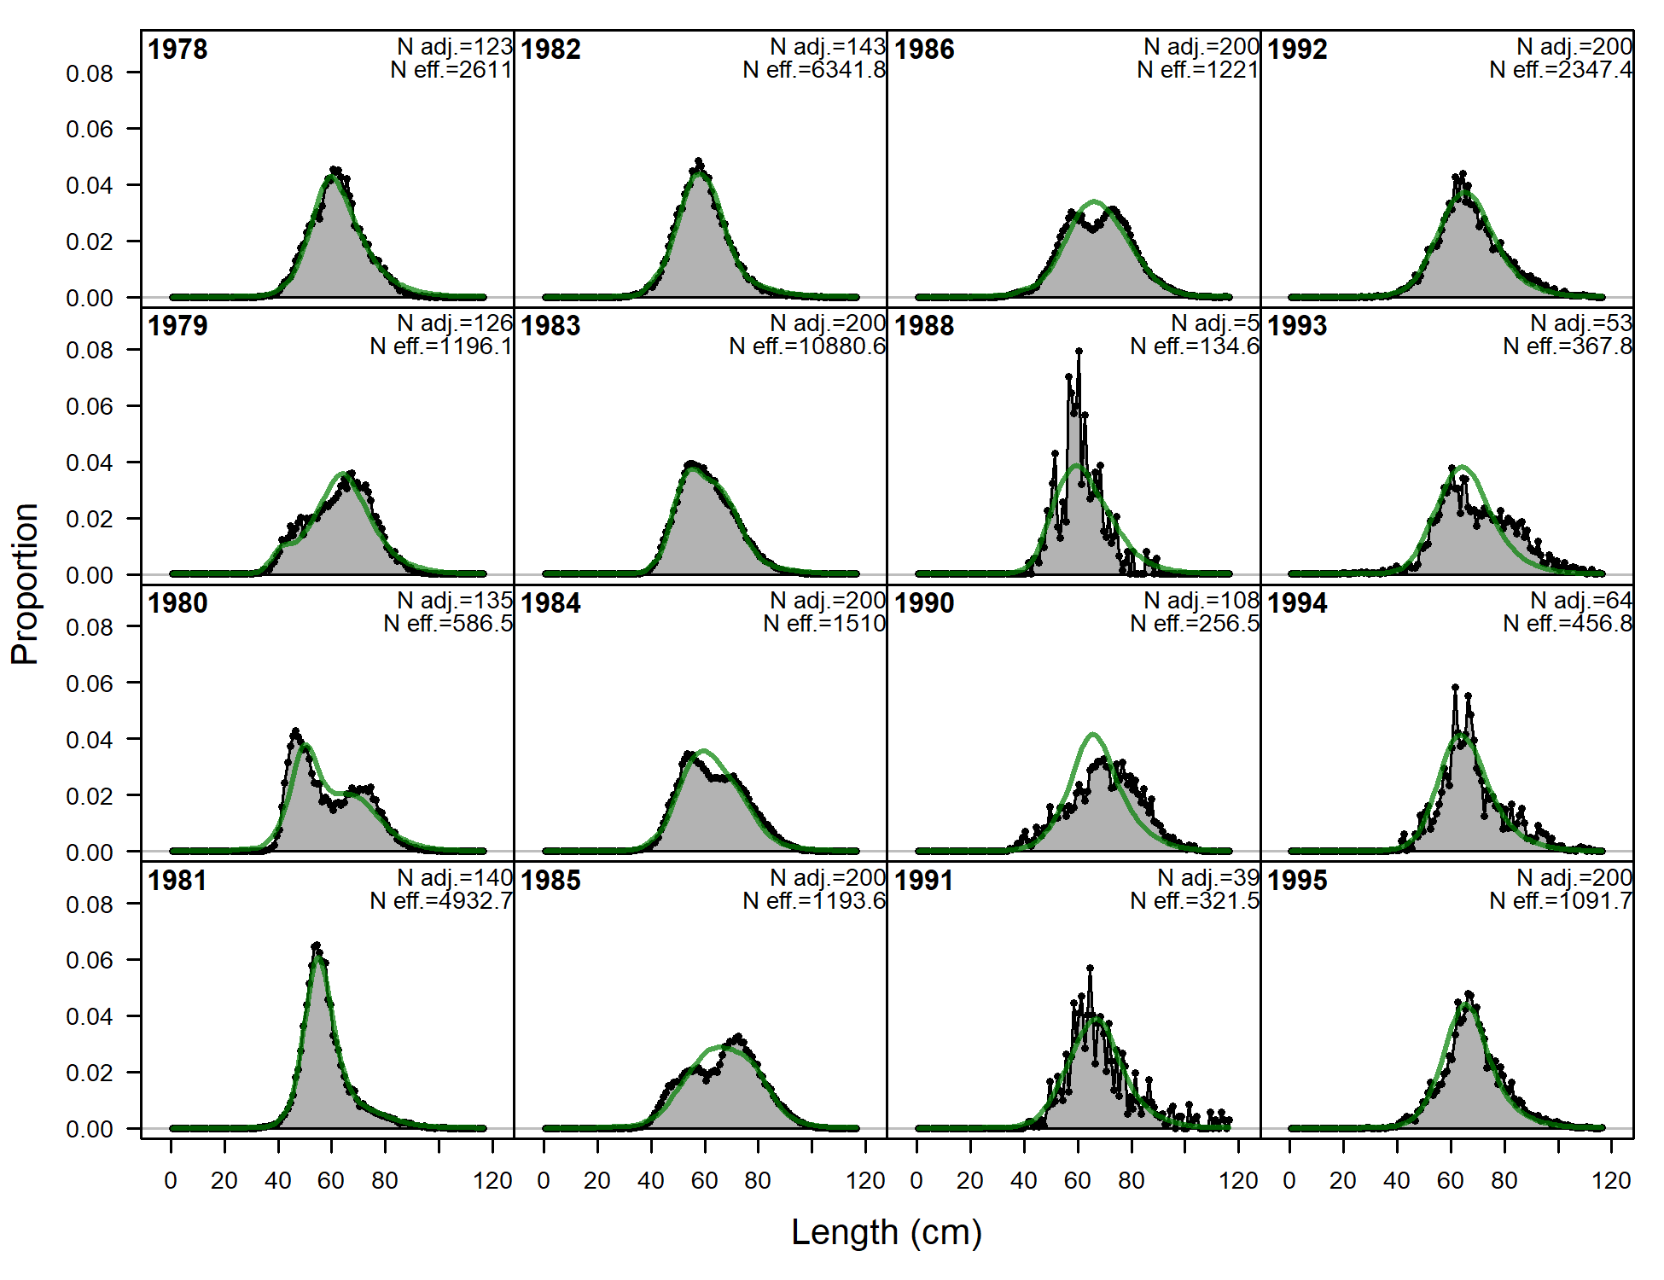 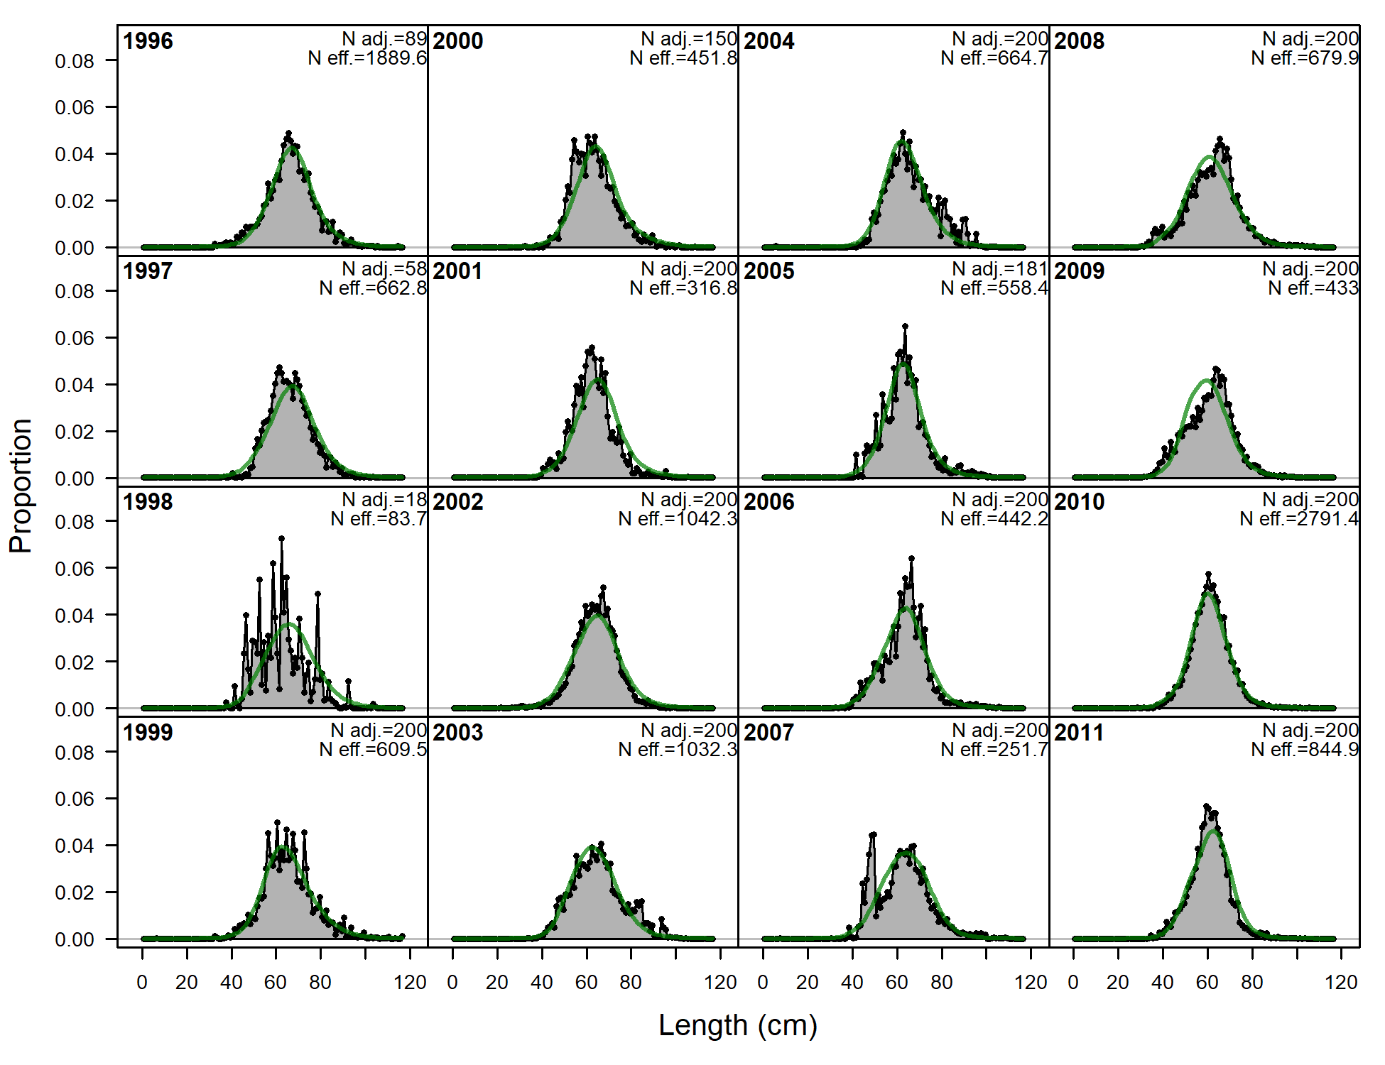 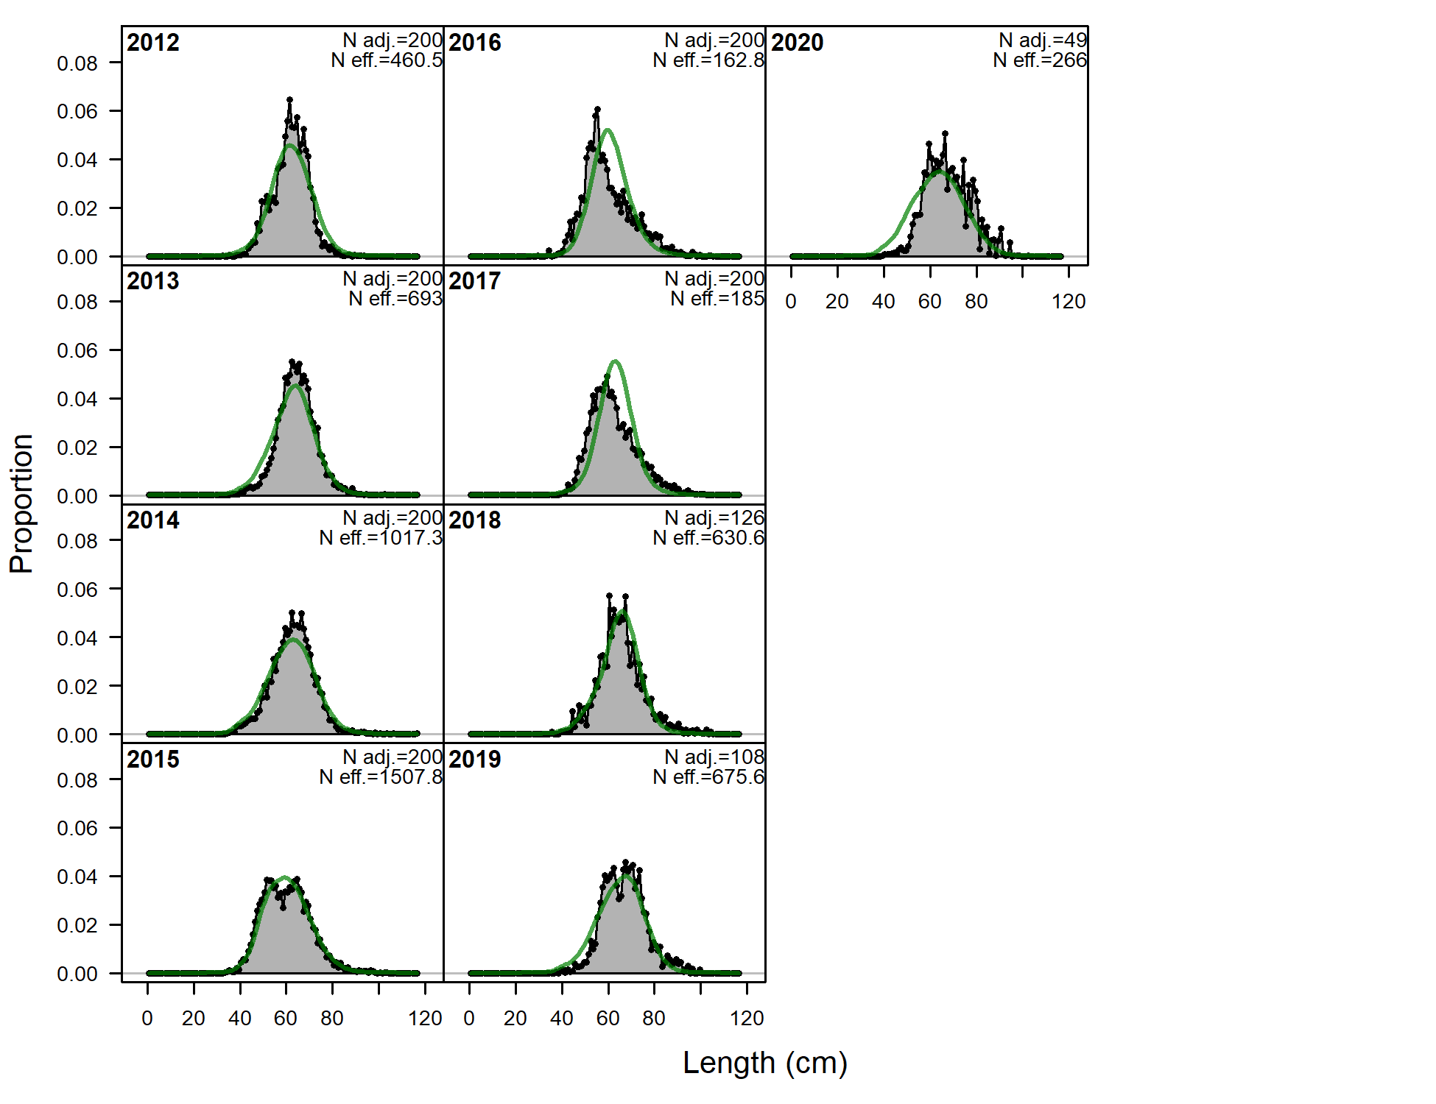 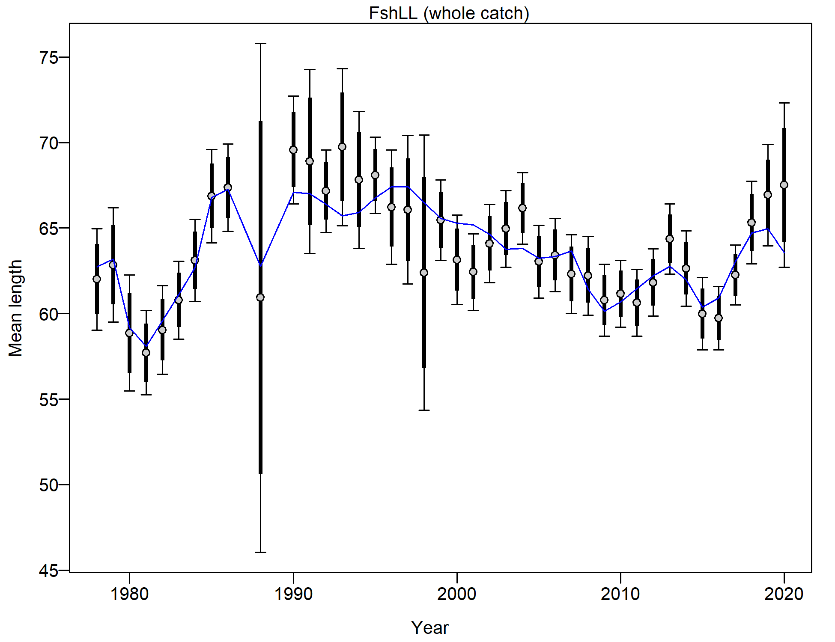

Figure 2.62 Longline fishery length composition and Model 19.1 fit (top and left) and mean length (cm; right bottom).

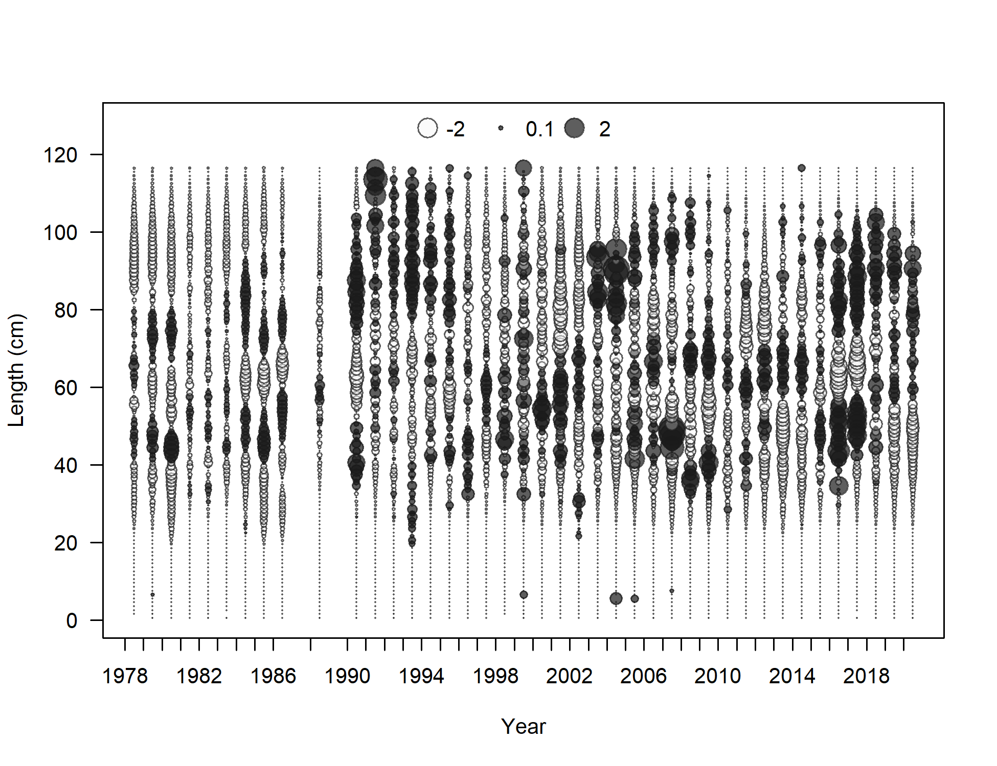

Figure 2.63 Longline fishery length composition and Model 19.1 fit (top and left) and Pearson residuals.

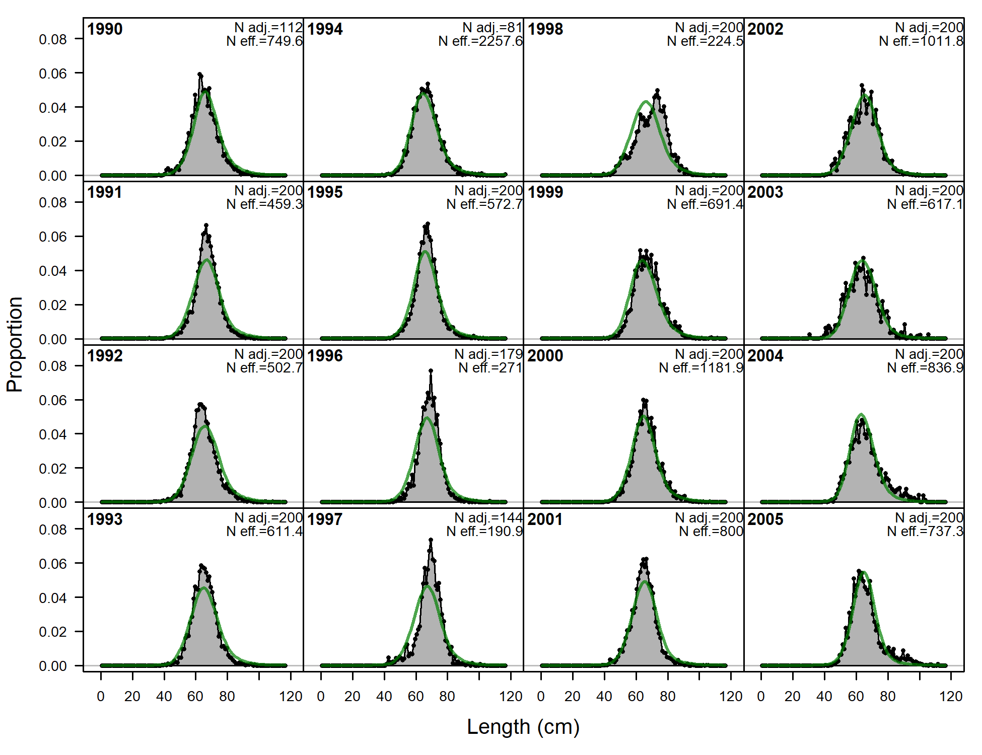 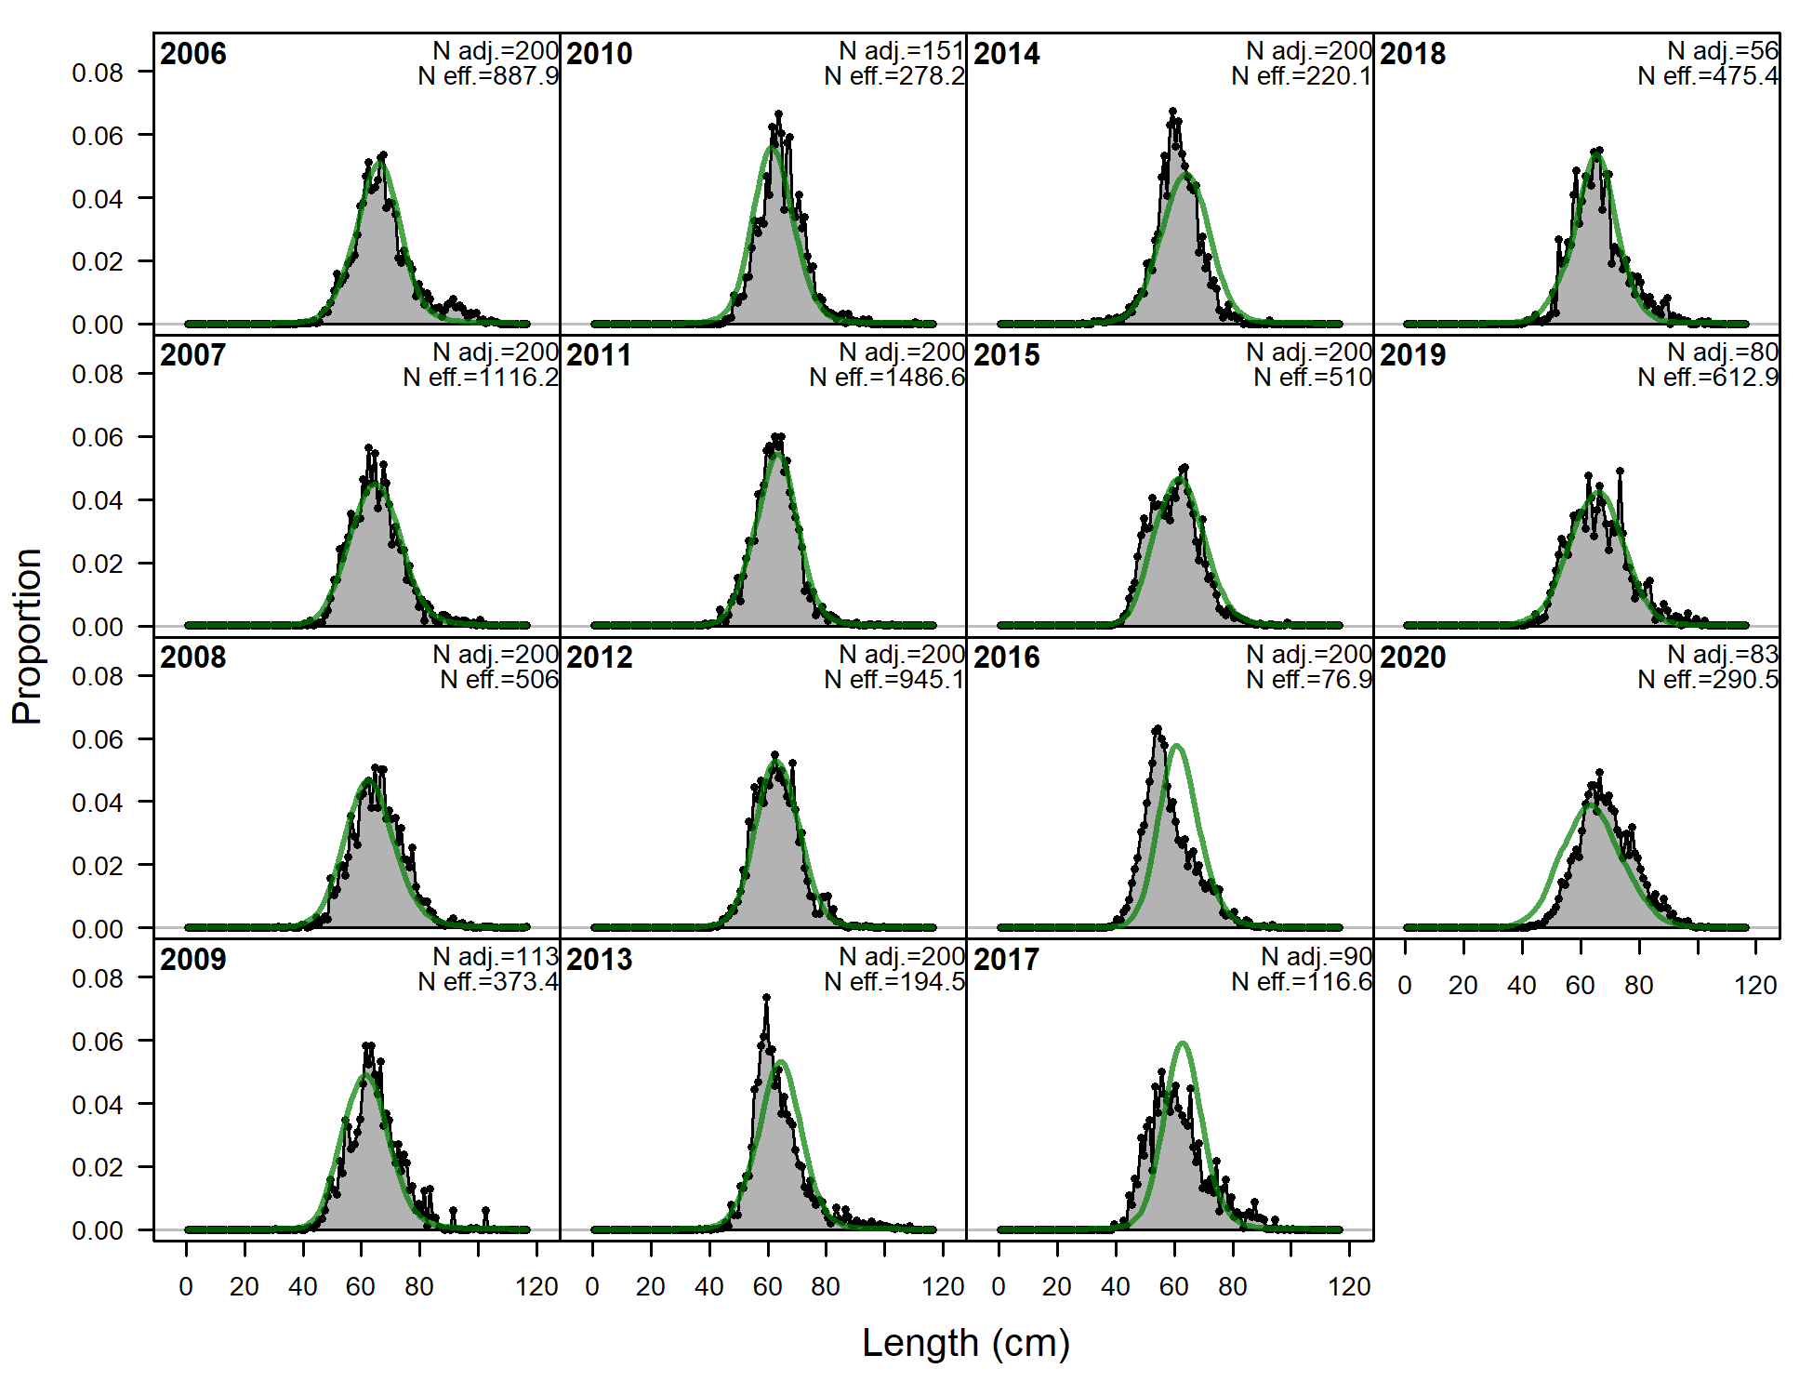 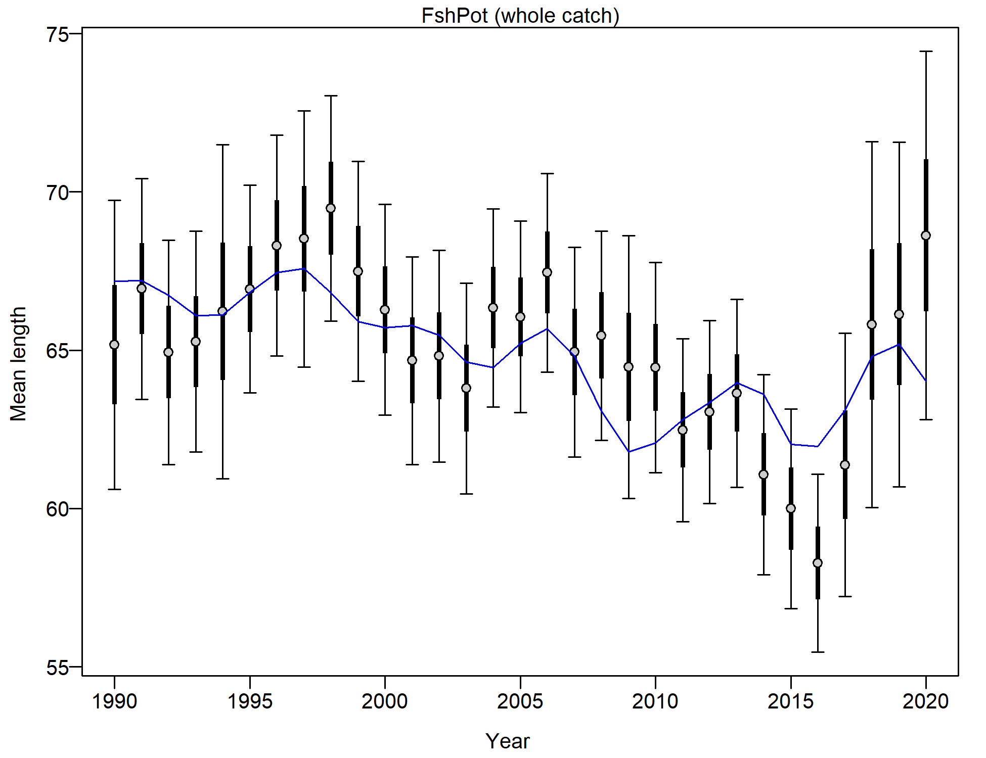 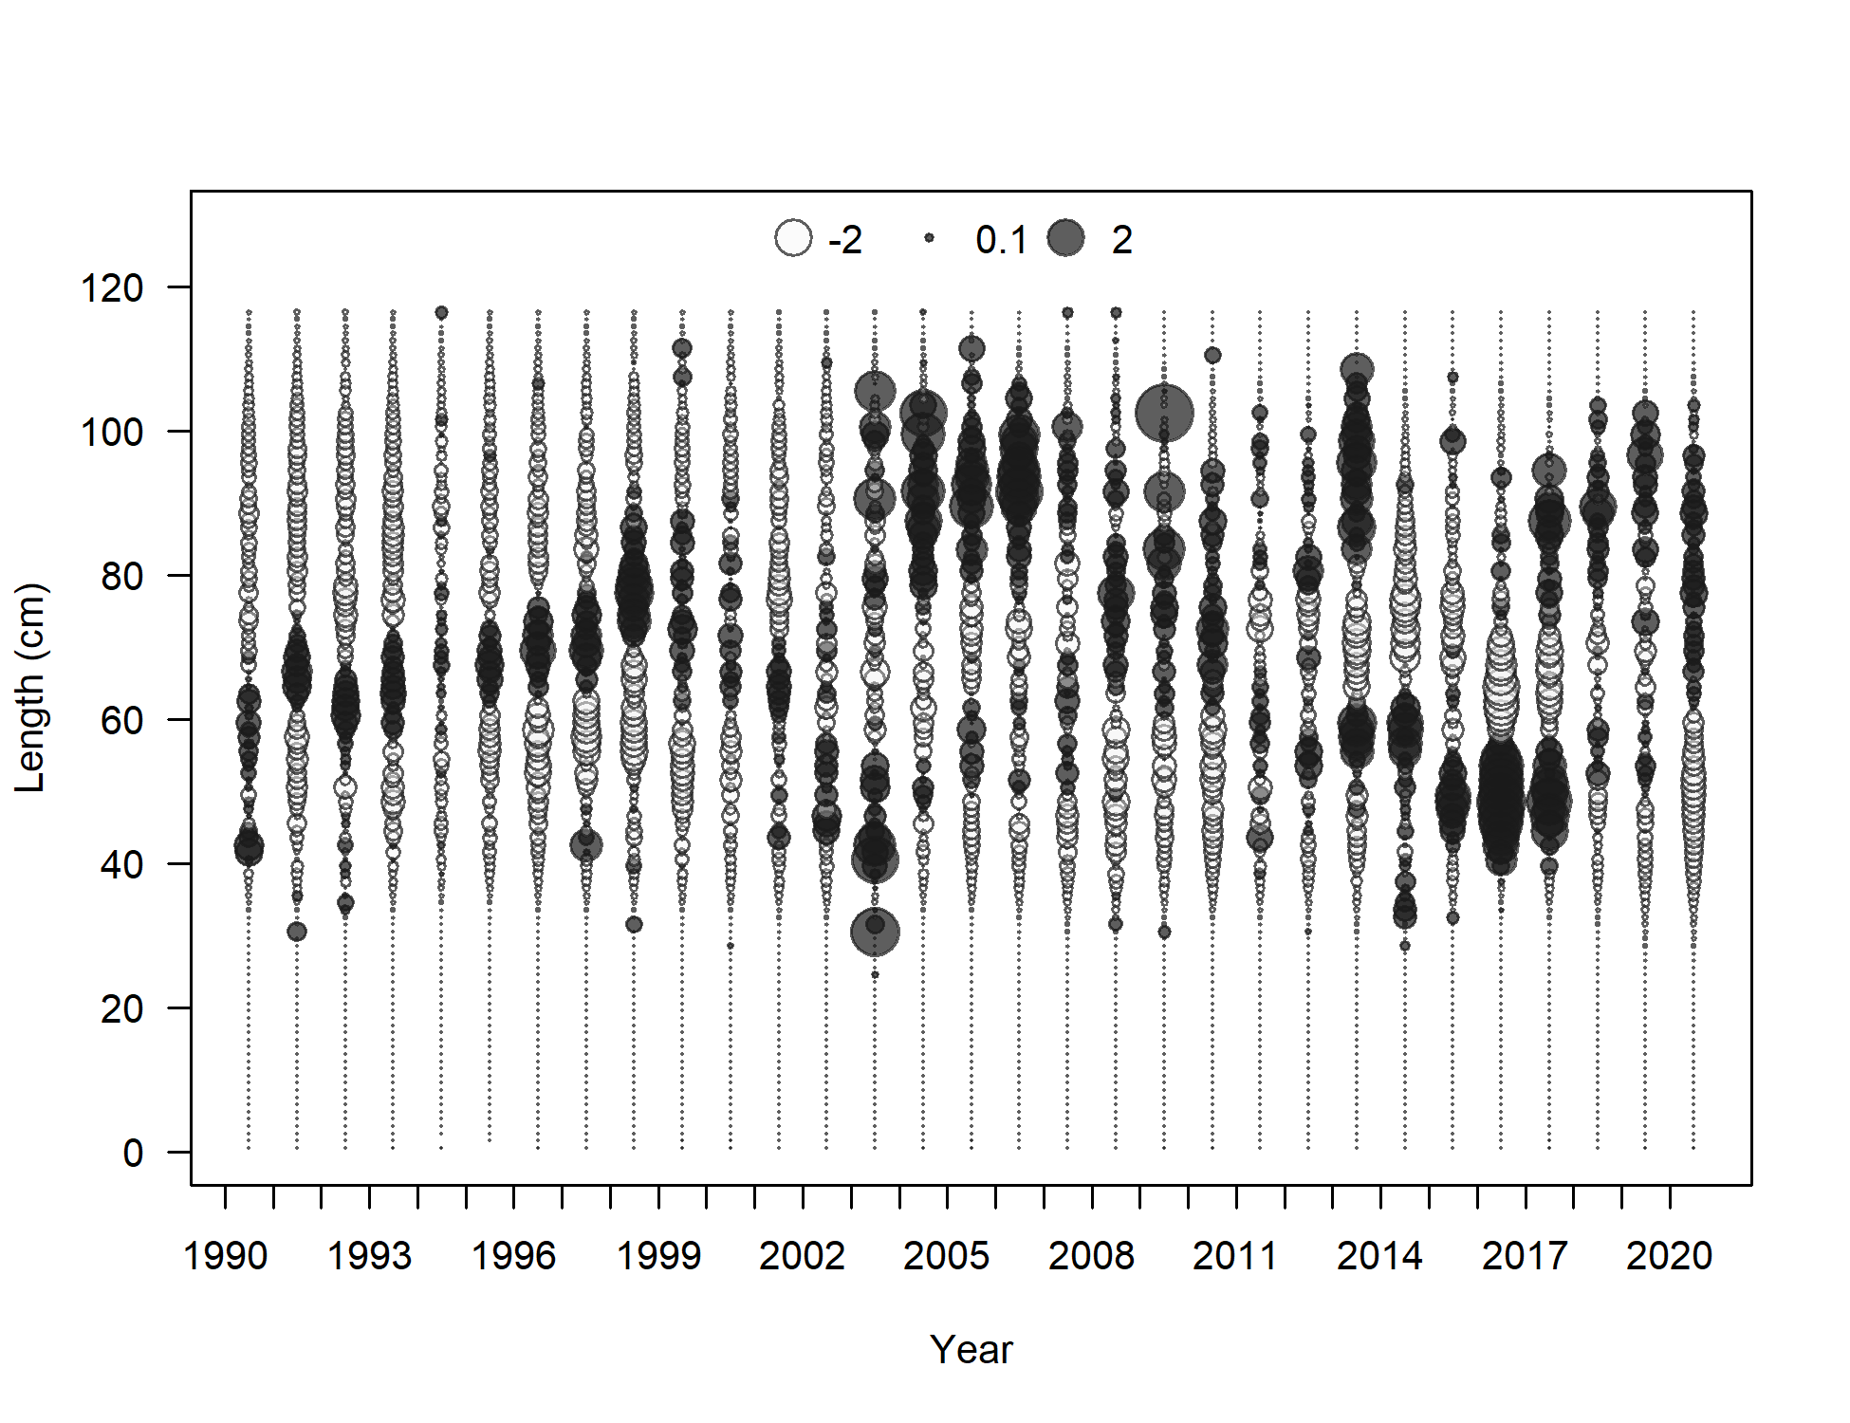

Figure 2.64 Pot fishery length composition and Model 19.1 fit (top), mean length (bottom left), and Pearson residuals (max=4.61; bottom right).

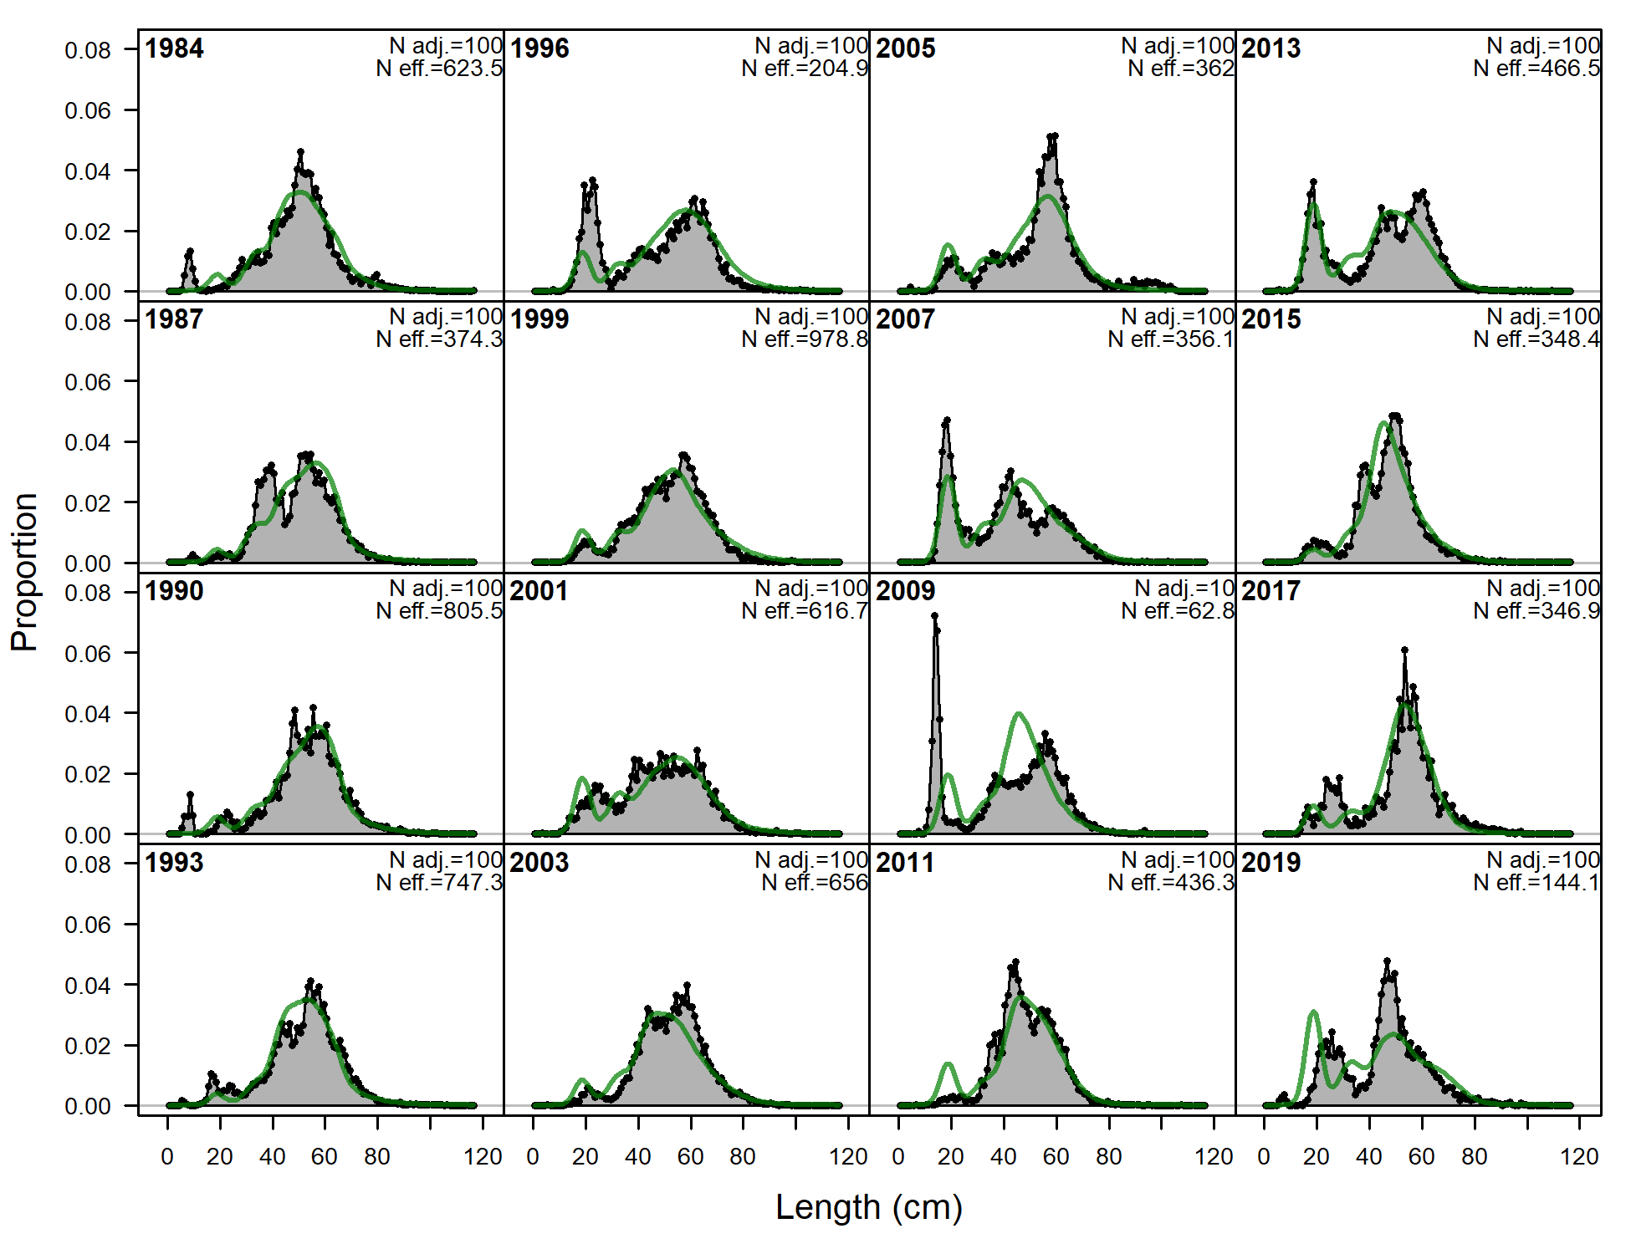

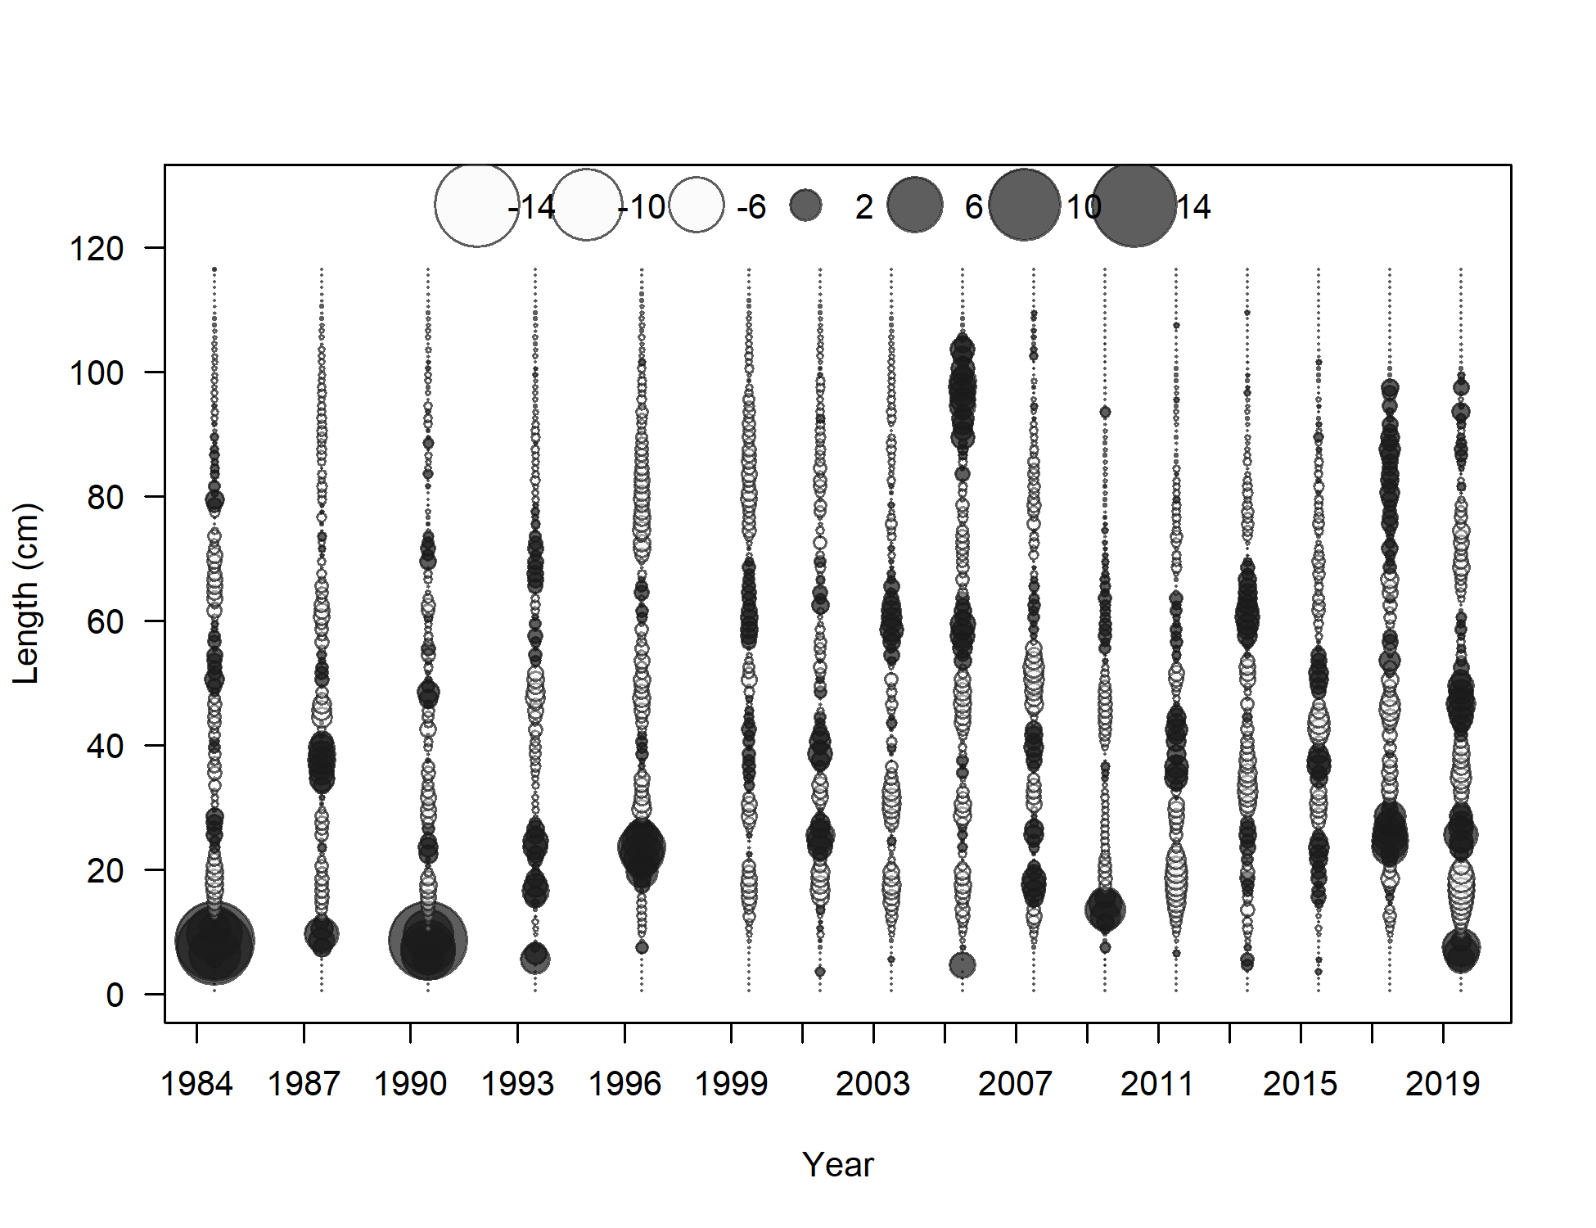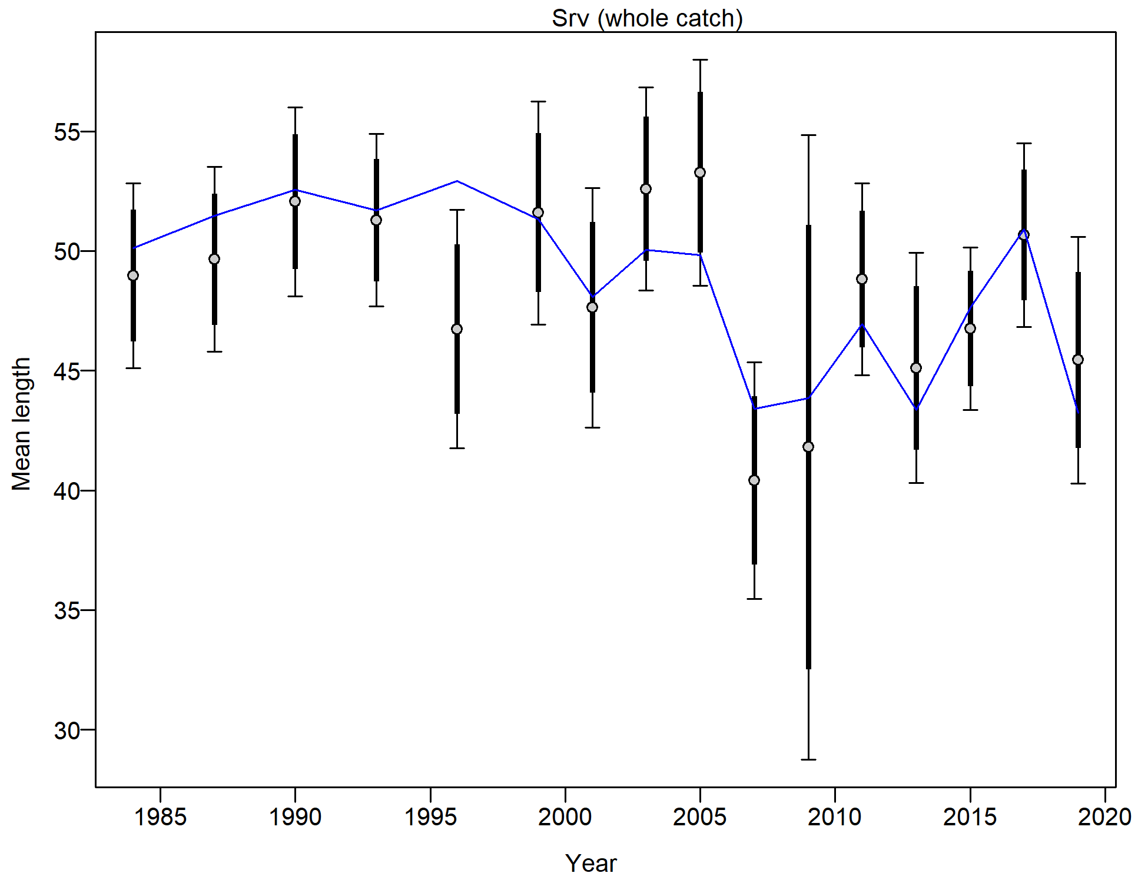

Figure 2.65 NMFS bottom trawl survey length composition and Model 19.1 fit (top), Pearson residuals (left bottom; max = 9.66), and mean length (cm; right bottom).

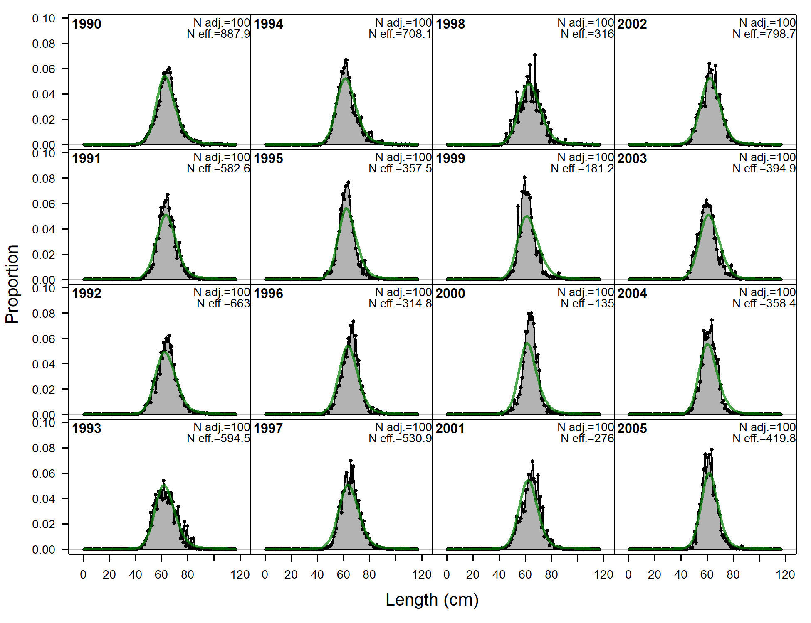 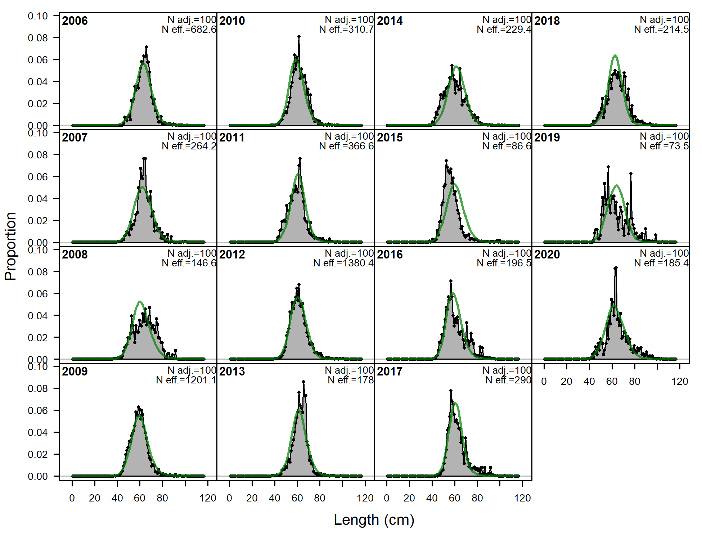

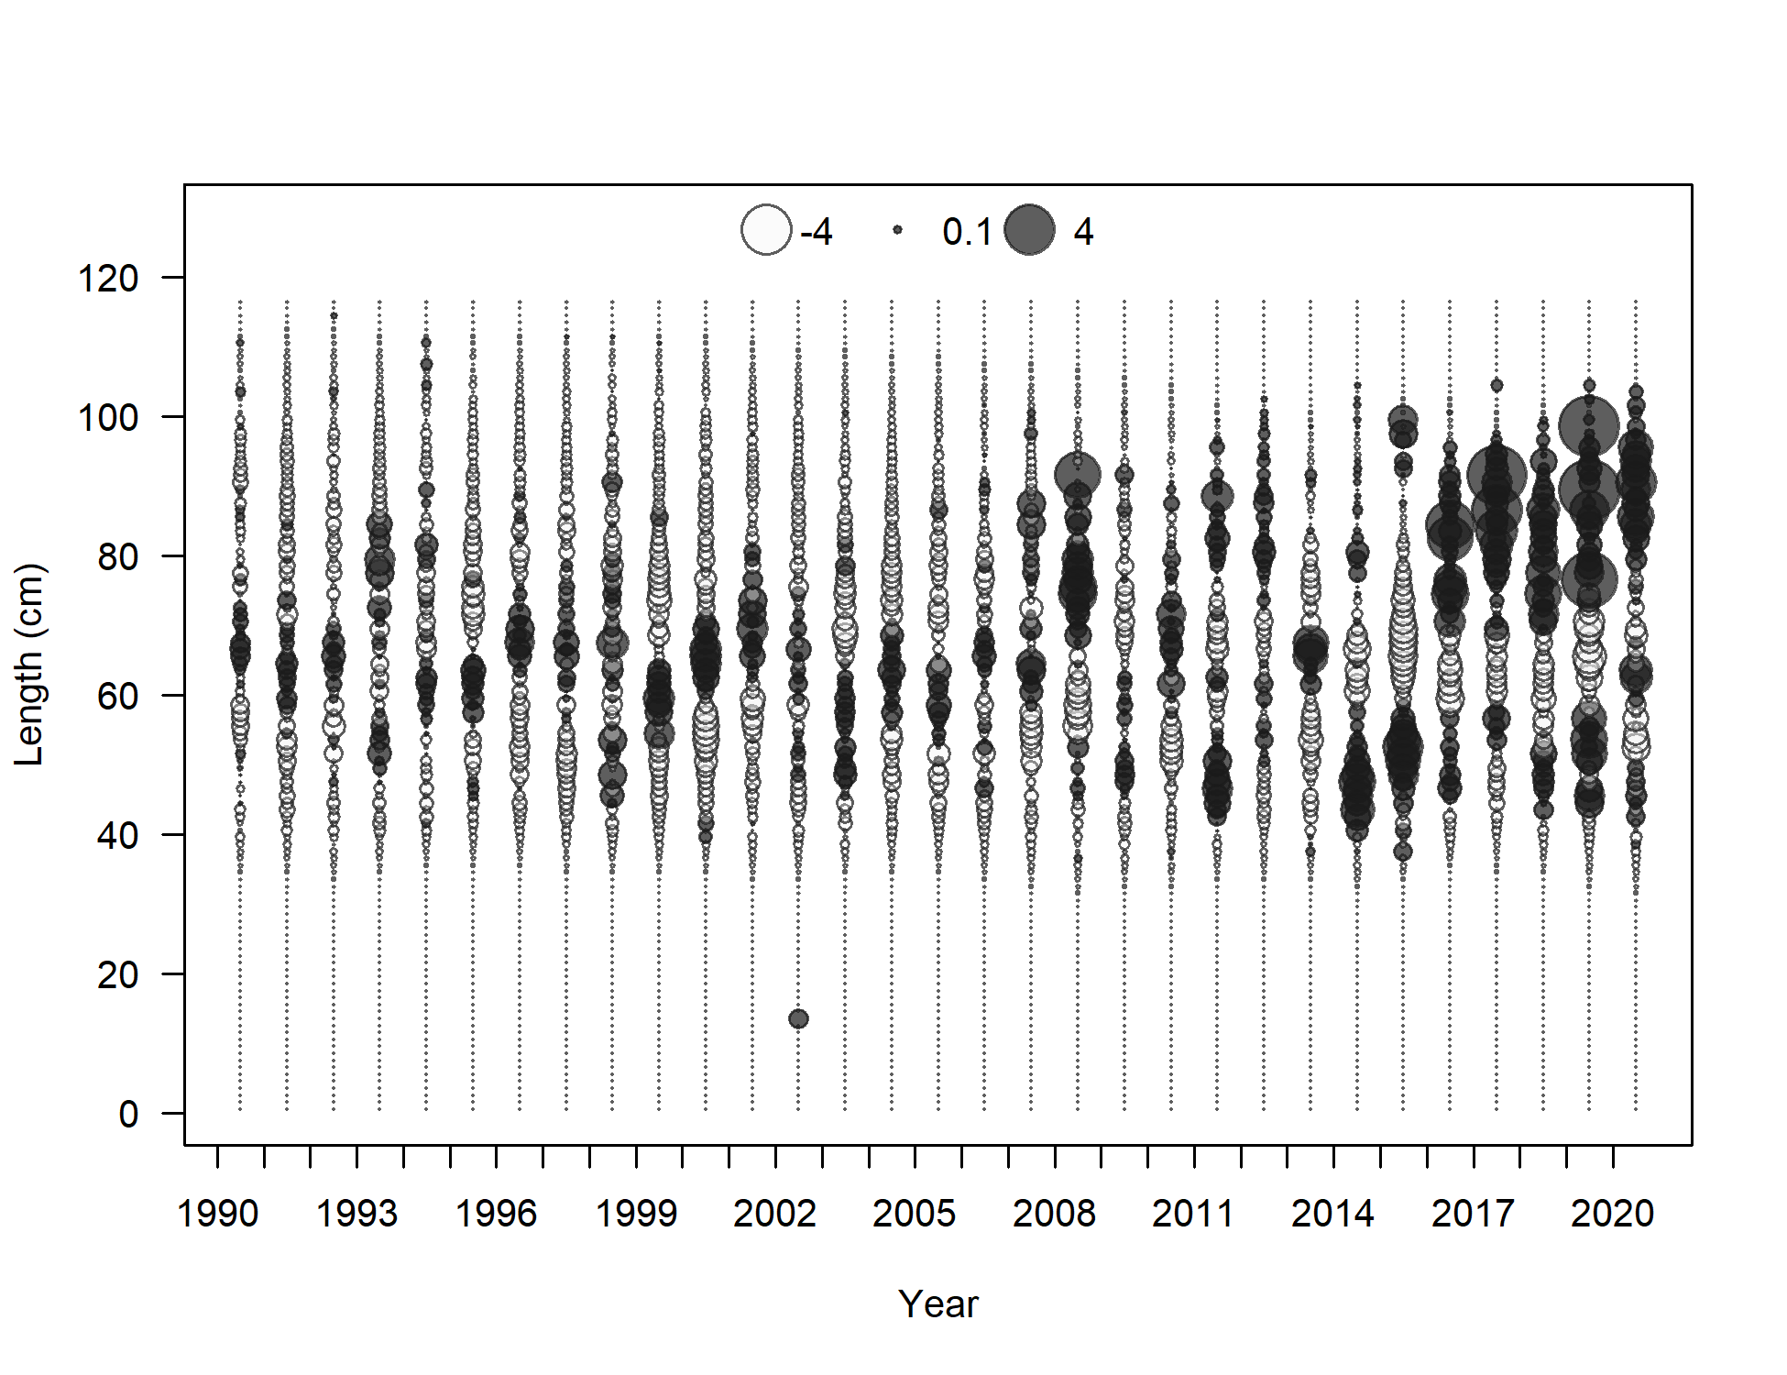 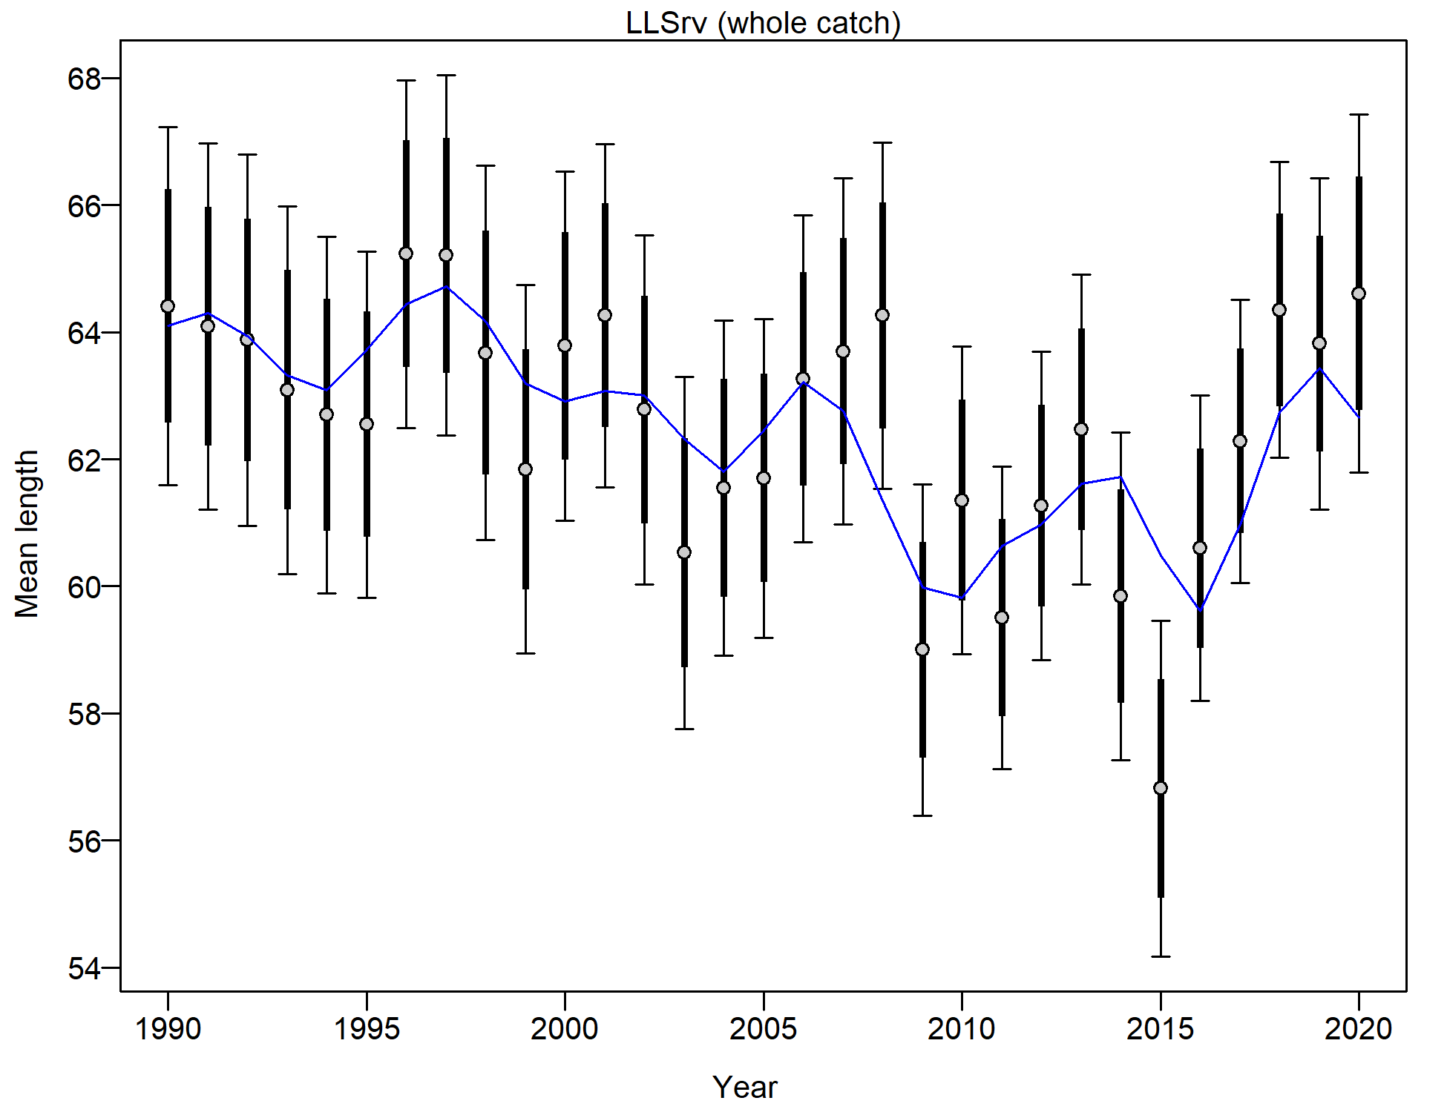

Figure 2.66 AFSC Longline survey length composition and Model 19.1 fit (top), Pearson residuals (left bottom; max=5.19), and mean length (cm; right bottom).

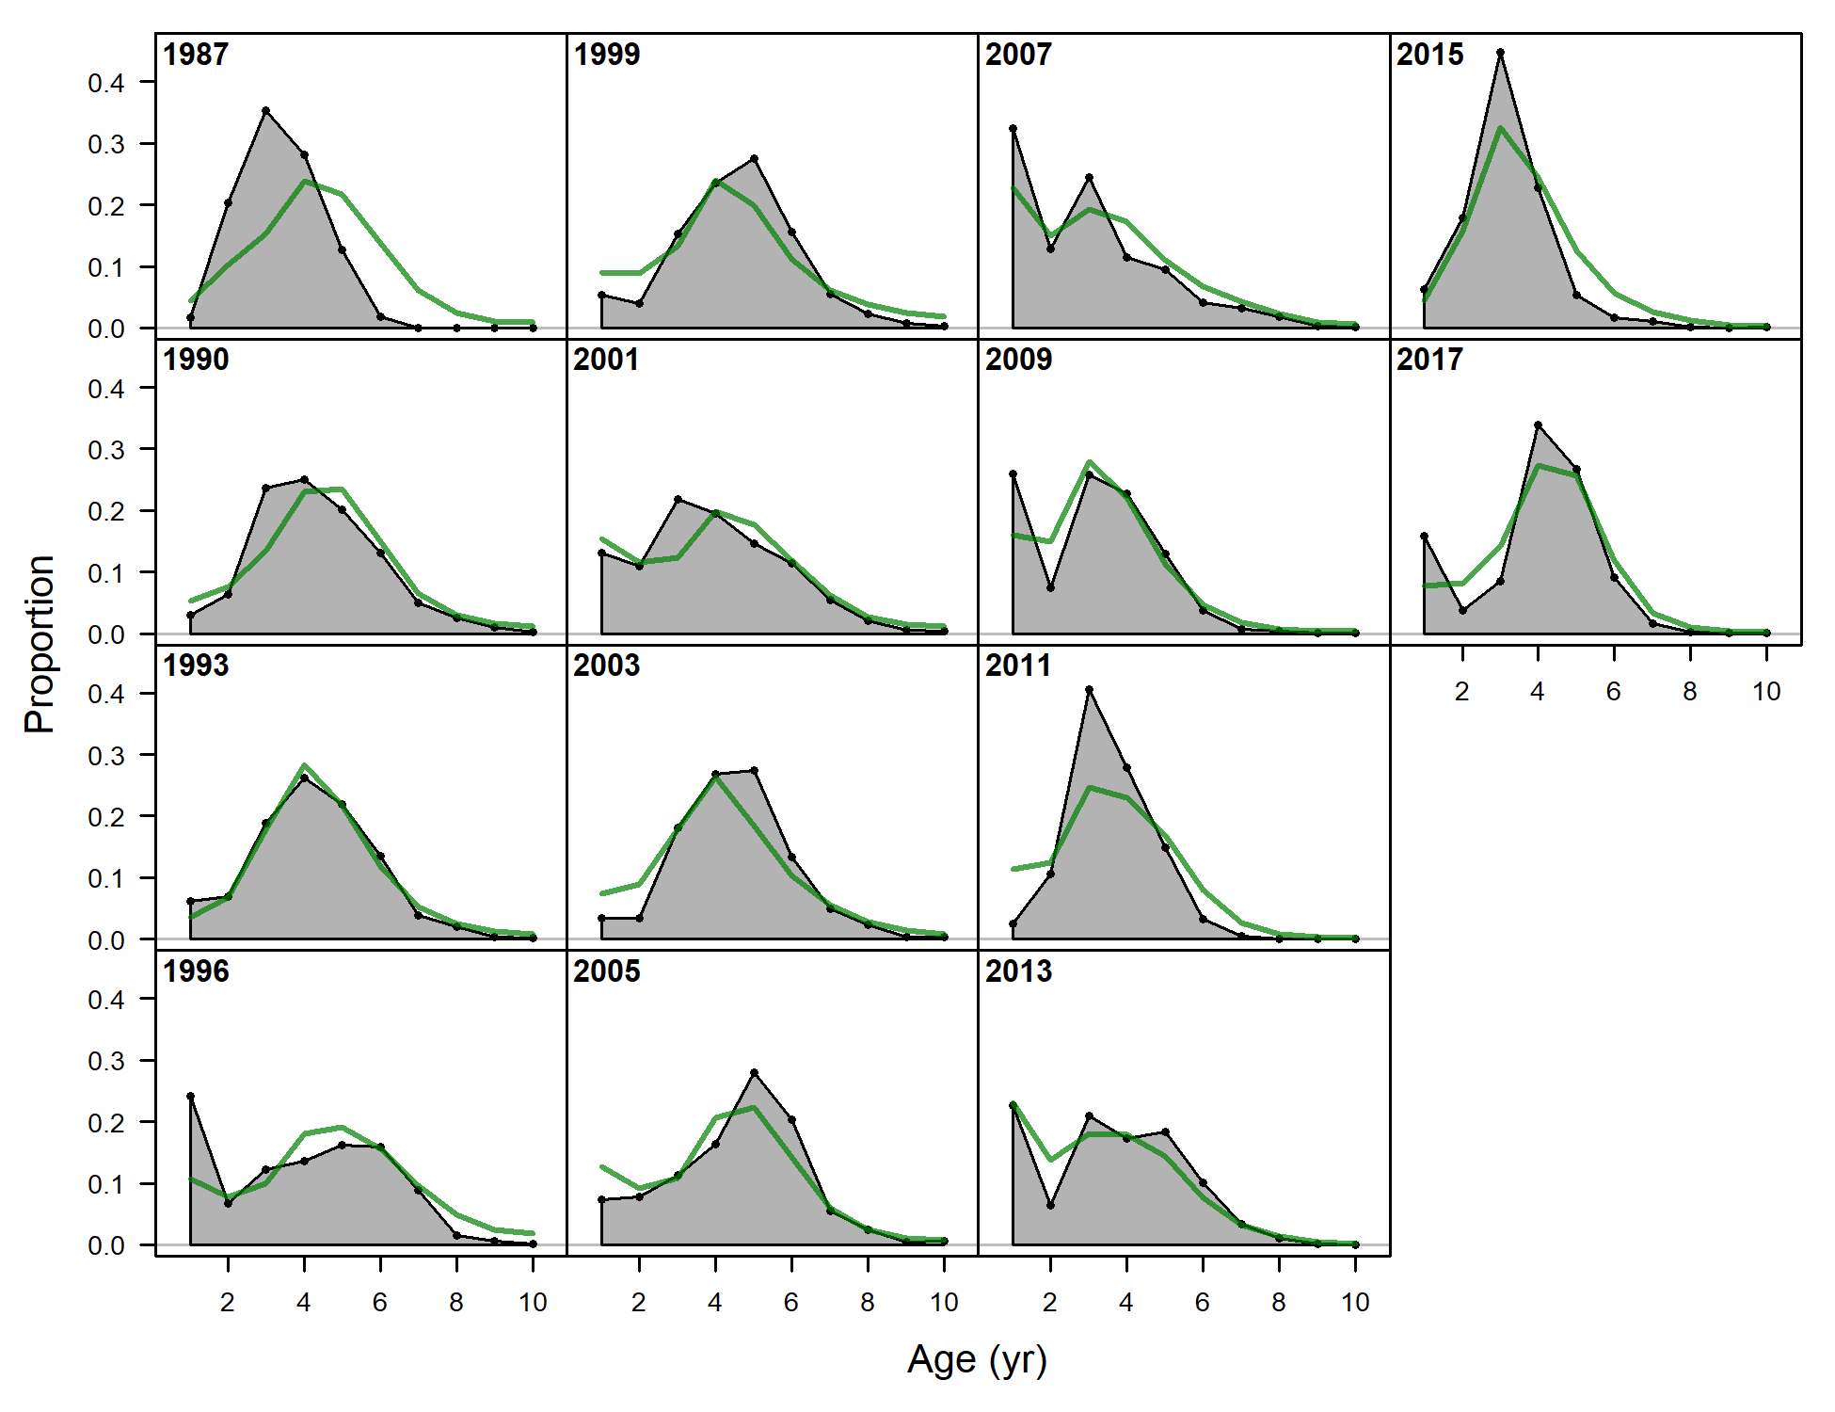

Figure 2.67 NMFS bottom trawl survey (Srv) age composition and Model 19.1 fit (left). Note the age data fits are not included in the objective function.

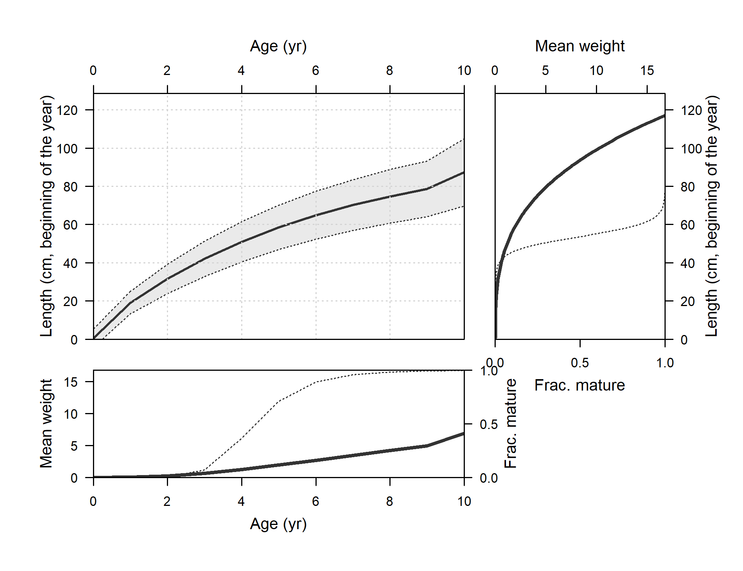

Figure 2.68 Model 19.1 length at age, weight at age, weight at length, and fraction mature at length, weight, and age.

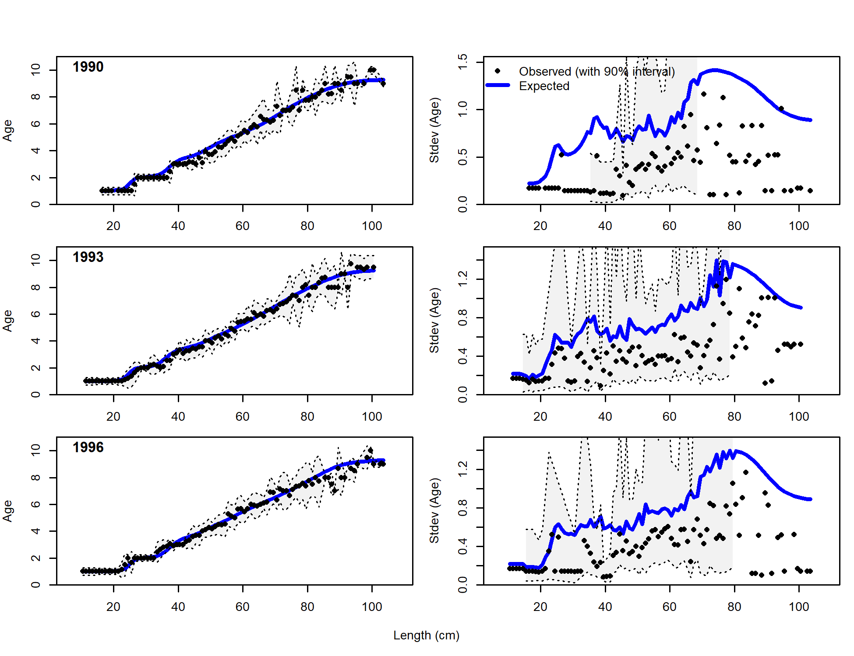 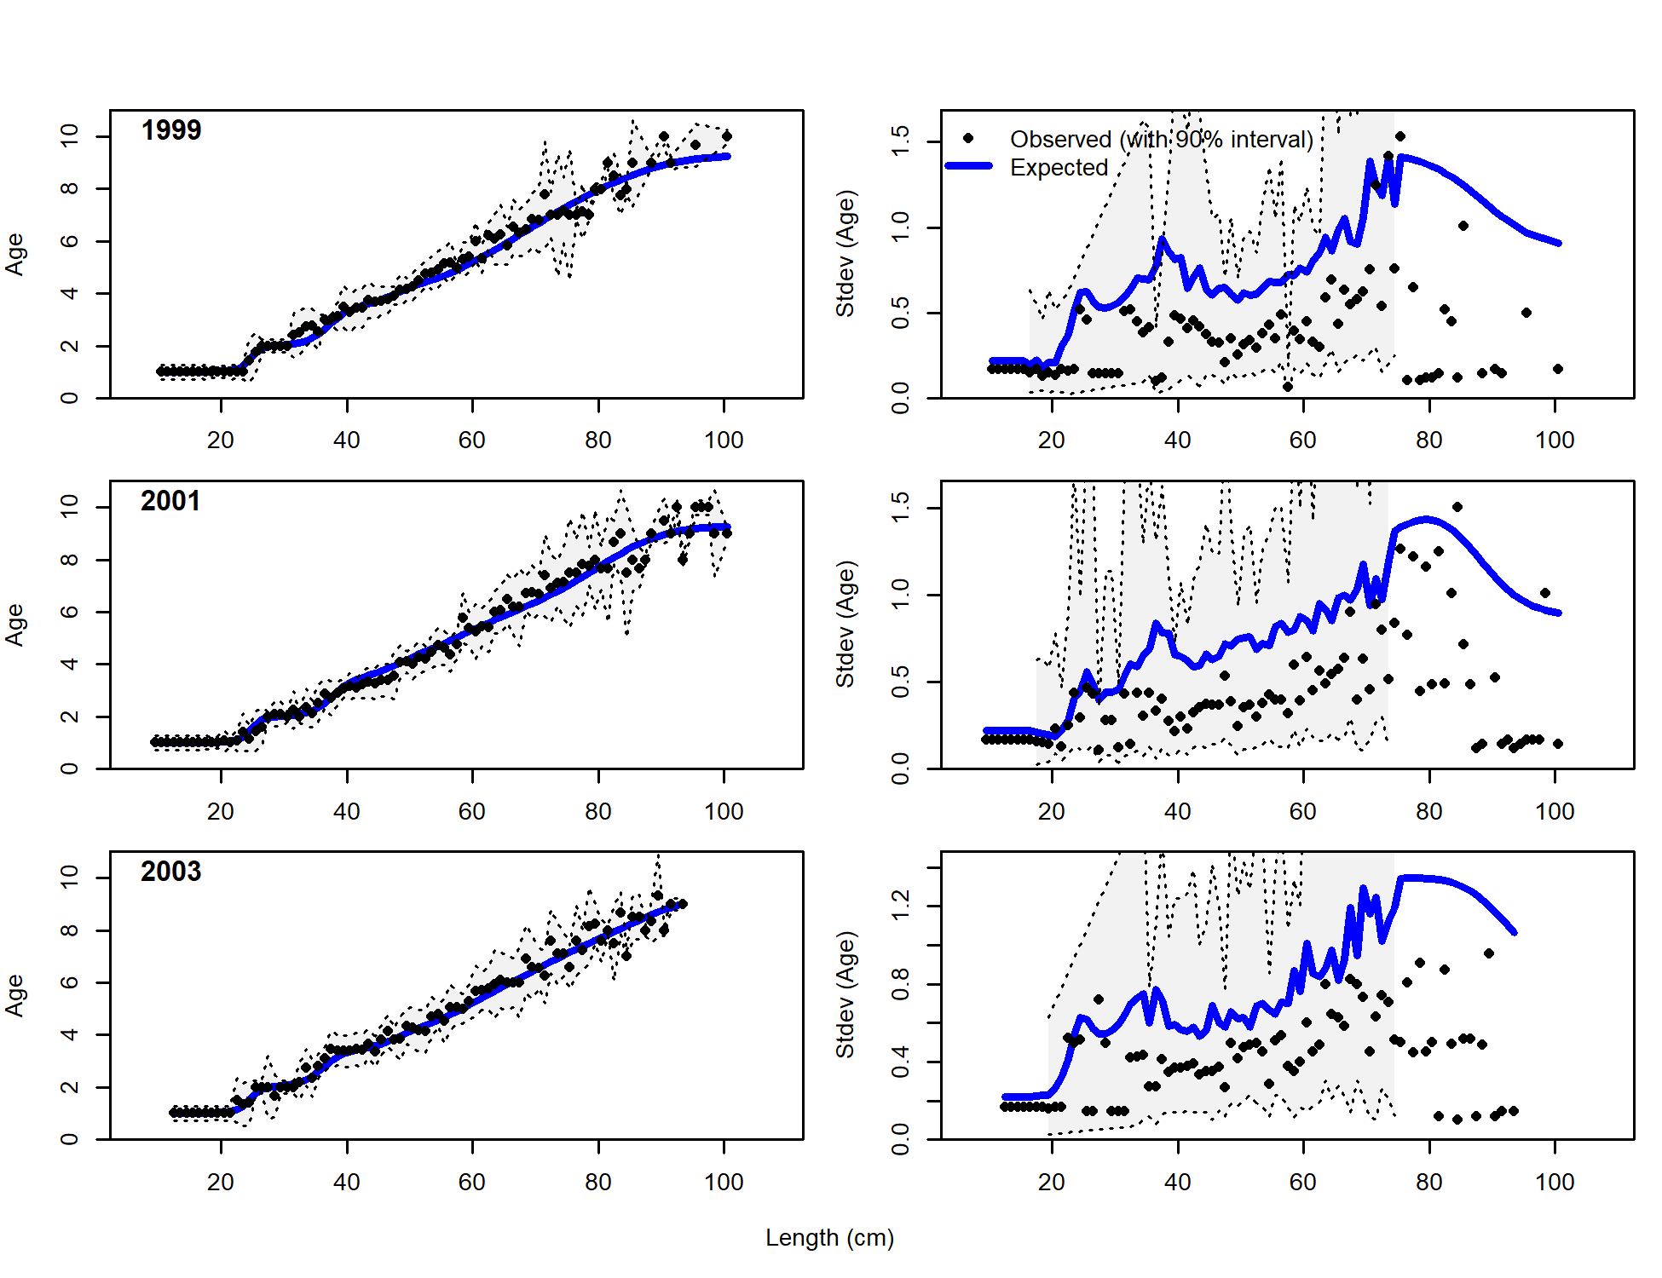 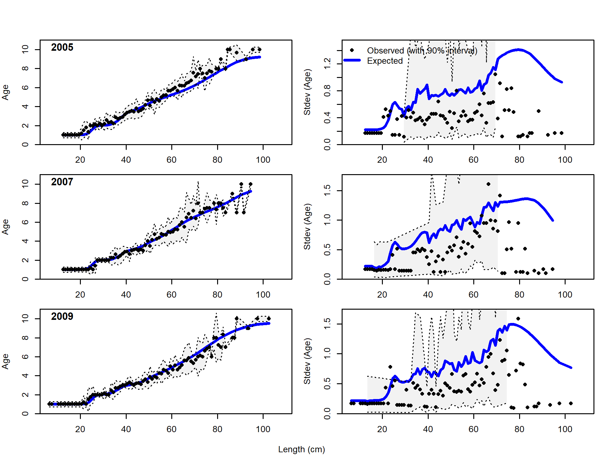 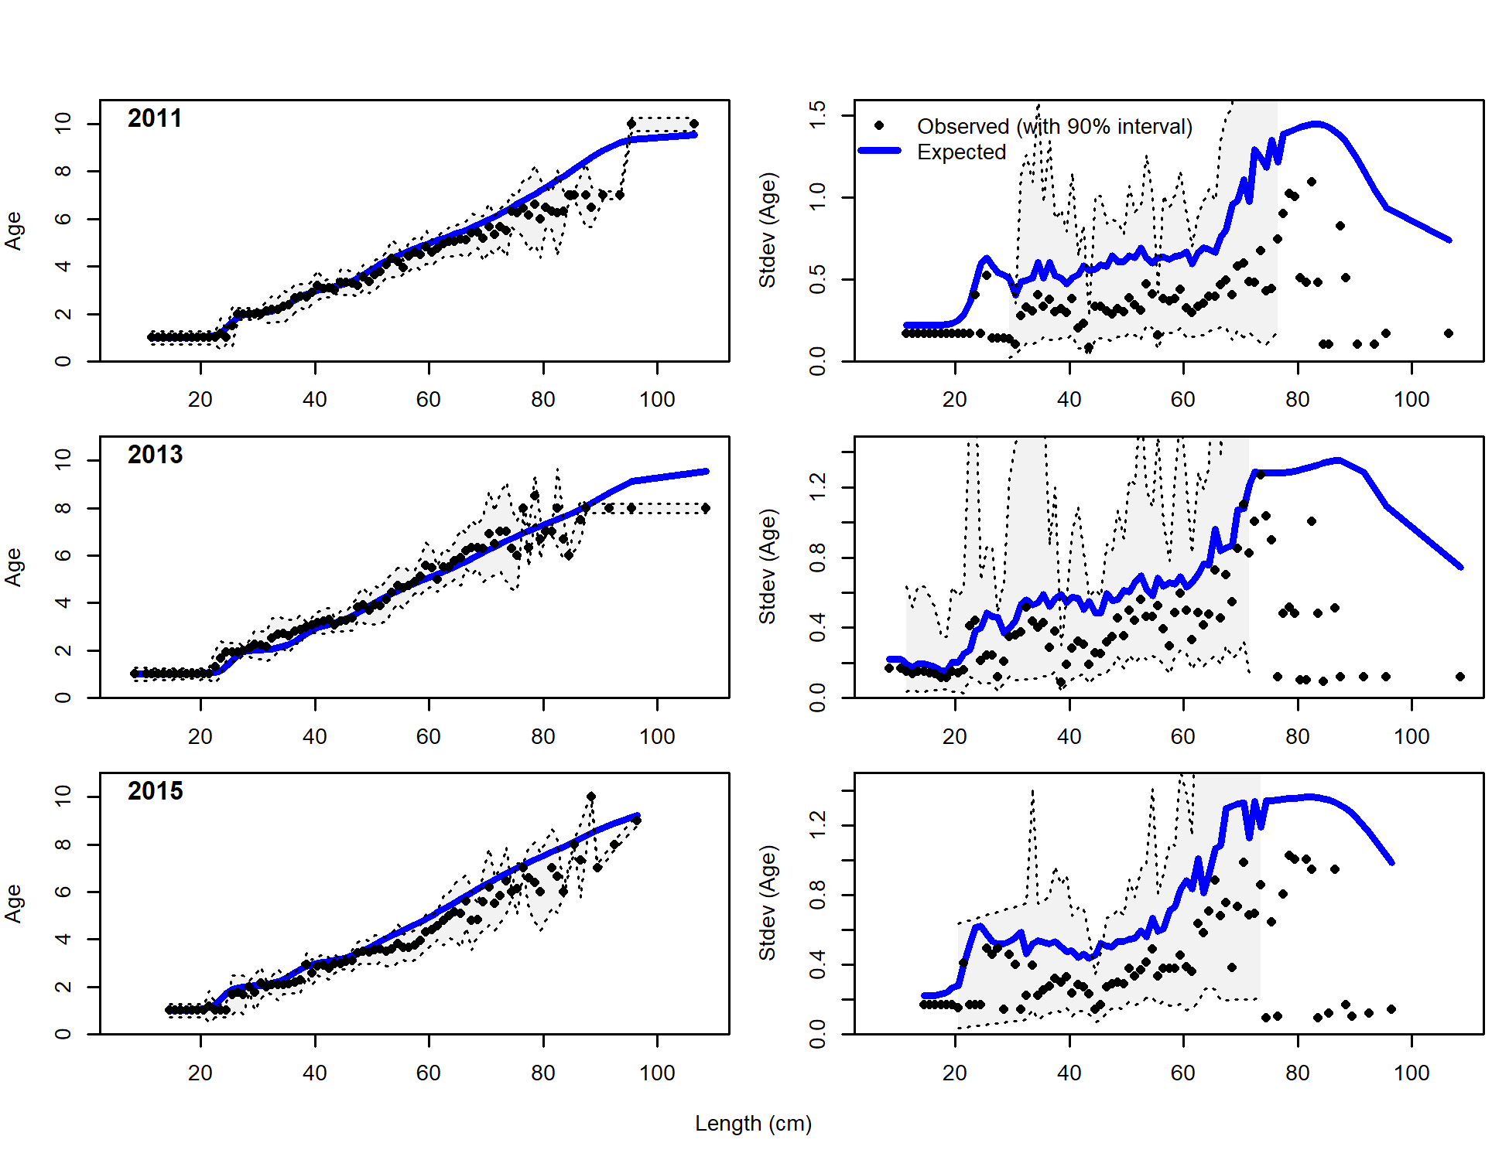

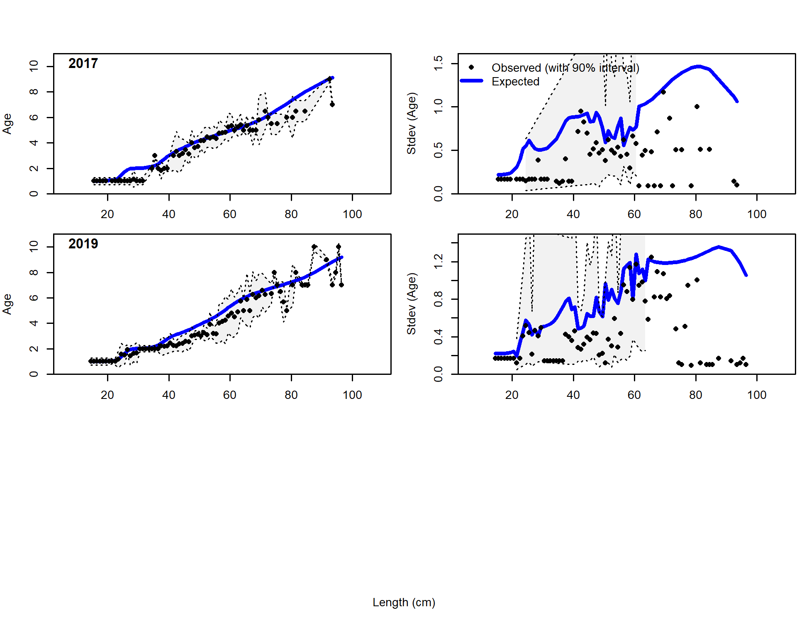

Figure 2.69 NMFS bottom trawl survey (Srv) conditional length-at-age data and Model 19.1 fit.

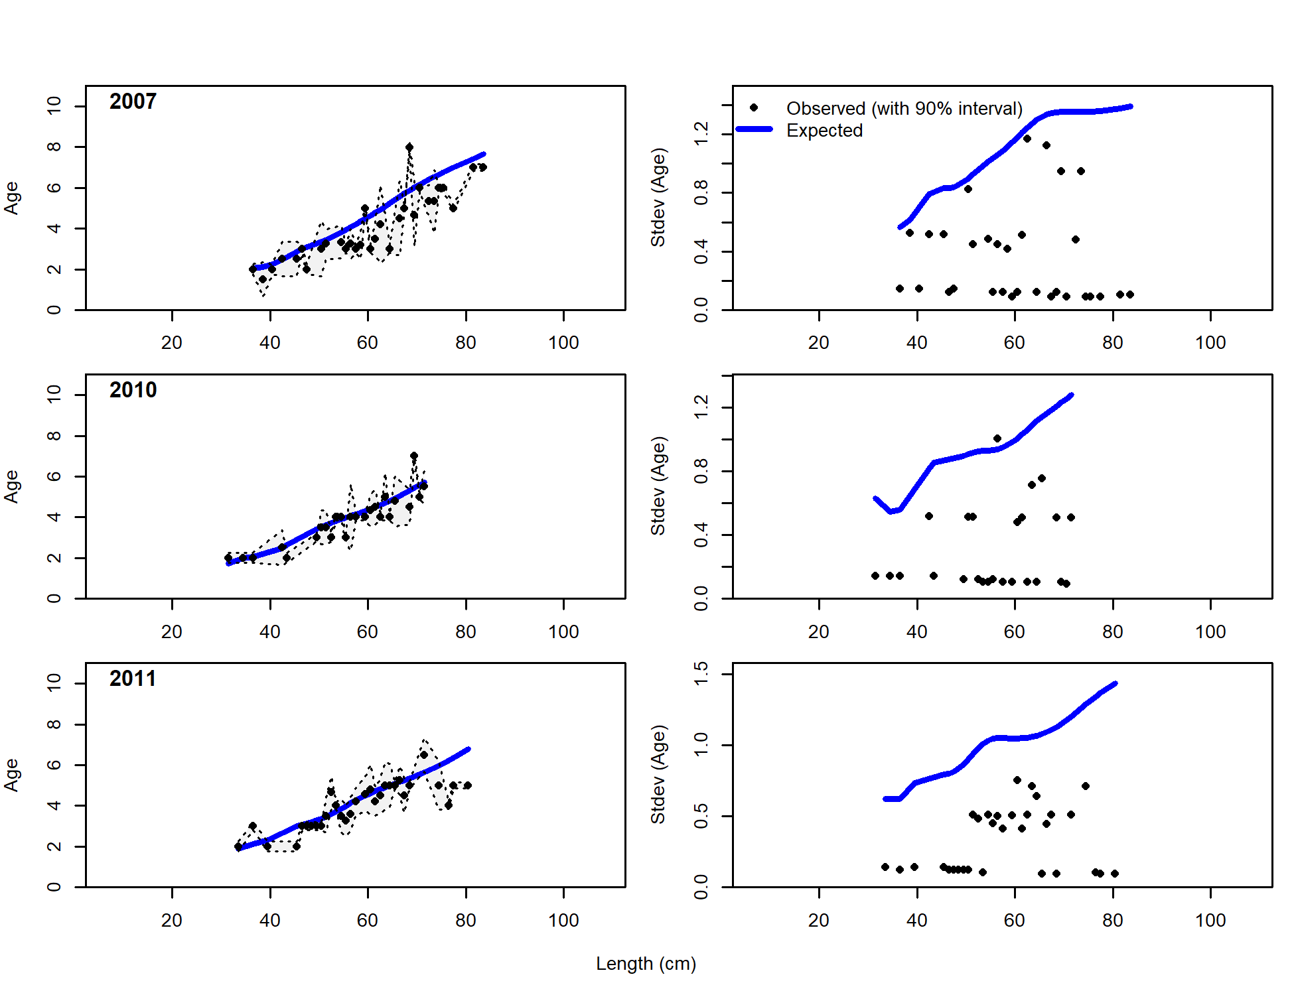 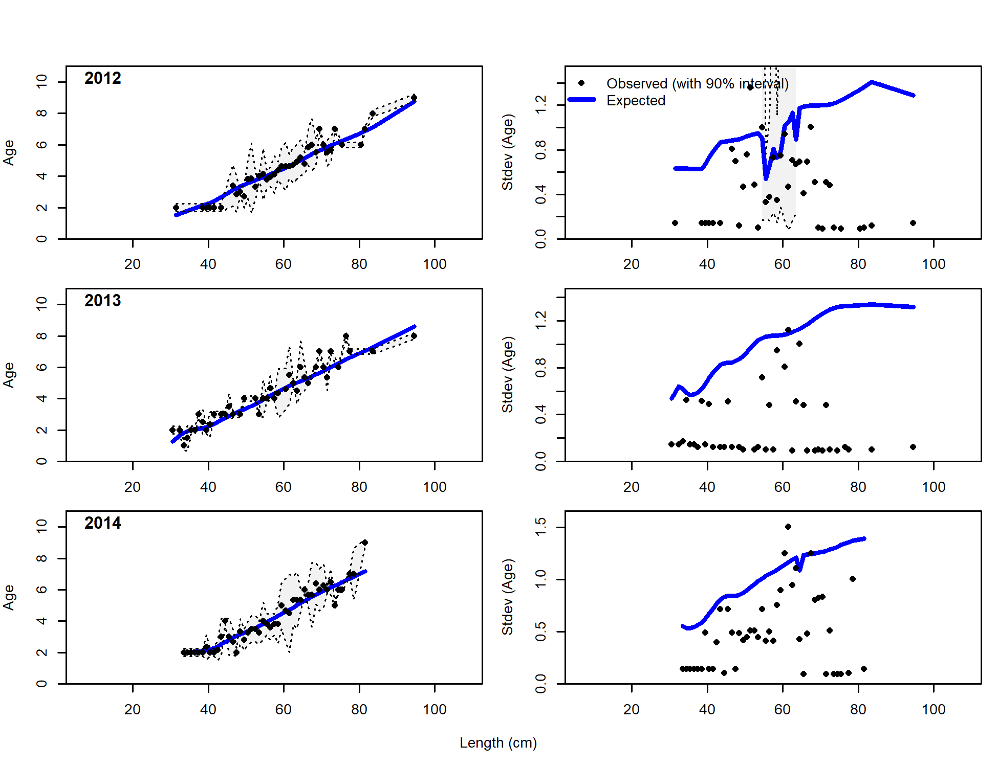

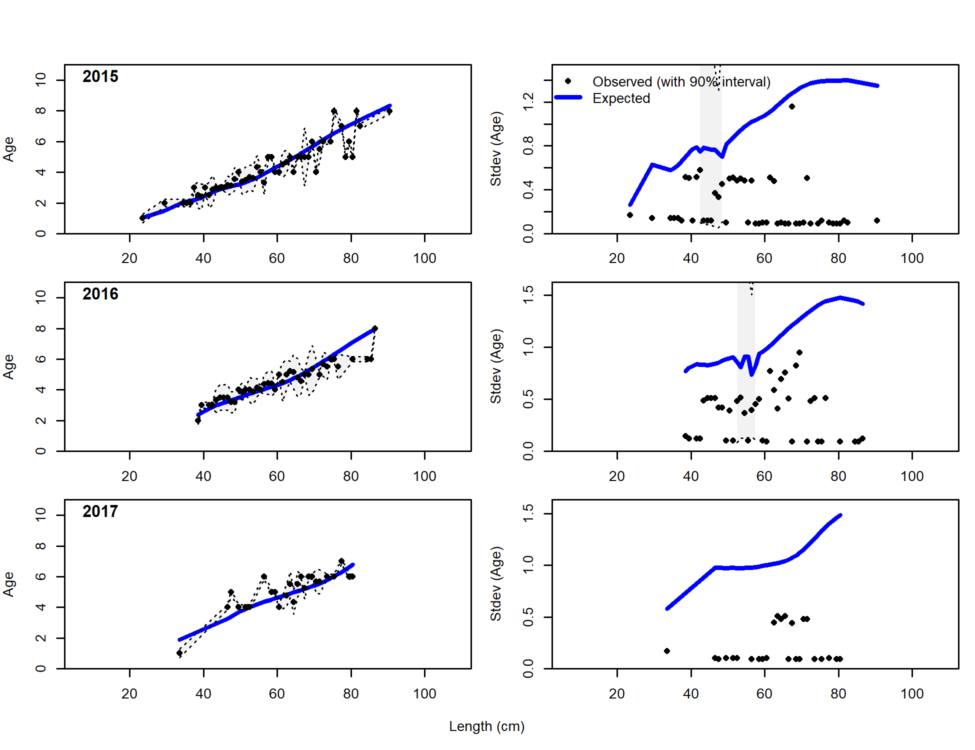 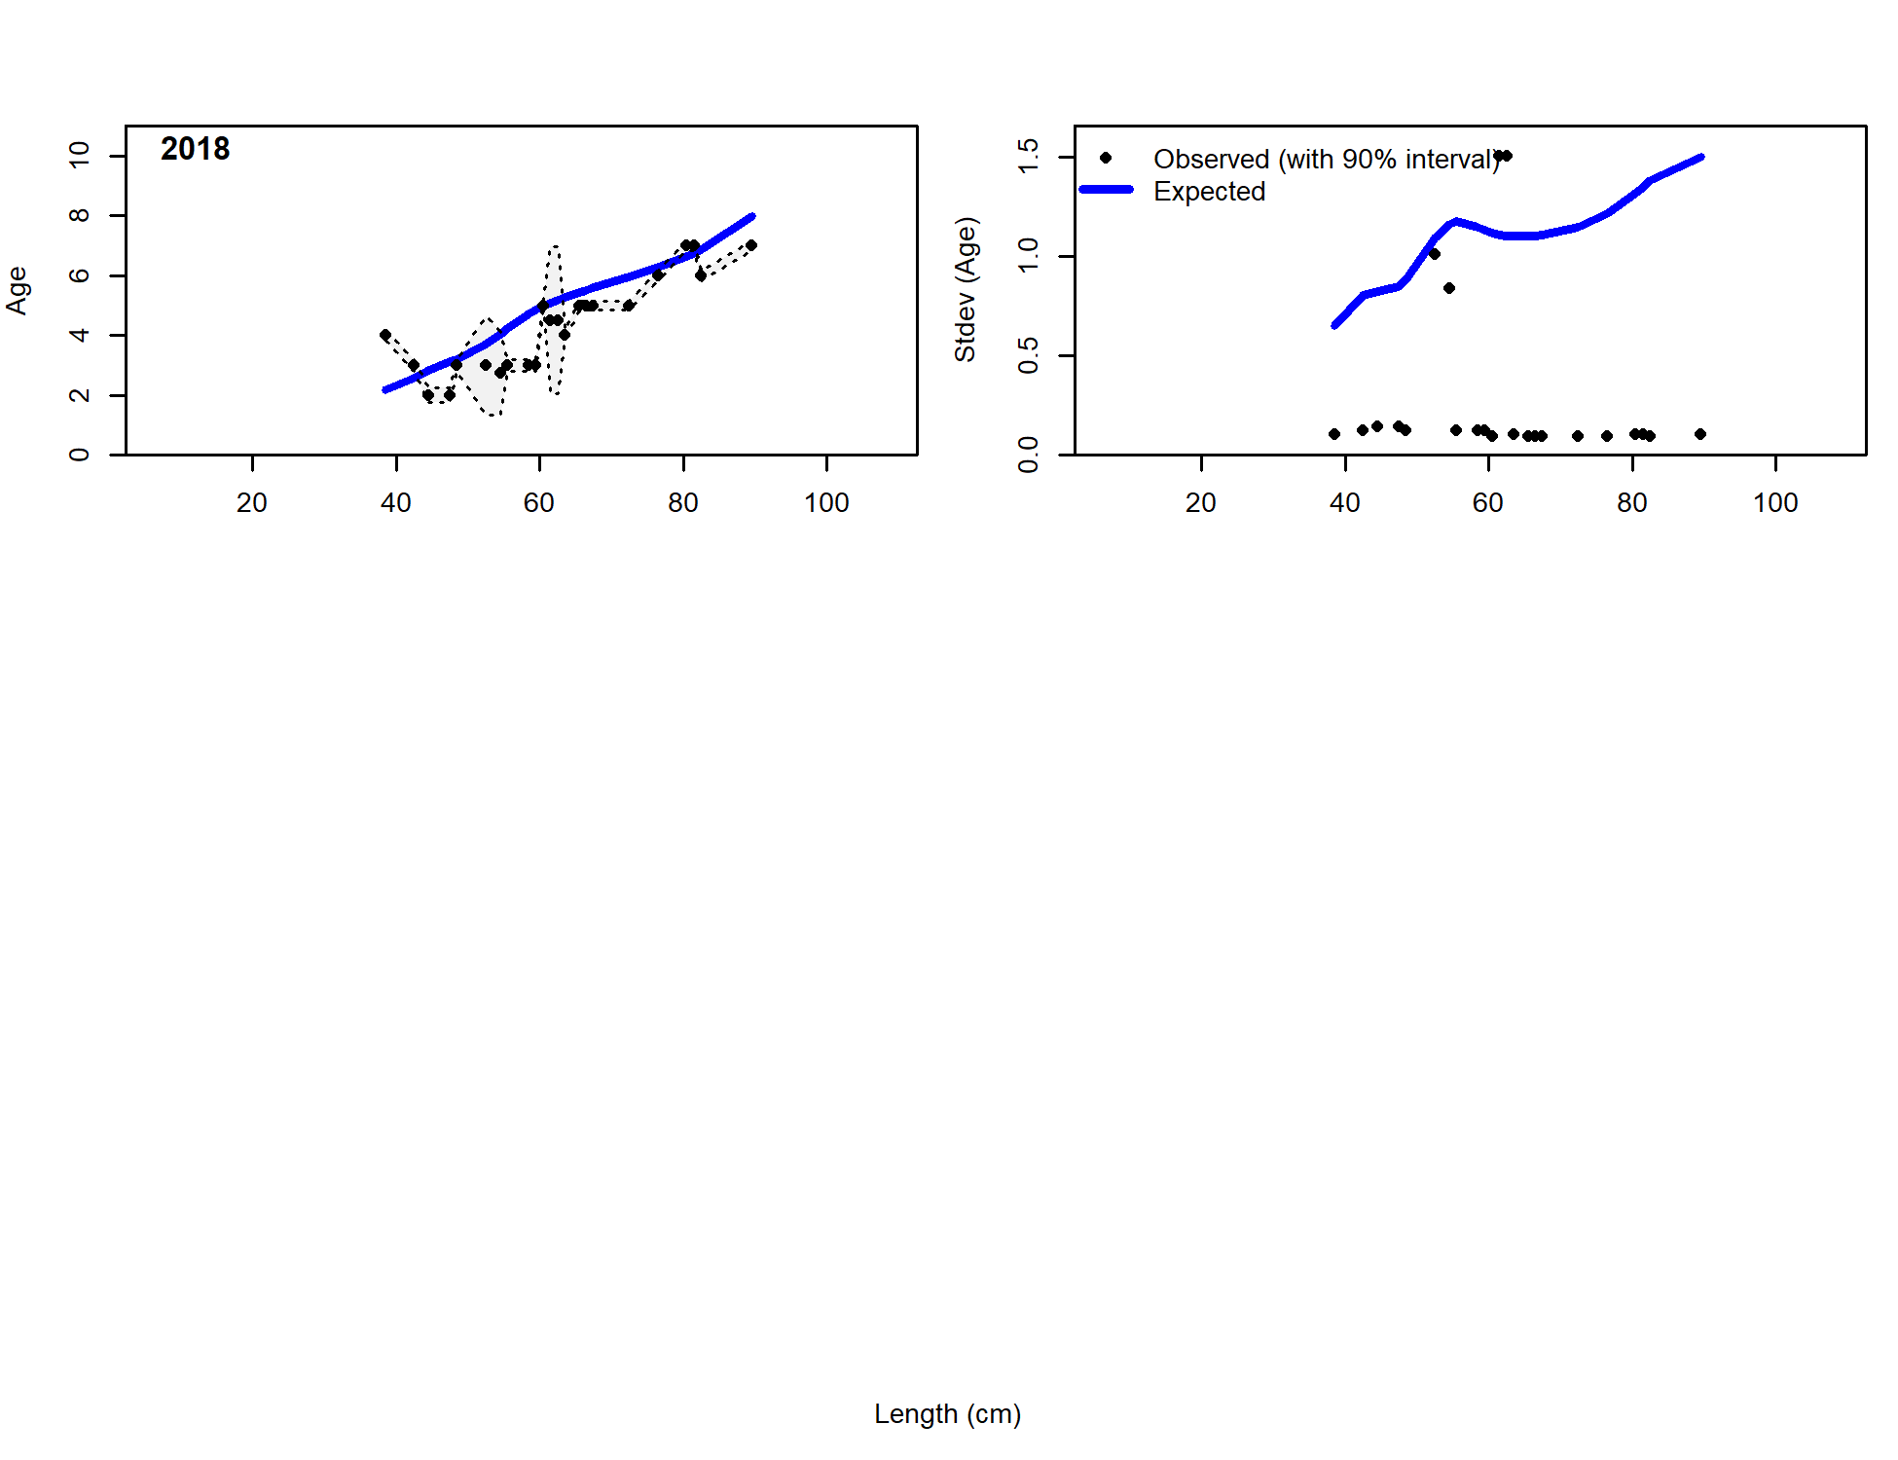

Figure 2.70 Trawl fishery conditional length-at-age data and Model 19.1 fit.

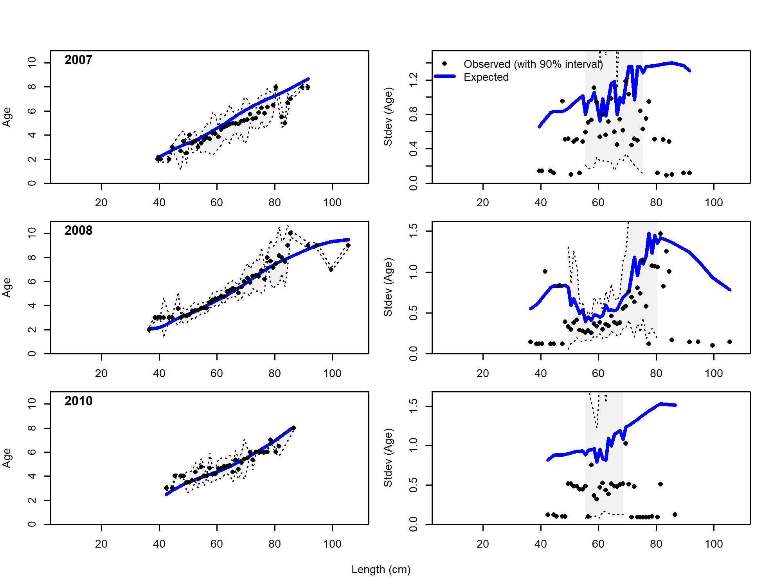 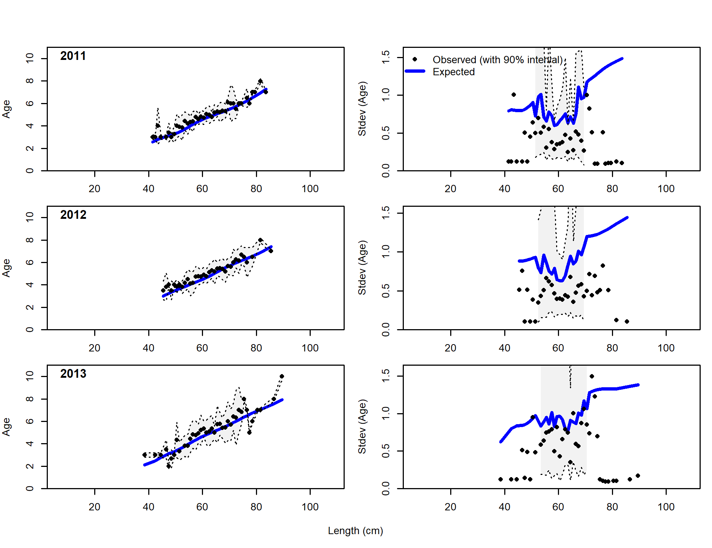

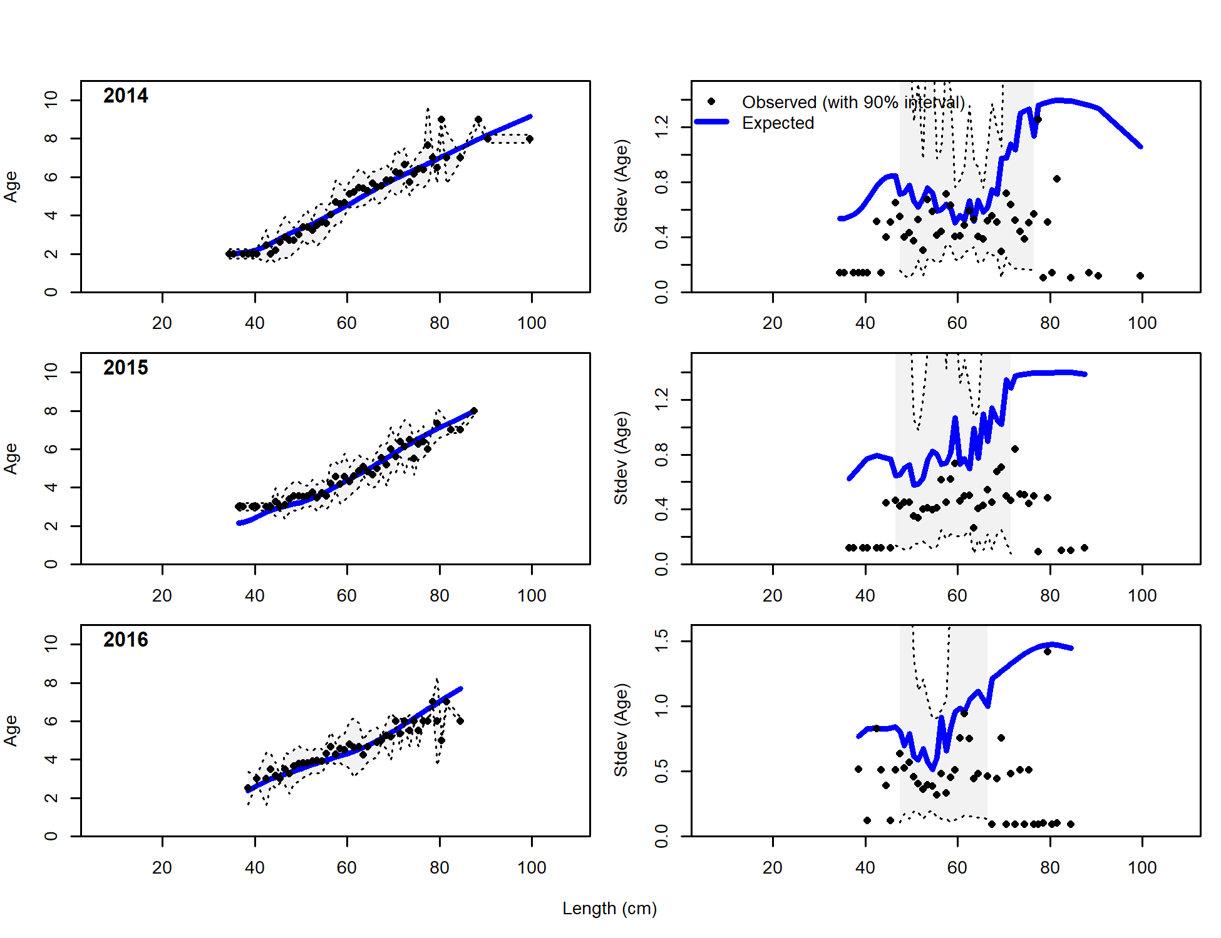 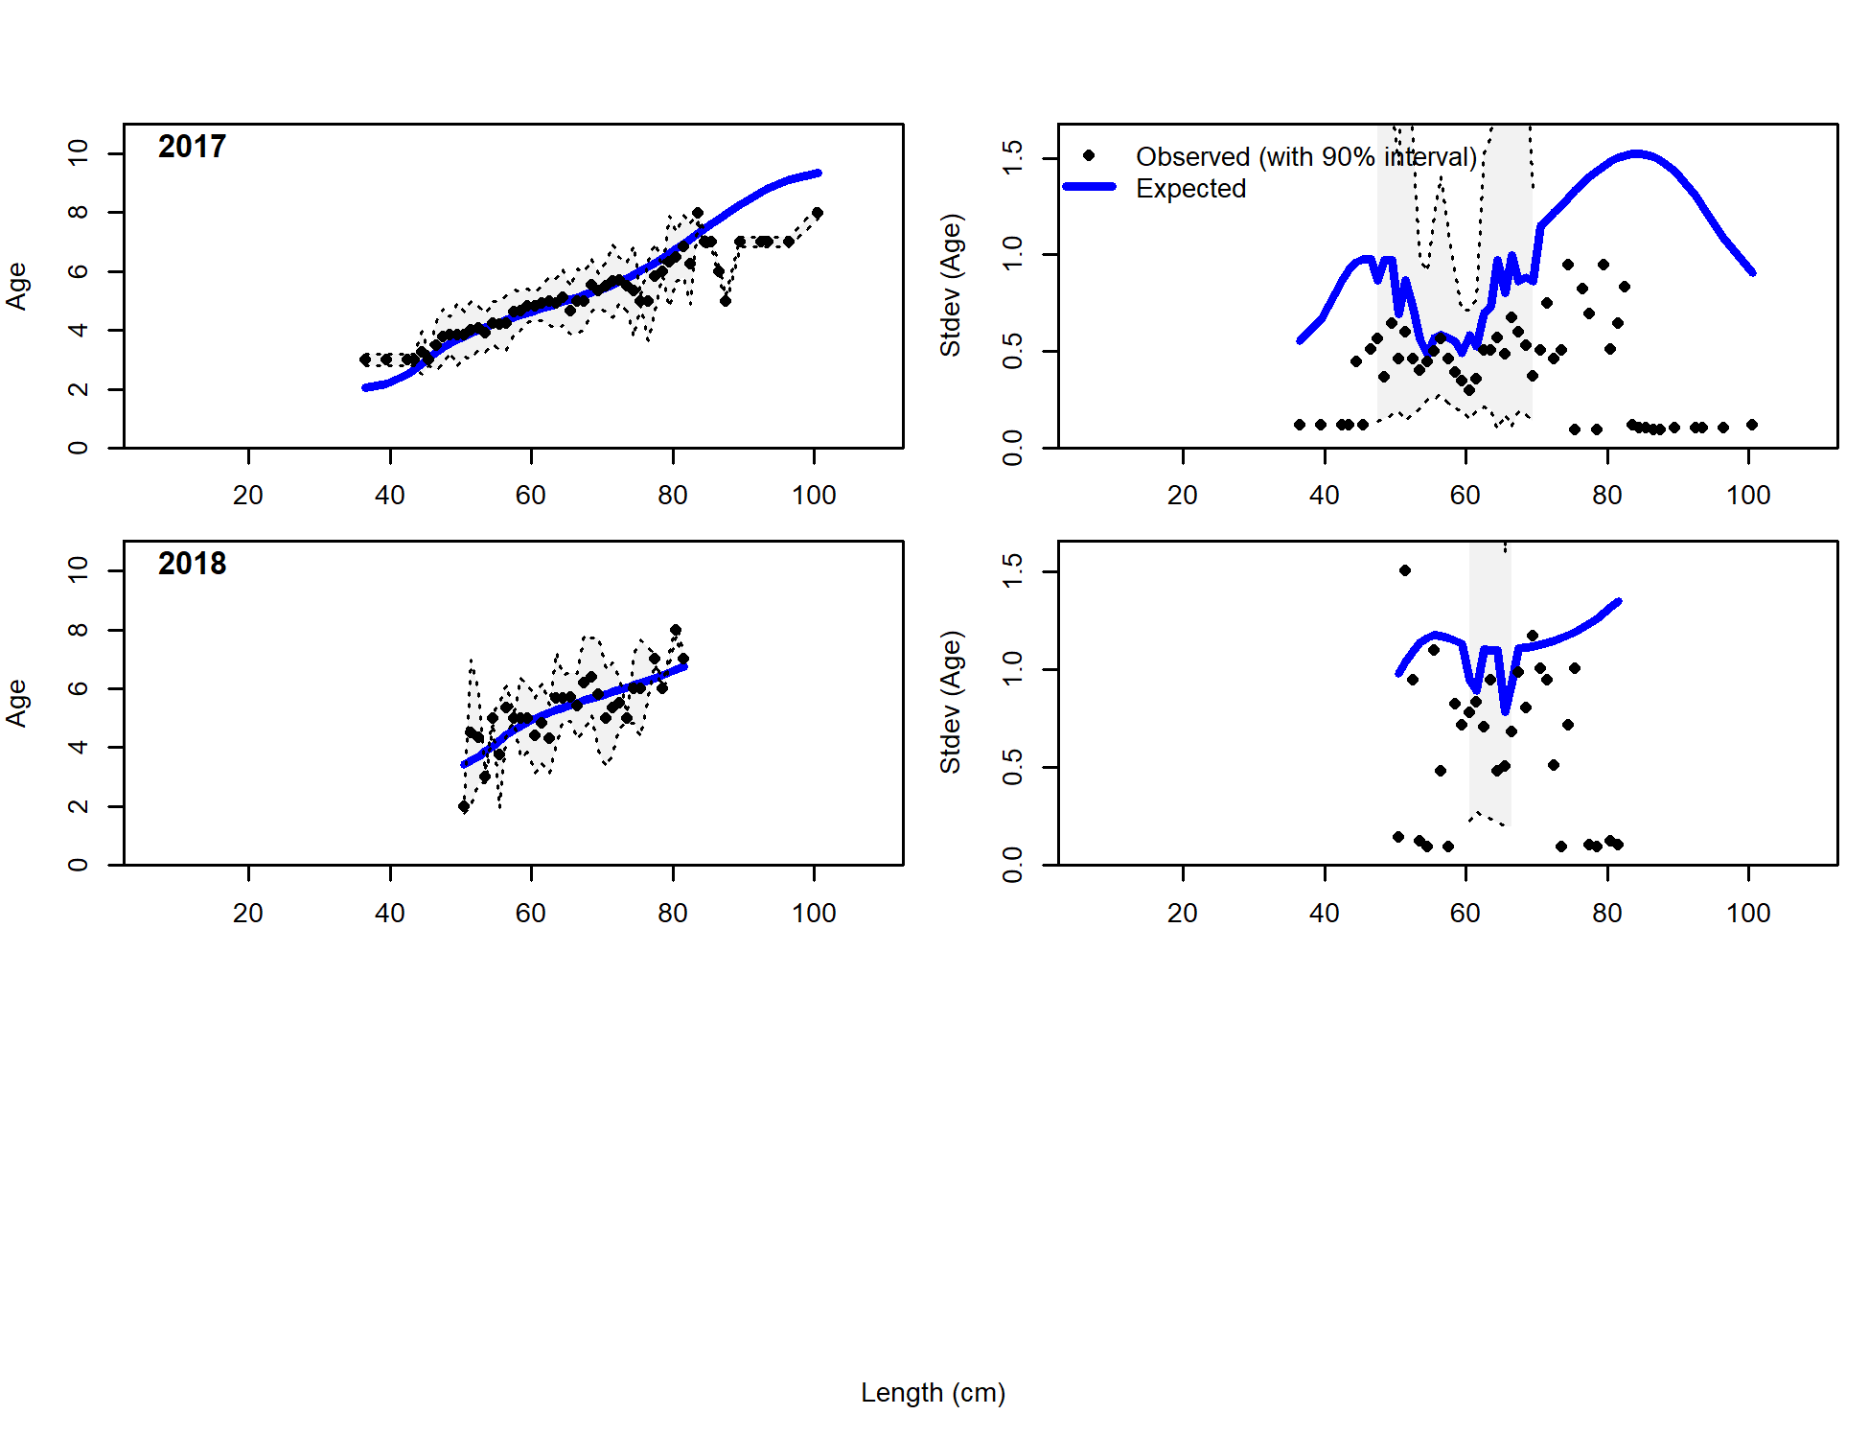

Figure 2.71 Longline fishery conditional length-at-age data and Model 19.1 fit.

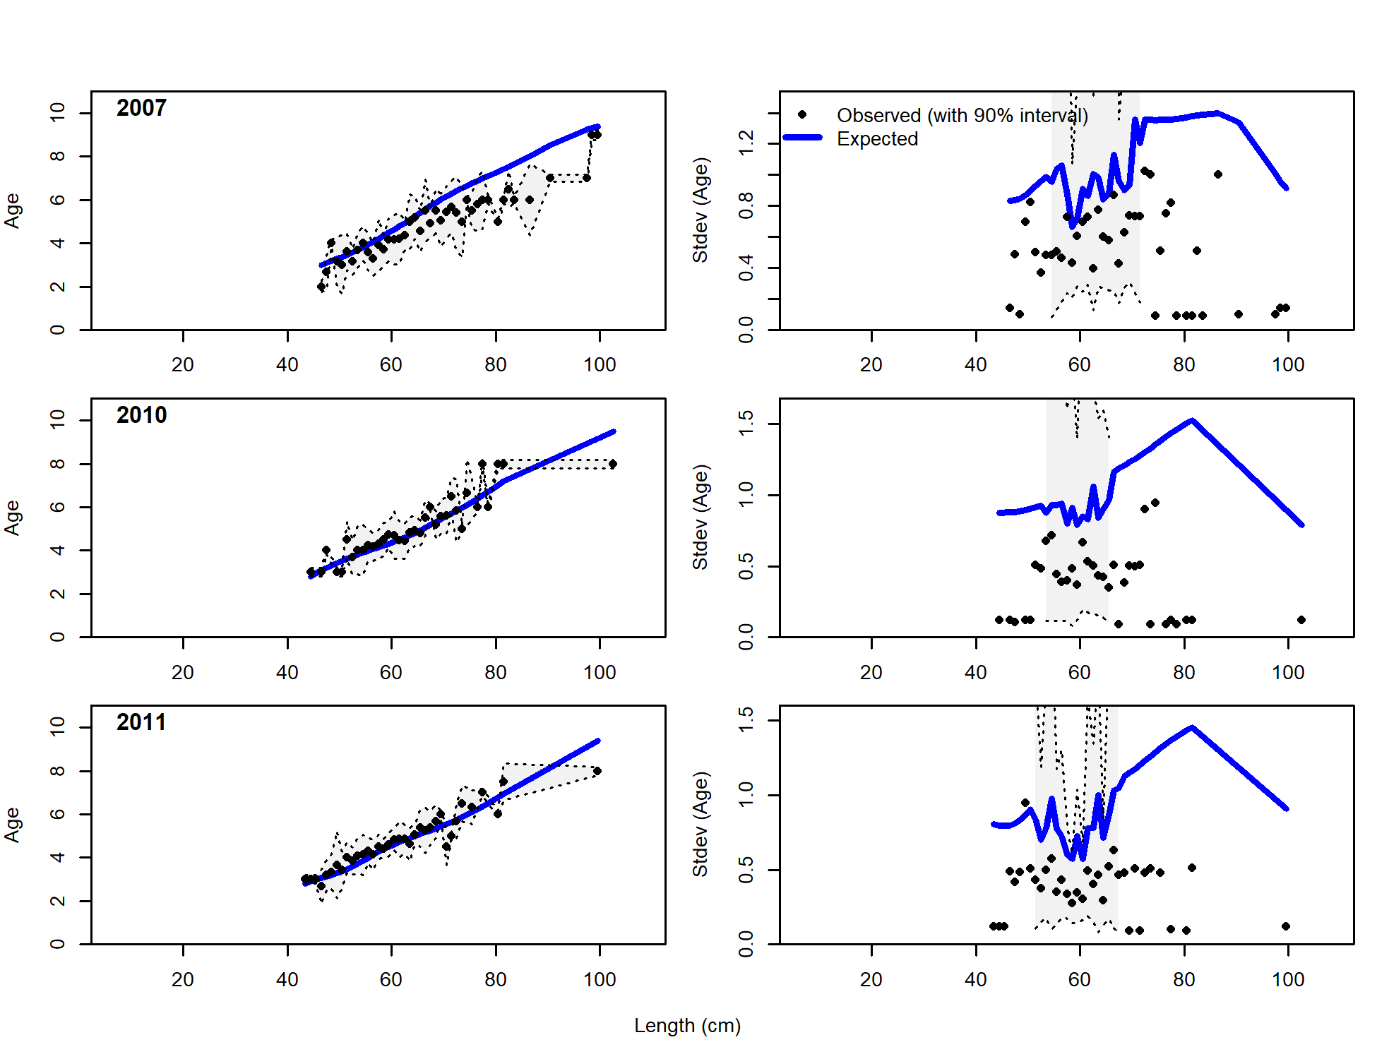 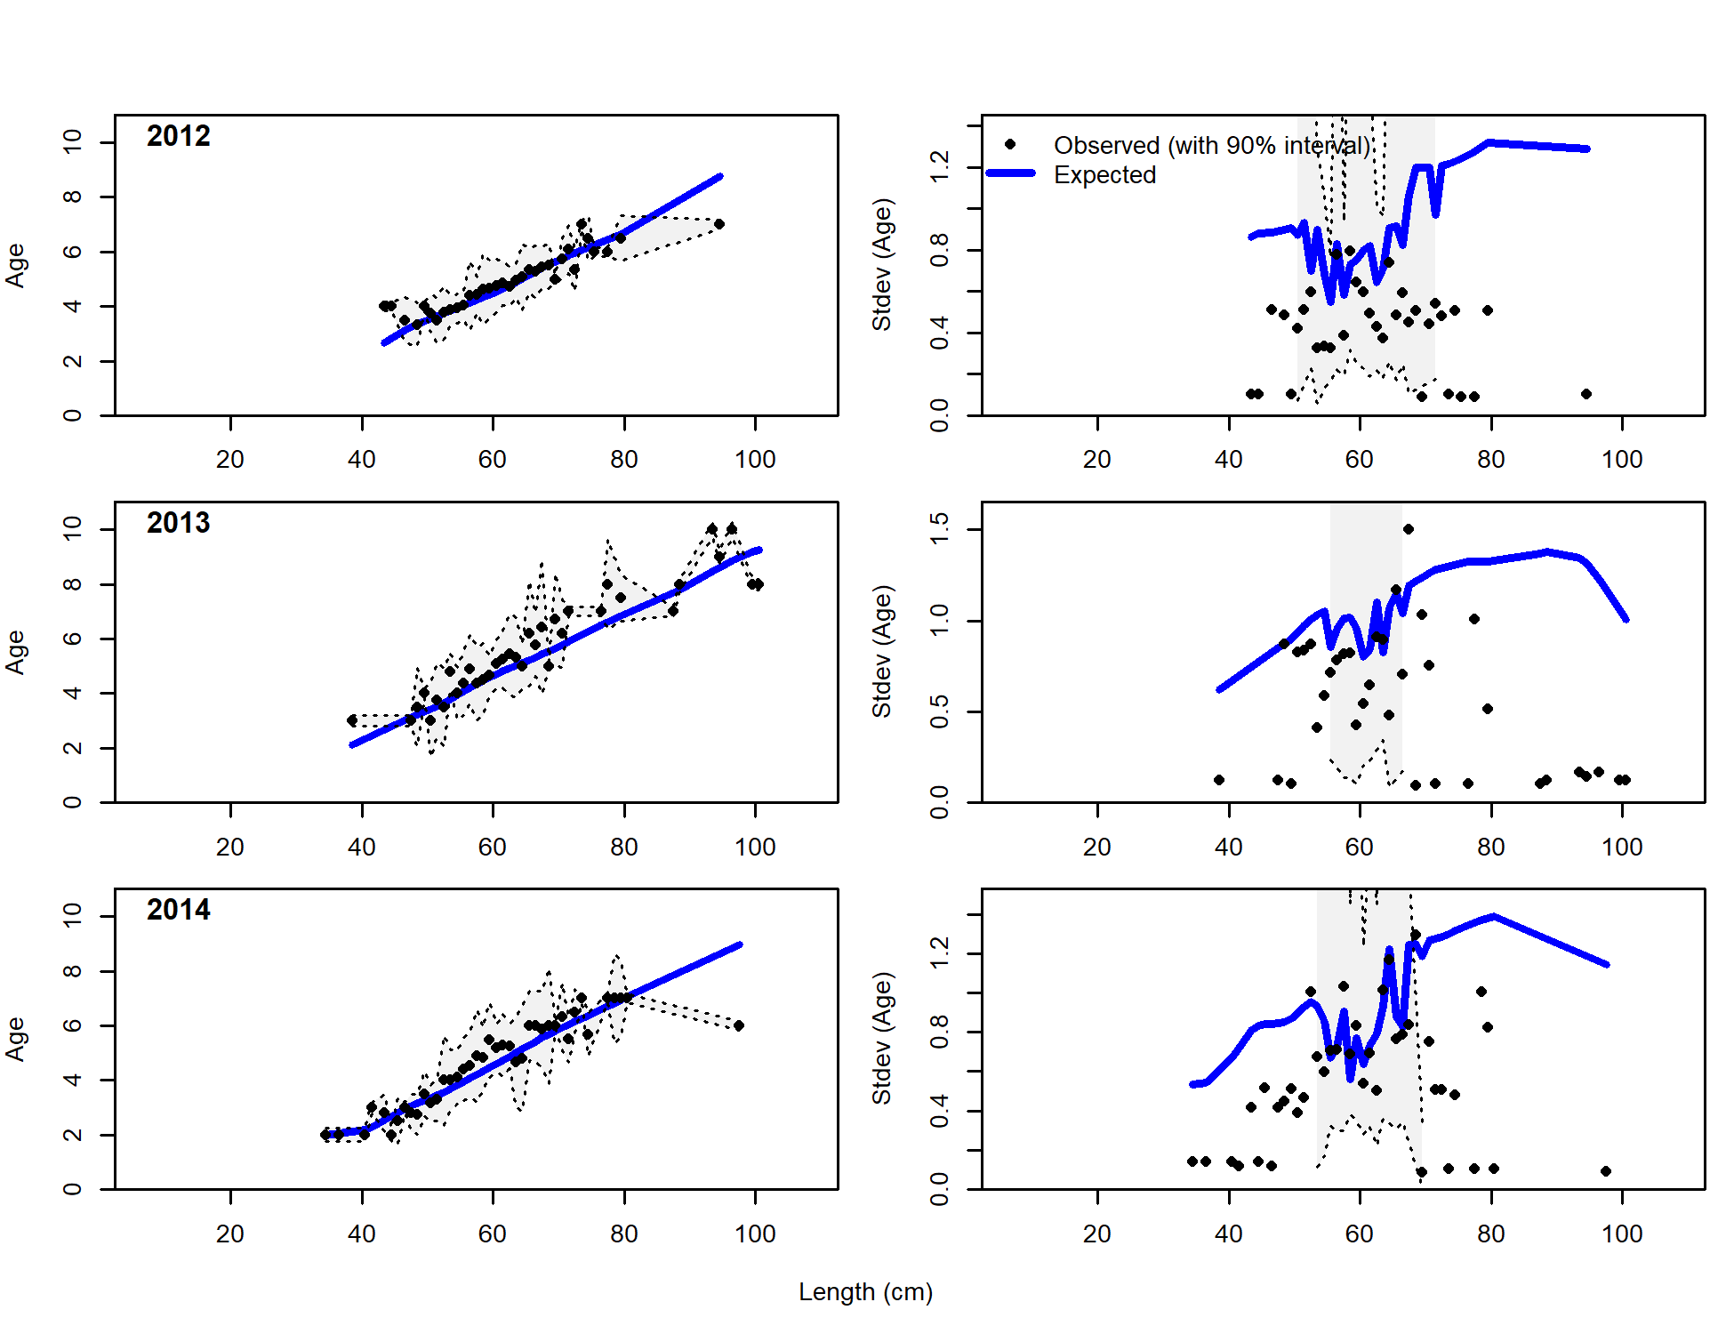 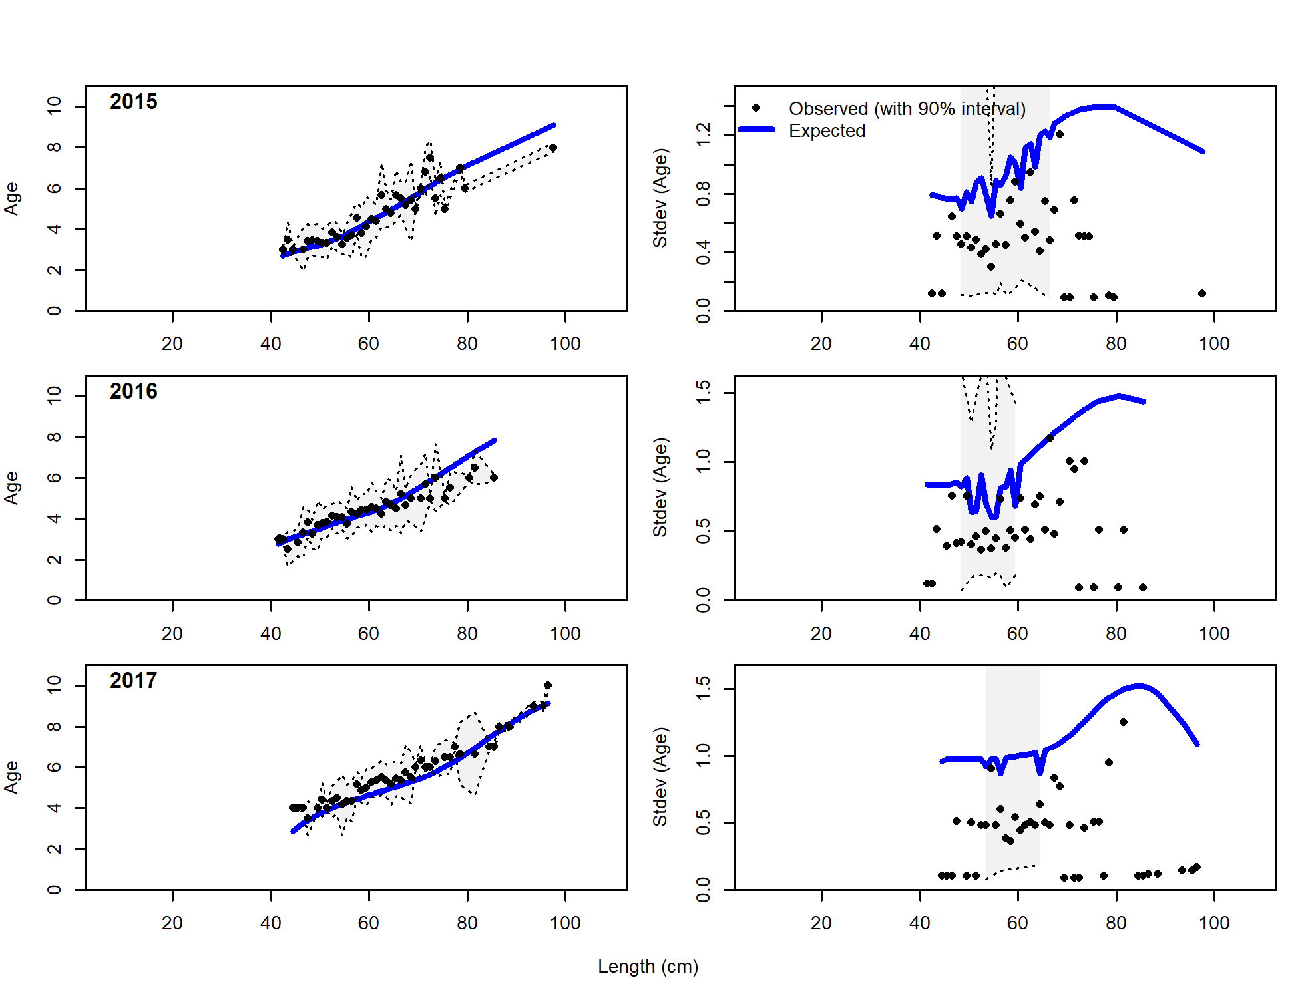 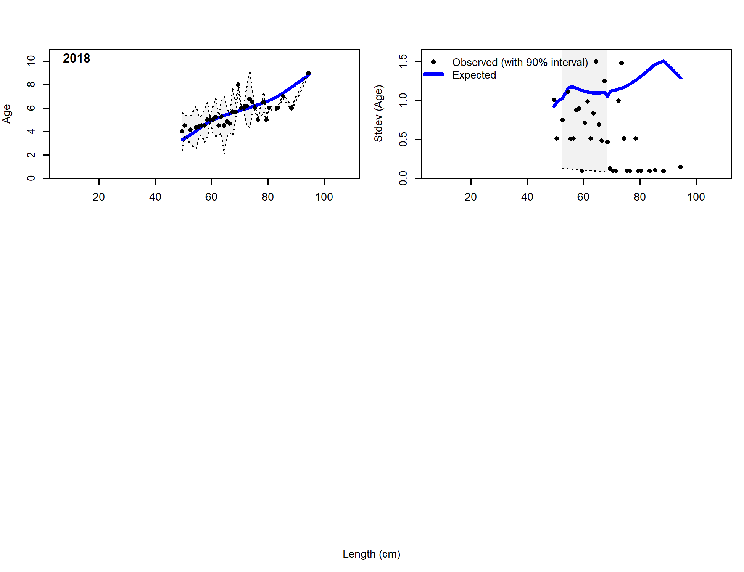

Figure 2.72 Pot fishery conditional length-at-age data and Model 19.1 fit.

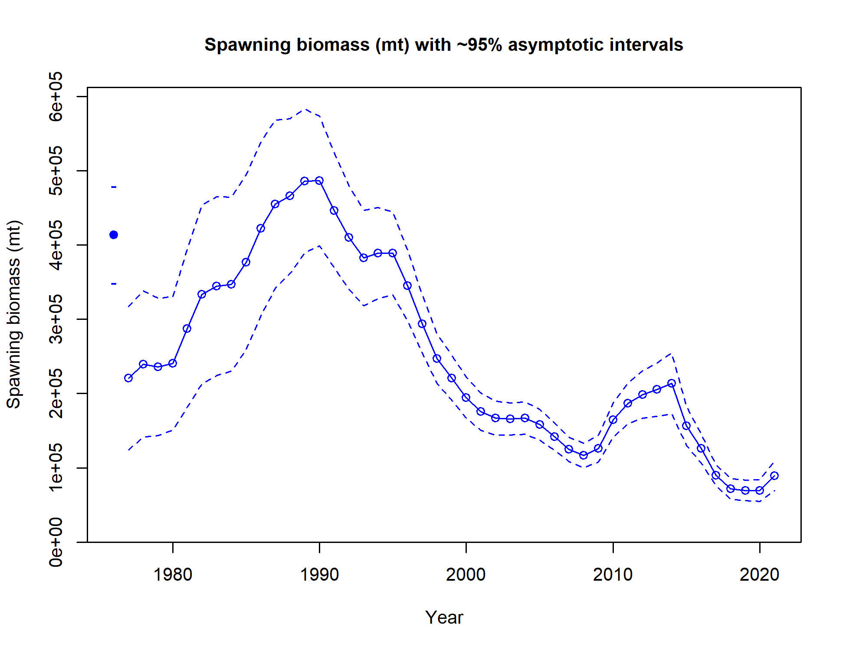 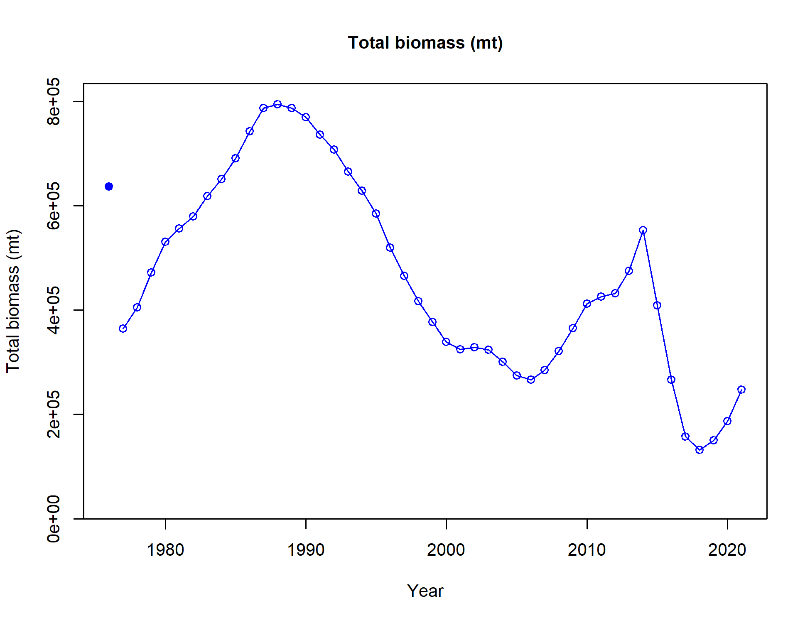

Spawning Biomass (t)

Figure 2.73 Model 19.1 predicted spawning output (femal spawning biomass; t) with 95% asymtotic error intervals (top) and total biomass (t).

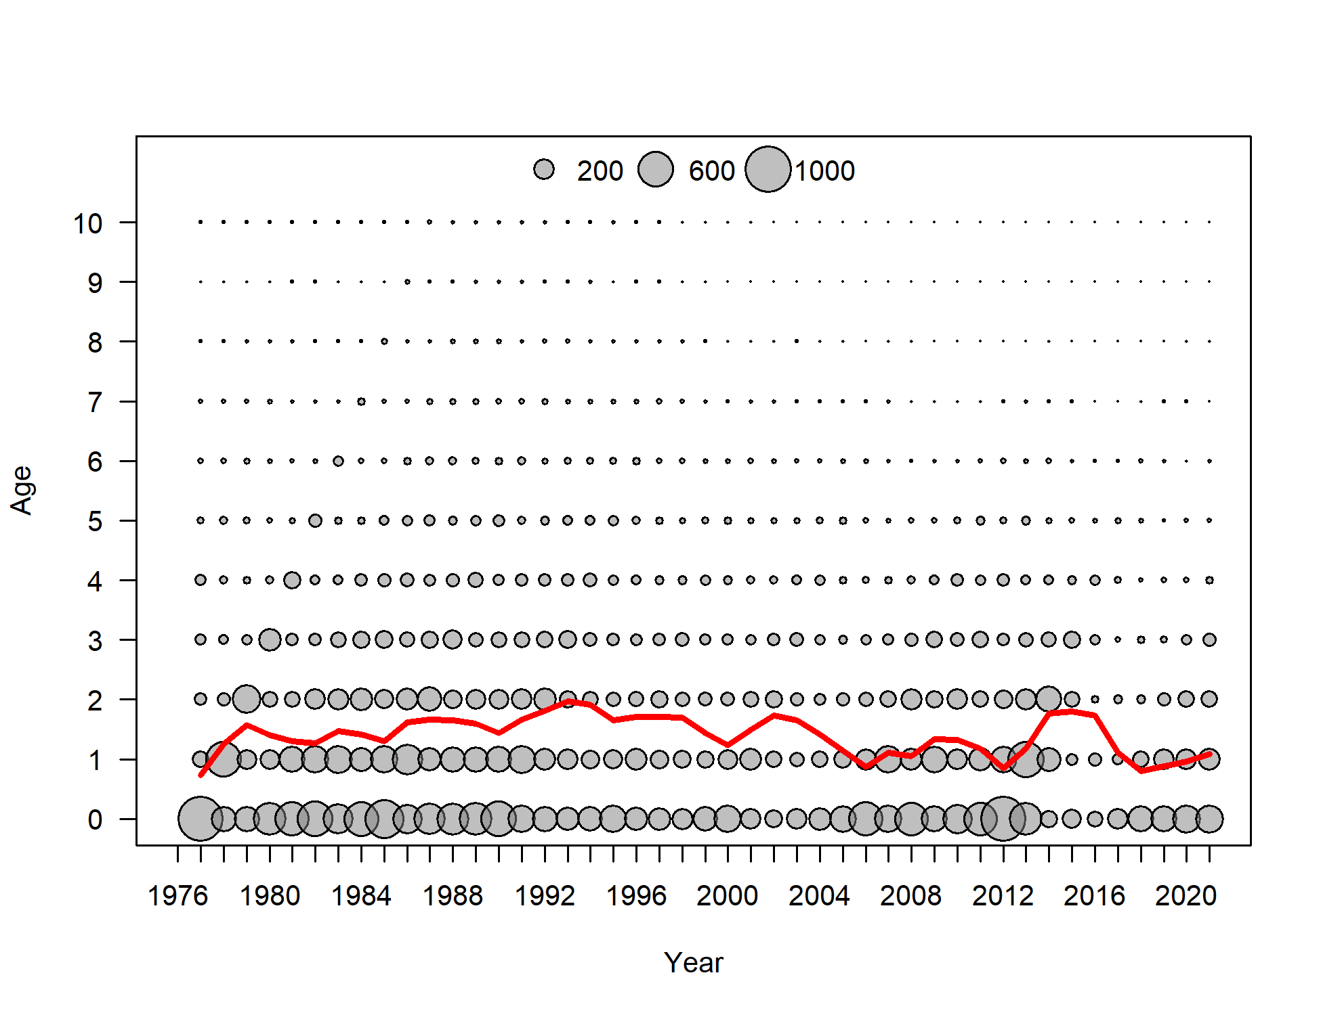

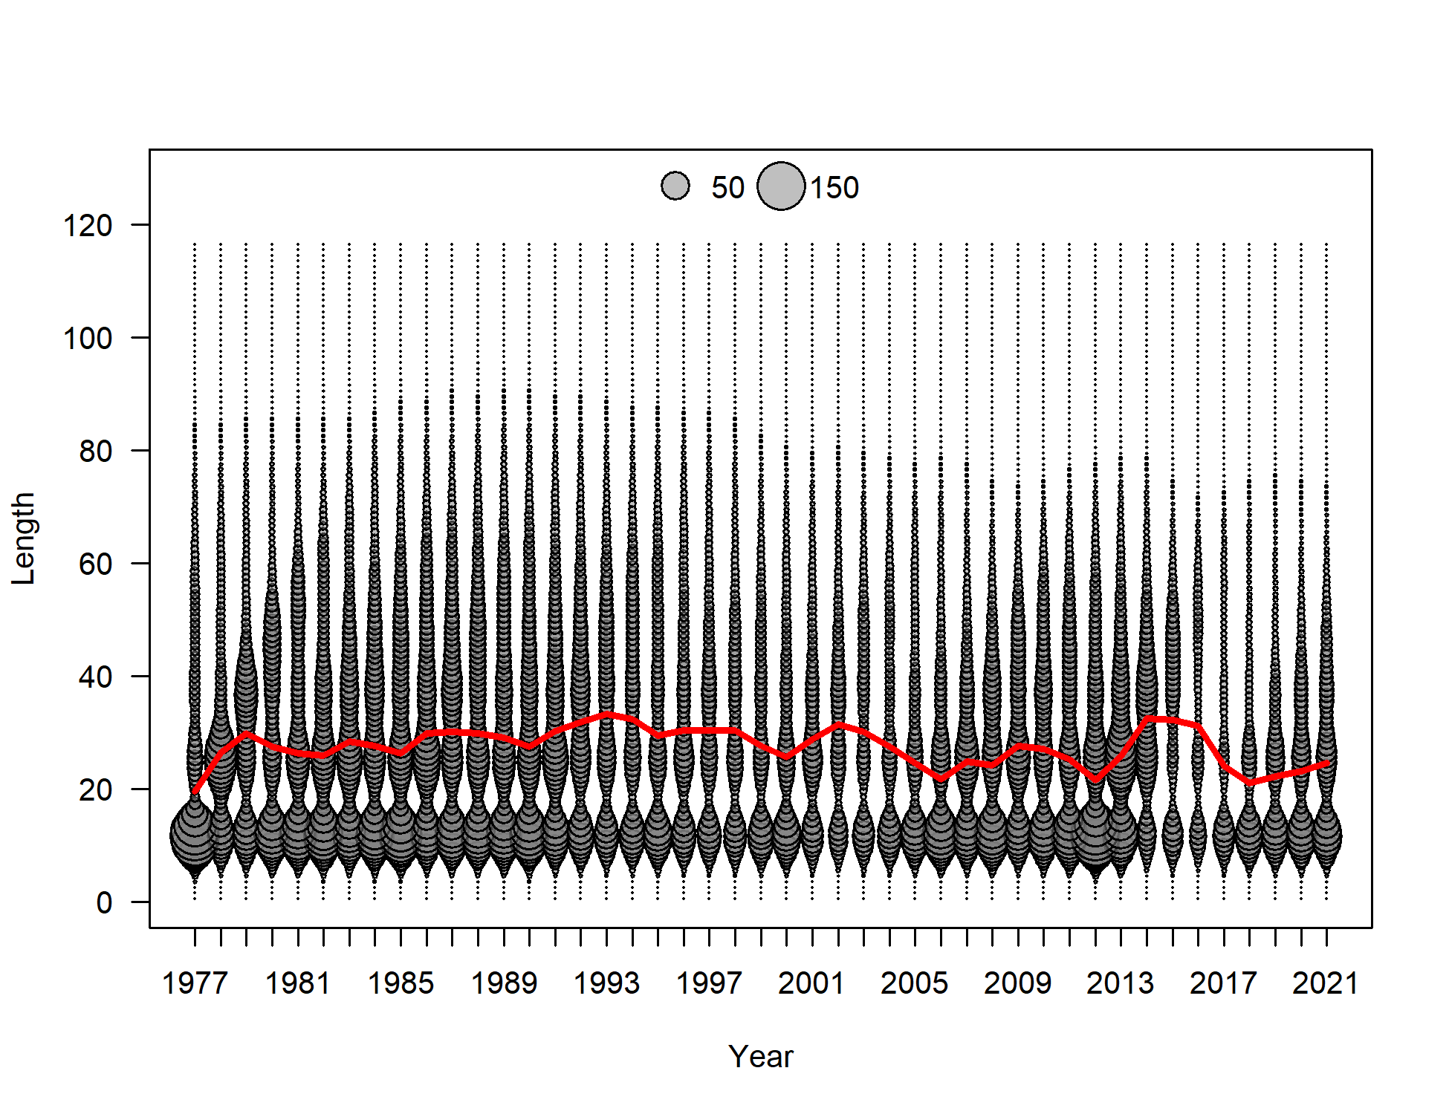

Figure 2.74 Model 19.1 predictions of middle of the year number at age (top) with mean age (red line) and numer at length (bottom)with mean length (red line).

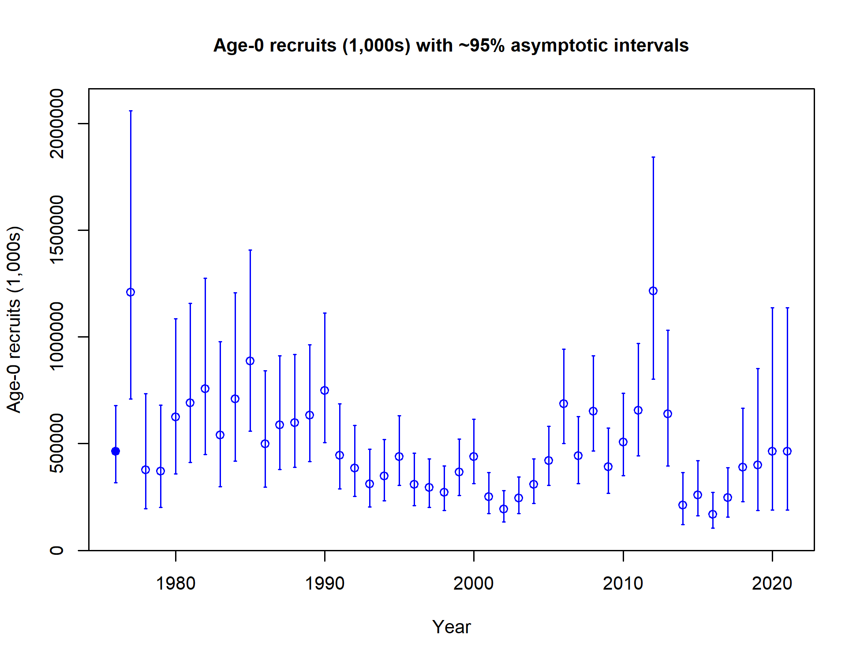

Figure 2.75 Model 19.1 age-0 recruitment (1000’s) with 95% asymtotic error intervals.

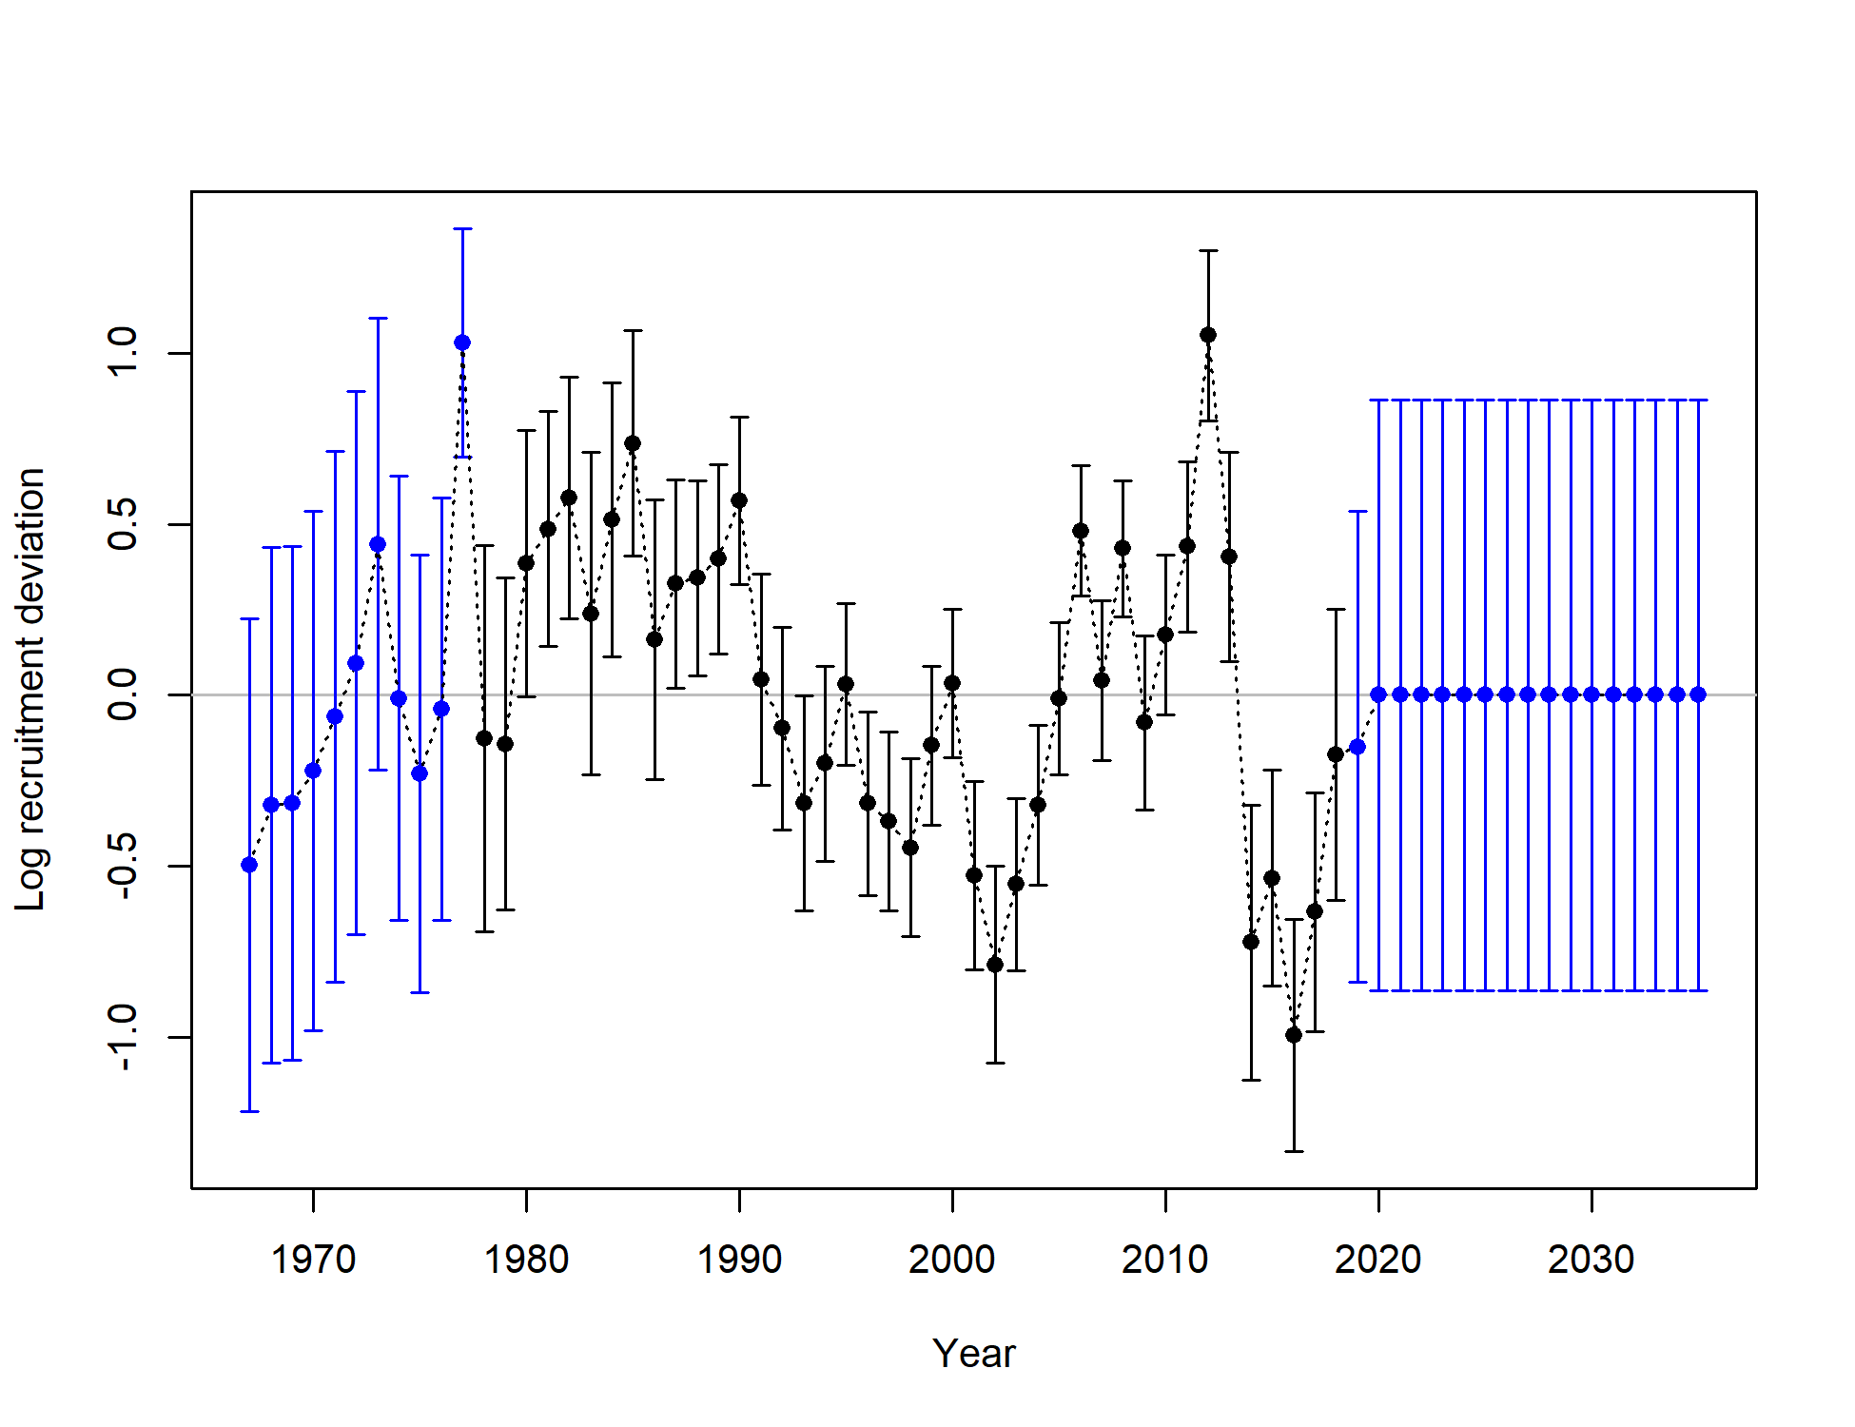

Figure 2.76 Model 19.1 log recruitment deviations with 95% asymtotic error intervals.

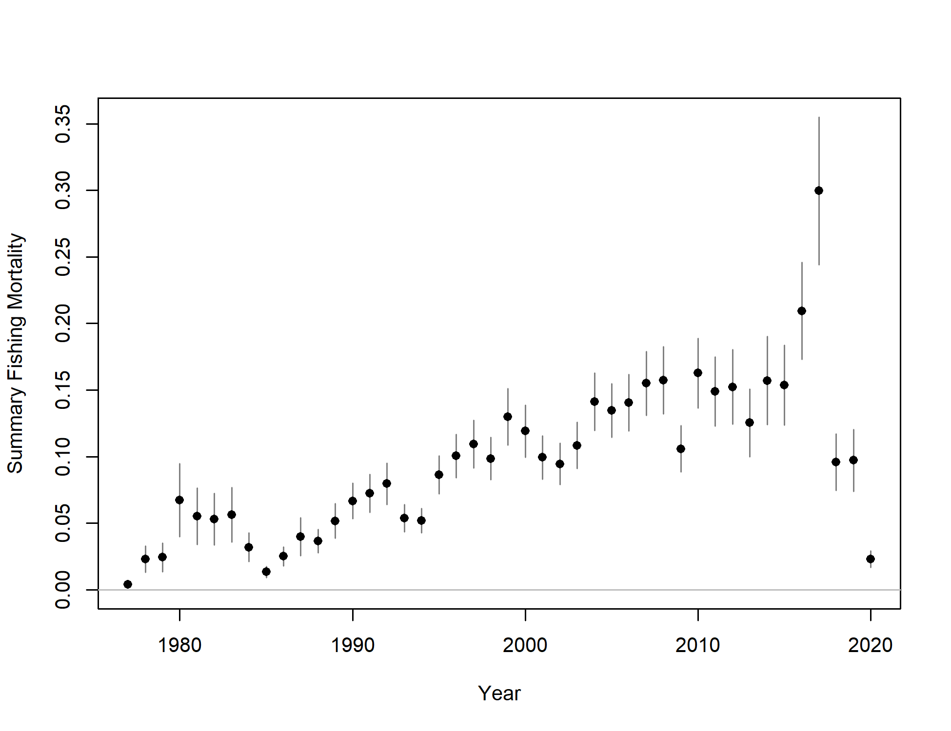 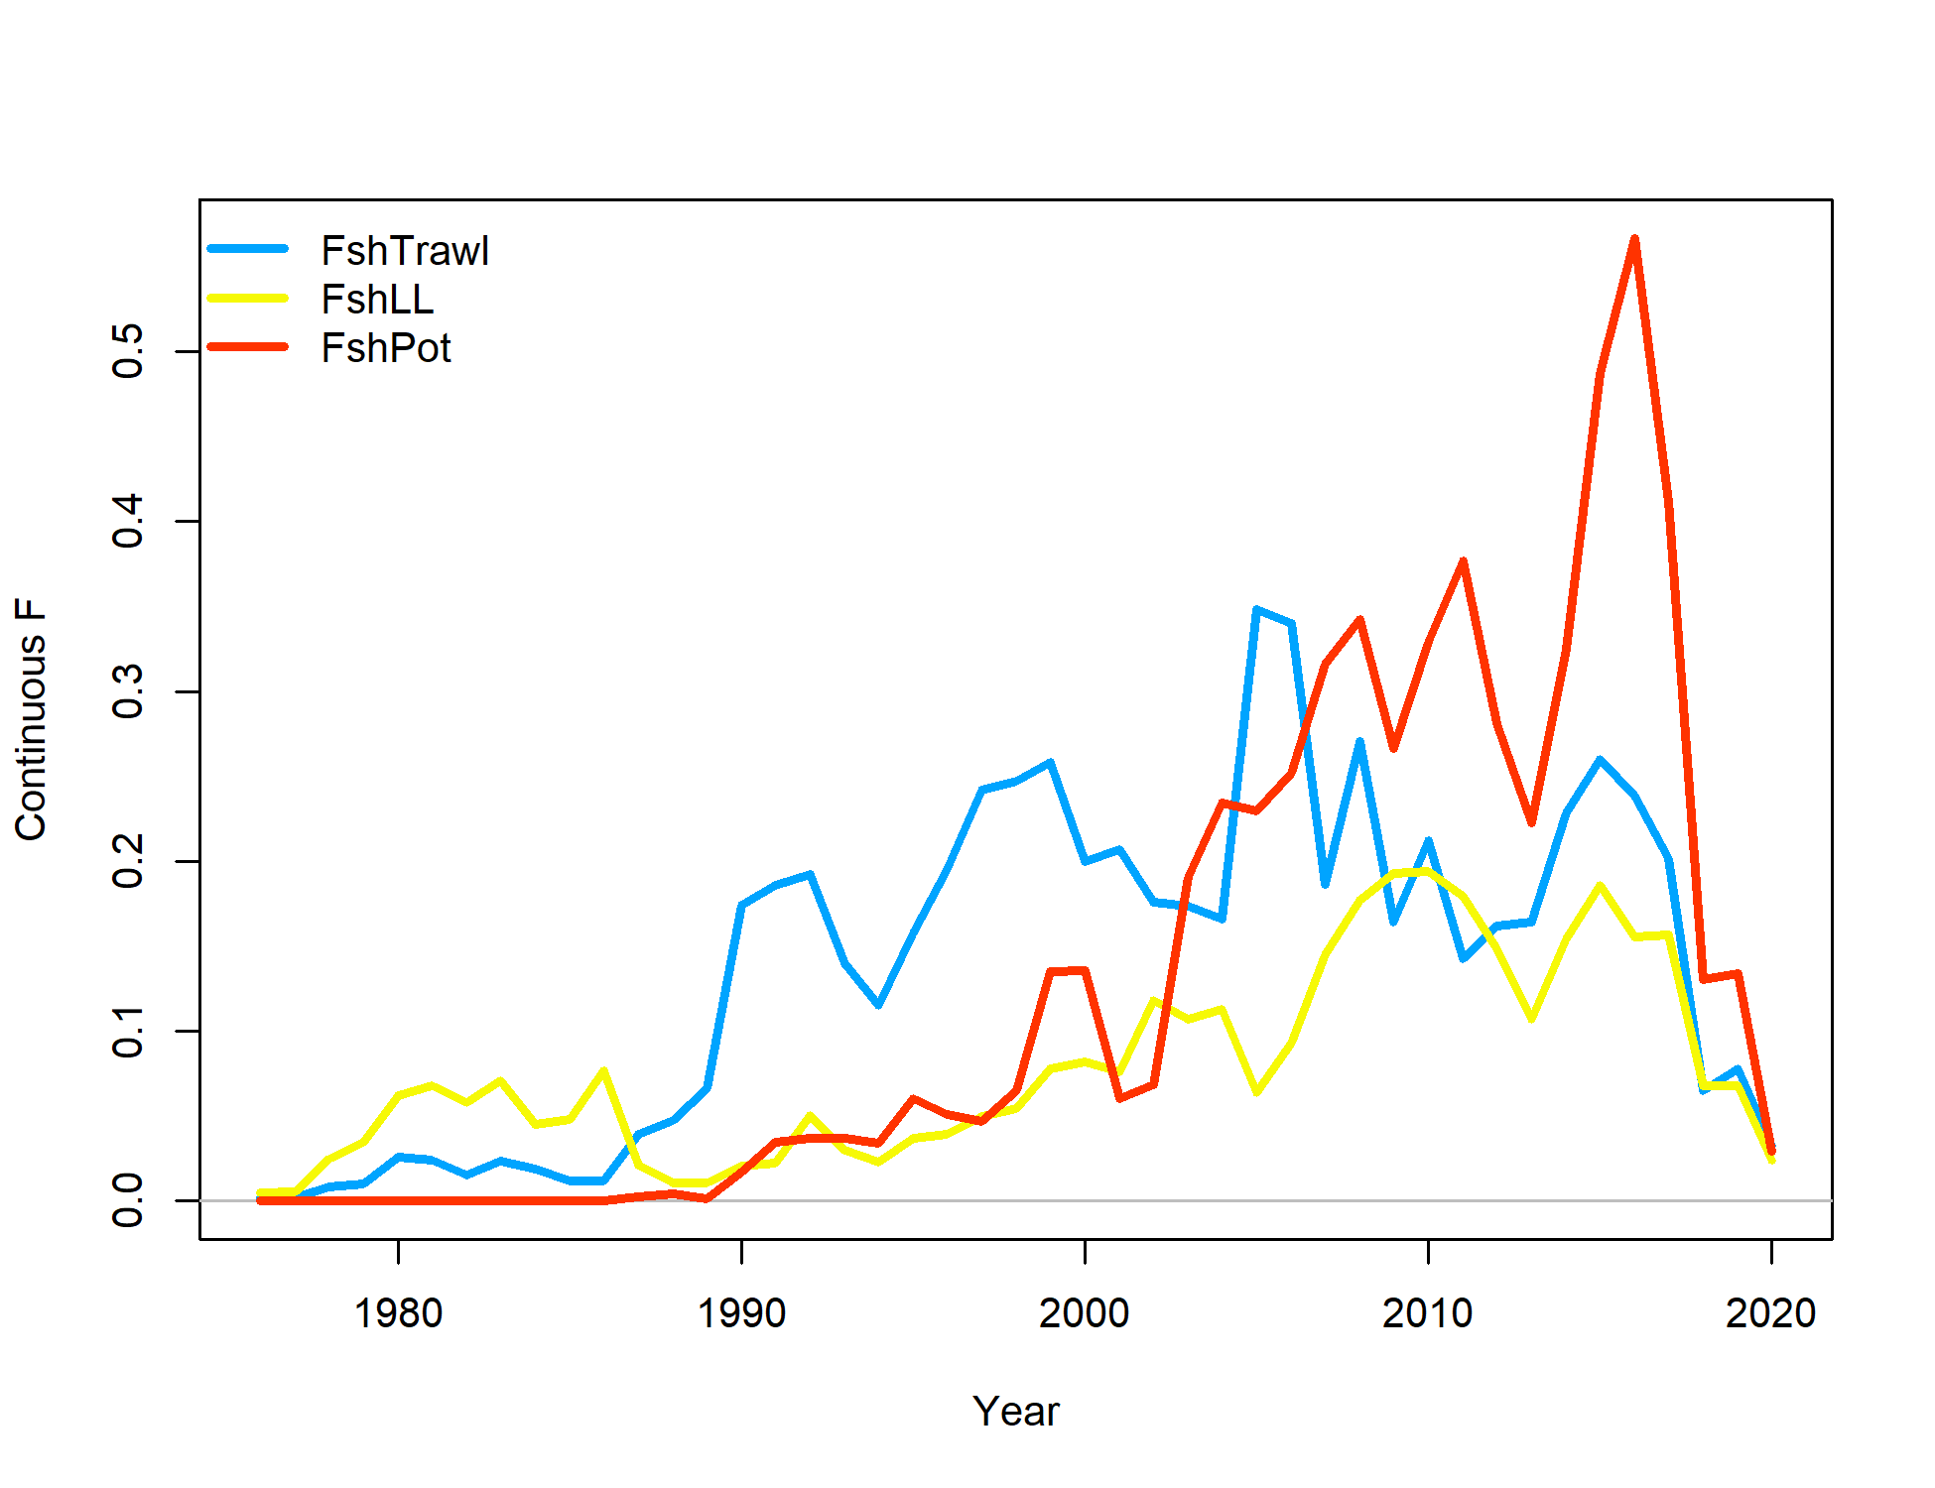

Figure 2.77 Model 19.1 age 3-8 true fishing mortality (top) and continuos fishing mortality by trawl (FshTrawl), longline (FshLL) and pot (FshPot) fisheries (bottom).

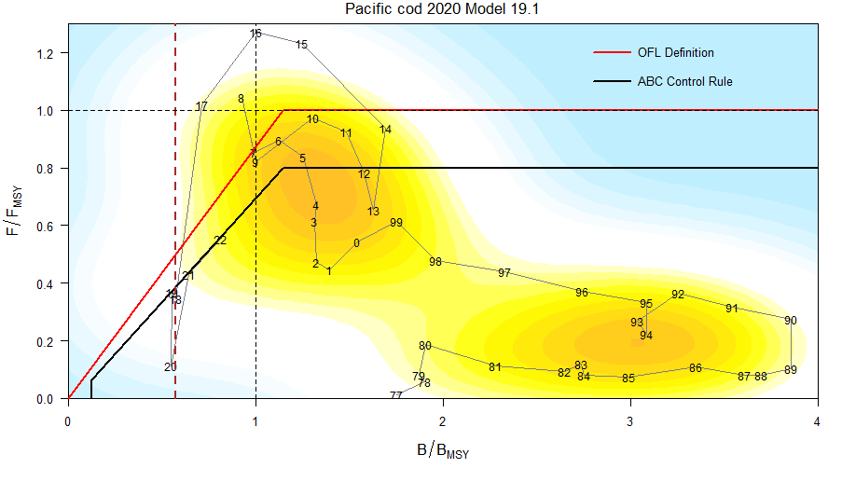

Figure 2.78 For Model 19.1 ratio of historical F/*Fmsy* versus female spawning biomass relative to *Bmsy* for GOA pacific cod, 1977-2022. Note that the proxies for *Fmsy* and *Bmsy* are *F35%* and *B35%*, respectively. The Fs presented are the sum of the full Fs across fleets. Dashed line is at B*20%*, Steller sea lion closure rule for GOA Pacific cod.

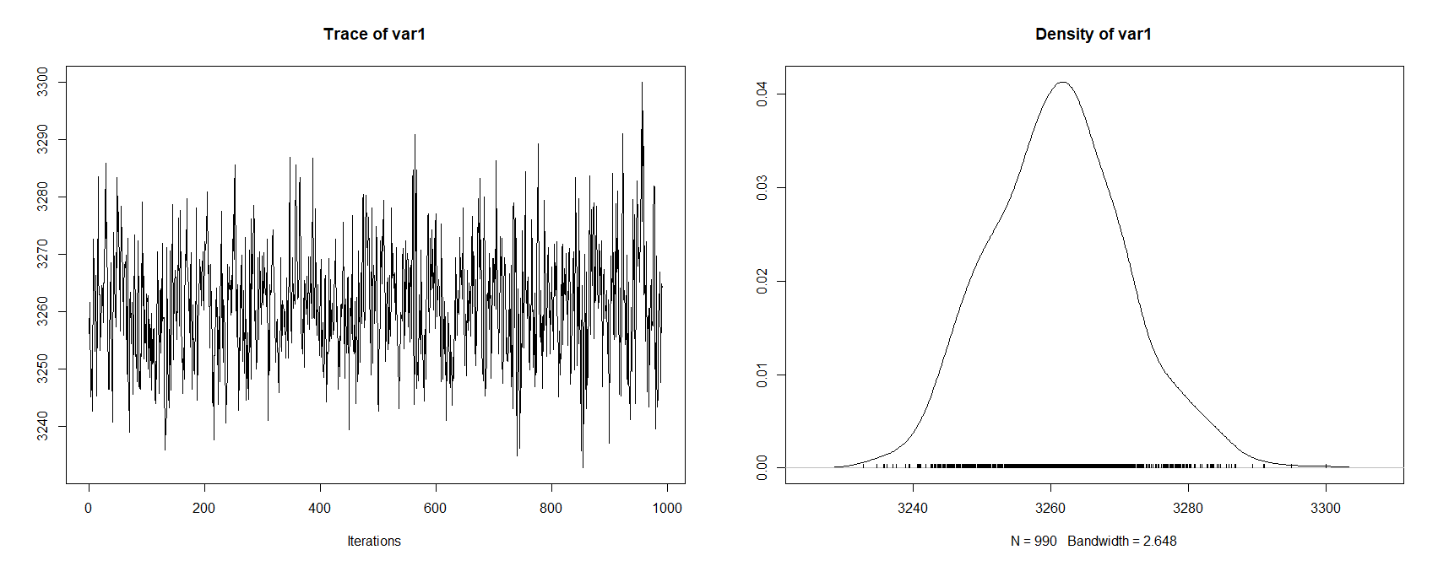 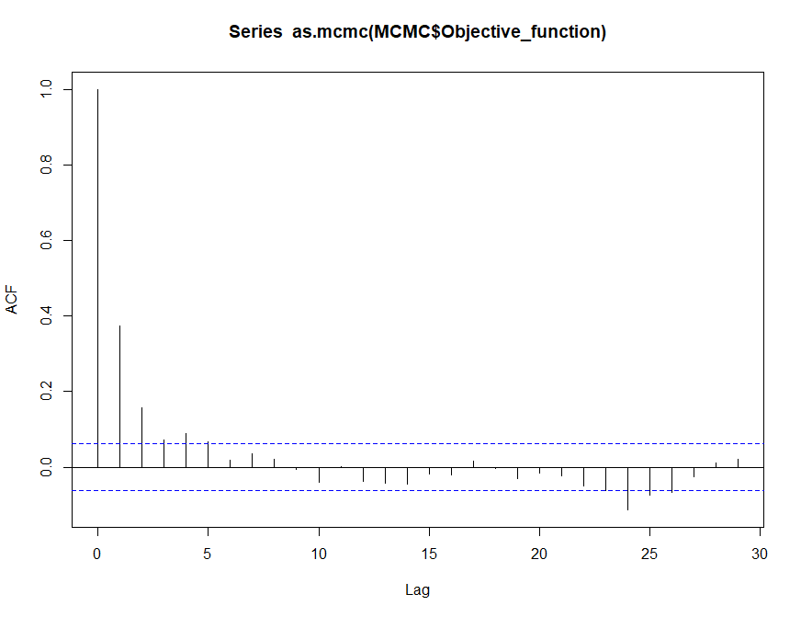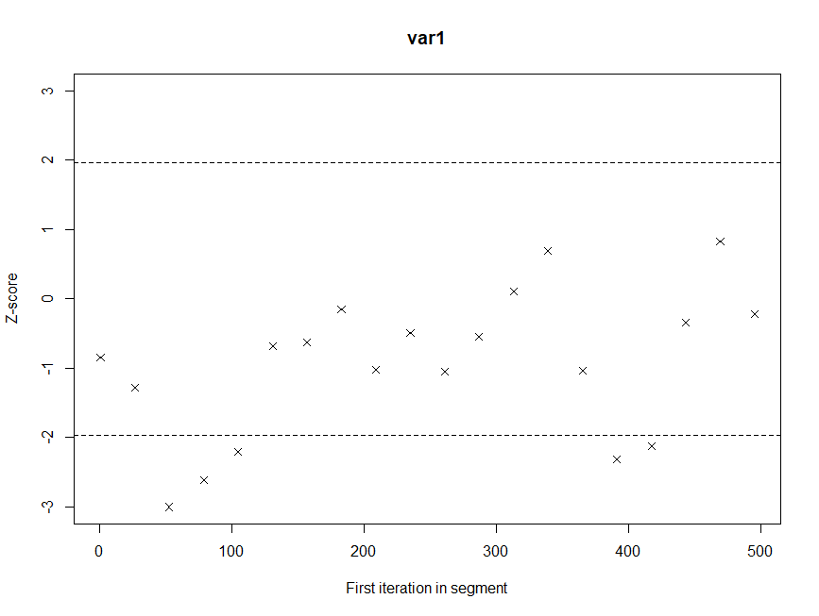

Figure 2.79 Model 19.1 MCMC trace (top left), density (top right), autocorrelation function plot (bottom left), and Geweke diagnostic plot (bottom right) for the objective function.

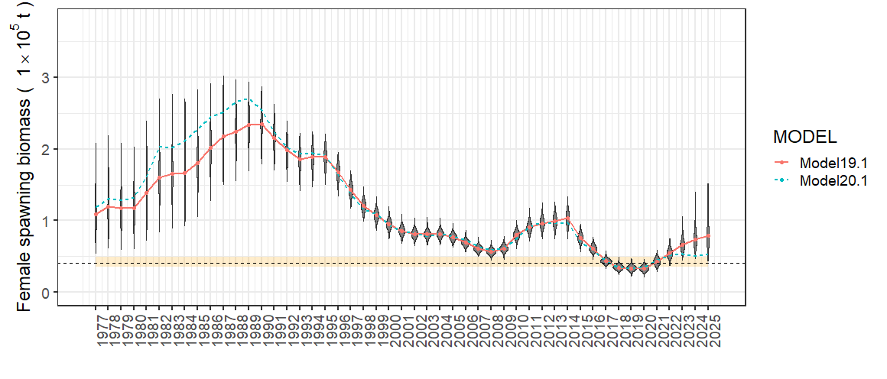

Figure 2.80 Model 19.1 MCMC posterior distribitions of beginning of the year female spawning biomass 1977-2025. Dotted line is the projected SSB*20%* with 95% confidence interval in orange. The blue dashed line is the posterior median for Model 20.1.

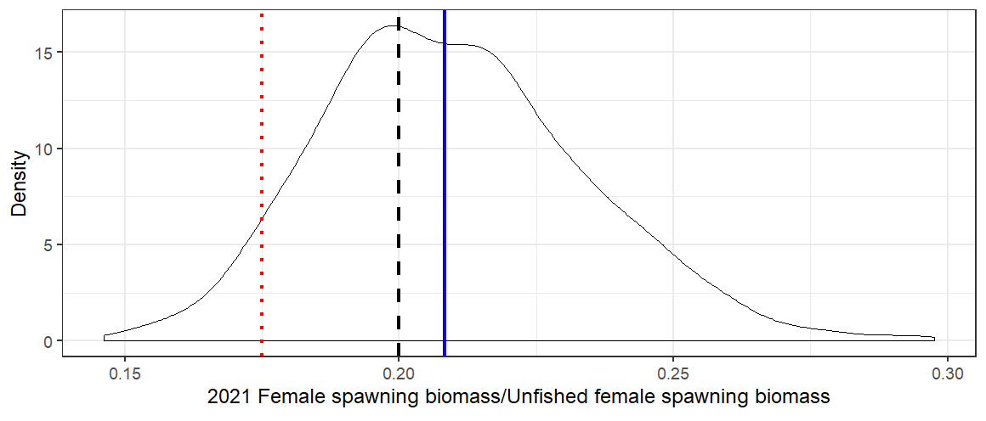

**Posterior Median SSB2021**

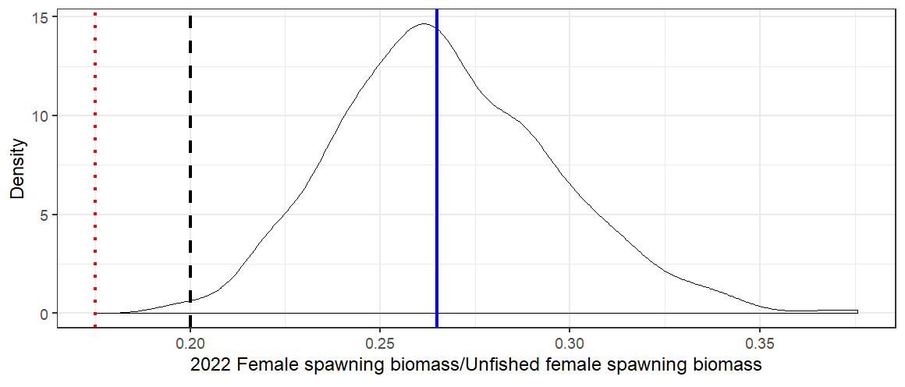

**Posterior Median SSB2022**

Figure 2.81 Model 19.1 MCMC posterior distribitions of the (top) 2021 and (bottom) 2022 spawning stock biomass ratio with estimates for SSB20% (black dashed line) and SSB17.5% (Red dotted line) from the projection model, and posterior median (blue solid line) for beginning year 2021 and 2022.

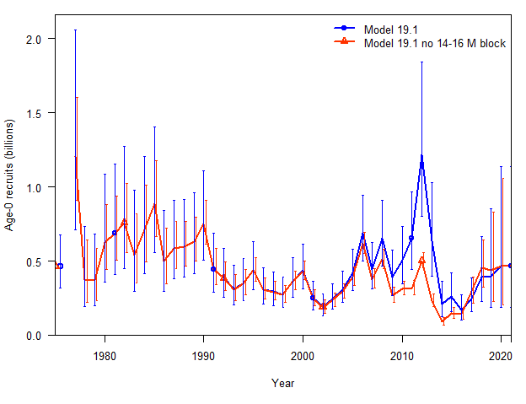

Figure 2.82 Model 19.1 Age-0 recruits with and without the 2014-2016 fitting block on natural mortality showing differences in estimated recruitment for 1977-2021.

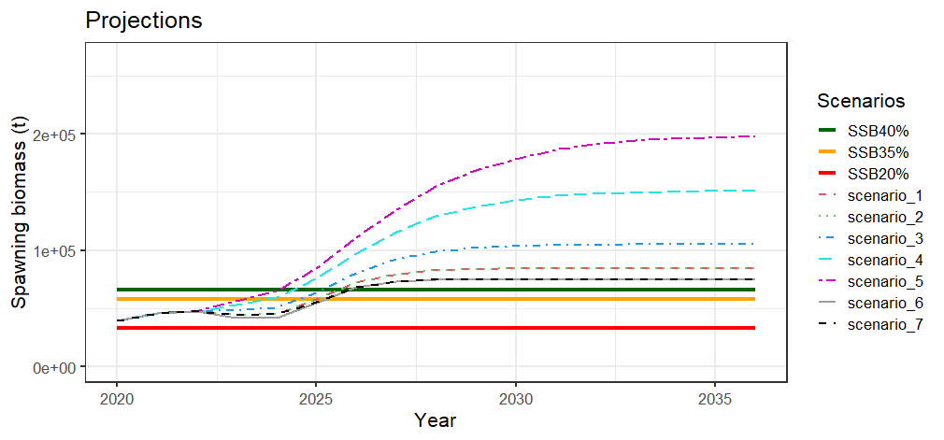 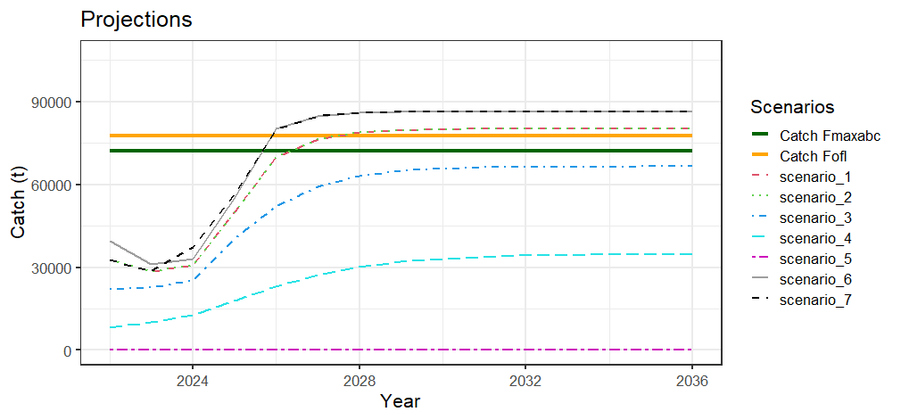

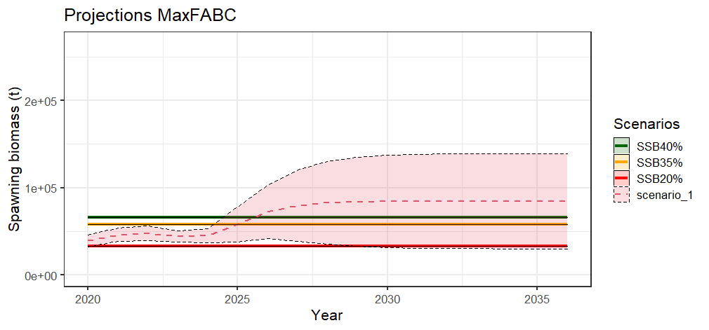 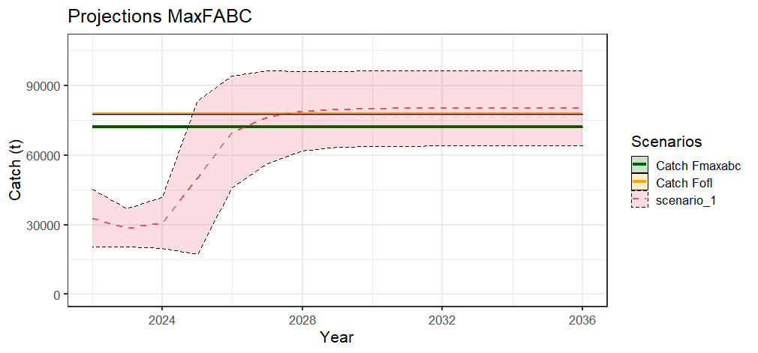

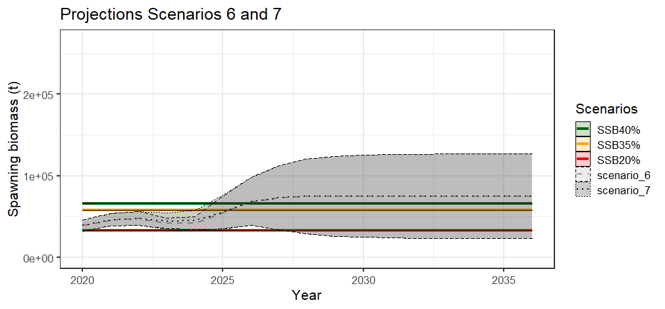 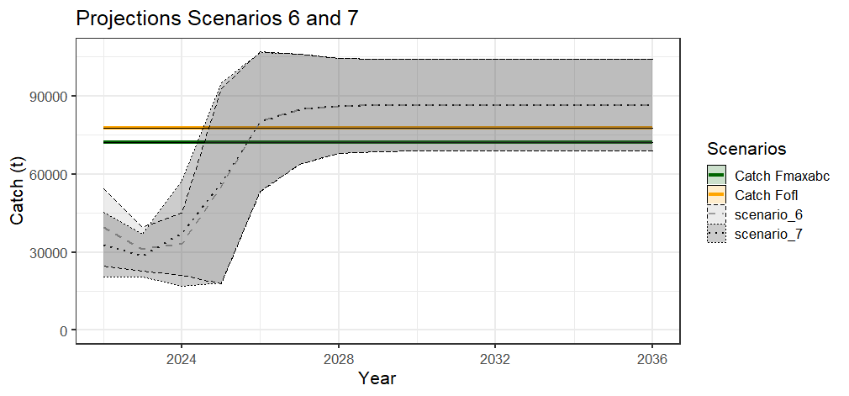

Figure 2.83 Model 19.1 projections of female spawning biomass (top left ) and catch (top right) for the seven management scenarios, for scenario 1 a max ABC (middle), and scenarios 6 and 7 for status determination (bottom ).

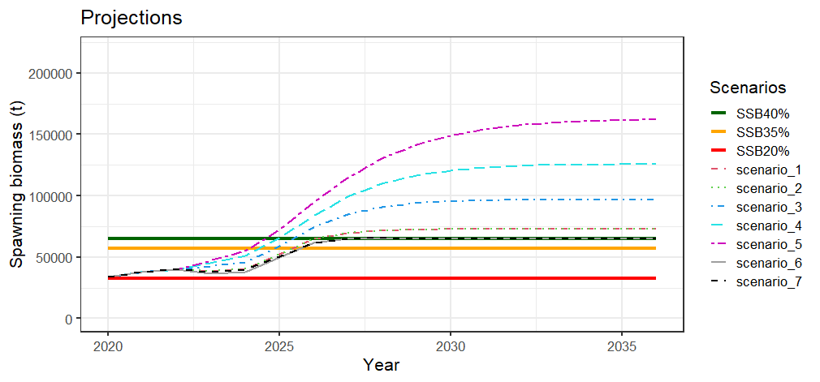 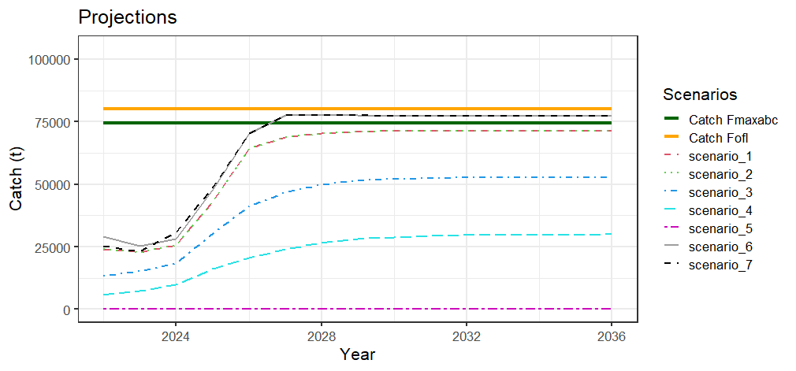

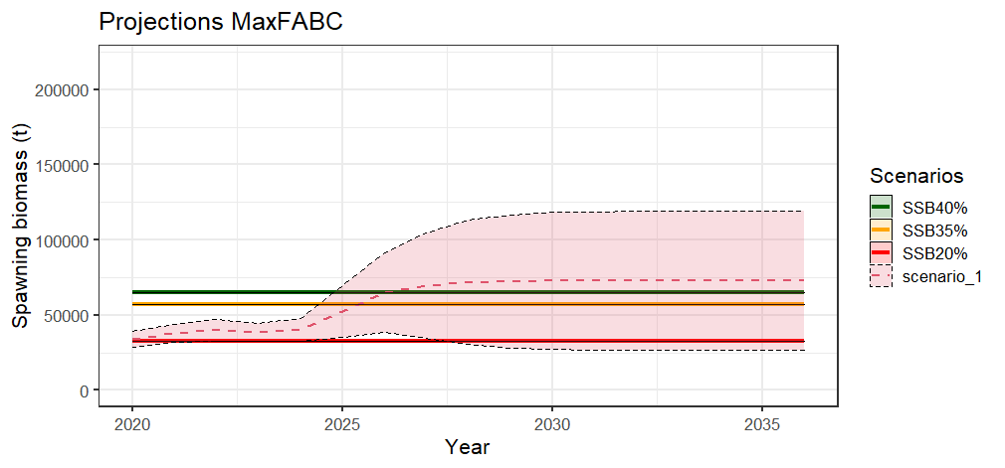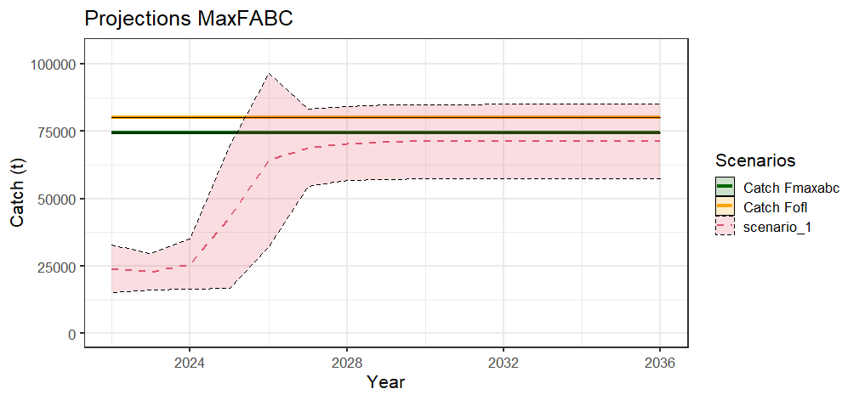

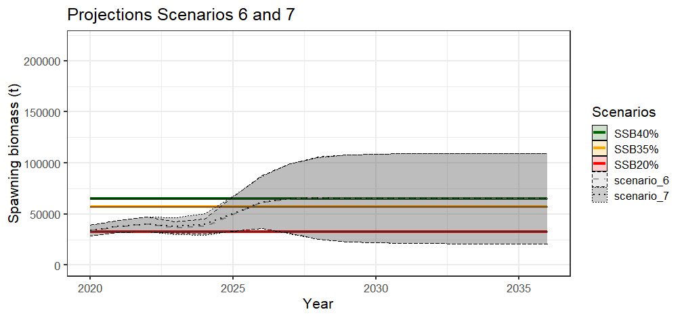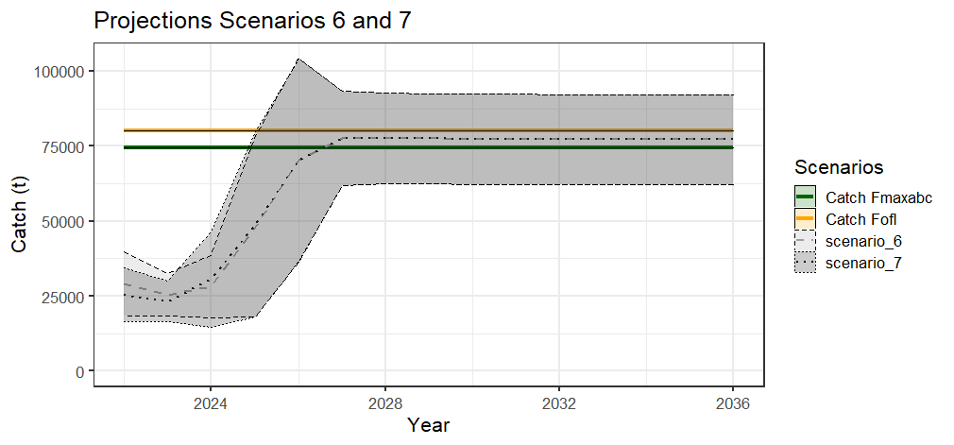

Figure 2.85 Model 21.2A projections of female spawning biomass (top left ) and catch (top right) for the seven management scenarios, for scenario 1 a max ABC (middle), and scenarios 6 and 7 for status determination (bottom ).

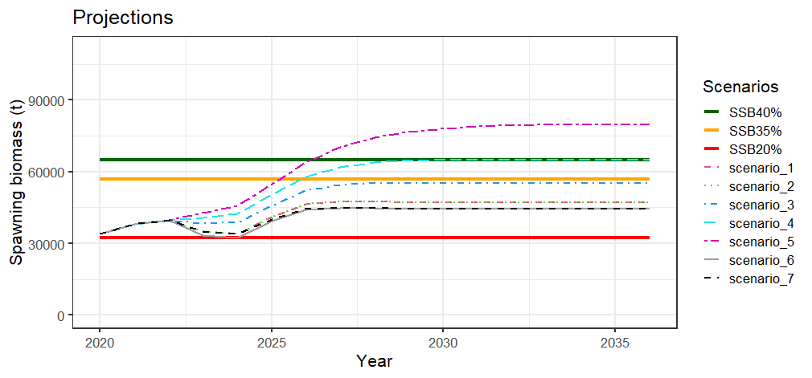 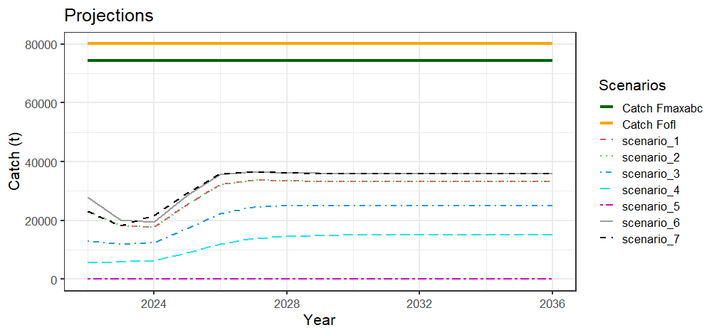

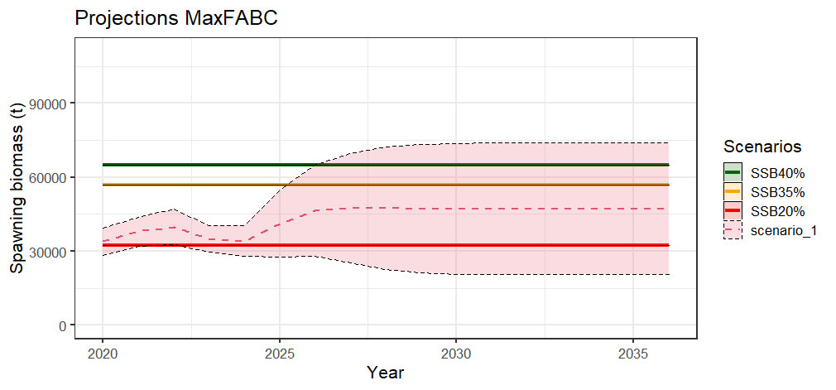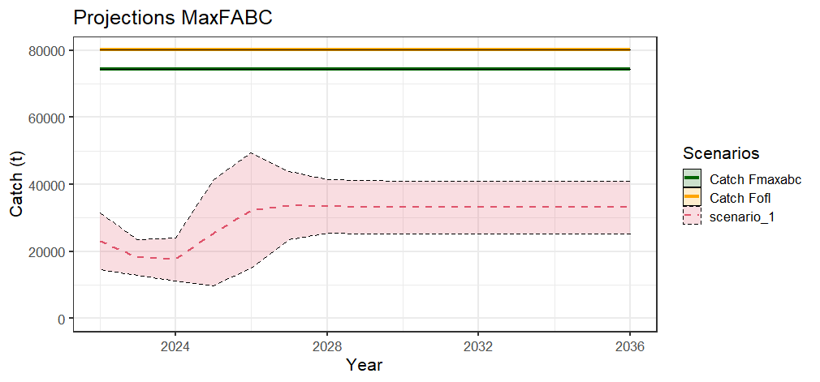

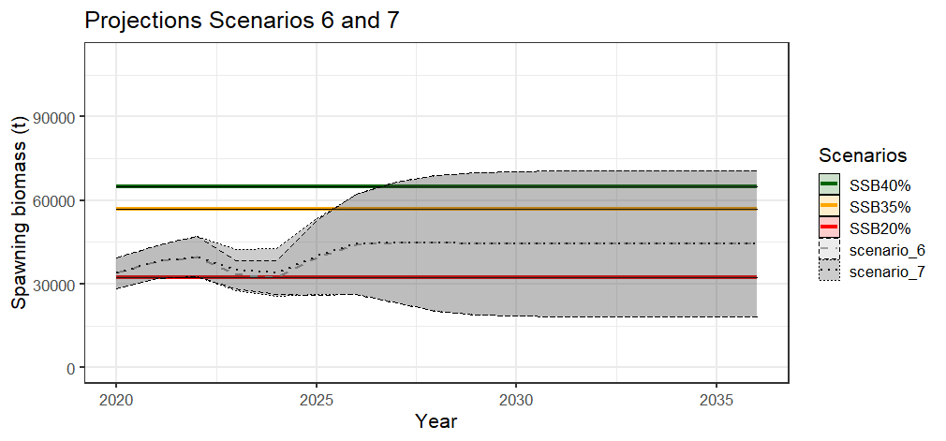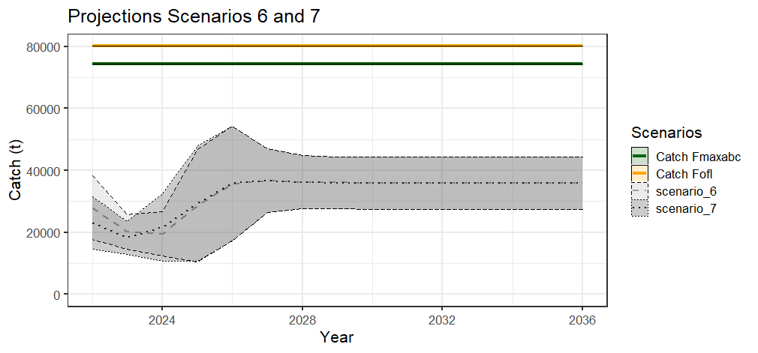

Figure 2.83 Model 21.2B projections of female spawning biomass (top left ) and catch (top right) for the seven management scenarios, for scenario 1 a max ABC (middle), and scenarios 6 and 7 for status determination (bottom ).

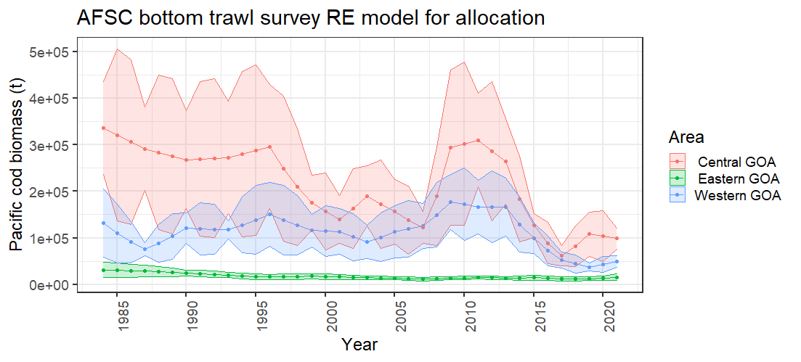

Figure 2.84 Random effects model results for the AFSC bottom trawl survey area used for area allocation.